React Notes

Table of Contents

Styles 6

React Test 7

Effects, Reducers & Context 9

What is Side Effect ? 9

useEffect() Hook 10

Use Effect Example 10

UseEffect and Dependencies 11

What to add & Not to add as Dependencies 12

setTimeout() and clearTimeout() in useEffect() 12

UseReducer() Hook 13

Understanding useReducer() 13

Reducer state in UseEffect() dependency 14

useReducer() vs useState - State Management 15

Context 15

Context Example 16

Step 1: Initializing the Context 16

Step 2: Context Provider 16

Step 3: Context consumer 17

Context consumer using hook 17

Making context dynamic 18

Using centralized state management using Context 18

Context Limitation 20

Rules of Hooks 20

useImperativeHandler Hook 21

Practice Food Order App 21

Adding Cart Button 22

Adding a meals component 23

Adding a Form 24

Adding a Model via React Portal 26

Adding Cart Close Functionality 26

Adding Cart Context 27

Using Cart Context 27

Using Cart Reducer 28

Using and forwarding Ref’s 28

Reducer logic for adding and removing items from cart 30

Implementing Animation to Cart Button 30

Video Demo 31

How React Works? 32

Understanding 32

Demo - Inserting the element without refreshing the UI 34

Child component re evaluation 34

Preventing Function Re-Creation using useCallBack() 35

Component and state 36

State update and Scheduling 37

useMemo() hook 37

Class based Components 38

Class based components alternative to Functions 38

First class-based component 39

Managing state in class-based component 40

Component Lifecycle – using useEffect() functionality in Class based component 41

componentDidUpdate() 41

componentDidMount() 42

Using context in class-based component 42

Class Based Component vs Functional component 43

Error Boundary 44

HTTP Request 45

Browser-side Apps Don’t Directly Talk to Databases 45

Using fetch and then functions 46

Using Async Await 46

Handling the Loading with States 46

Handling error using try catch 48

Using UseEffect for sending Http Request 48

Http POST request 49

Building Custom Hooks 49

What are Custom Hooks ? 50

Creating Custom Hook 51

Configuring the custom hooks 51

Custom Hook to handling Http Requests 52

Working with Form and User Input 53

Dealing with Form Submission and Getting input values 55

Doing the validation on submission 56

Disabling the button based on the state 57

Refactoring the functionality 58

Custom Hook 59

Using reducer in custom hook 60

Using Http in Food Order APP 61

Reusing the useHttp hook 61

Demo 61

Redux 62

What is Cross-Component / App-Wide State? 63

Then Why do need a Redux when we already context Provider 63

How Redux Works? 65

Redux Core Concept 66

Redux Demo 66

Required redux package for react project 67

Registering the redux store in react app 67

Use the redux store in react component 68

Use the redux store in react class based component 69

Counter App Demo 70

Passing data via dispatch action 70

Working with multiple state in redux 71

Redux Challenges & Introducing Redux Toolkit 74

Redux Toolkit Example 74

Using Multiple States 77

Advanced Redux Concept 79

Using asynchronous code with Redux 80

React Dev Tool 84

React Router 84

Why routing? 85

Router Basic 86

Using Link to navigate to Route 87

Using NavLinks to navigate to Route 87

Route Param 88

Using “Switch” and “exact” for configuring routes 89

Working with Nested Routes 91

Using Redirect 91

Route for handling unknown URL paths 92

Programmatic Navigation 93

Quote App Implementation So Far 93

Prompting User on Navigation 94

Working with Query Parameters 95

Removing the component based on URL 96

Writing more flexible route code 97

React Router 6 98

Switch changed to Routes 98

Exact has been removed 98

element is introduced in Route tag. 98

Order of the Routes does not matter 98

NavLink activeClassName has been removed 99

Redirect changed to Navigate 99

While adding the nested routes, no need to specify the parent path 100

Alternate way specifying the alternate route 100

useHistory changed to useNavigate 101

Promt is removed. 101

Deploying React App 101

Deployment Step 101

Deployment Optimization 102

Building the code for production 103

Upload Production Code to Server 103

Adding Authentication to React App 107

Adding User Signup 109

Adding User Sign In 112

Redirecting the login page after the password change 114

Protecting Frontend Page 114

Storing login token in storage browser 115

Auto logout 115

Handling the timer while logout 116

Next JS 117

Why Next JS? 117

Next JS Key Feature and Benefits 118

Create Next JS Project 118

Nested Pages 119

Dynamic Page 120

Extracting a Dynamic Parameter Value 121

Linking between Pages 121

Other way – using Link from next js 122

Preparing project pages 123

Adding a new meetup form 125

Adding a Navigations 126

Adding a navigation bar to entire pages 127

Meetup App - Implementation so far 128

Data Fetching for static pages 128

Static Site Generation (SSG) 129

Regenerate the code 130

Server-Side Rendering (SSR) 131

getStaticPaths() 131

Working with MongoDB 132

Inserting data to MongoDB 133

Loading Data from MongoDB 135

Loading a Dynamic Data in MeetupDetails page 135

Adding a Meta Data to Page before Deployment 136

Animation 137

Preparing the project for adding animation 137

Animating the model pop up 137

CSS Animation Property 139

Using ReactTransition group 140

Adding Transition to Model Popup 142

Wrapping the Transition Component 143

Animation Timings 144

Transition Events 145

CSSTransition component 147

Using a classnames in CSSTransition component 148

Using TransitionGroup to manage multiple transitions 148

Other React Animation Library 149

Replacing Redux with React Hooks 149

Testing React App 152

What is Testing? 152

Different Kind of Test 153

What to test ? 153

Running the test 154

Writing a test 155

Grouping test together with Test Suites 155

Testing connected component 159

Testing Asynchronous Code 160

Working with Mock 161

React + Typescript 161

What and Why? 162

Installing Typescript 163

npm init -y 163

npm install typescript 164

Compiling type script to JavaScript 164

Base Types 165

Array and Objects 165

Type Inference 166

Union Type 166

Type alias 166

Function and Function Types 167

Generics 167

Working with React TypeScript Project 168

Creating a project 168

Working with component and TypeScript 169

Working with props and Typescript 170

Adding a Data Model 172

Sperate out by Adding a TodoItem component 173

Working with ref, useRef and Function Props 174

Managing State 176

Removing Todo Item 177

Using Context API 180

tsconfig.json 182

# Styles

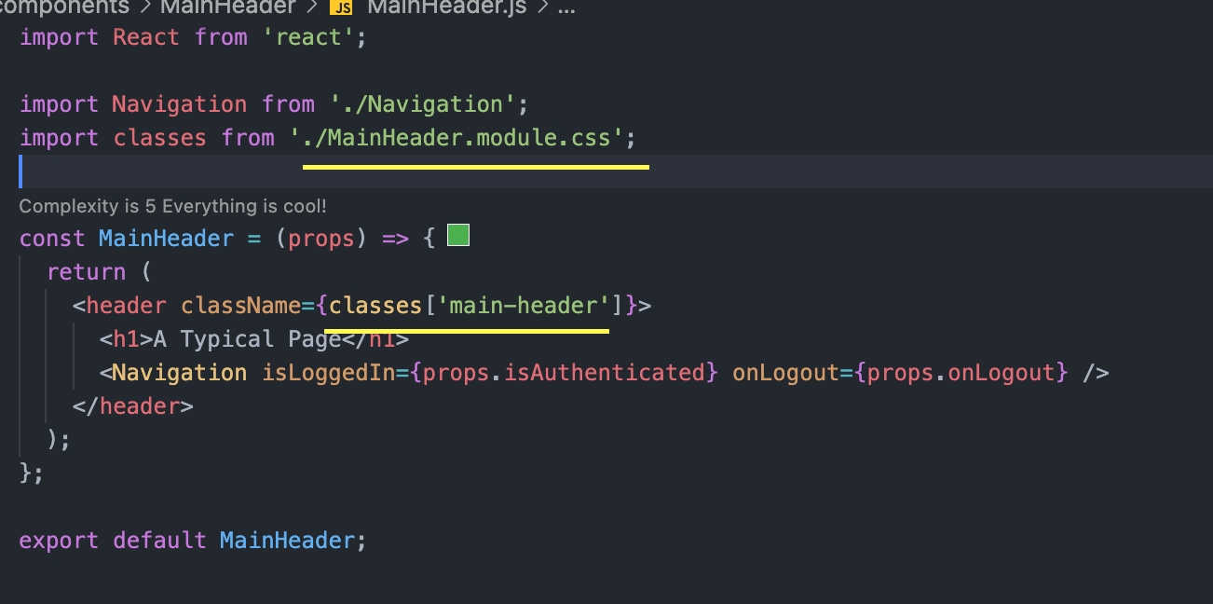

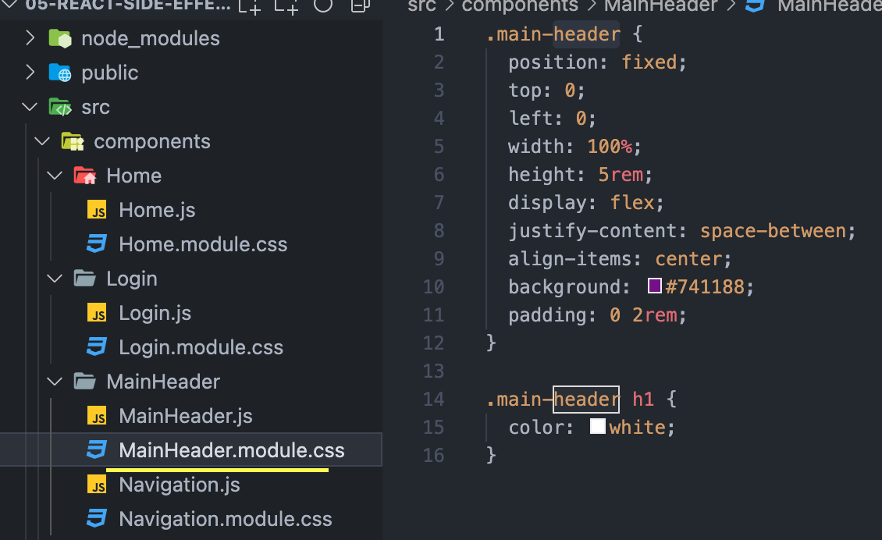

# React Test

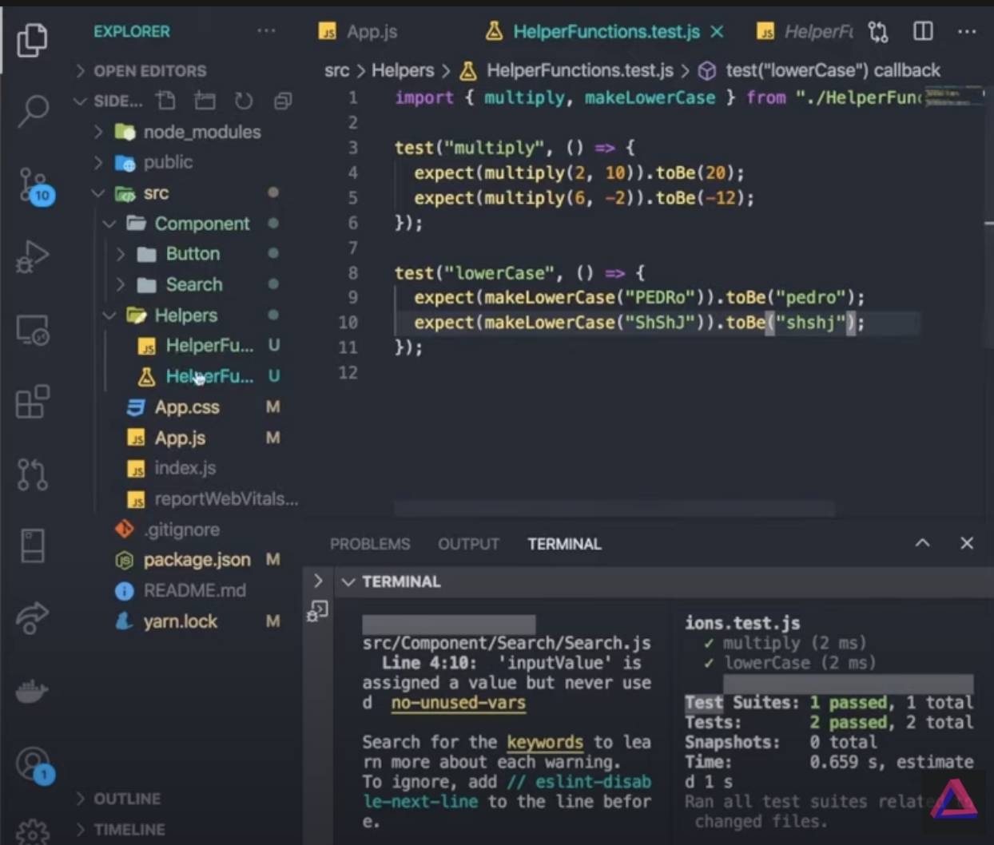

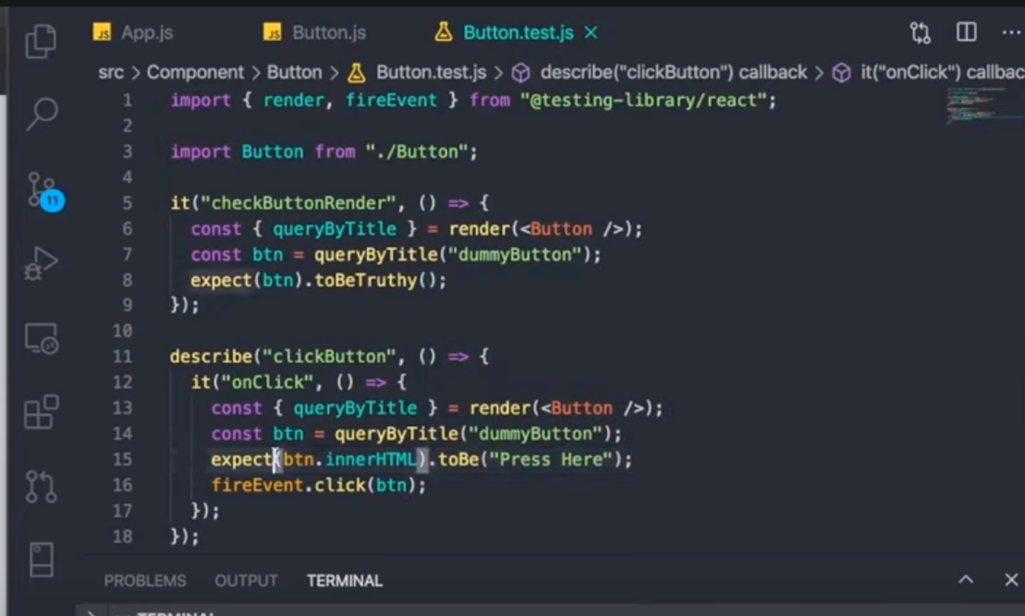

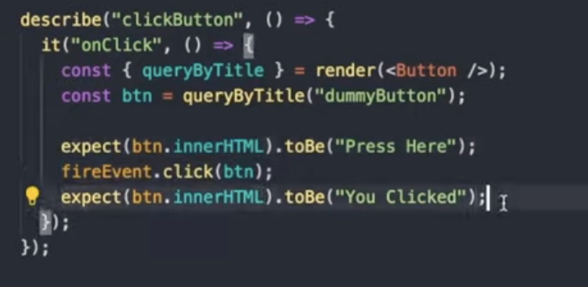

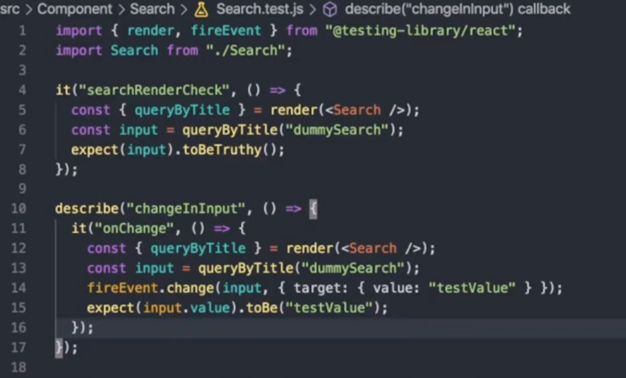

# Effects, Reducers & Context

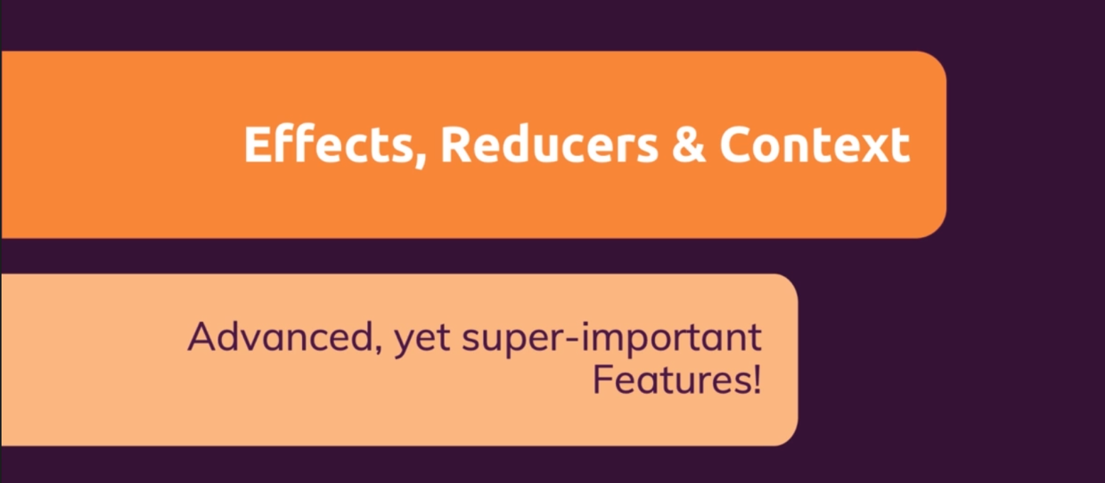

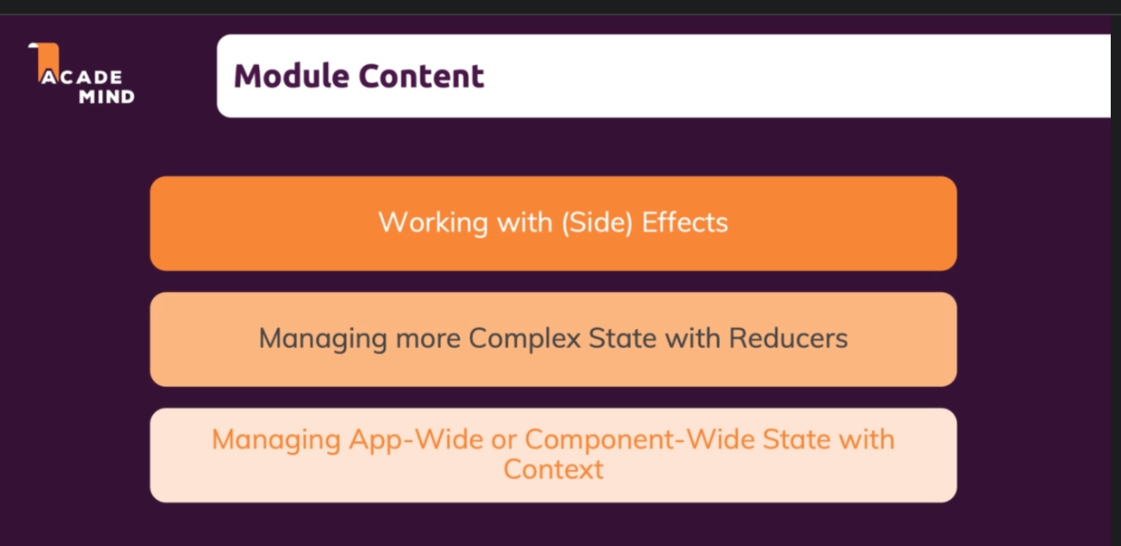

## What is Side Effect ?

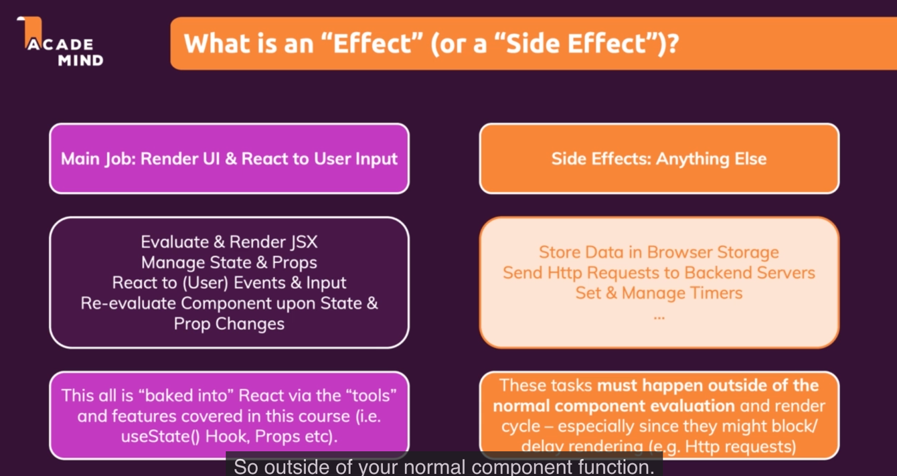

## useEffect() Hook

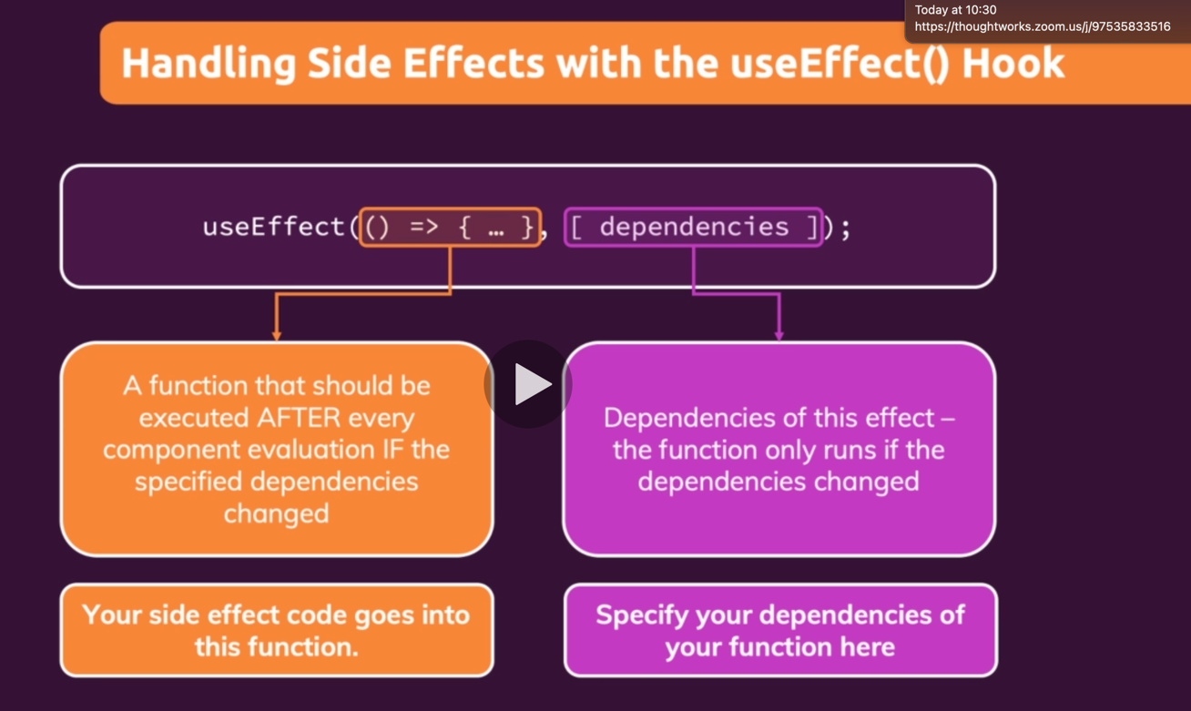

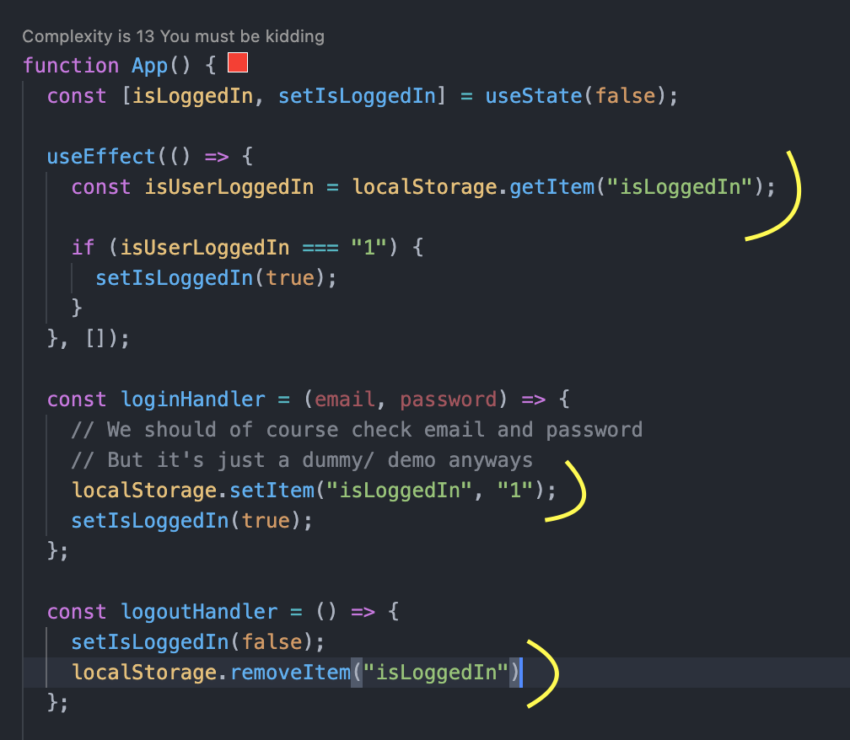

localStorege is built-in storage in browser.

### Use Effect Example

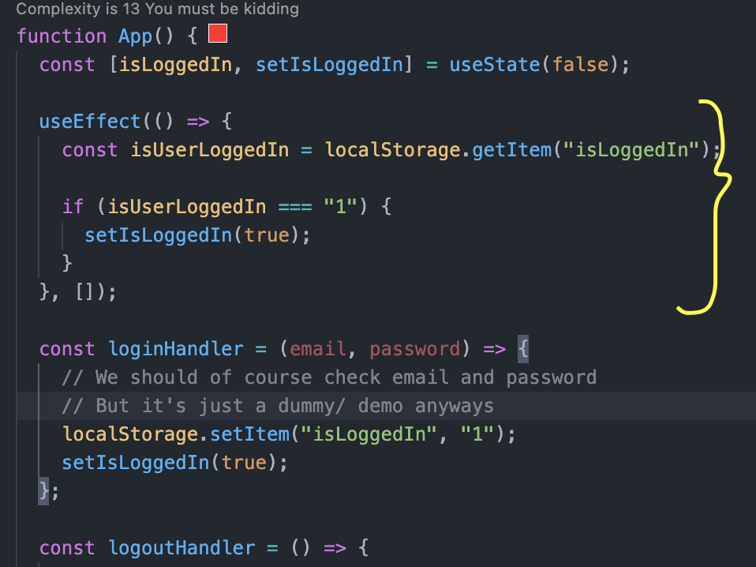

This useEffect() function run only once on starting the app, since we don’t specified the dependency.

### UseEffect and Dependencies

If we remove the second argument (without an array of dependencies) from the useEffect function, useEffect is executed every time component is reevaluated. It causes the infinite loop.

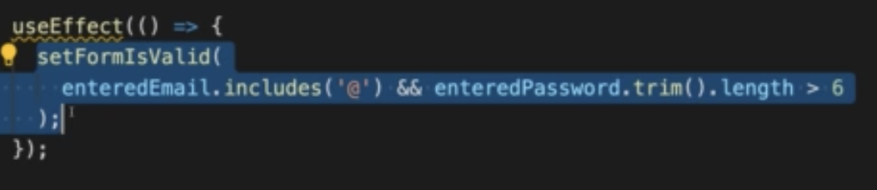

We can have a function and state variable in useEffect dependency. Whenever dependencies changes useEffect function will be executed.

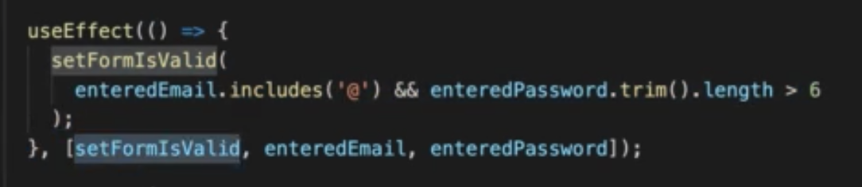

### What to add & Not to add as Dependencies

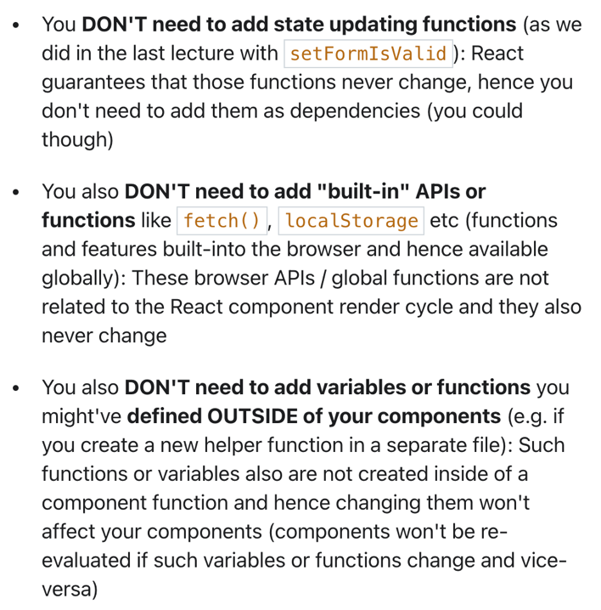 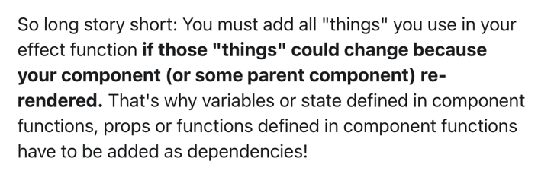

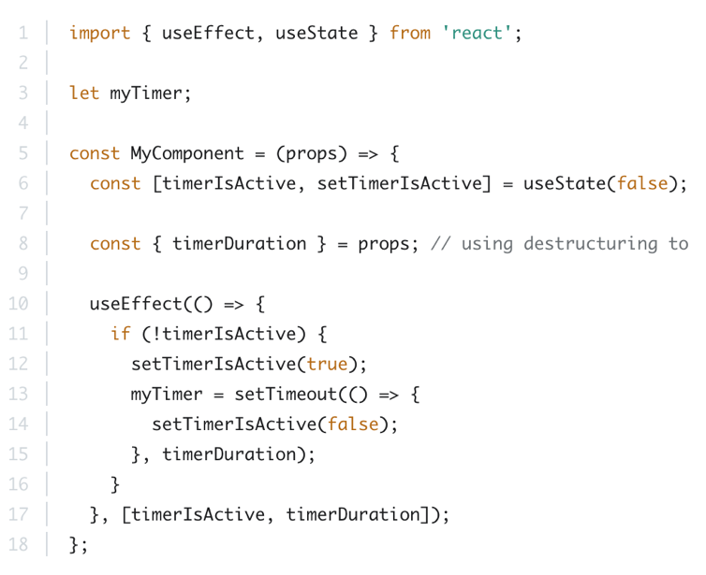 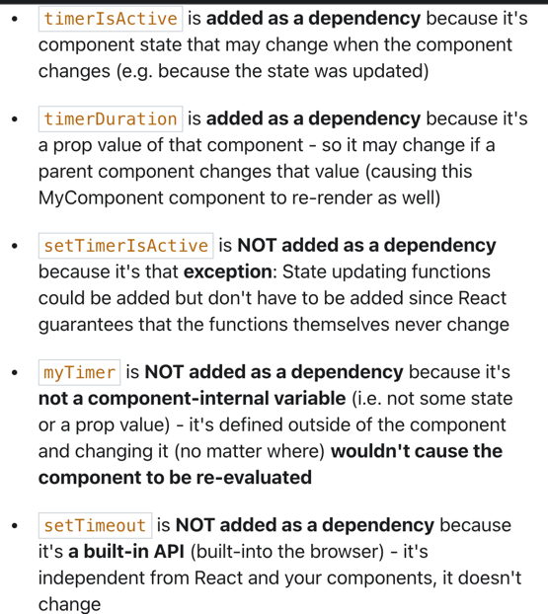

### setTimeout() and clearTimeout() in useEffect()

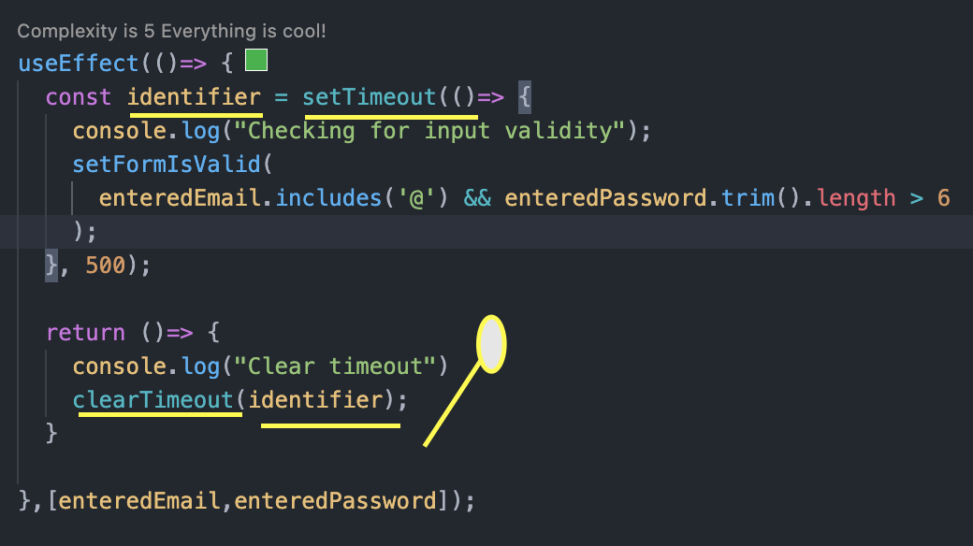

* setTimeout() – Based on the dependency, useEffect function will execute. Every time dependencies value changes, useEffect function trigger immediately after the component function render. So, every time key typed useEffect will get triggered. This will end make the multiple call to this function. To overcome this problem, we can use the setTimeout() function to make some delay the execution upon dependency changes. New timer will set on every time dependency changes.
* return statement inside the useEffect() – UseEffect function can return the function that will take care of the clean up activity. This return function will run at start of the useEffect function except the first time. In this example we are clearing the timer using clearTimeout() function.
* This clean up function also execute when the component is removed from the dom.

## UseReducer() Hook

* State update depends on other state.
* Two more state belonging together.

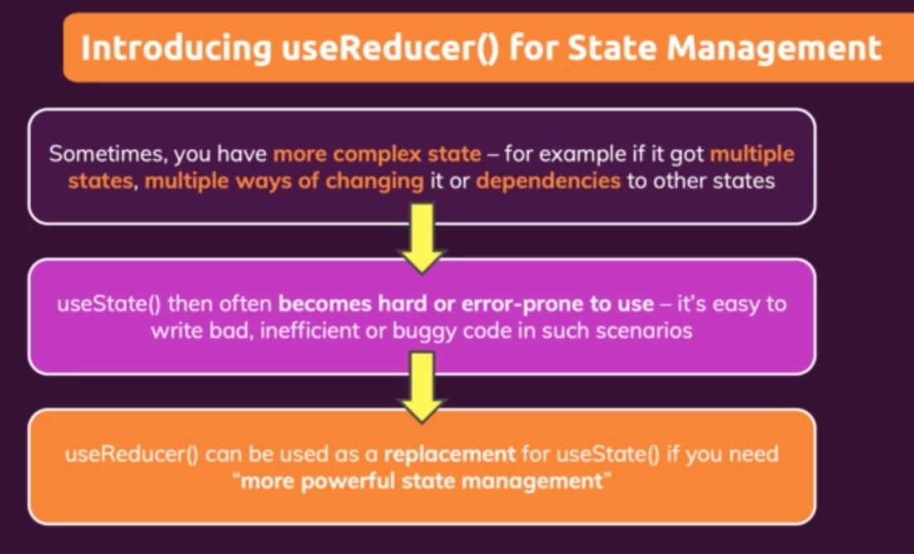

### Understanding useReducer()

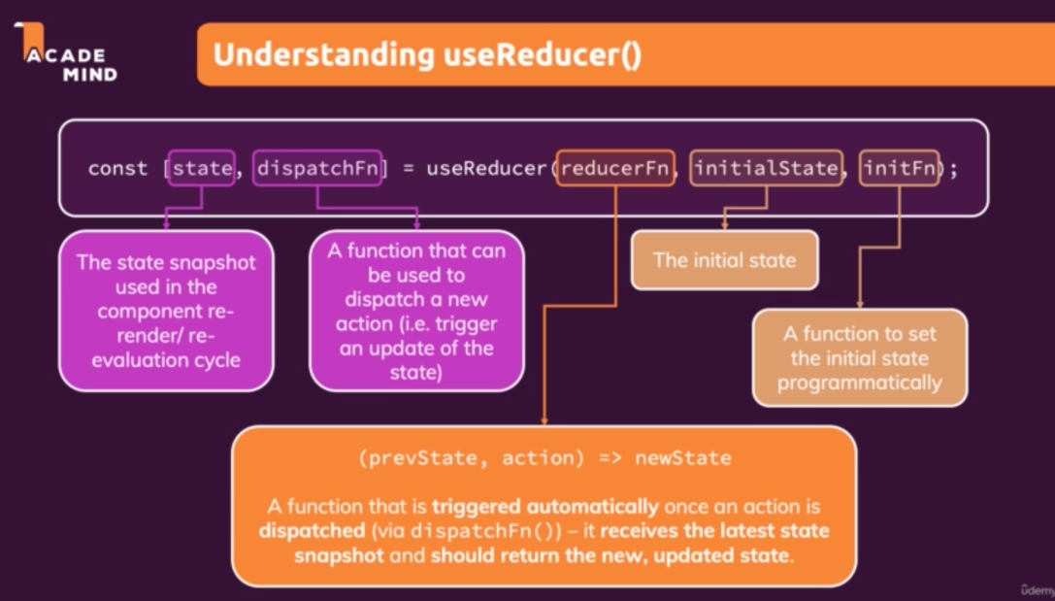

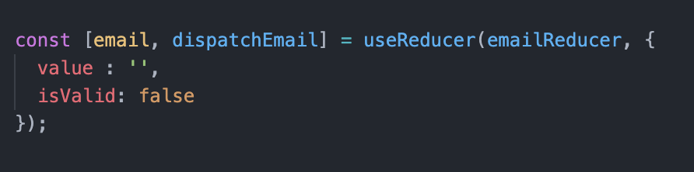

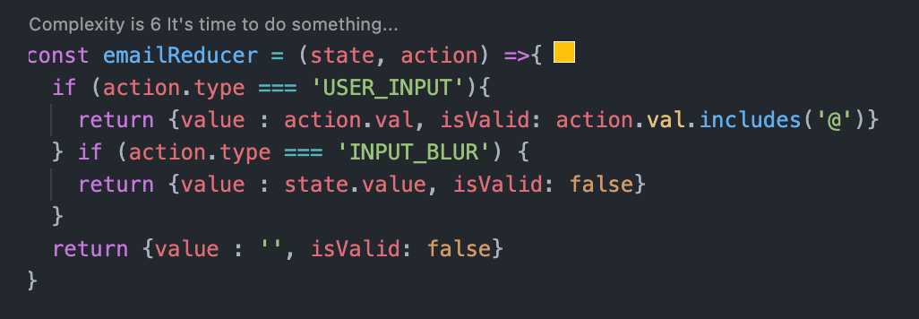

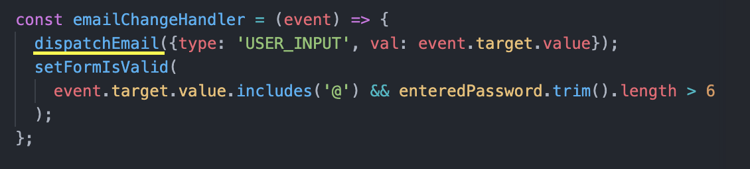

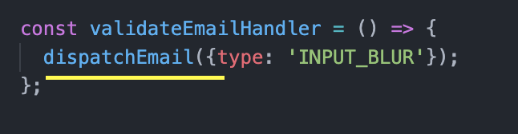

### Reducer state in UseEffect() dependency

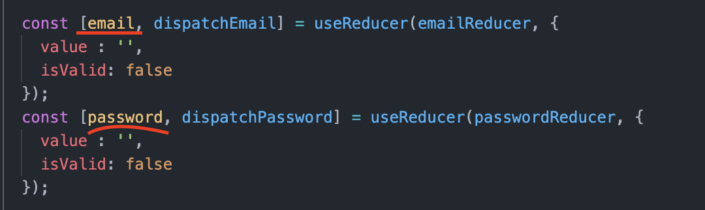

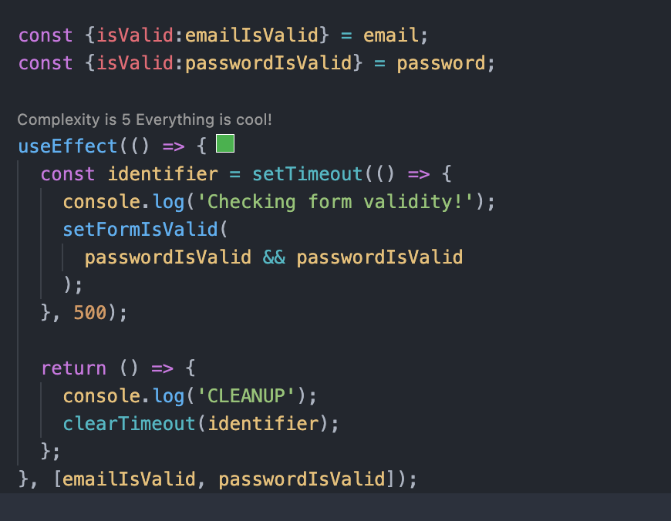

Here we are using the reducer’s object property on useEffect dependency. We pass specific properties instead of the entire object as a dependency.

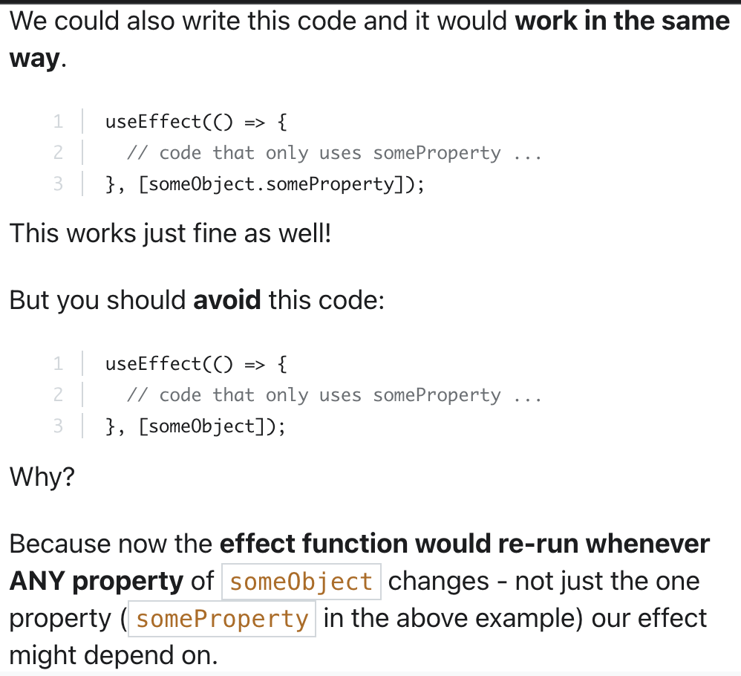

### useReducer() vs useState - State Management

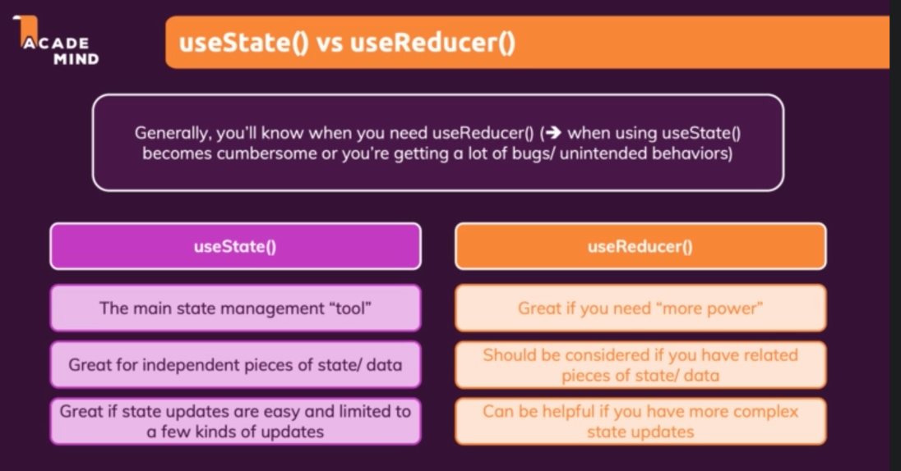

## Context

When we have larger project lifting the state up and down can be tedious.

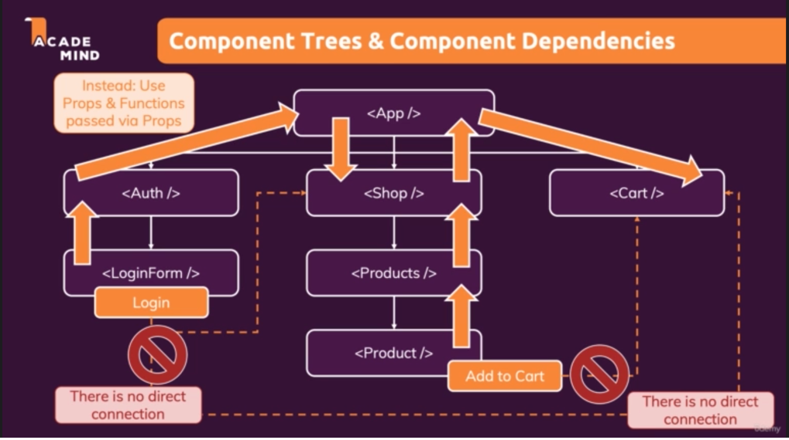

In this case we can use “Context”.

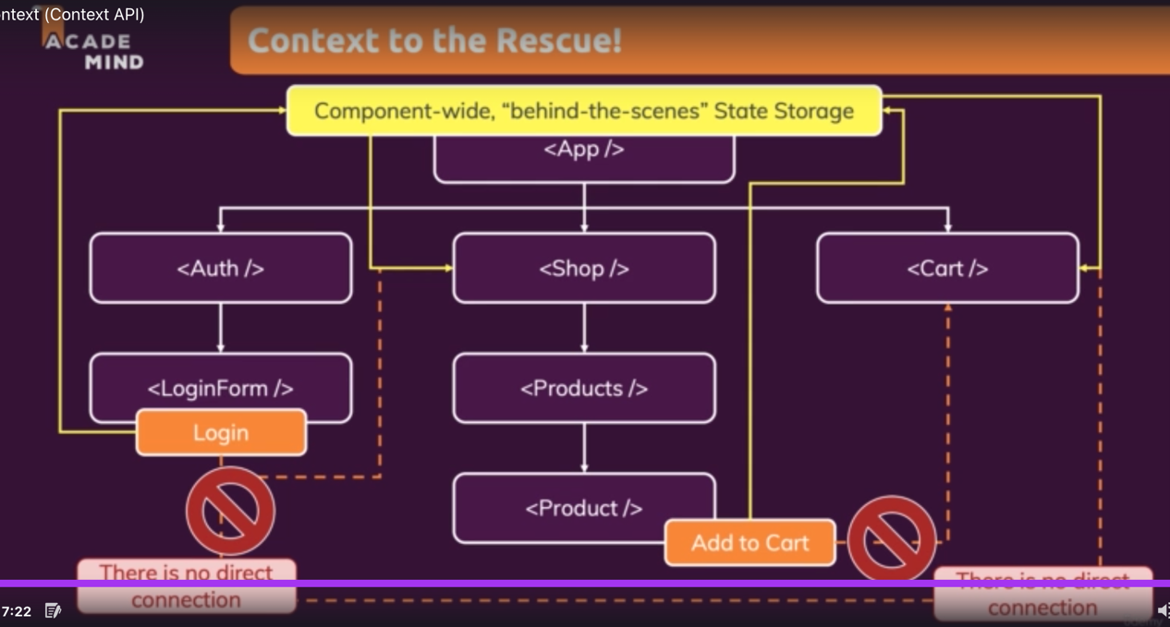

### Context Example

#### Step 1: Initializing the Context

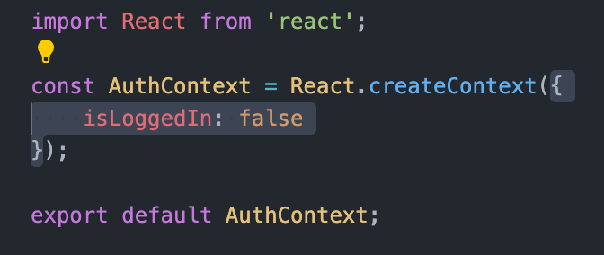

Here, AuthContext contains the component objects.

#### Step 2: Context Provider

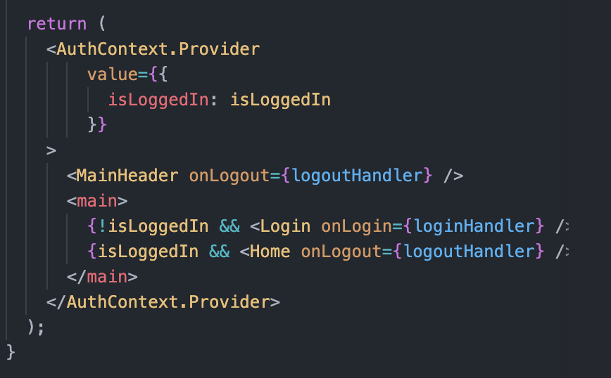

#### Step 3: Context consumer

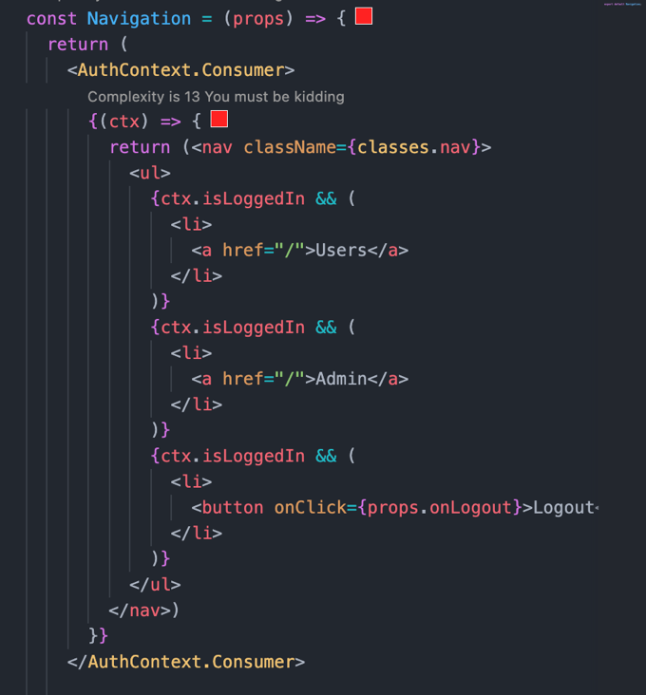

#### Context consumer using hook

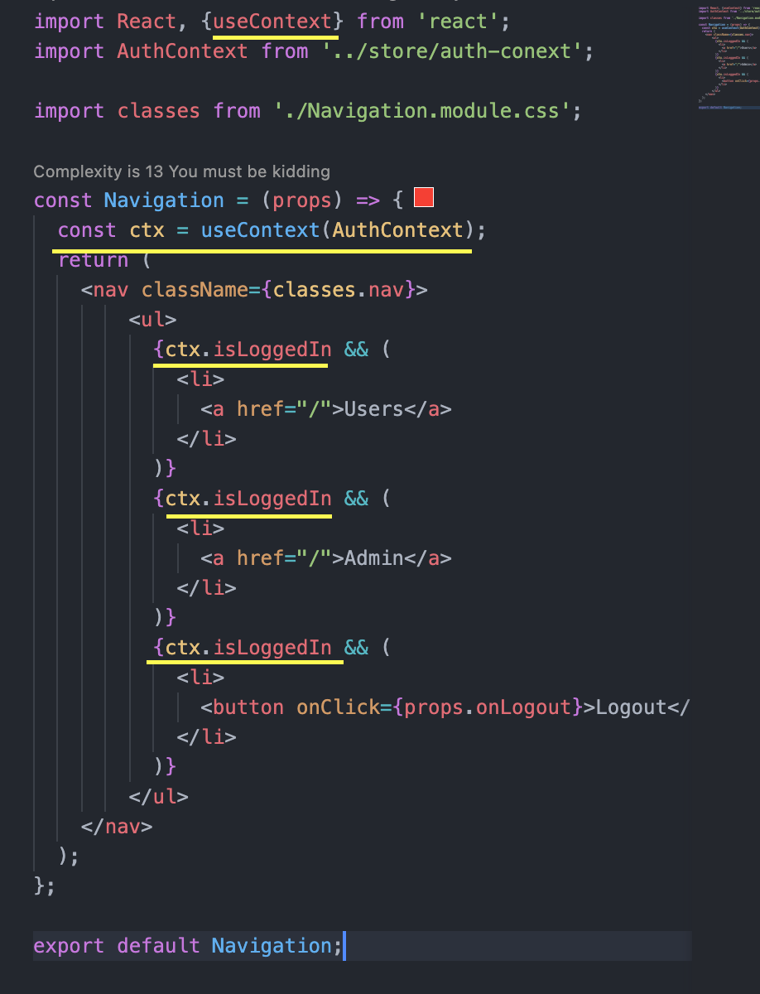

When we are forwarding prop values instead of using it, we can use context there.

Context use to manage the app wide state.

### Making context dynamic

Using the function as context.

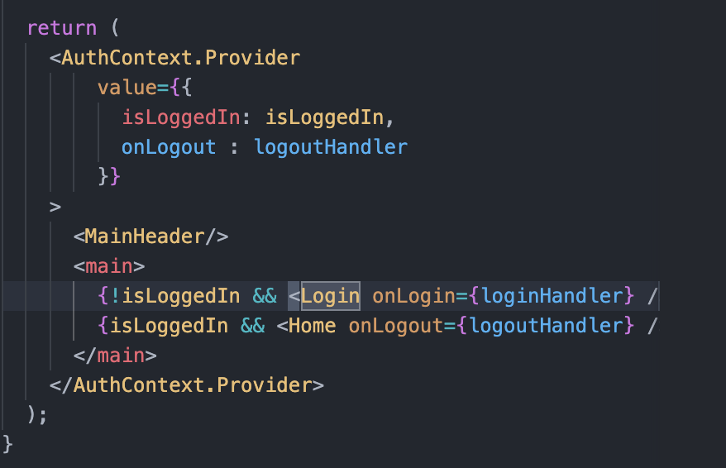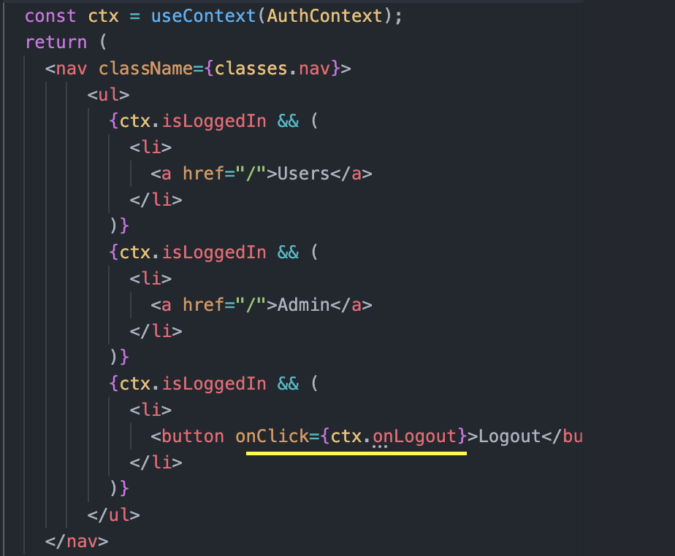

### Using centralized state management using Context

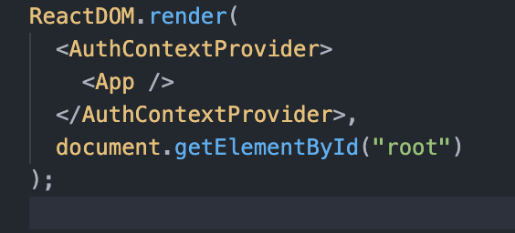

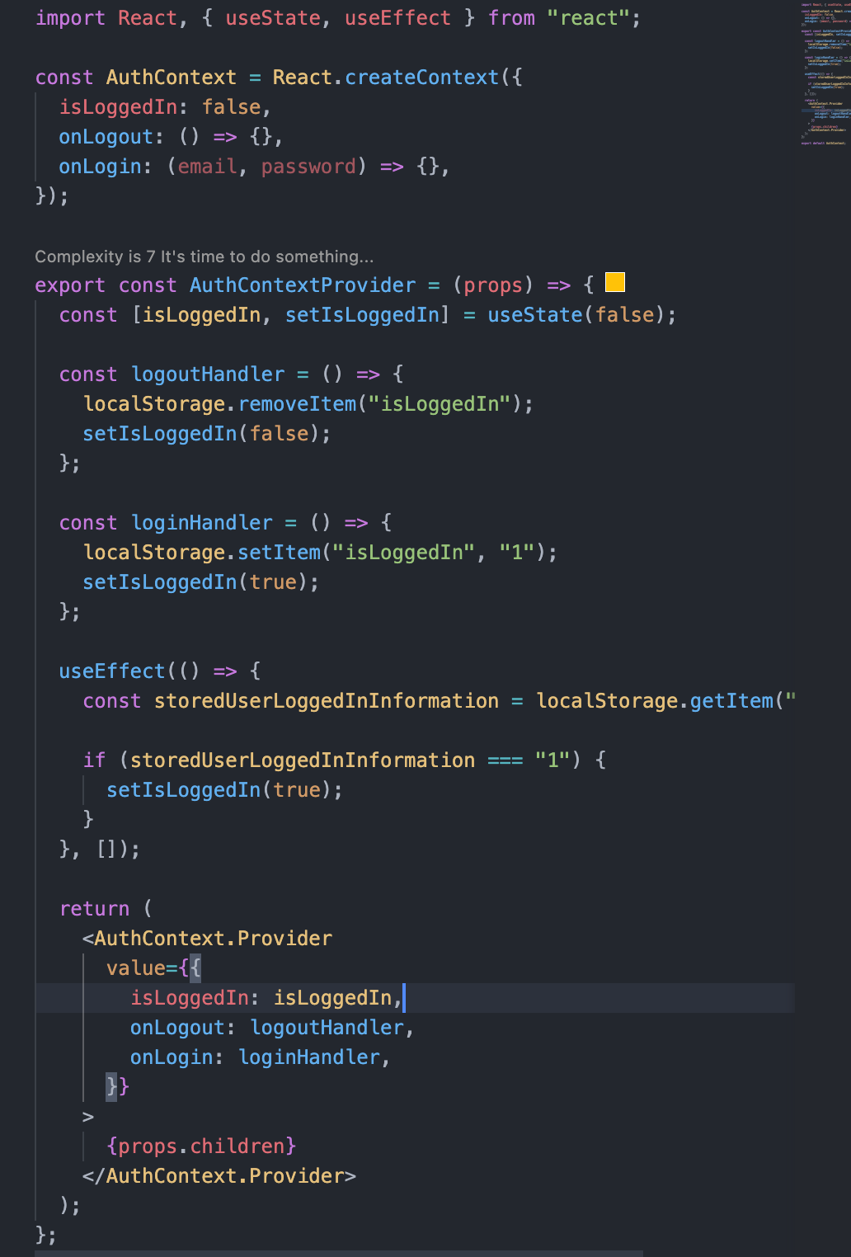

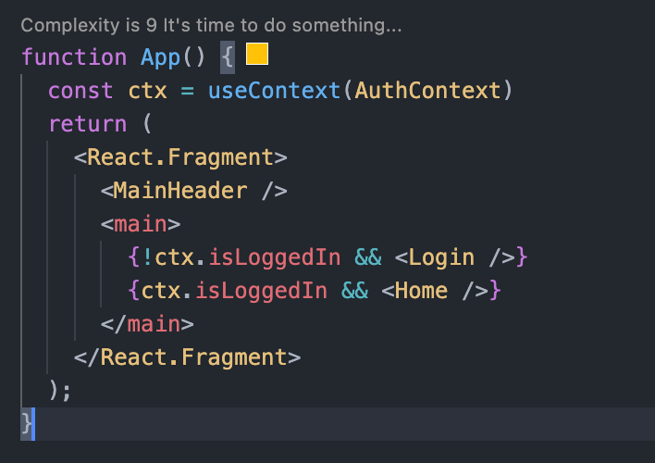

### Context Limitation

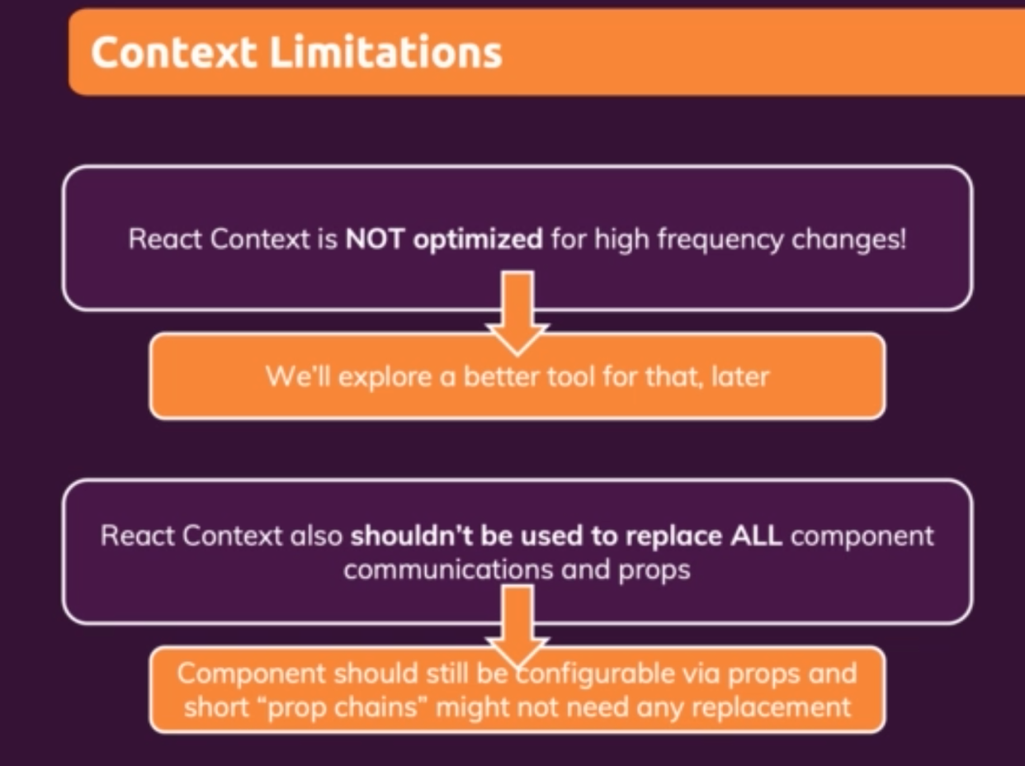

## Rules of Hooks

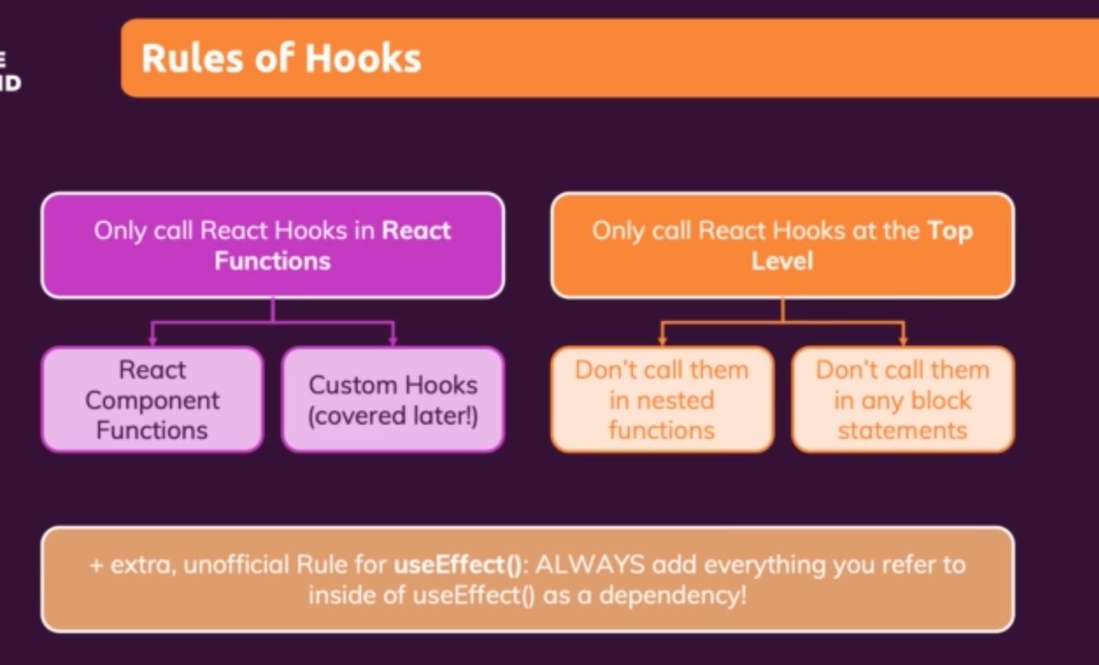

### useImperativeHandler Hook

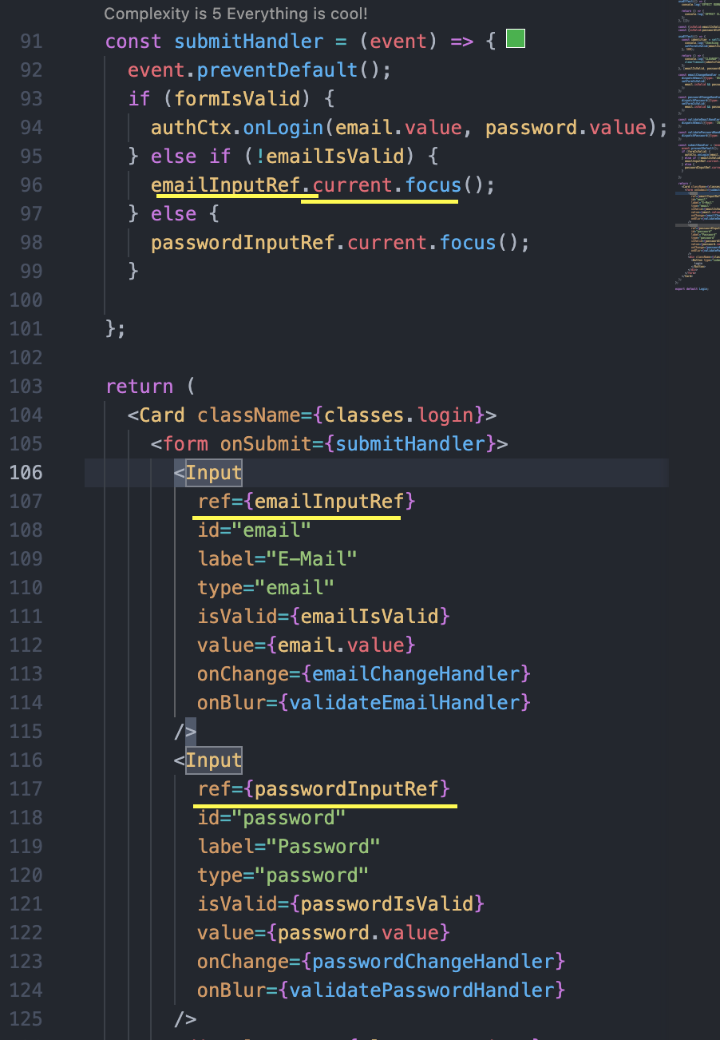 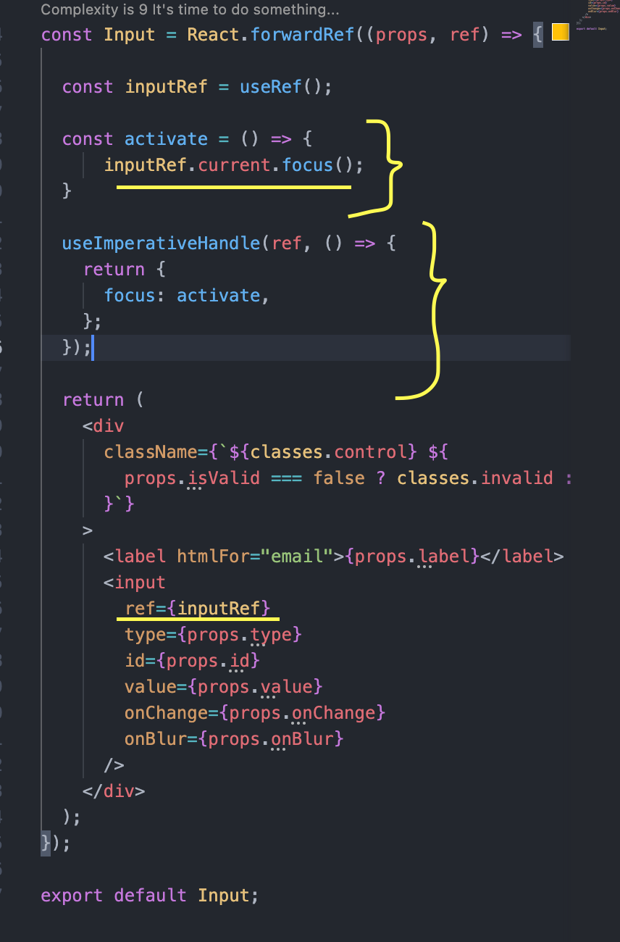

# Practice Food Order App

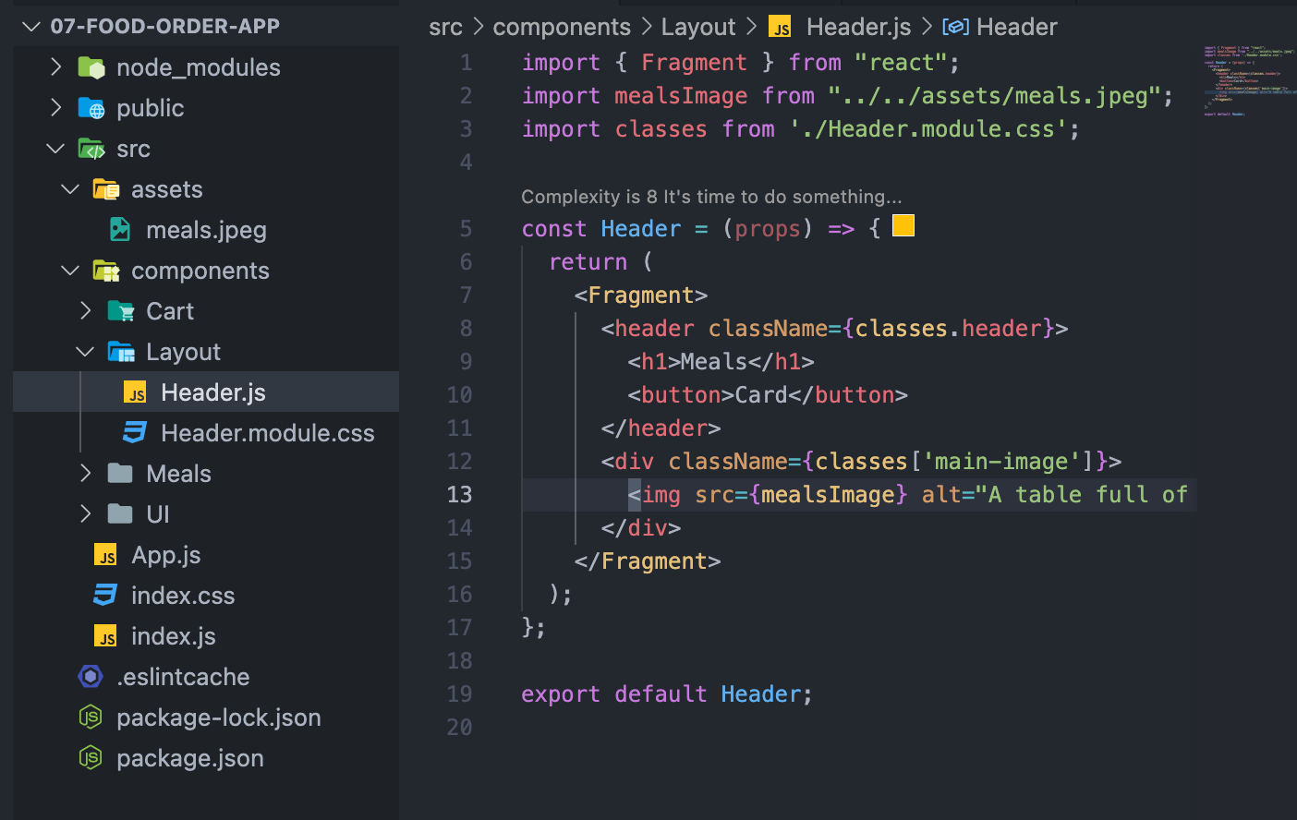

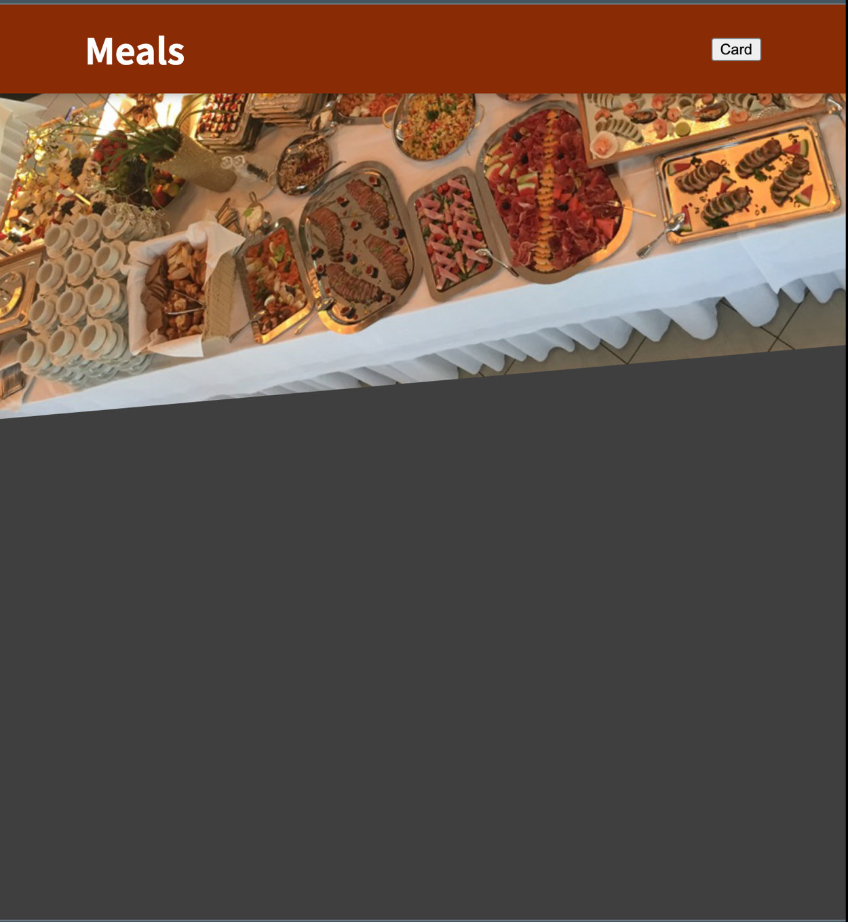

## Adding Cart Button

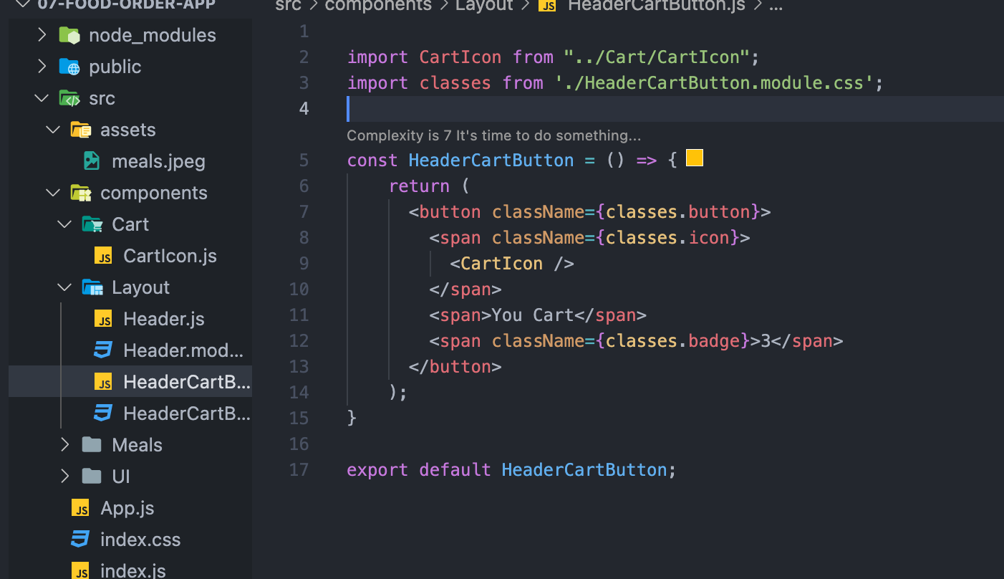

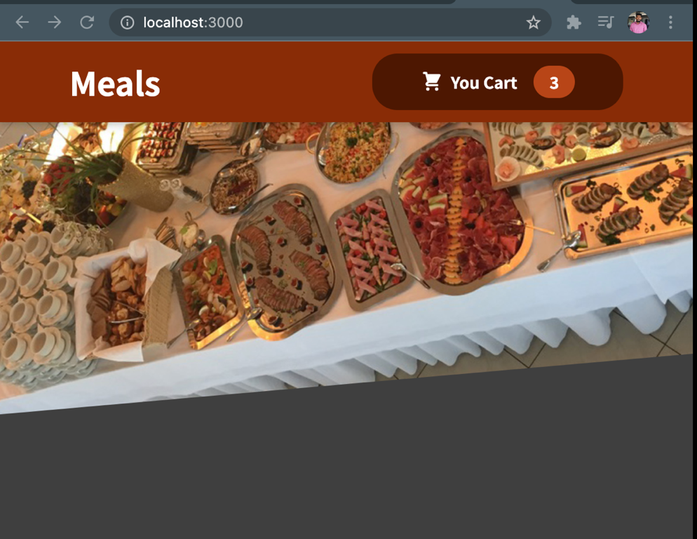

## Adding a meals component

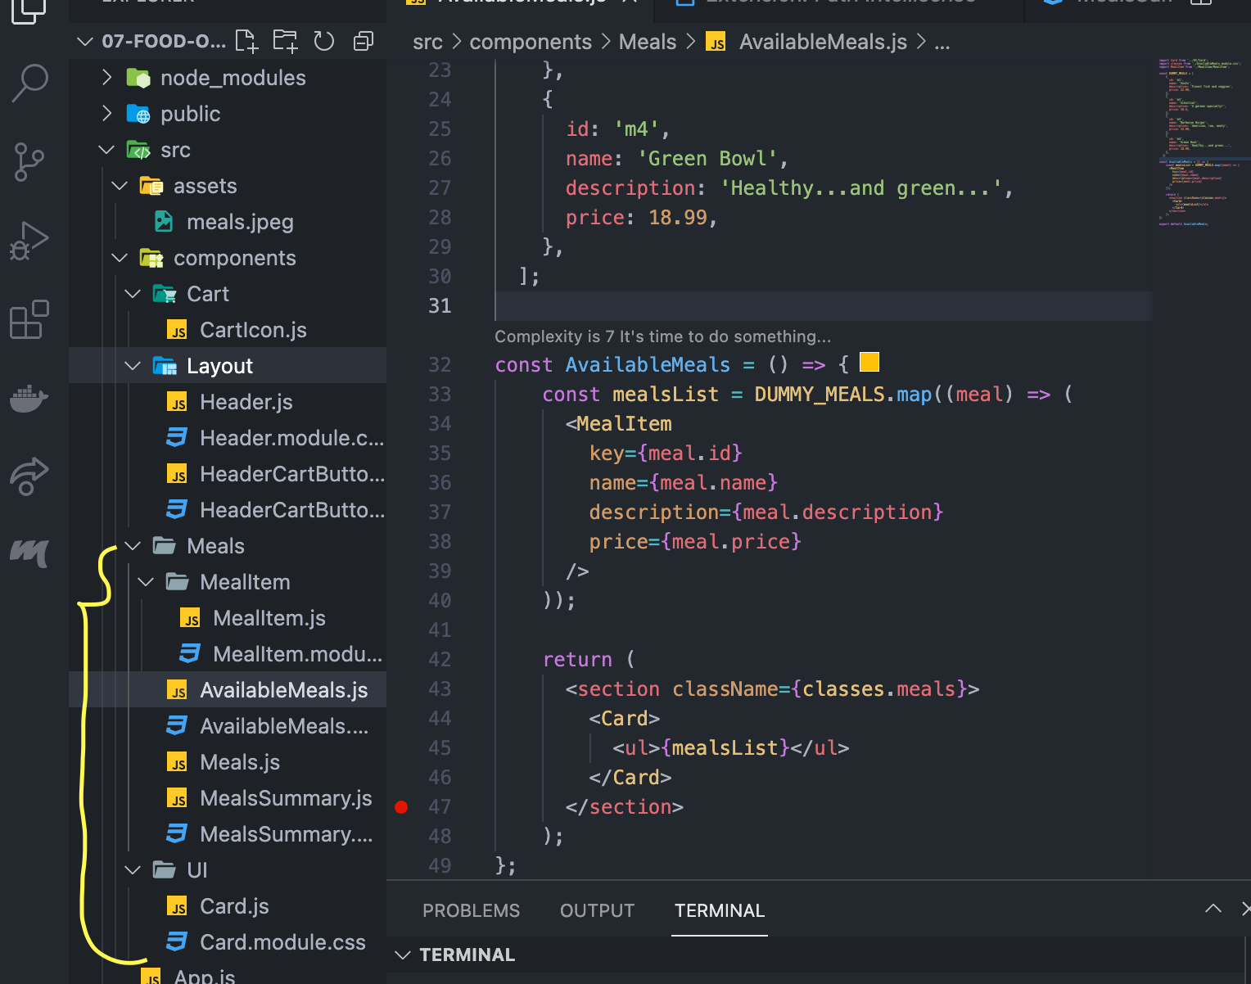

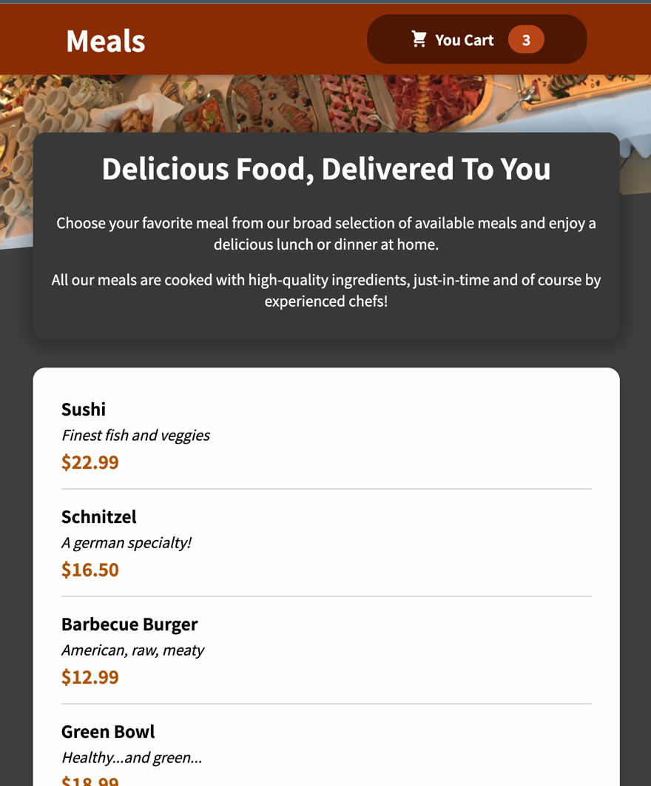

## Adding a Form

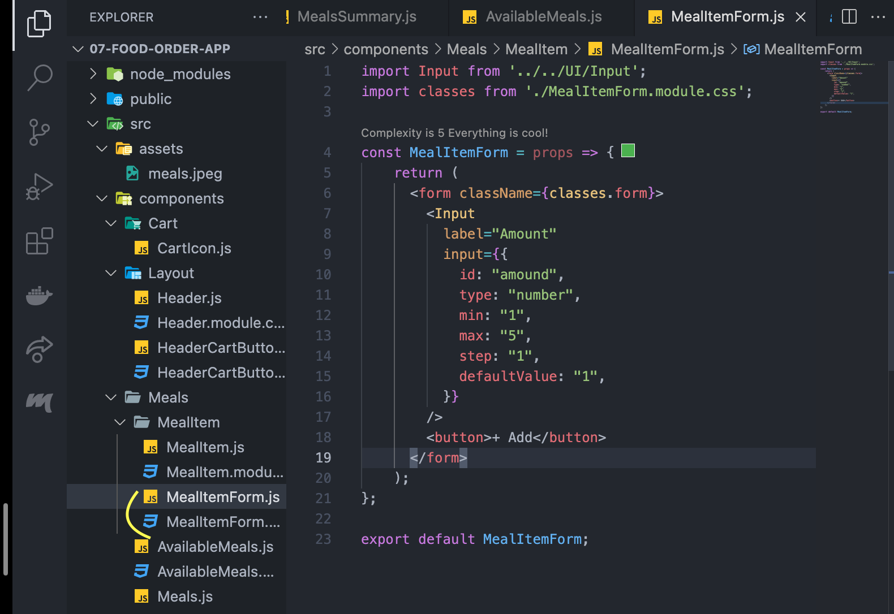

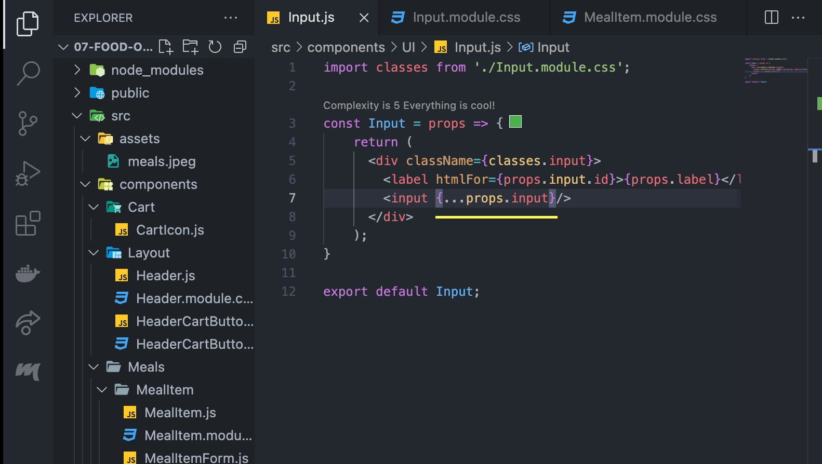

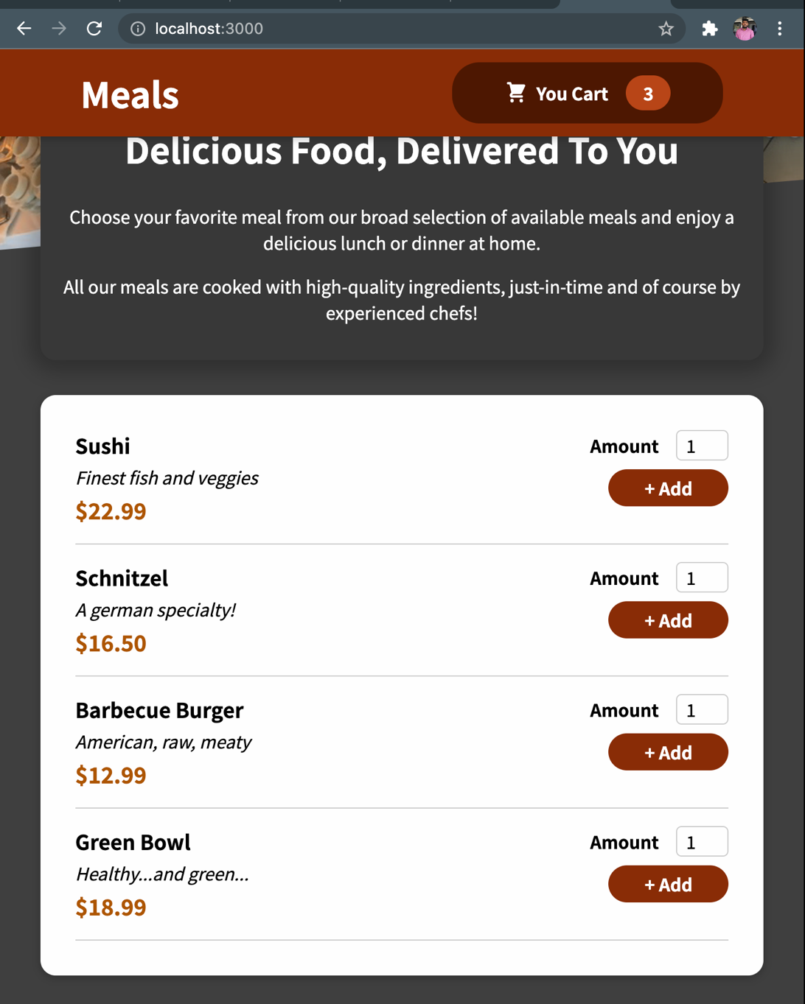

## Adding a Model via React Portal

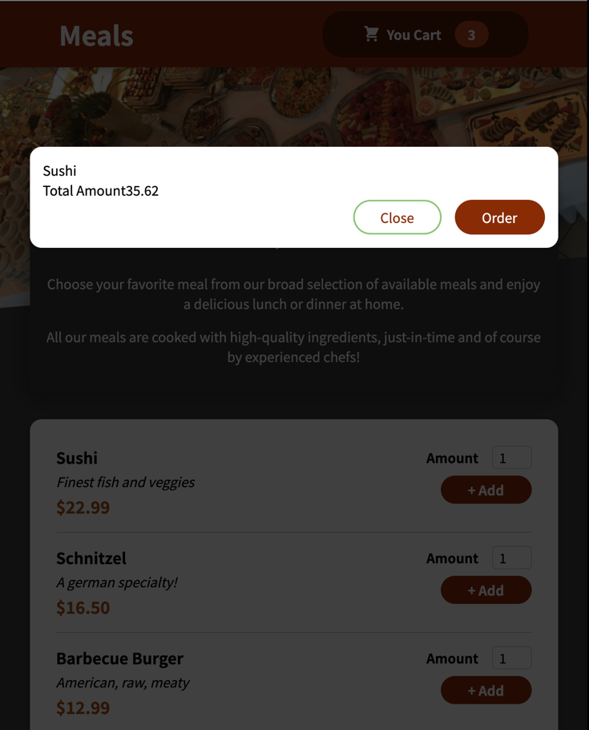 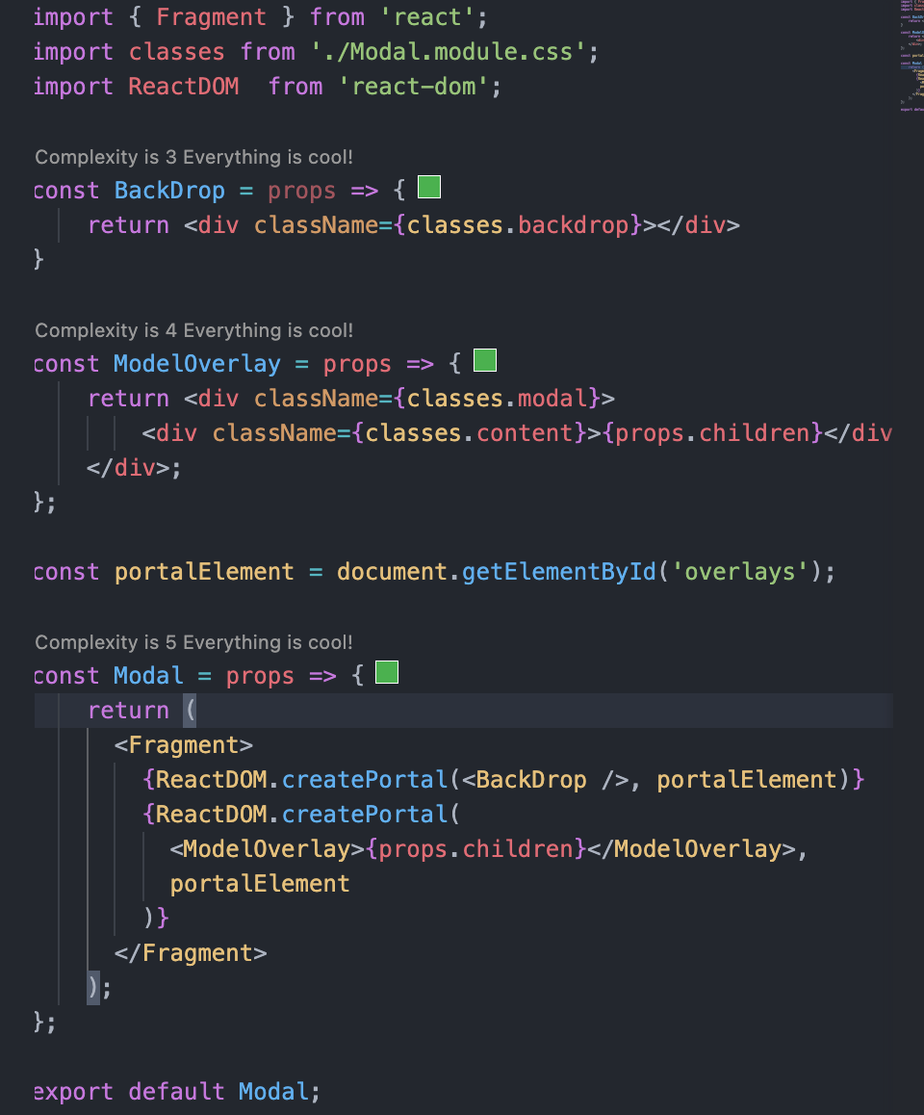

## Adding Cart Close Functionality

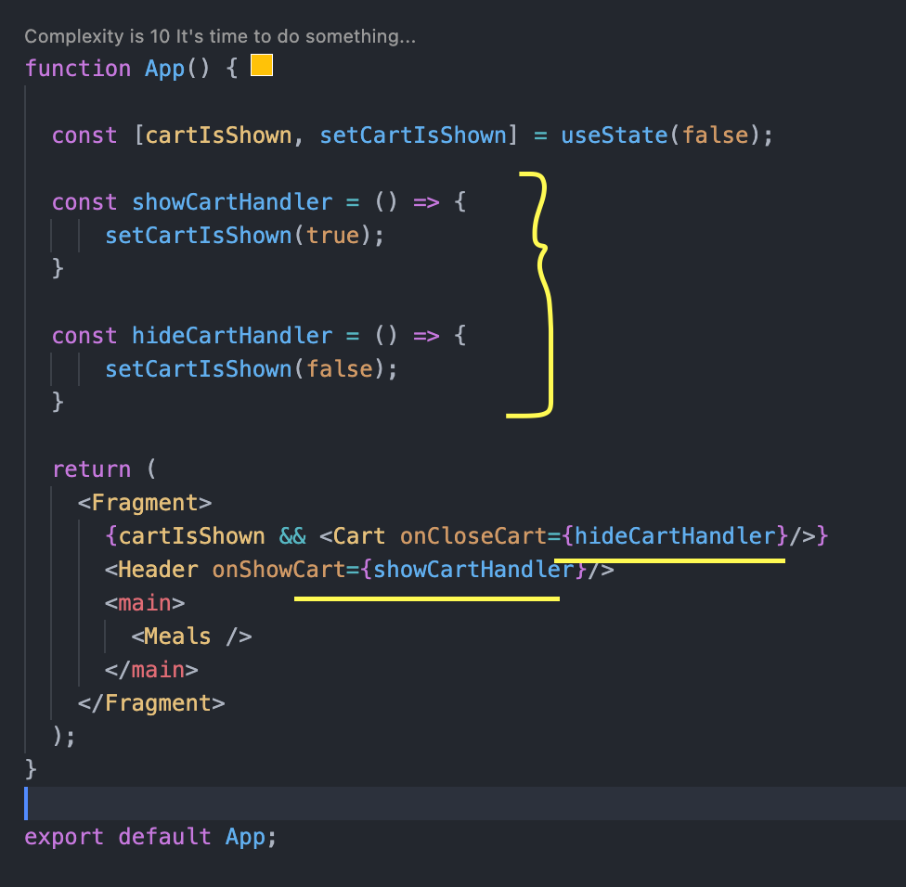

## Adding Cart Context

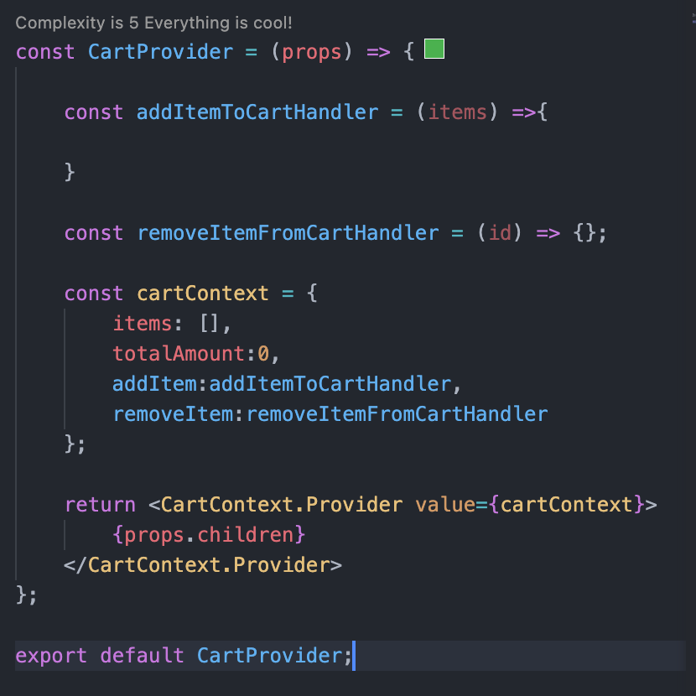 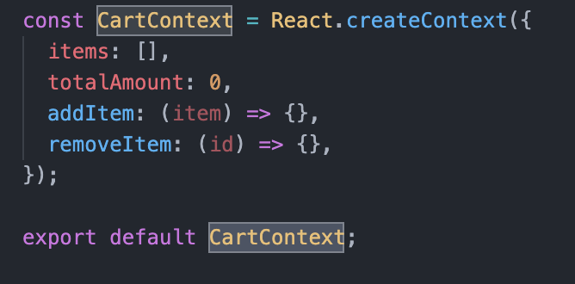

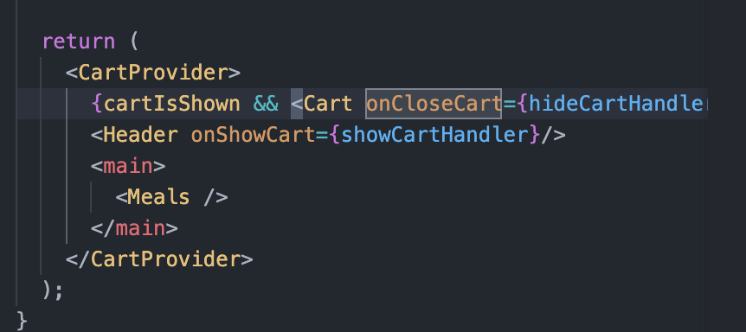

## Using Cart Context

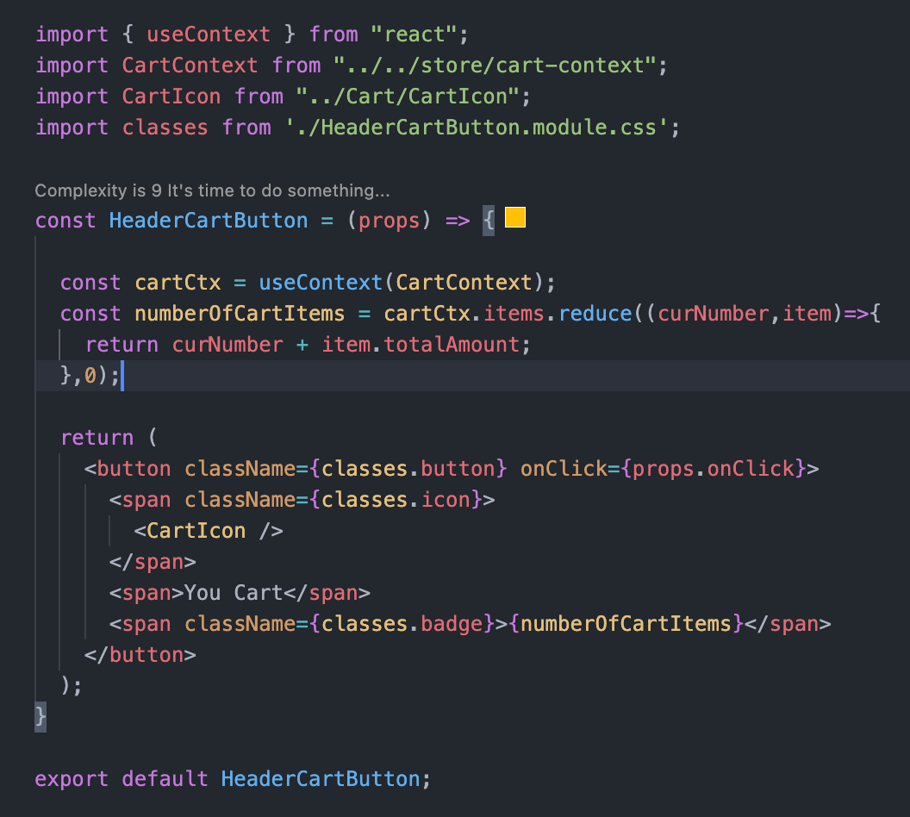

## Using Cart Reducer

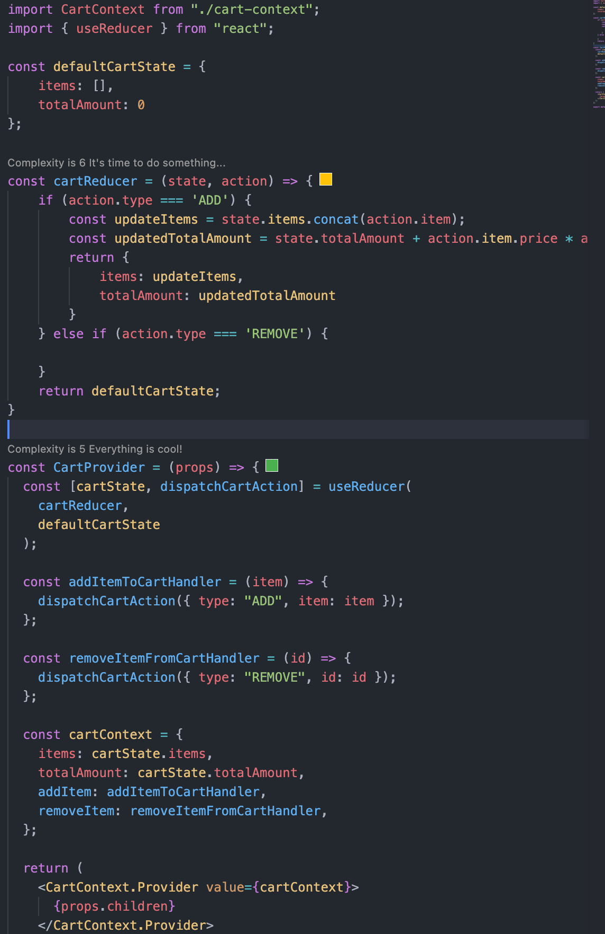

## Using and forwarding Ref’s

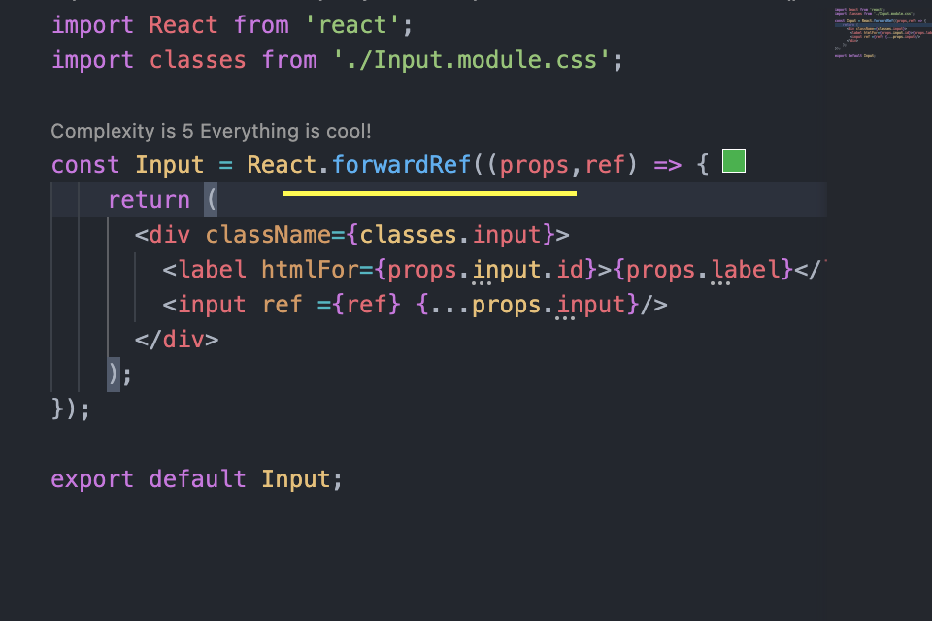

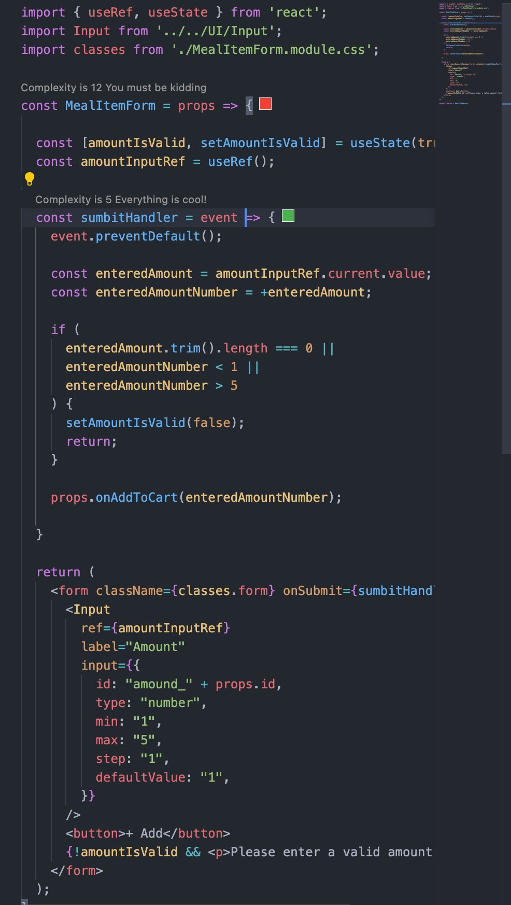

## Reducer logic for adding and removing items from cart

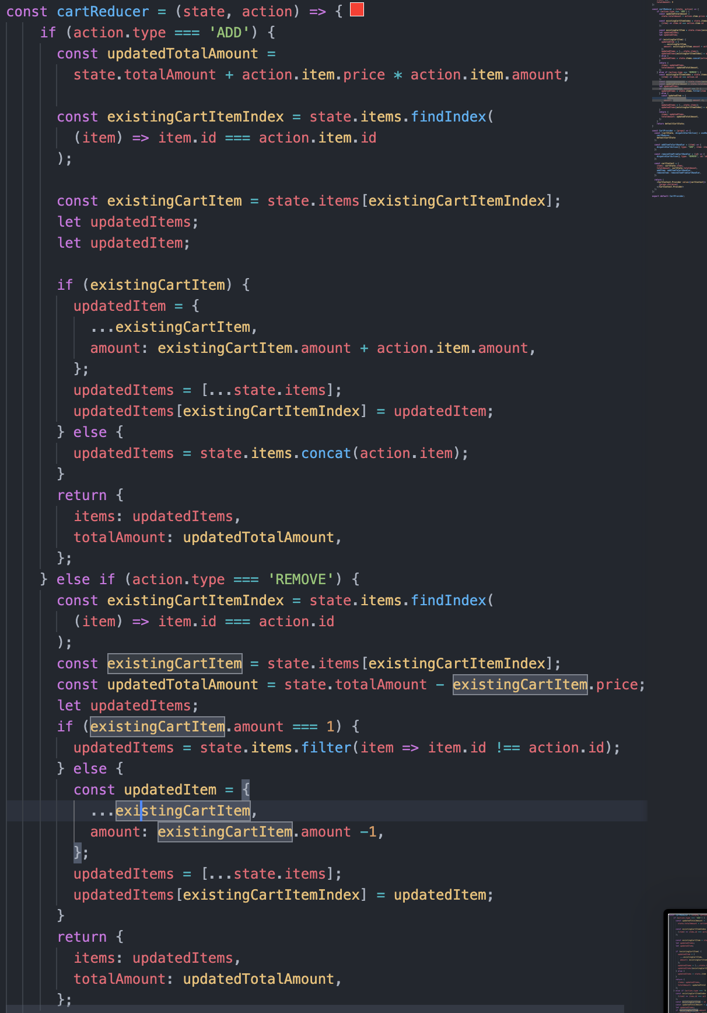

## Implementing Animation to Cart Button

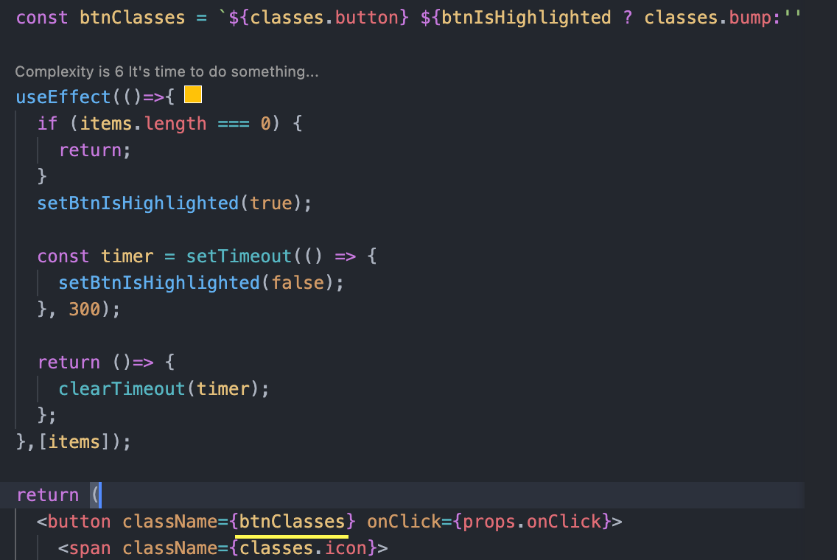

## Graphical user interface Description automatically generatedVideo Demo

# How React Works?

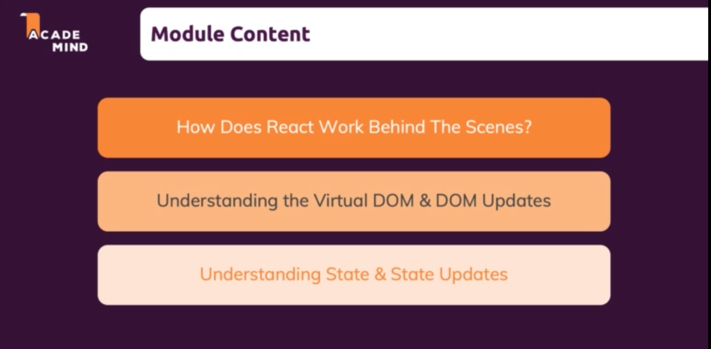

## Understanding

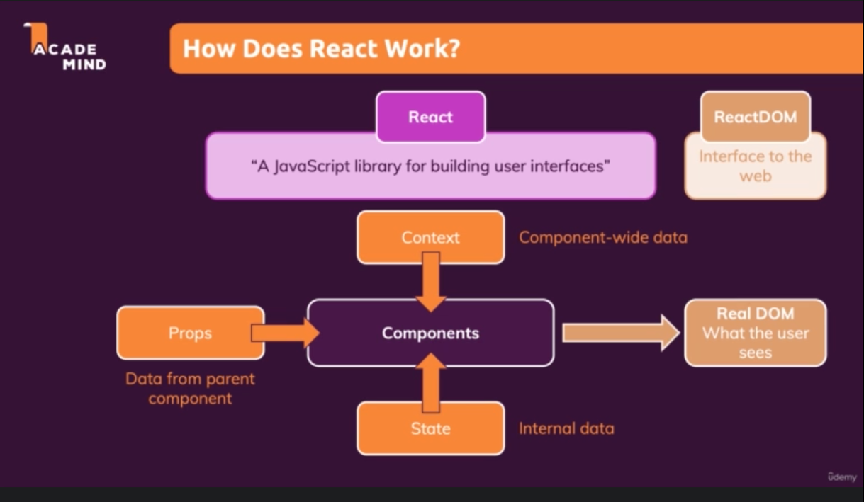

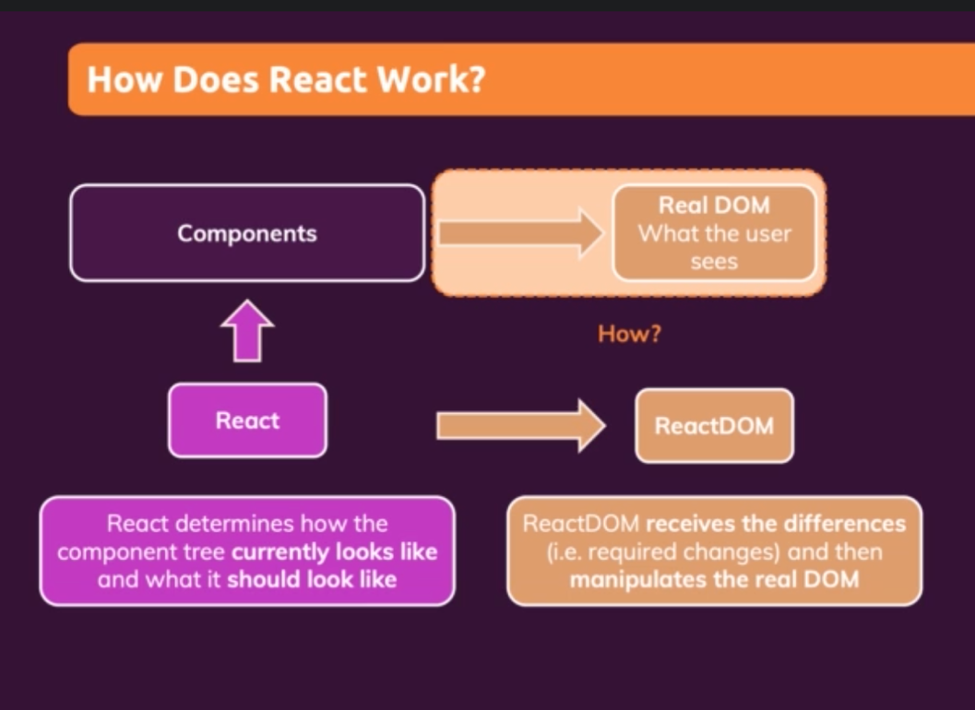

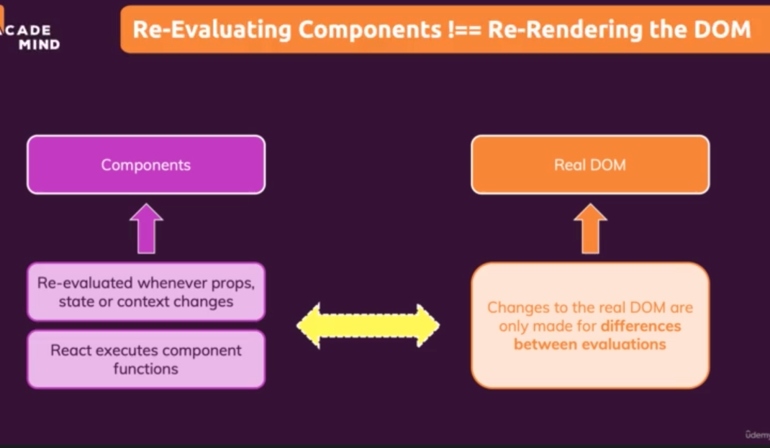

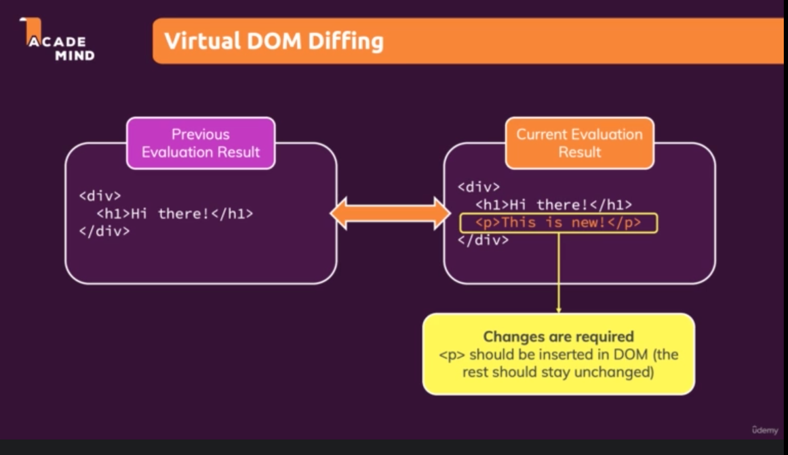

## Demo - Inserting the element without refreshing the UI

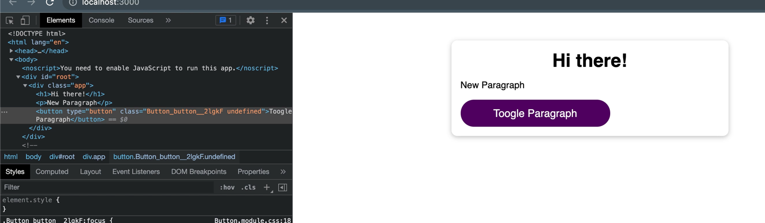

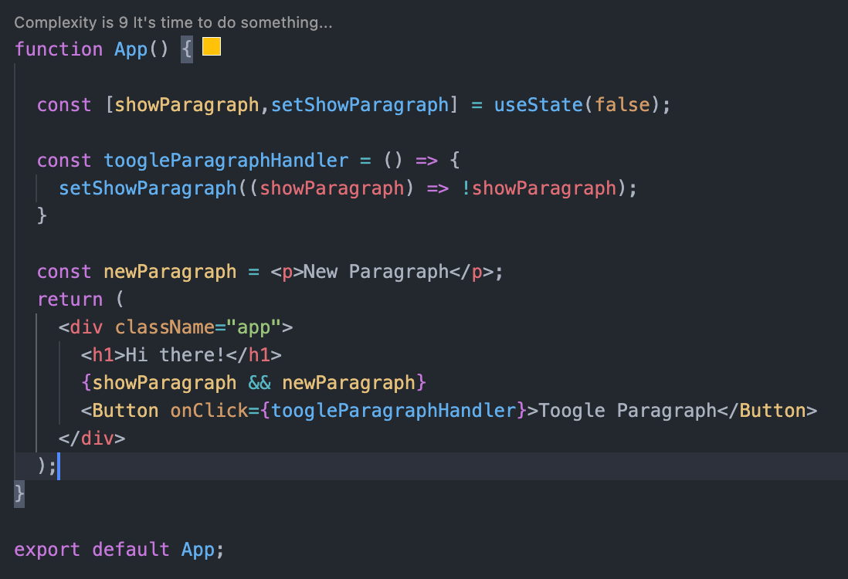

## Child component re evaluation

Child component re-executed when parent component state changes.

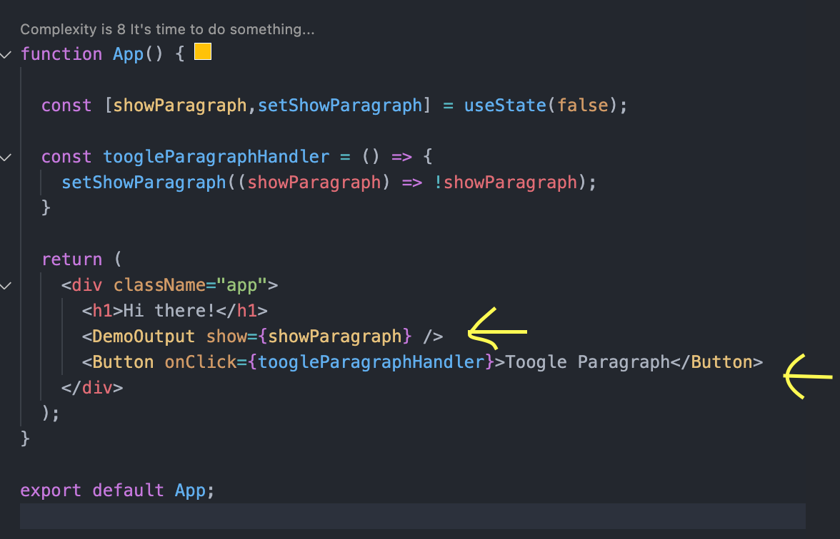

If we use the React.memo() it prevents re-evaluation of the component and its child component if state or object passed is not changes.

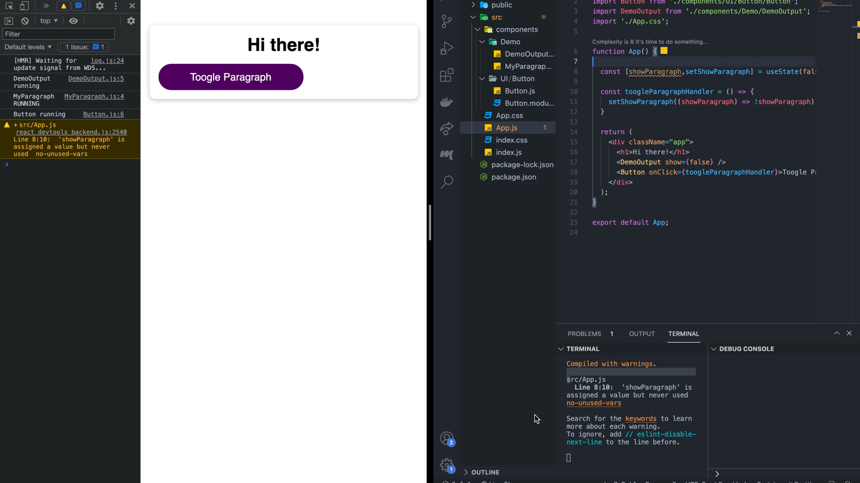

Here we used memo in Button component also, but button component executed when no value changes. That’s because, the function object we passed through onClick props, will be created every time App component re-evaluated.

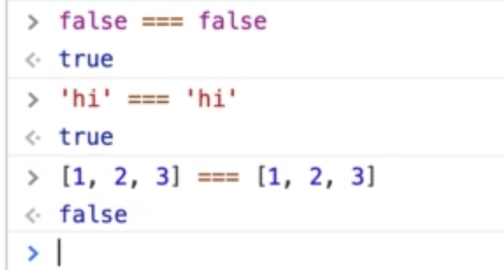

## Preventing Function Re-Creation using useCallBack()

* useCallBack() hook help us to save a function to help preventing recreation of it when component function re-evaluated.
* Saves the object in memory and reuse it when component function re-evaluated.
* First argument is function that we want to store in memory and second argument is dependency array.

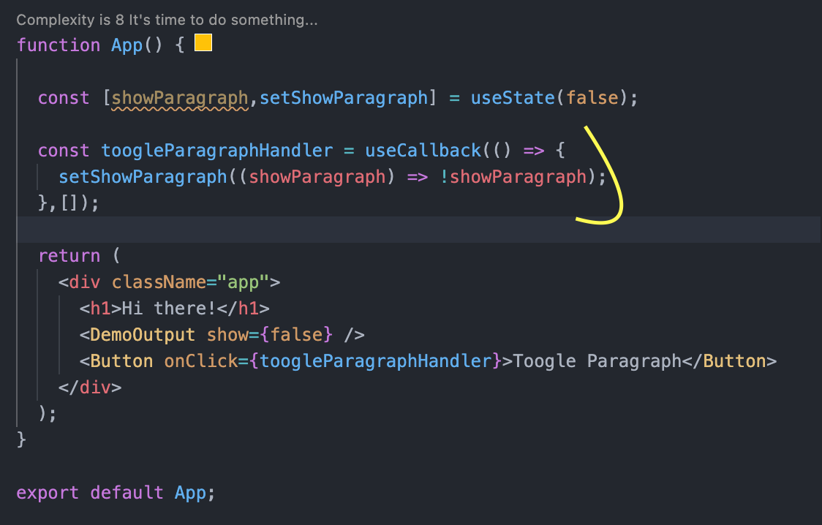

Using callback with dependencies changes.

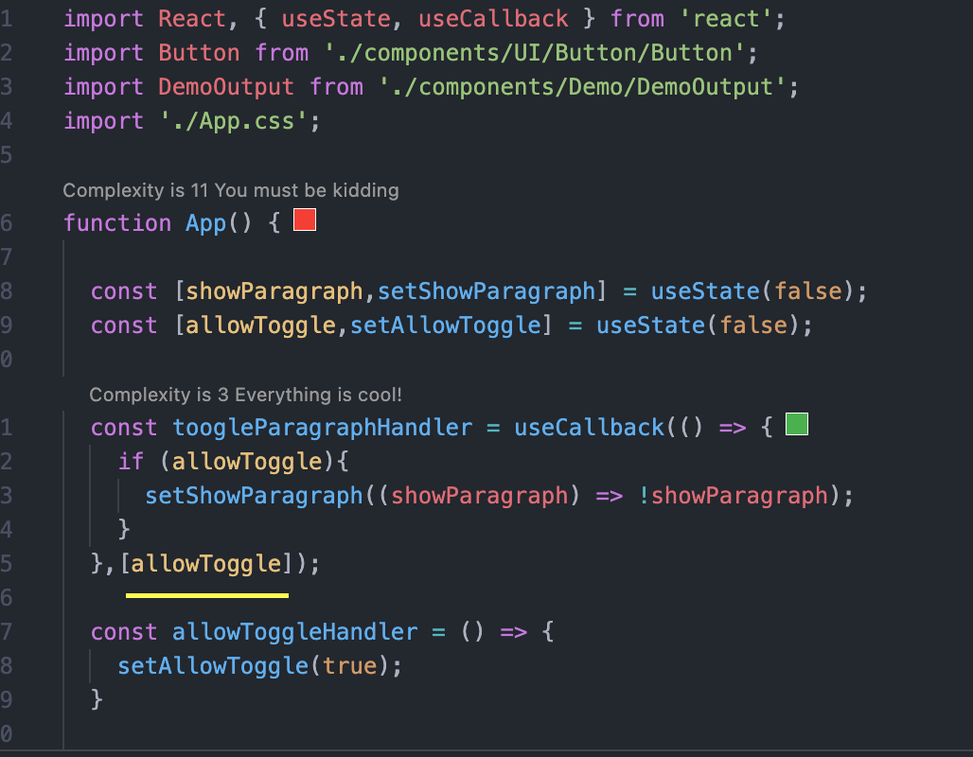

## Component and state

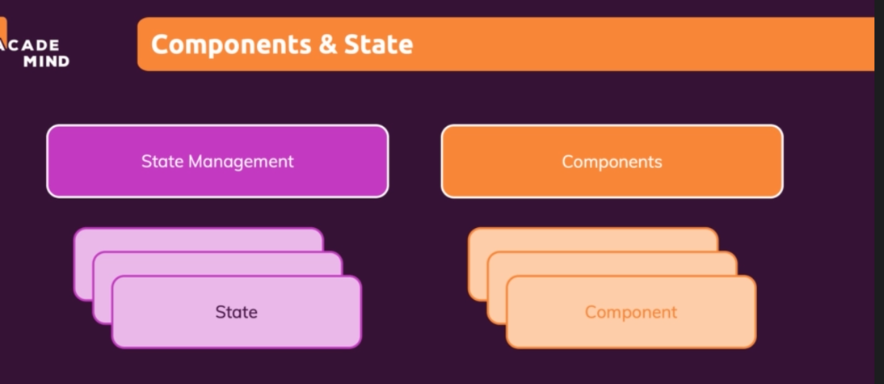

State is managed by react and connect with component.

## State update and Scheduling

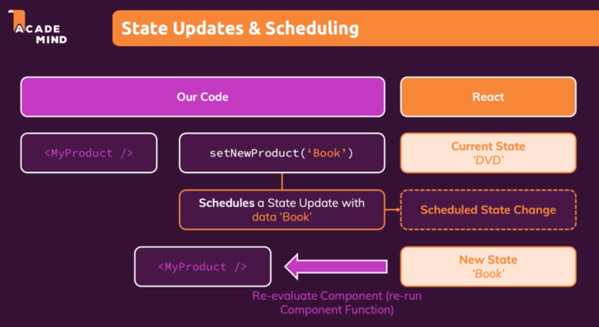

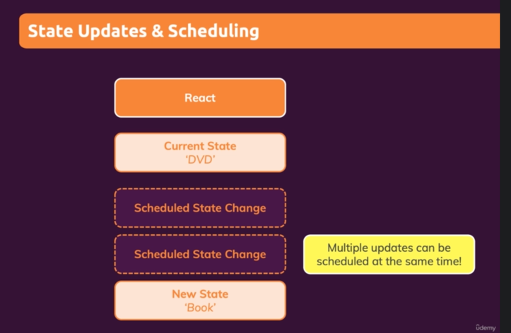

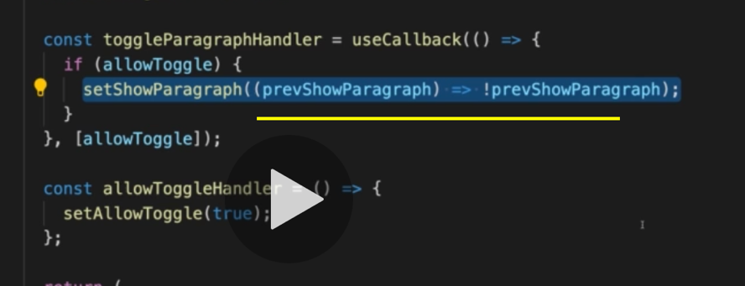

Due to the multiple state change, using the function in the state function helps. It always takes the previous state to update the state. Which means it always look into the latest state before updating the state.

State patching happens when multiple states are updated together.

## useMemo() hook

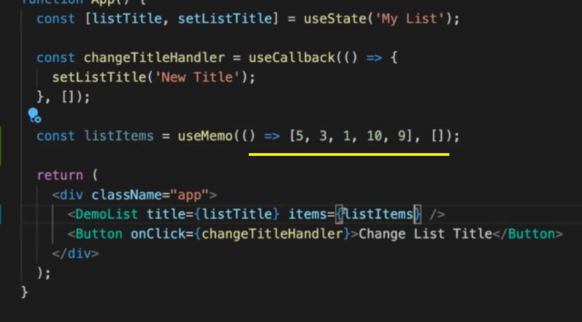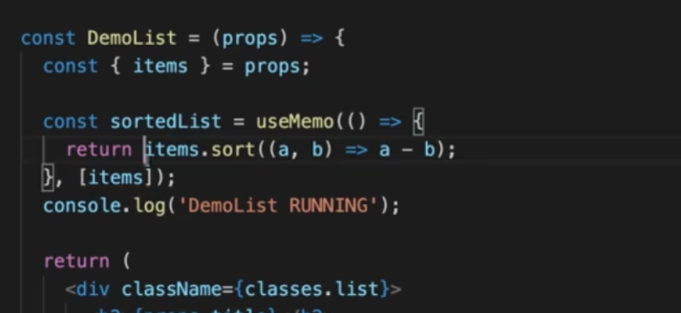

* useMemo() hook used to prevent the recreation of the object or function when component function reevaluated.

# Class based Components

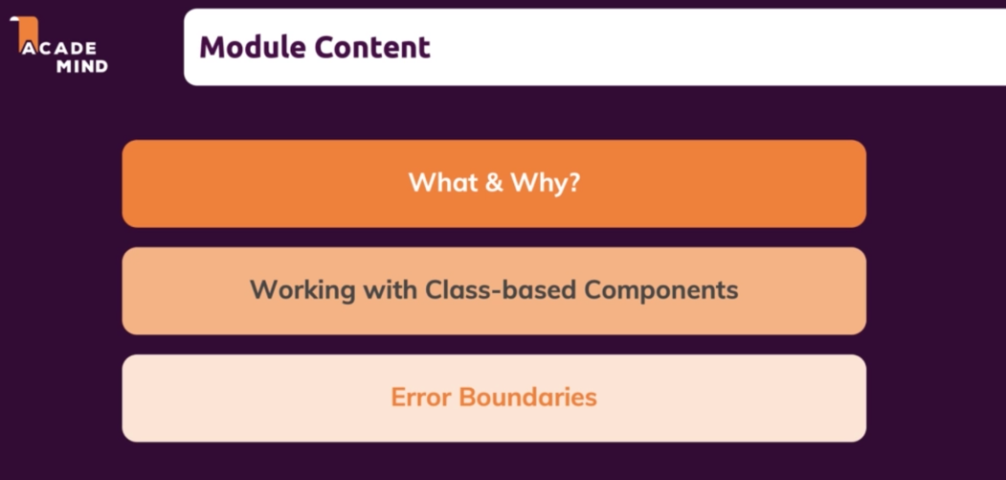

## Class based components alternative to Functions

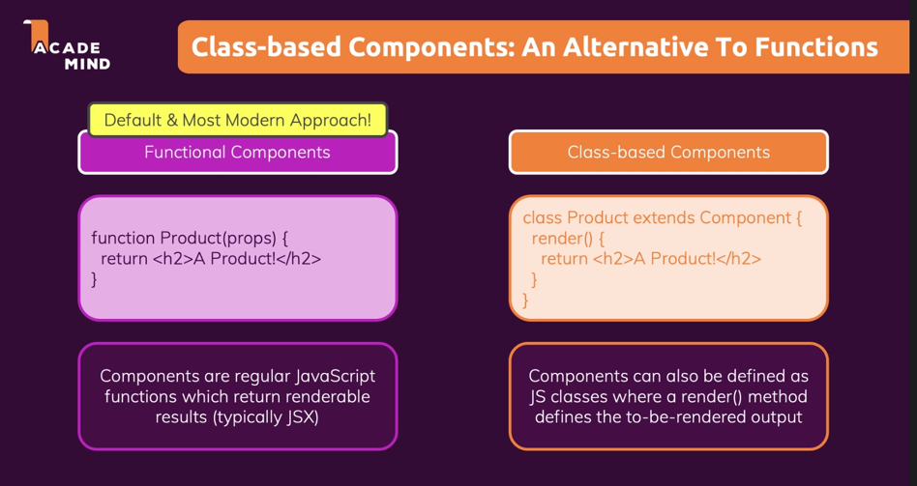

 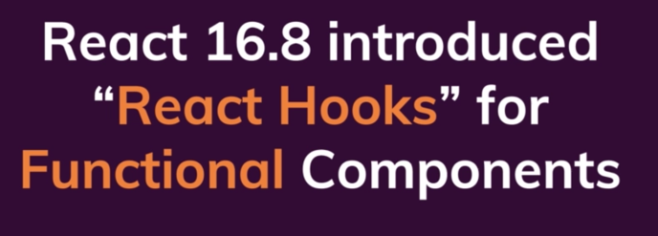



Functional component and class-based component can work together.

## First class-based component

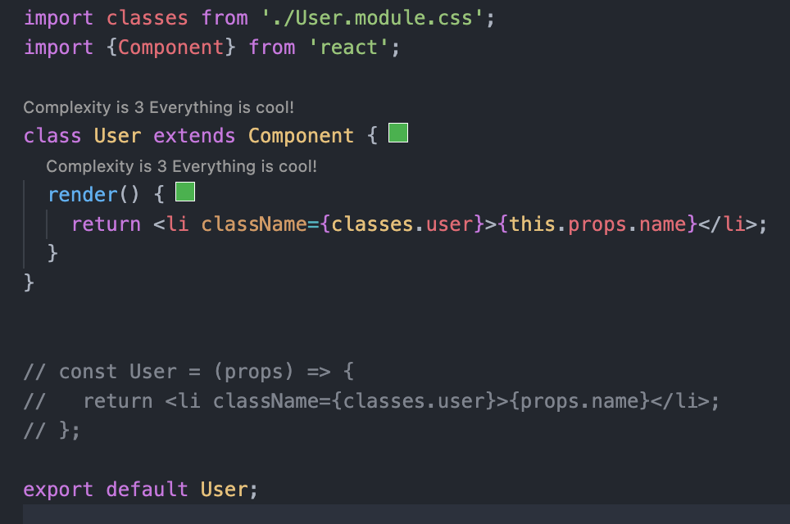

* Should extend ‘Component’ class
* Render function returns the JSX code.
* Need to use the ‘this’ keyword to access the props in class-based component.

## Managing state in class-based component

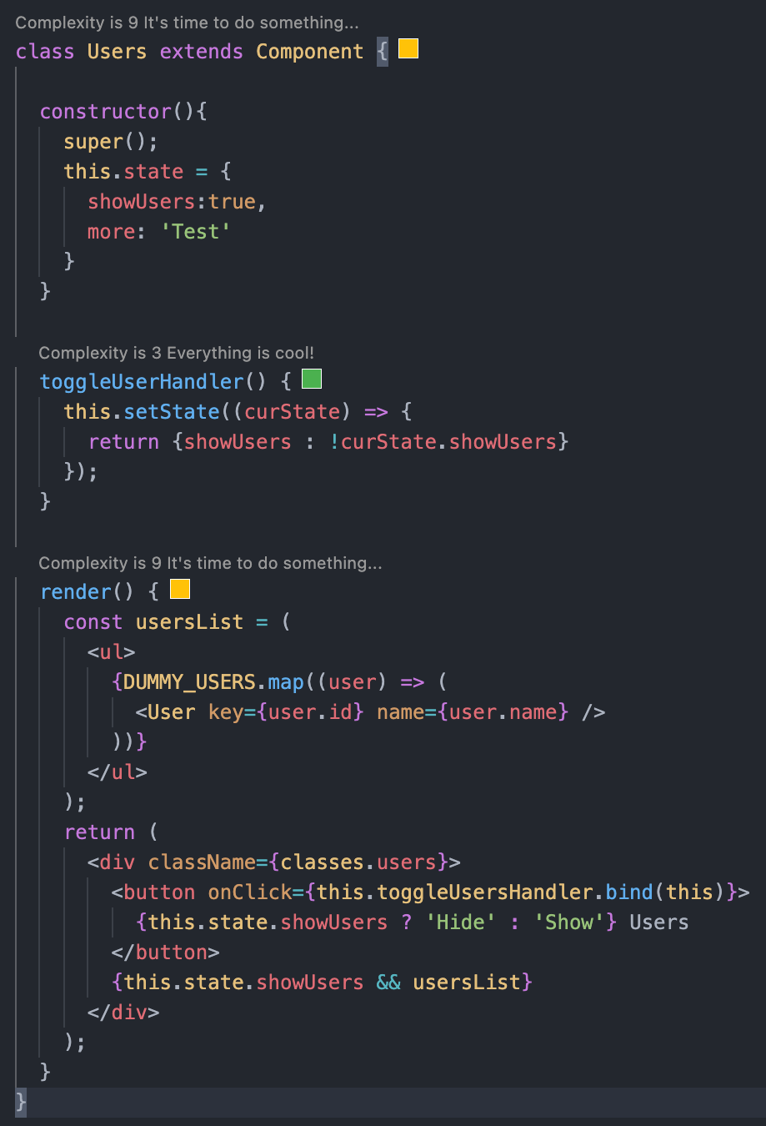

## Component Lifecycle – using useEffect() functionality in Class based component

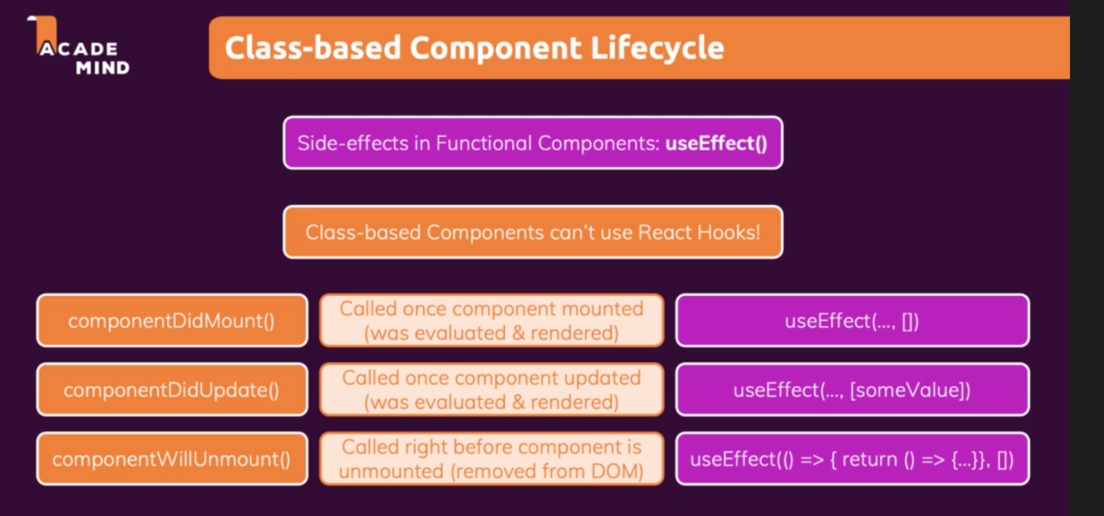

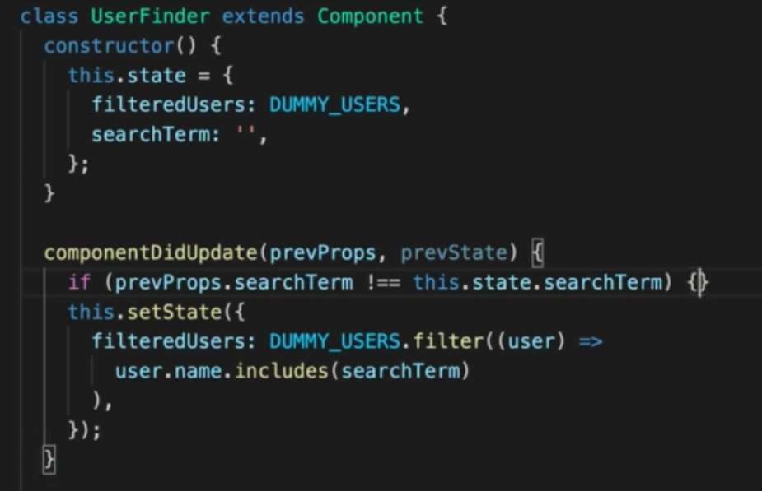

## componentDidUpdate()

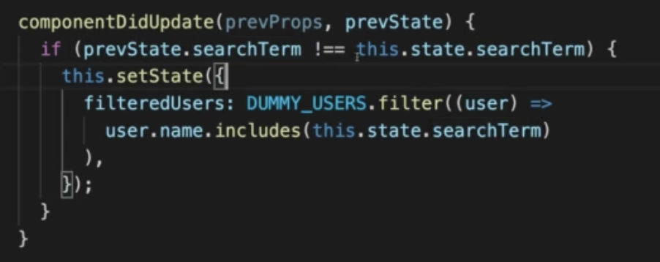

## componentDidMount()

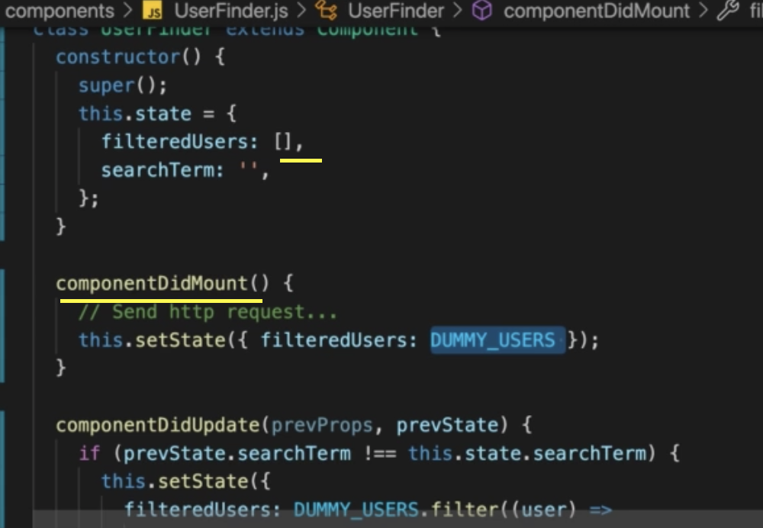

componentDidMount() function will be executed when component initialized.

## Using context in class-based component

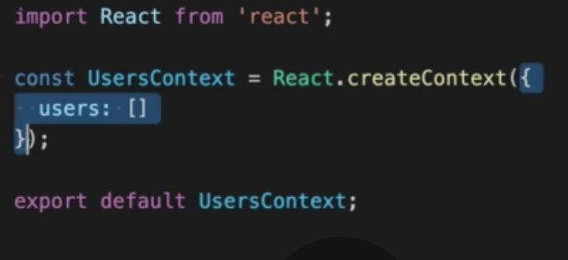

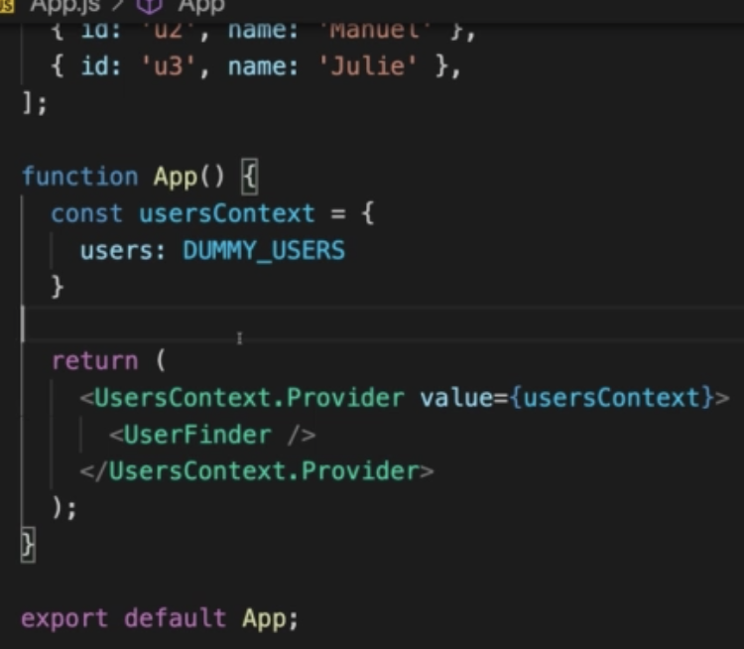

Only one context per class.

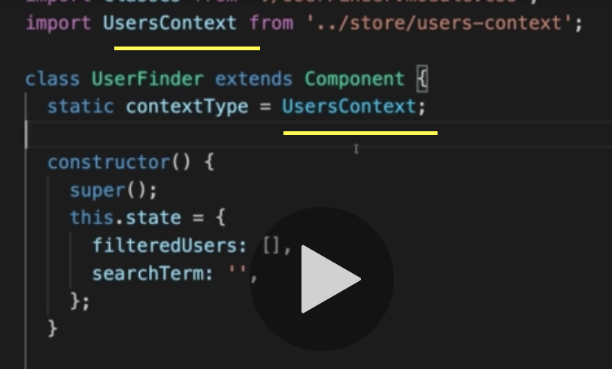

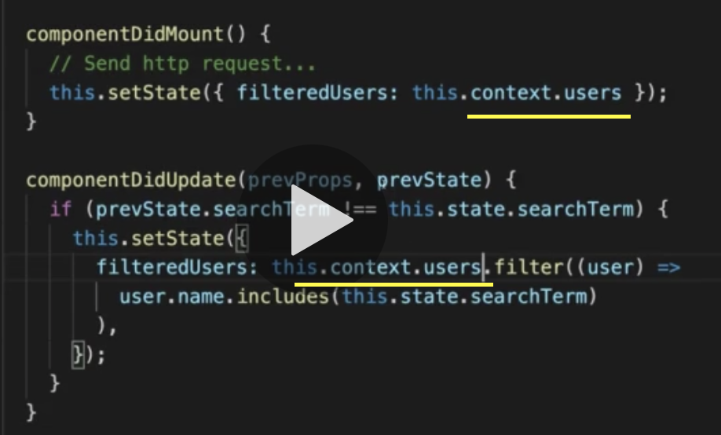

Functional components are leaner and flexible when compared to the class based component.

## Class Based Component vs Functional component

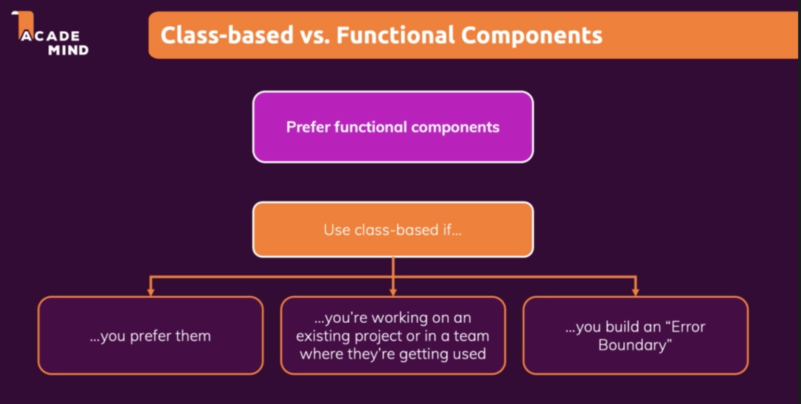

## Error Boundary

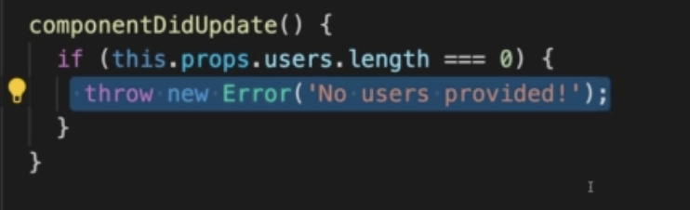

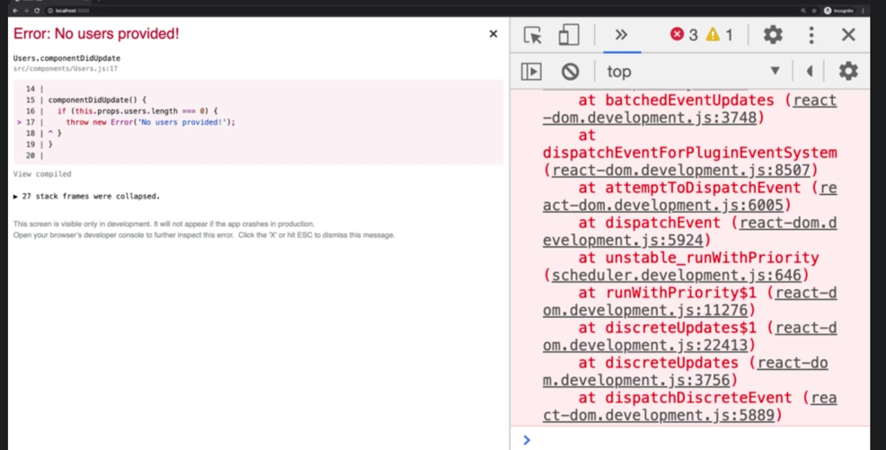

Having error in one component and handling it in another component.

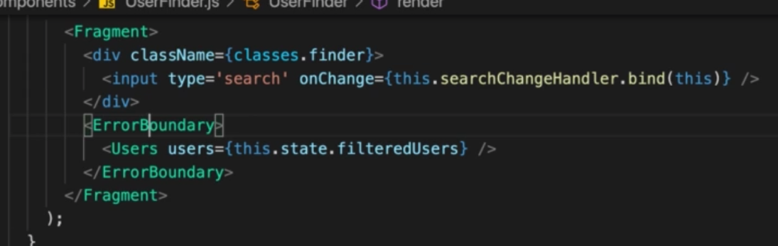

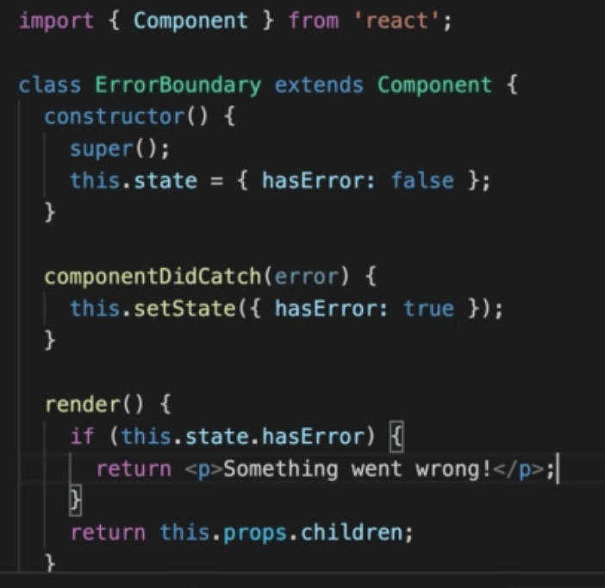

Error boundary cannot be implemented in functional component. Error boundary is limitation of functional component.

# HTTP Request

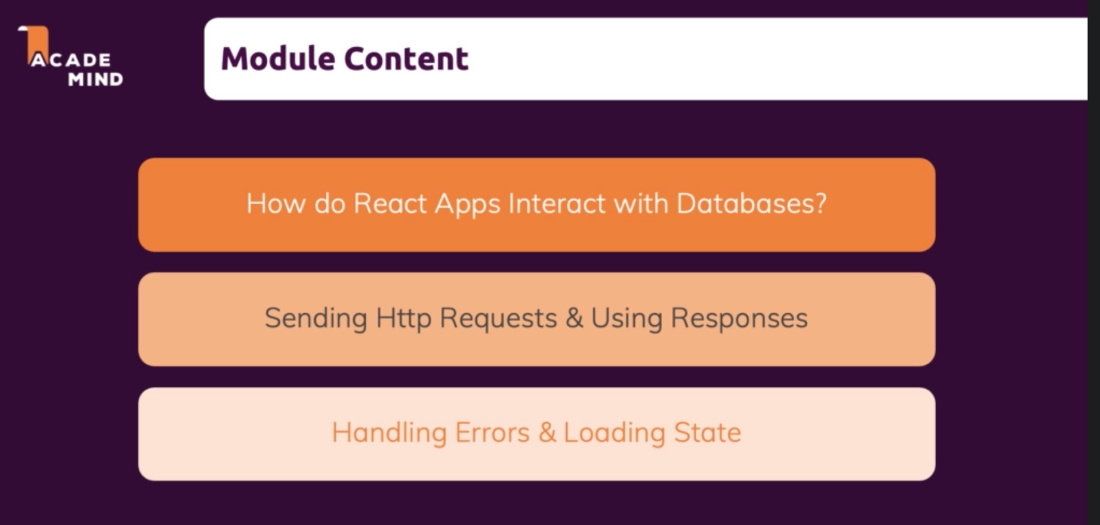

## Browser-side Apps Don’t Directly Talk to Databases

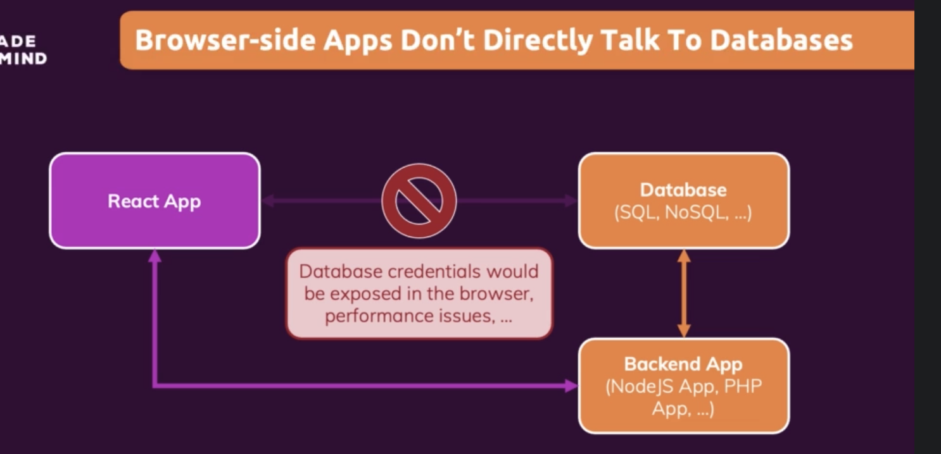

## Using fetch and then functions

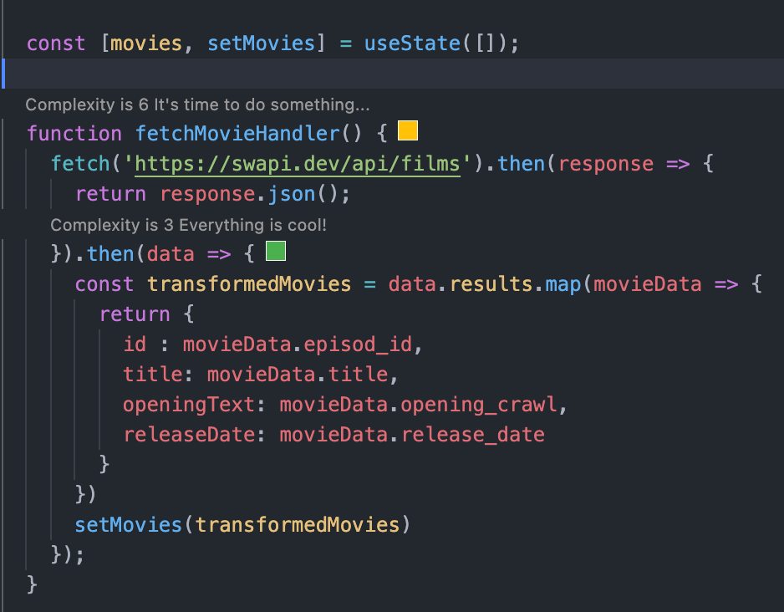

fetch() supports both GET and POST request. By default, GET request.

## Using Async Await

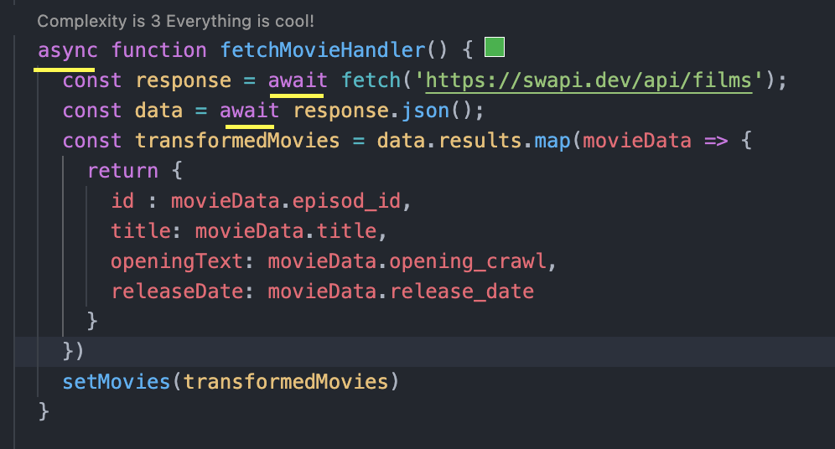

## Handling the Loading with States

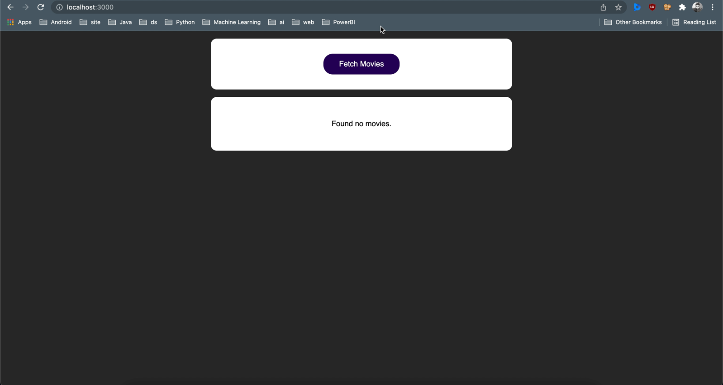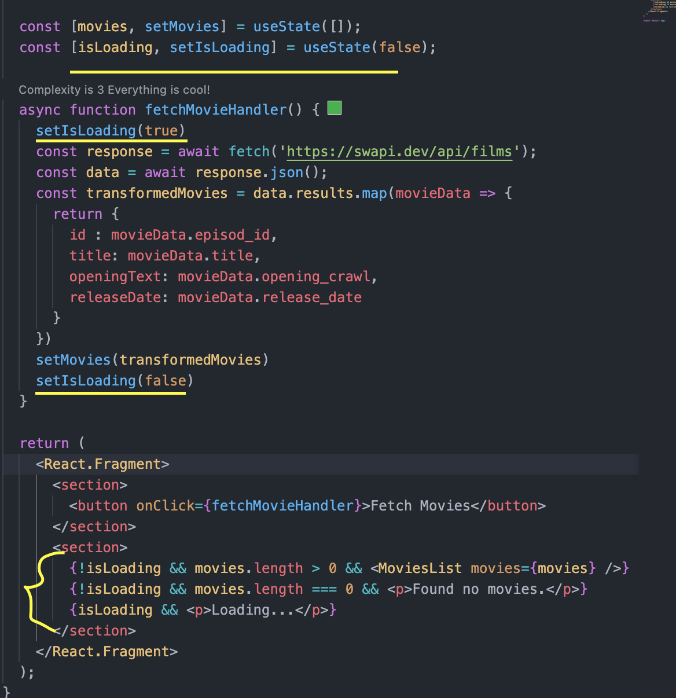

## Handling error using try catch

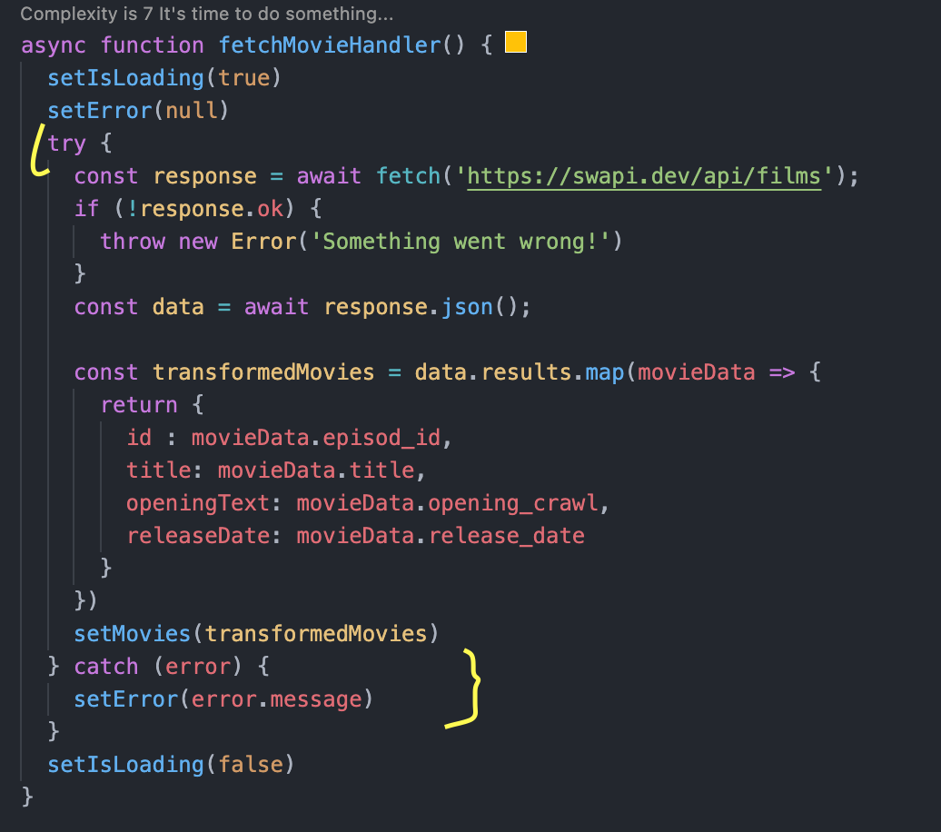

## Using UseEffect for sending Http Request

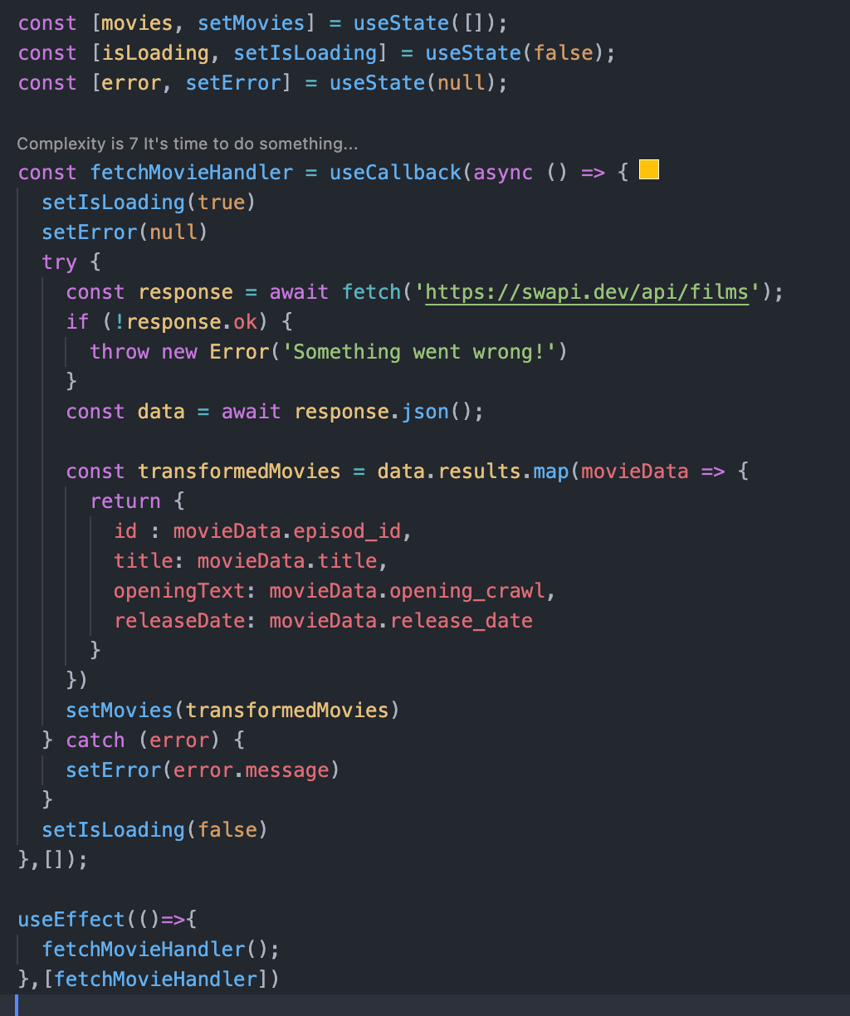

## Http POST request

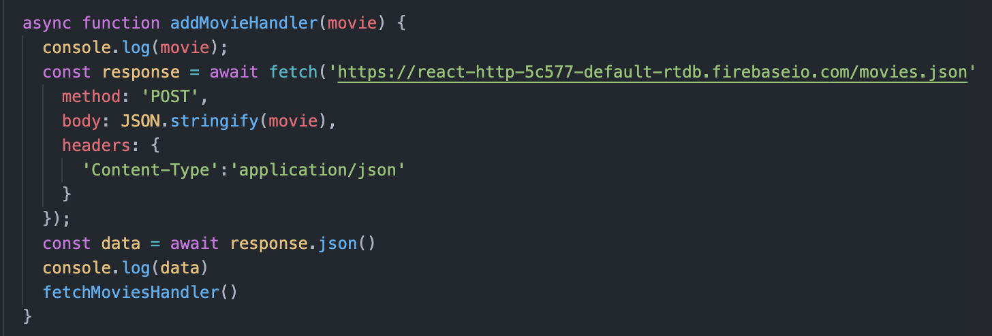

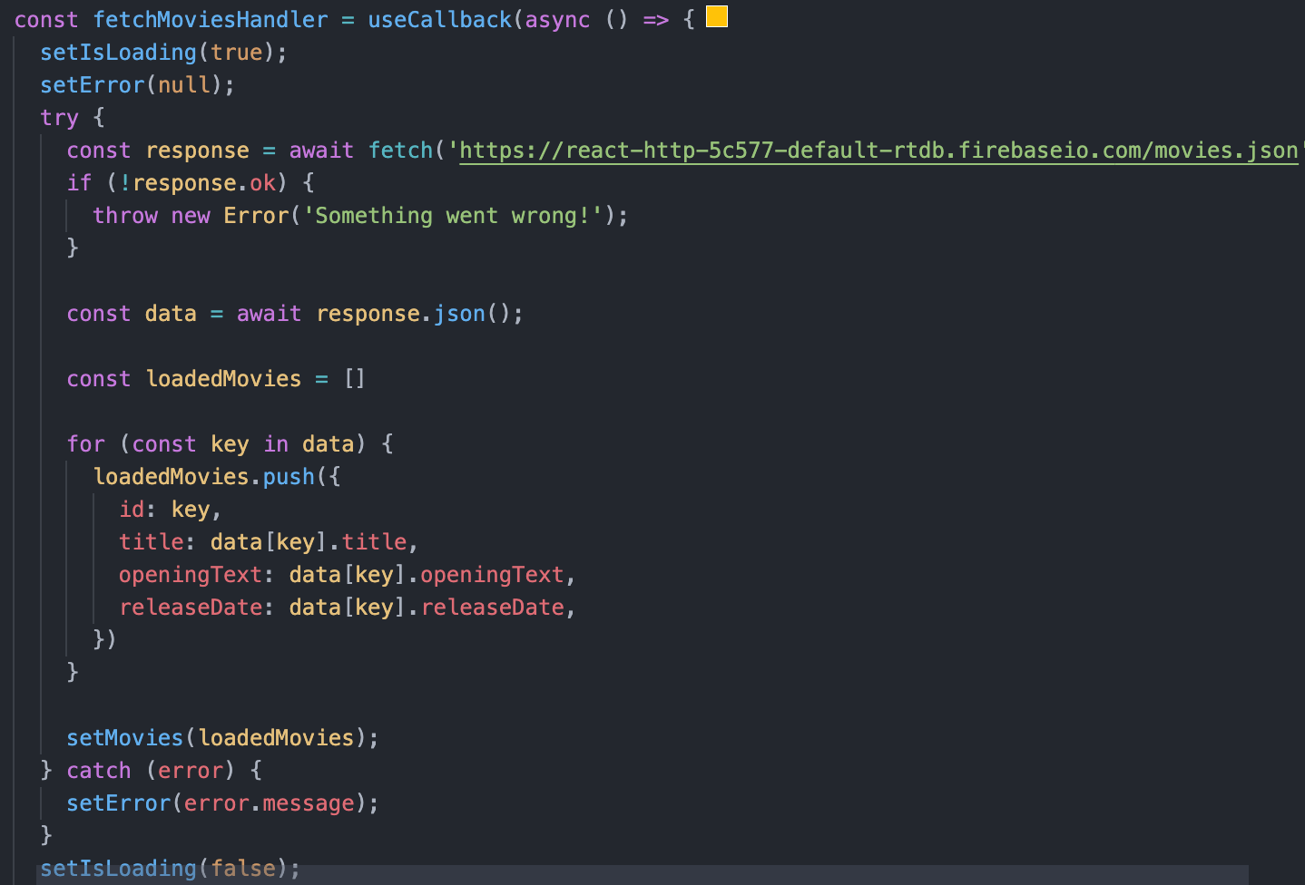

# Building Custom Hooks

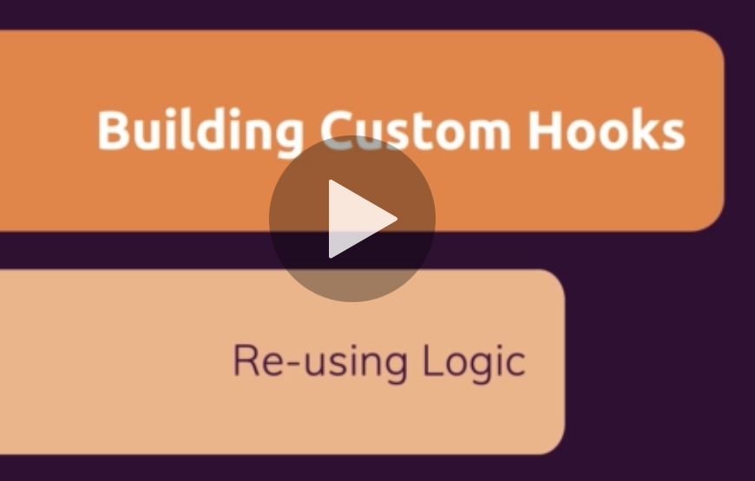

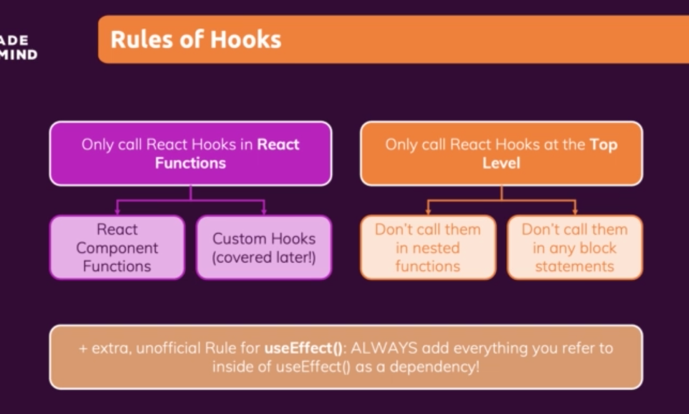

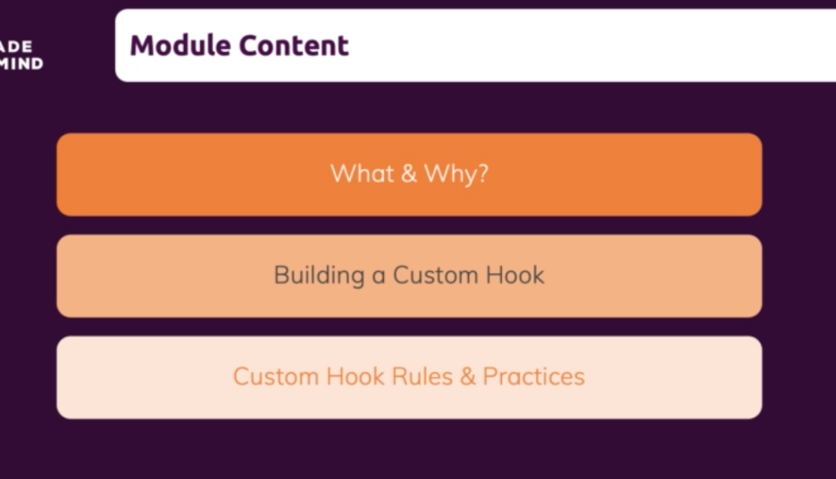

## What are Custom Hooks ?

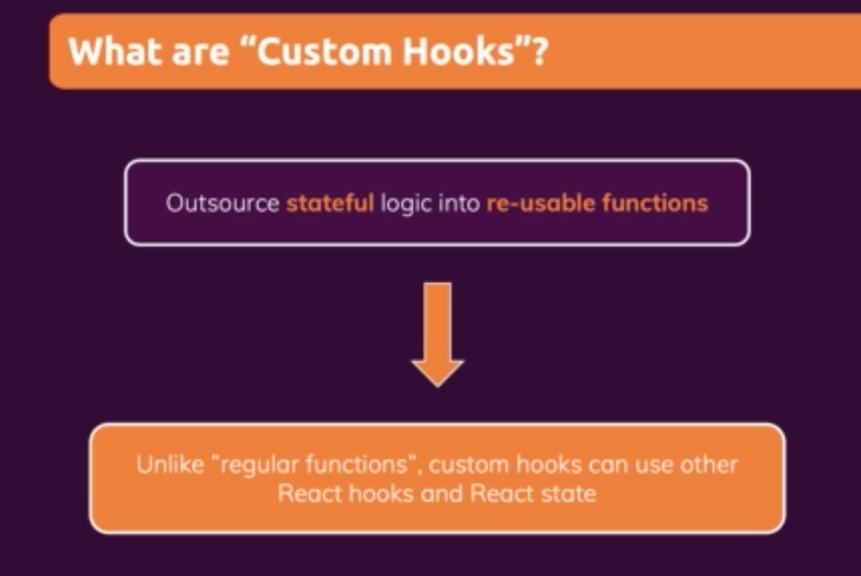

## Creating Custom Hook

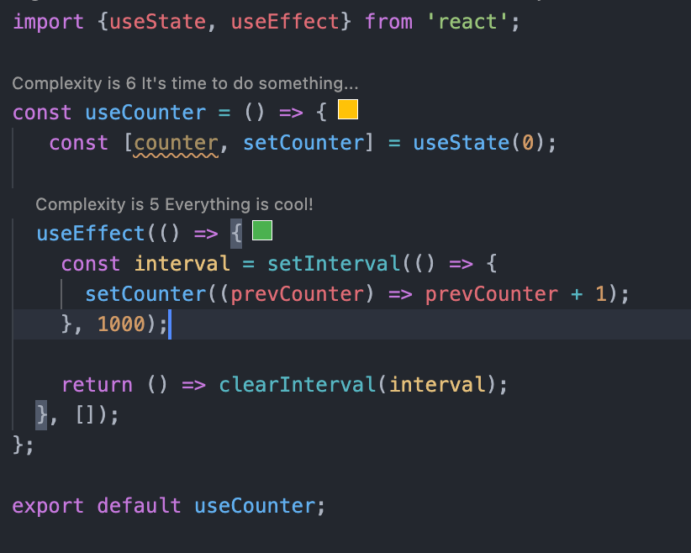

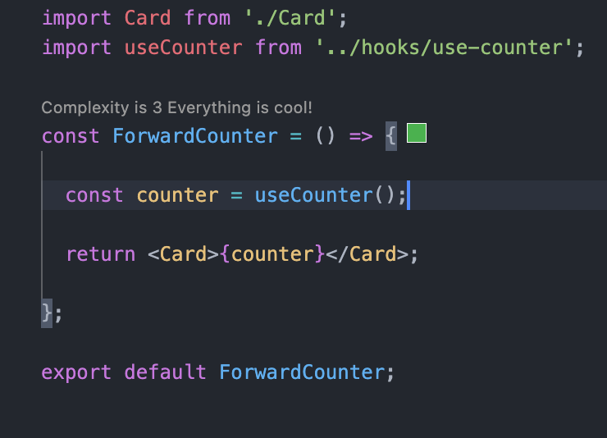

States defined in useCounter() (hook) are tied to component where it is being called. For each call, unique states will be defined.

## Configuring the custom hooks

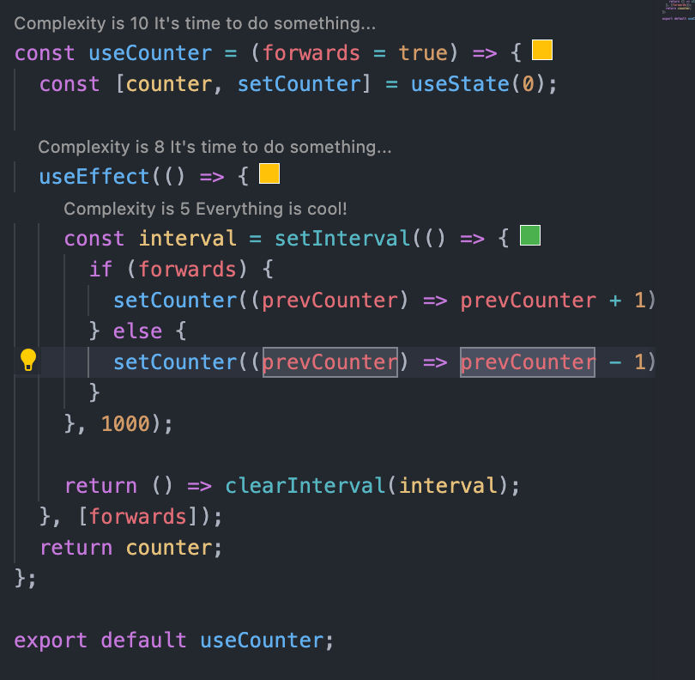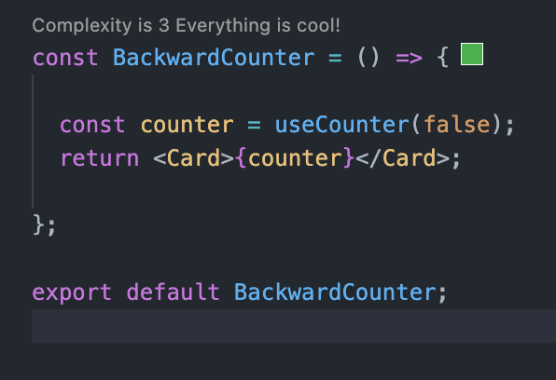

## Custom Hook to handling Http Requests

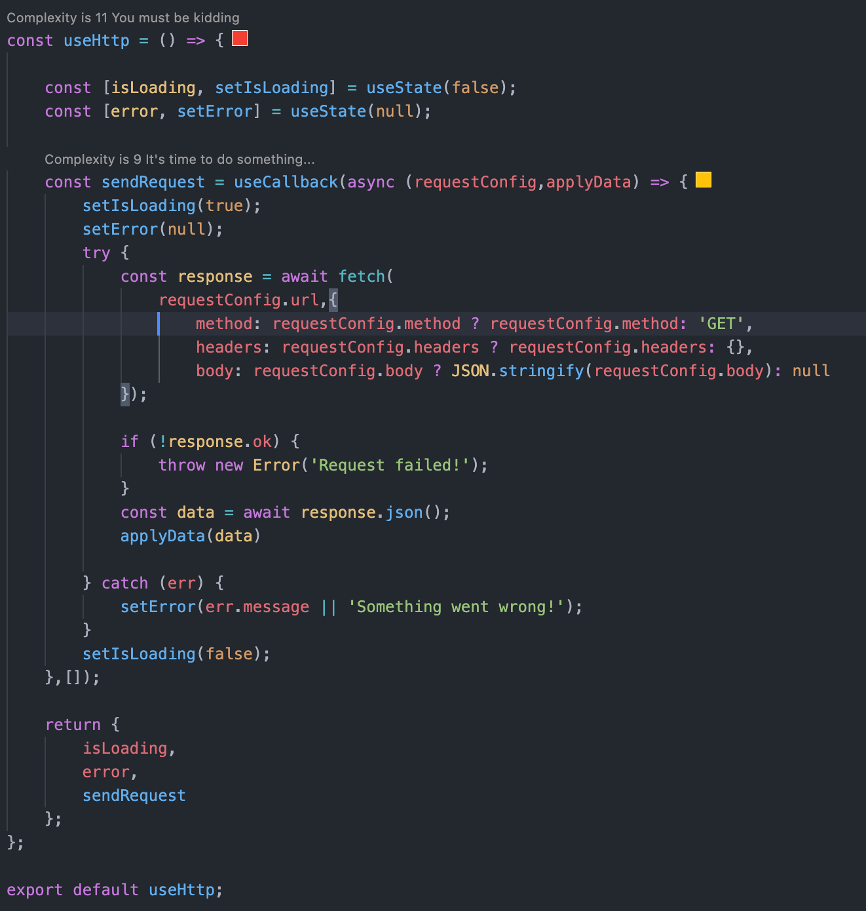

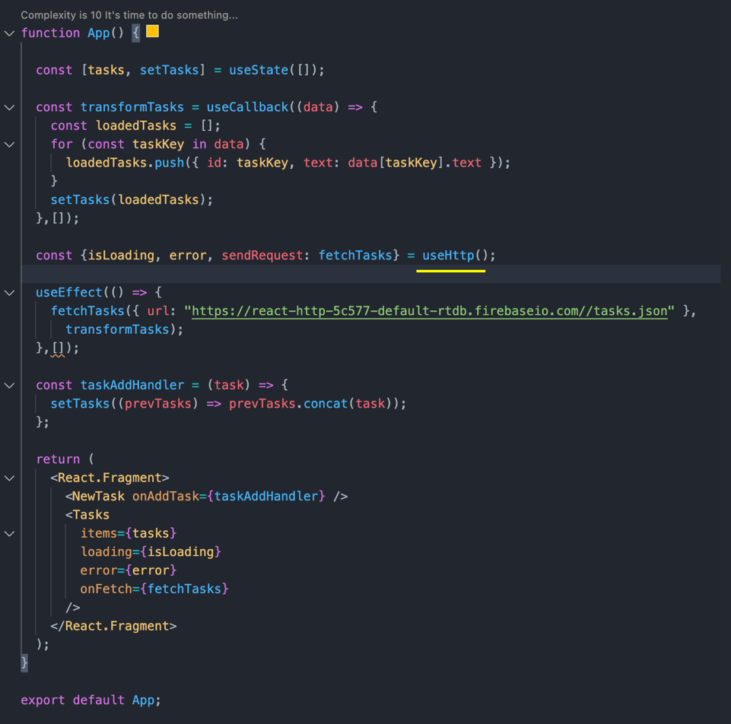

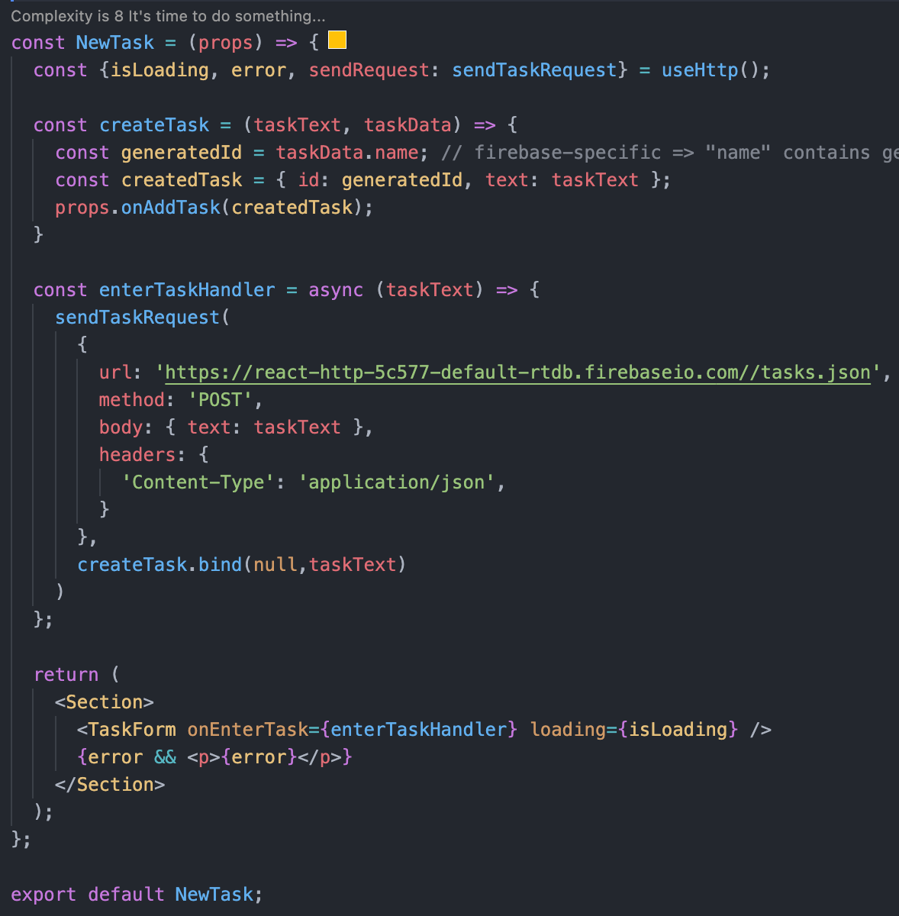

# Working with Form and User Input



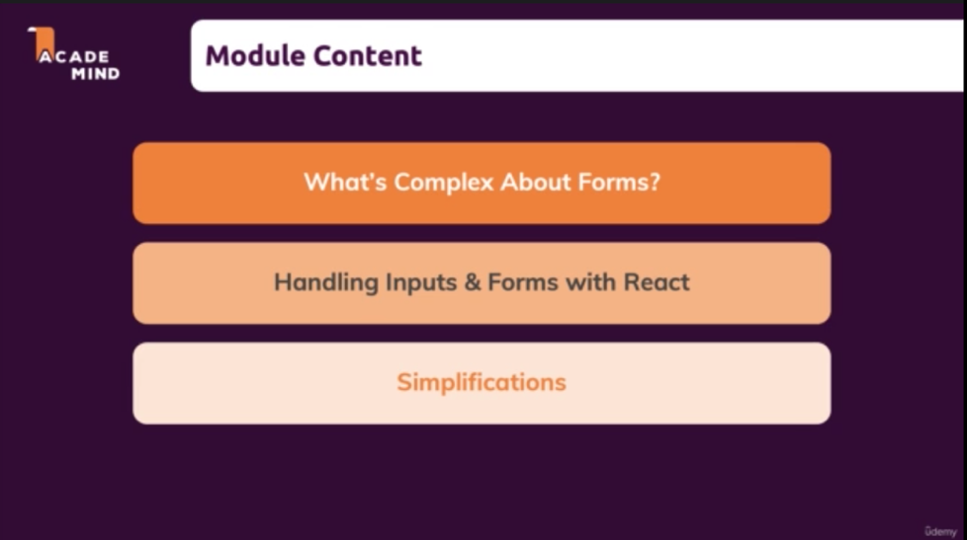

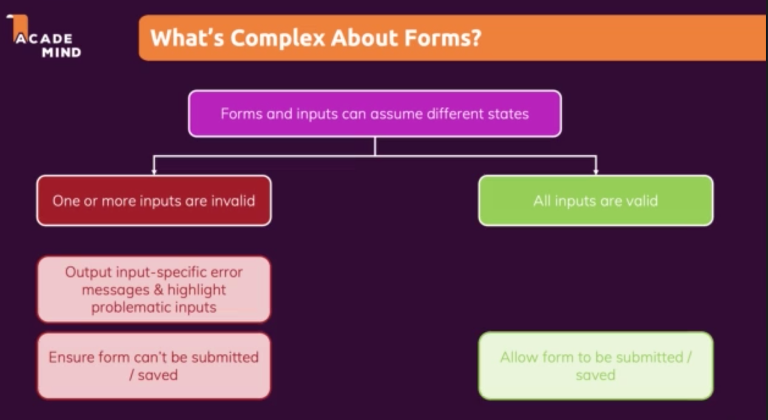

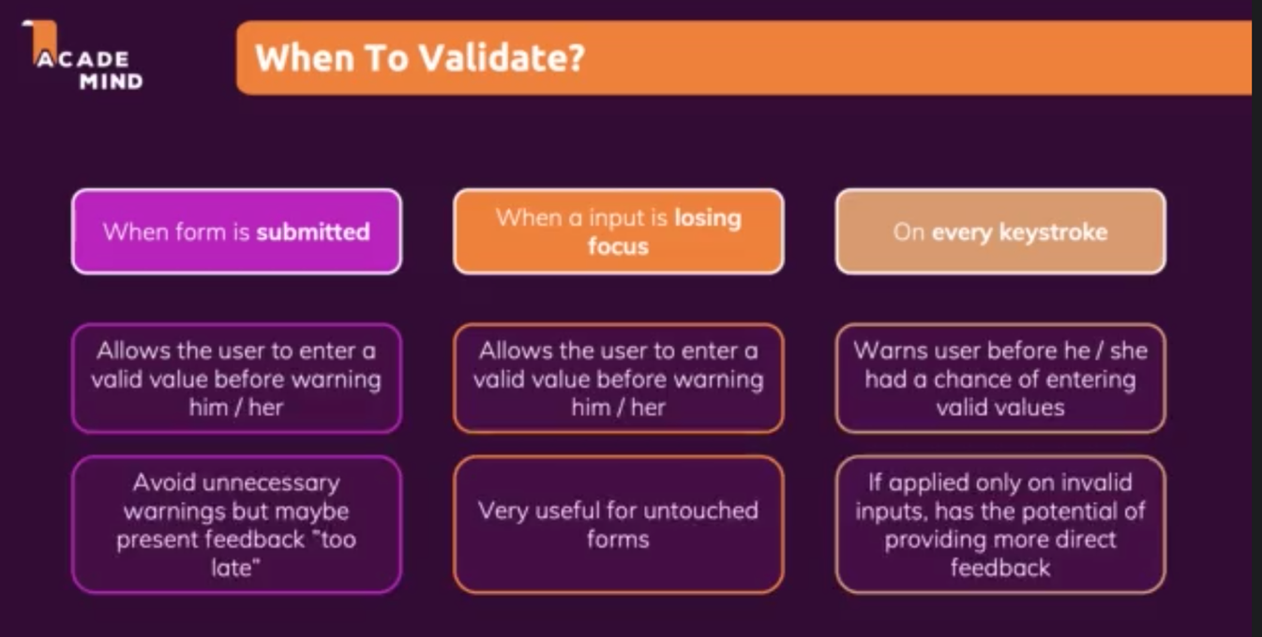

## Dealing with Form Submission and Getting input values

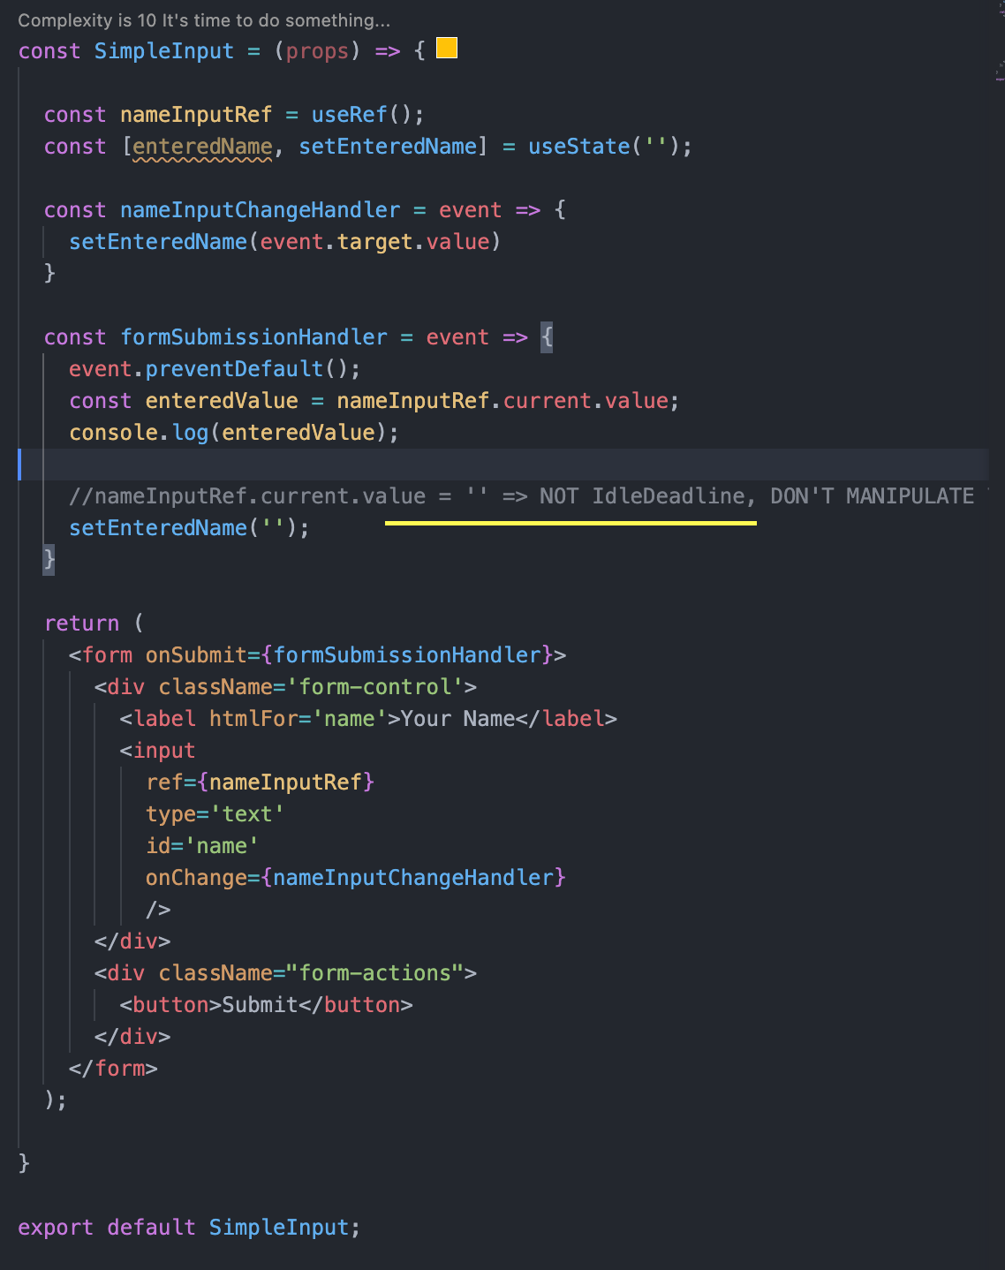

## Doing the validation on submission

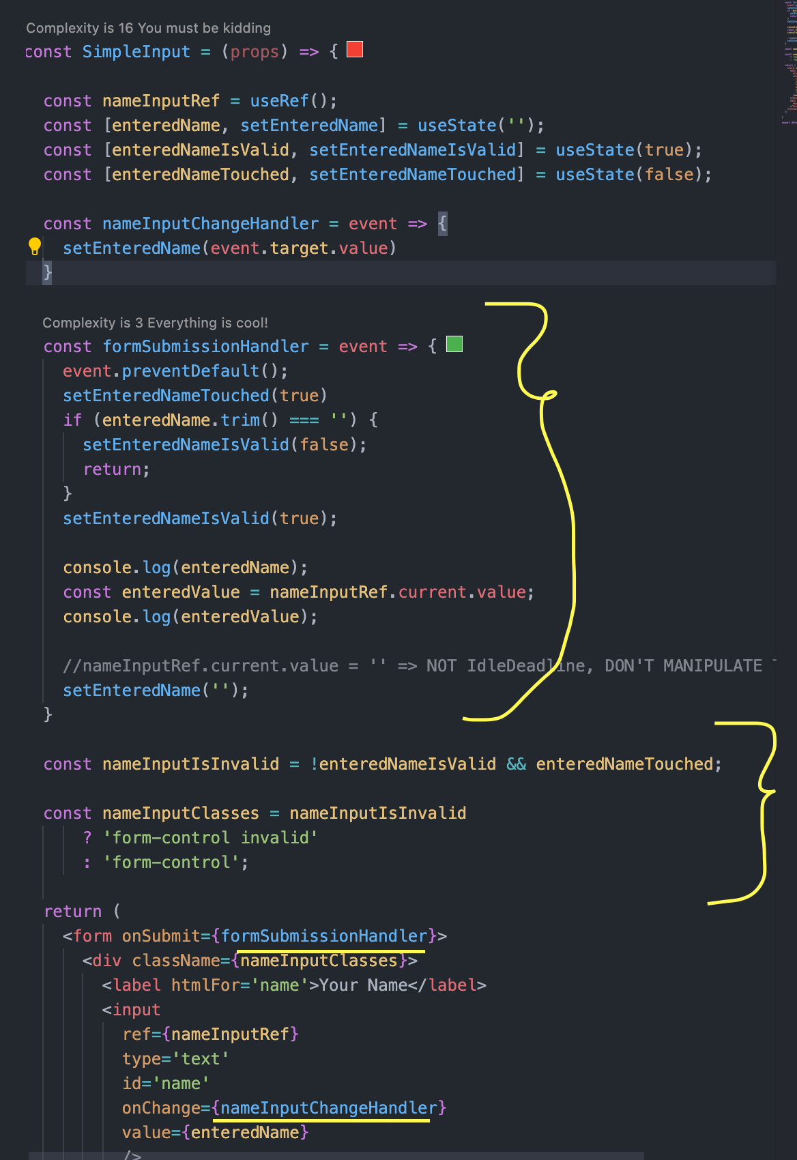

onBlur function will be triggered when input is loose focus.

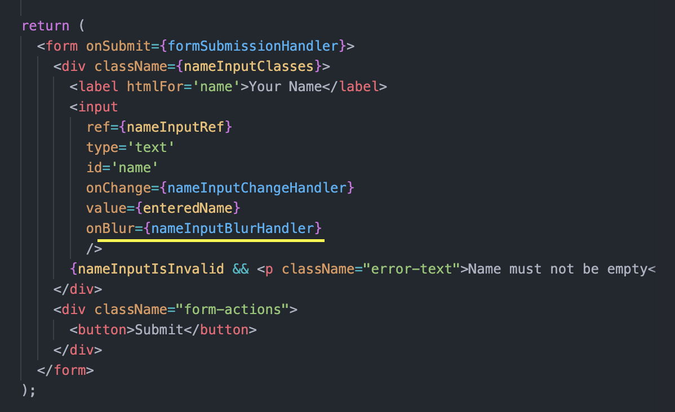

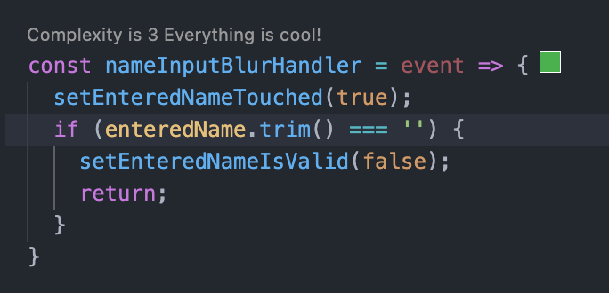

## Disabling the button based on the state

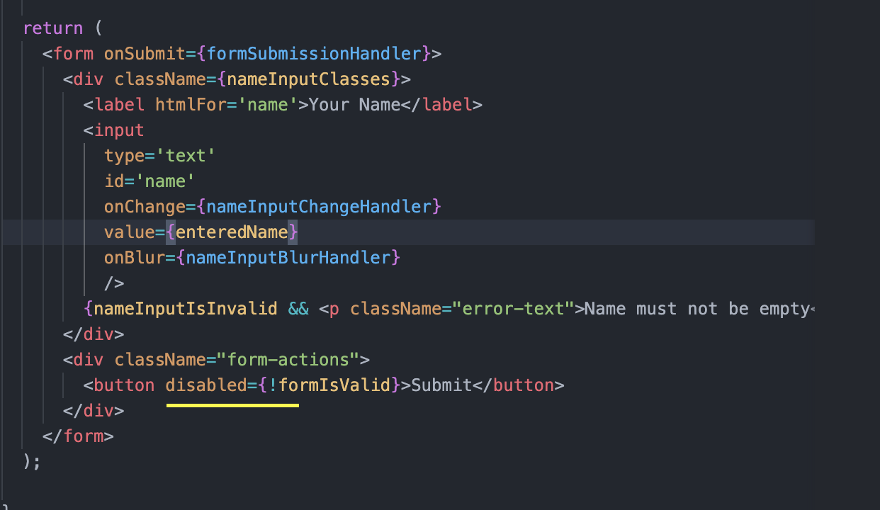

## Refactoring the functionality

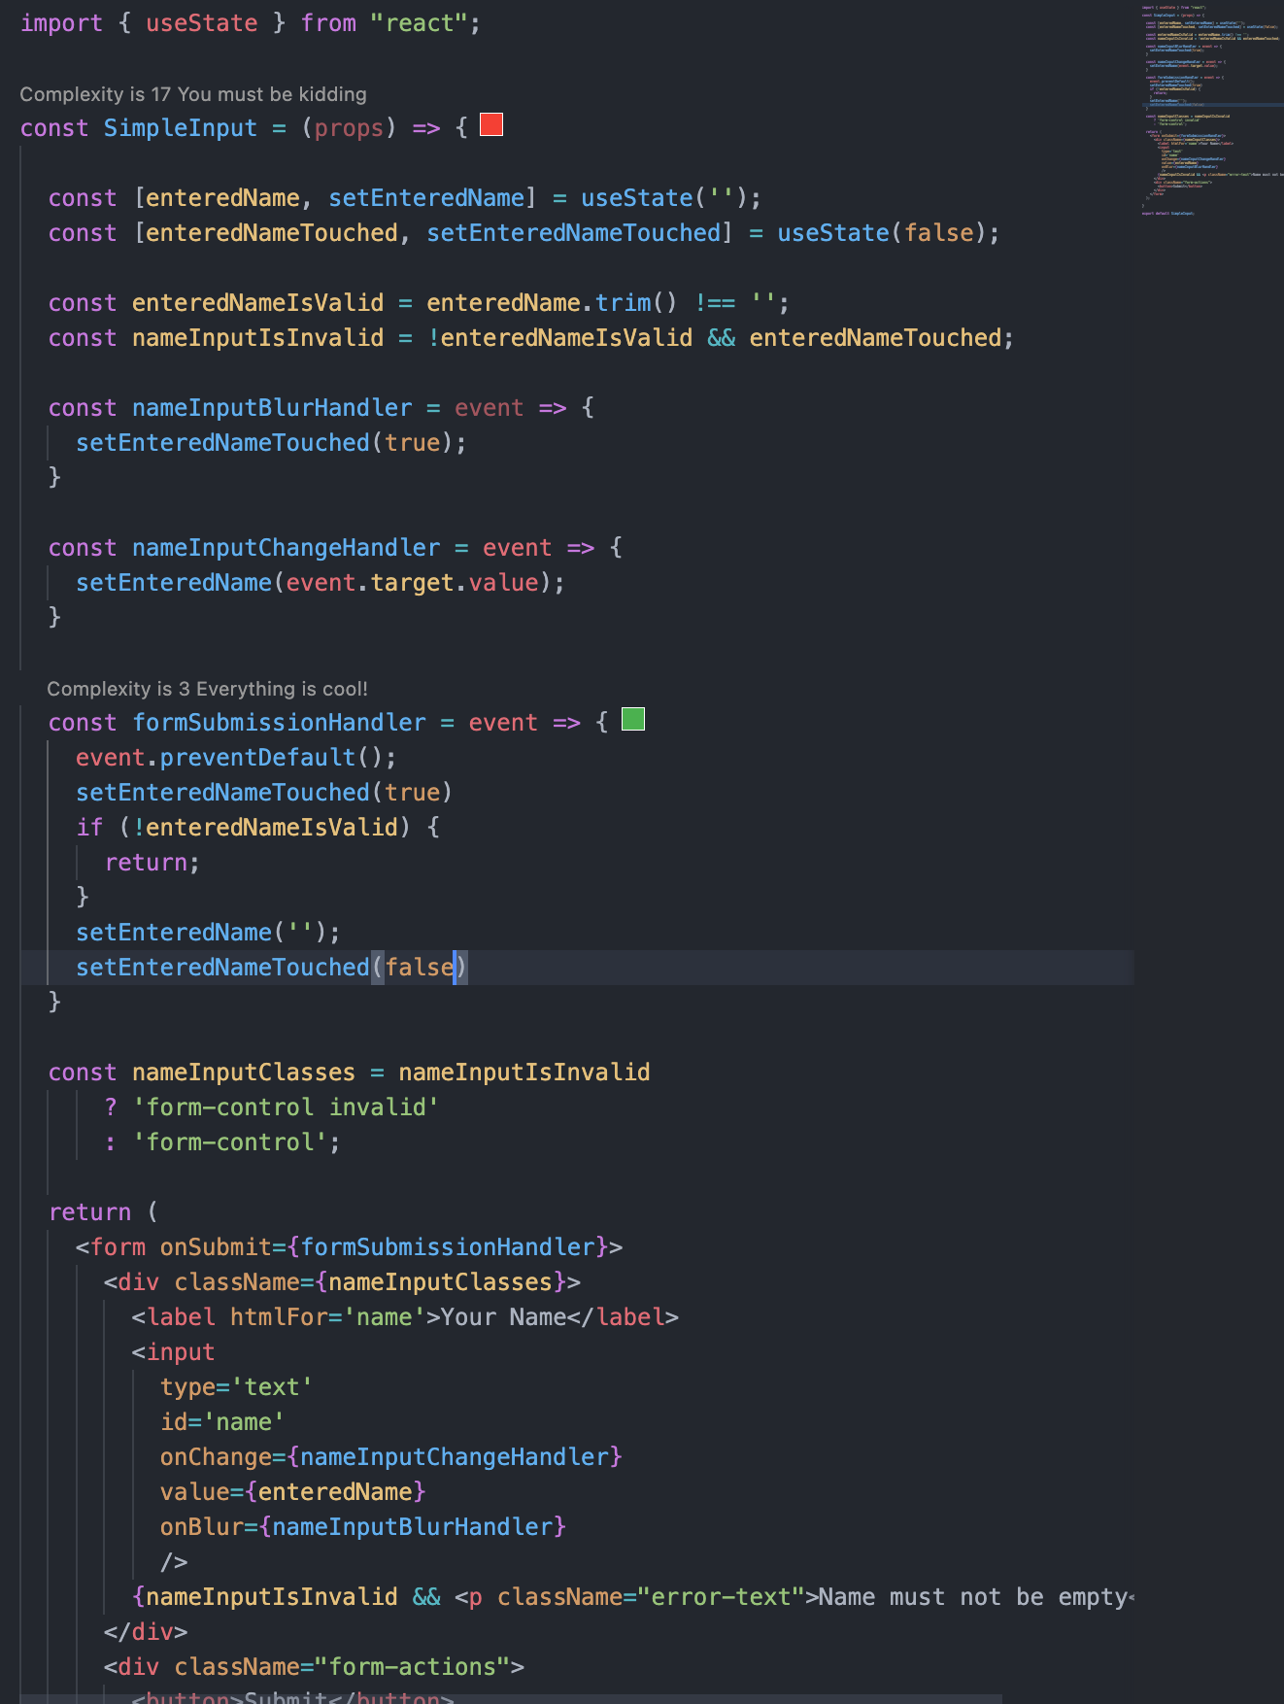

## Custom Hook

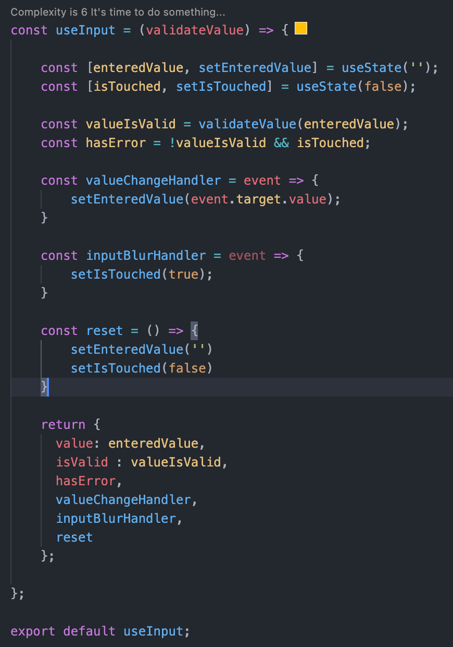

## Using reducer in custom hook

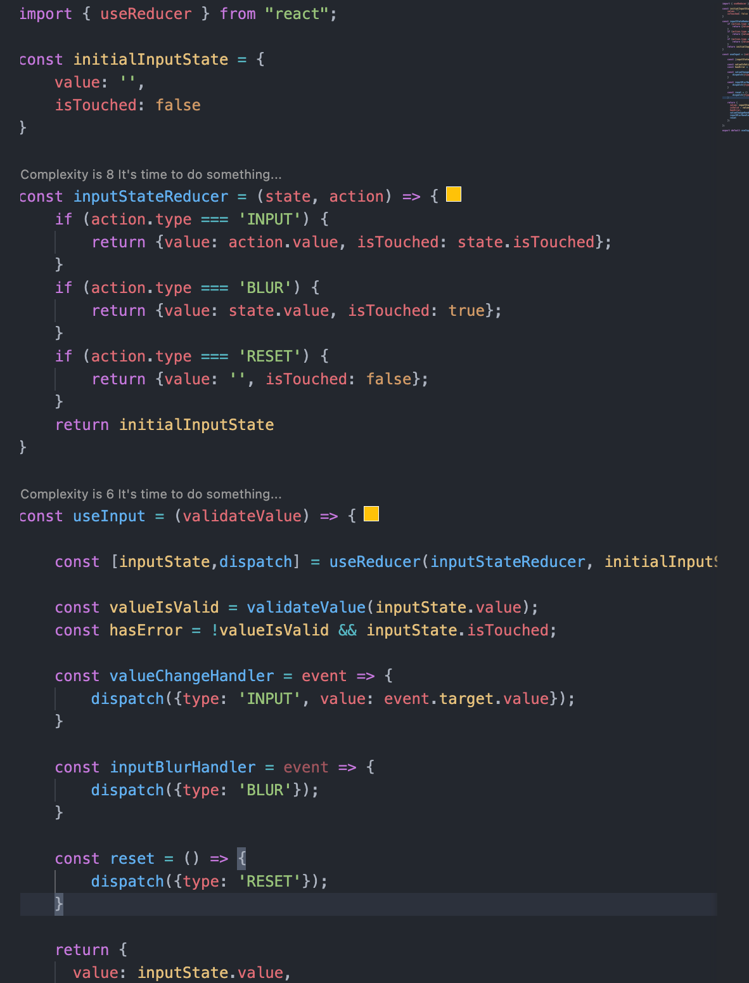

# Using Http in Food Order APP

## Reusing the useHttp hook

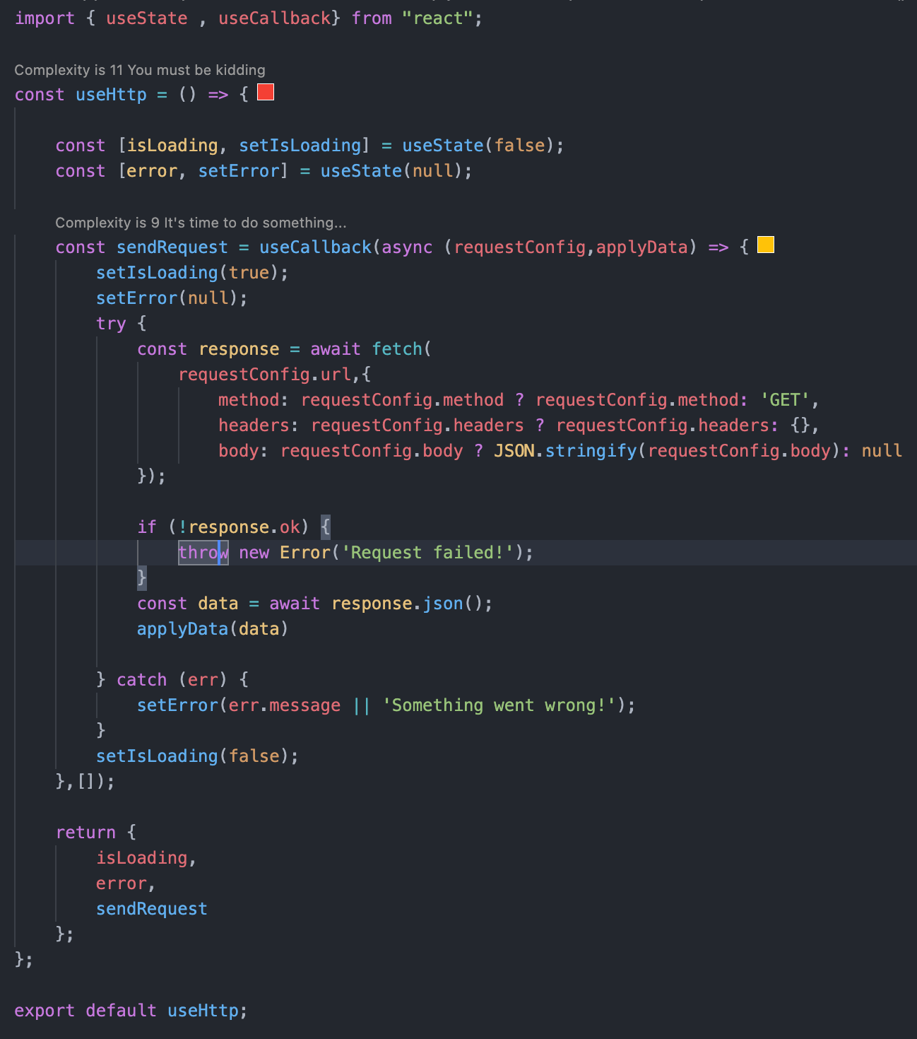

## Demo

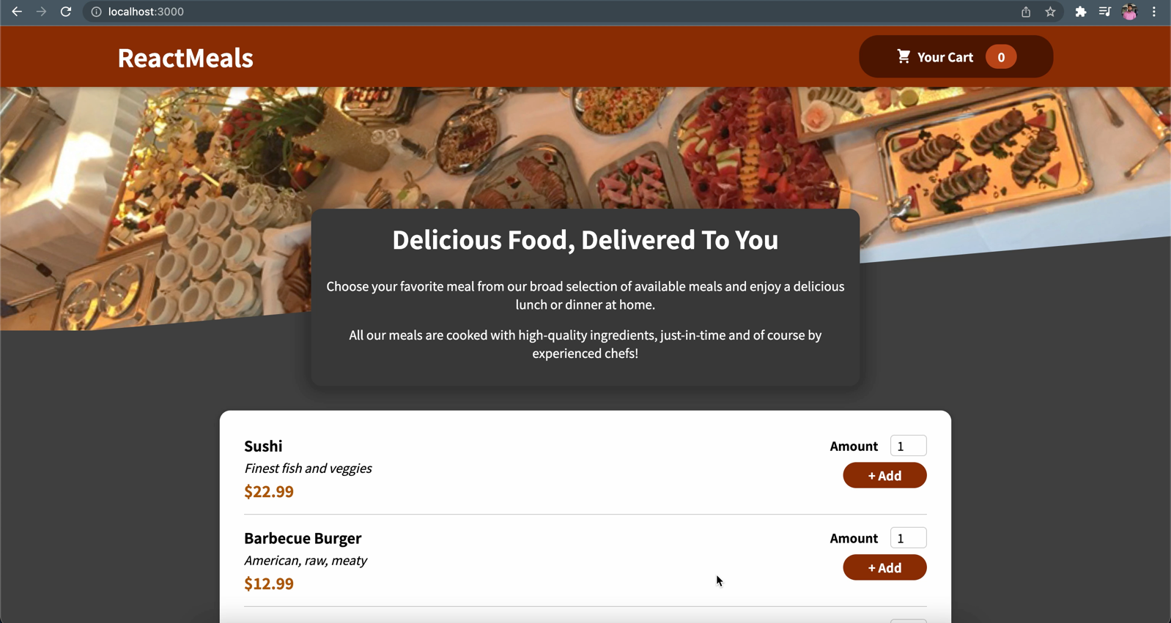

# Redux

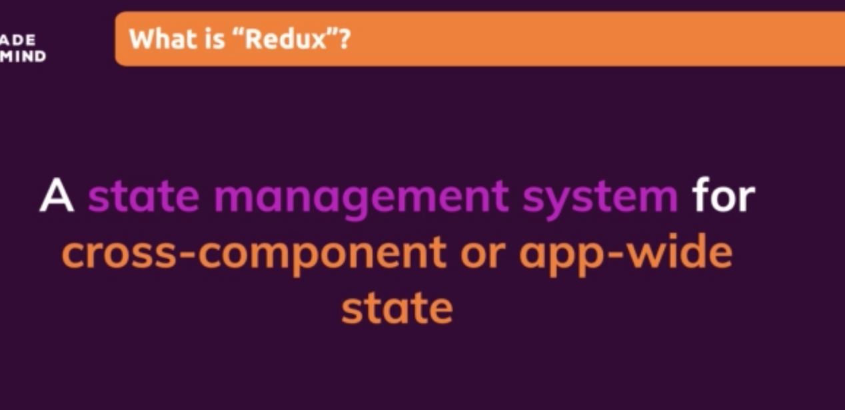

## What is Cross-Component / App-Wide State?

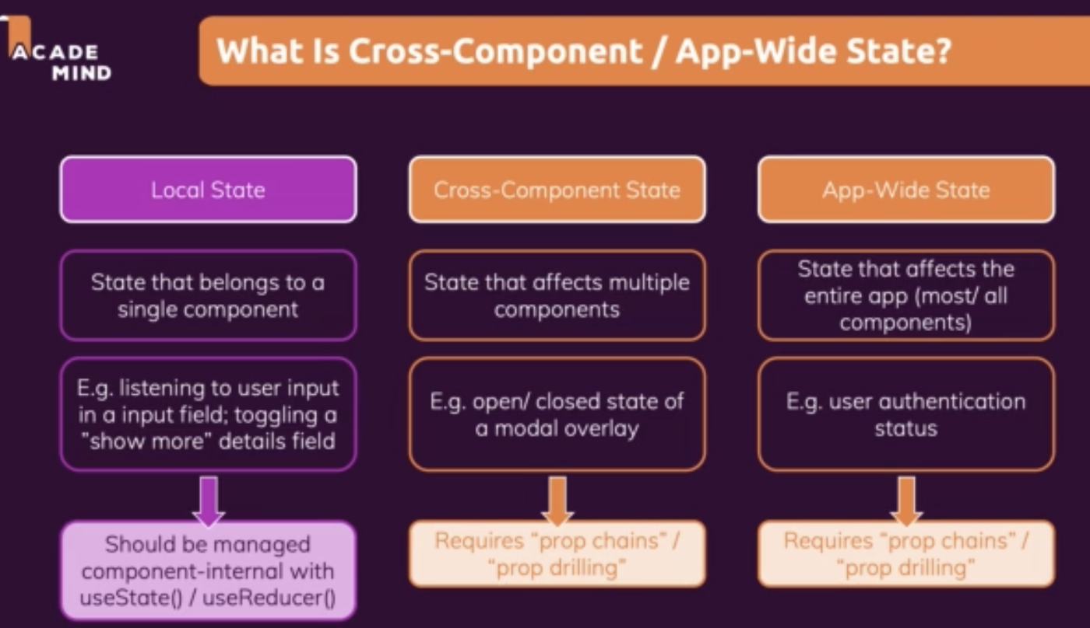

Redux used to manage the cross-component state similar to react context.

## Then Why do need a Redux when we already context Provider

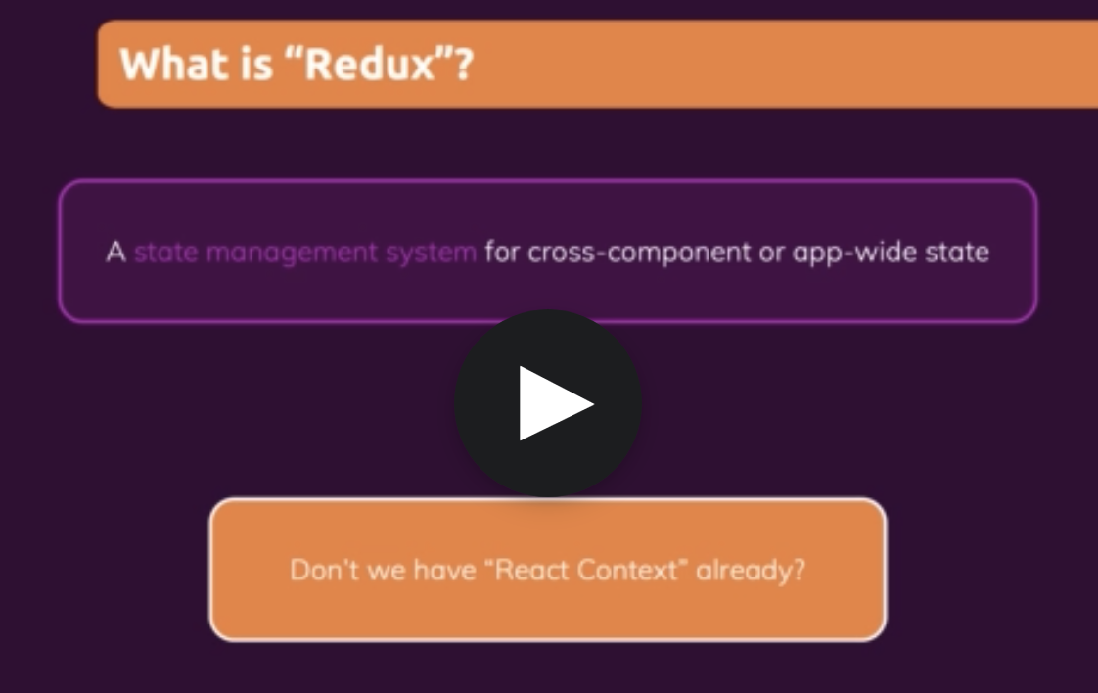

Disadvantage of Context Provider

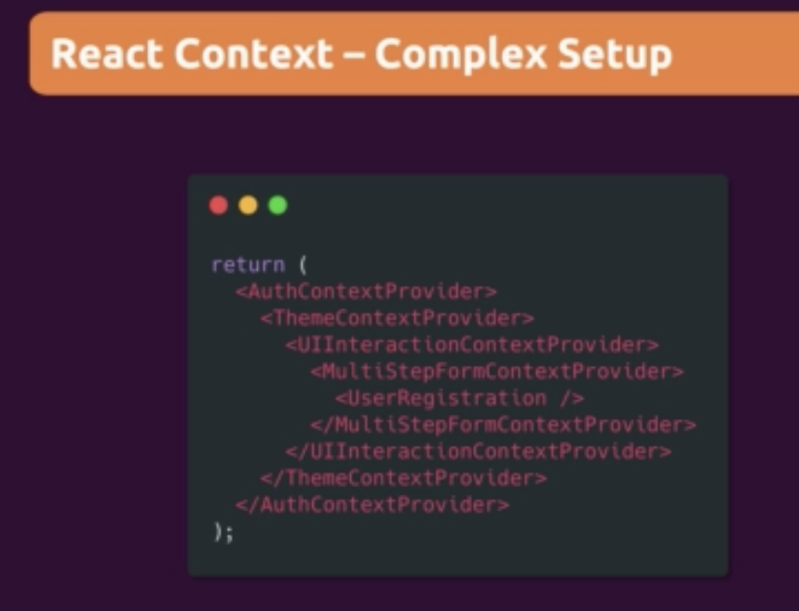

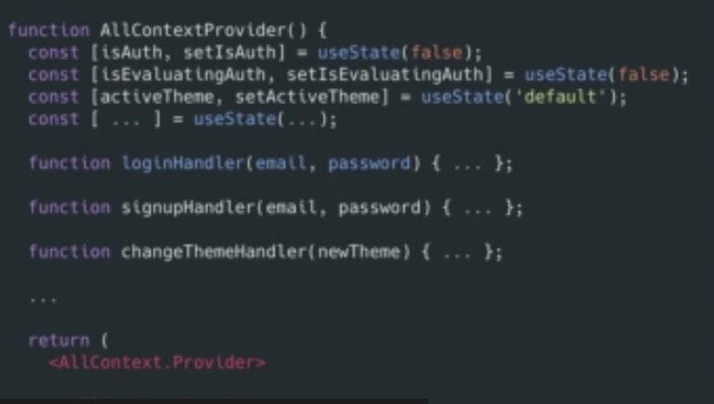

Context provider become large on large enterprise application.

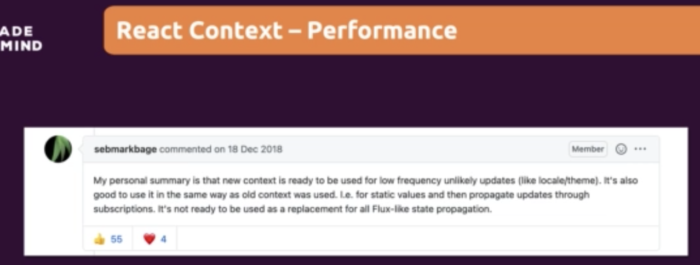

Redux is flux like state propagation.

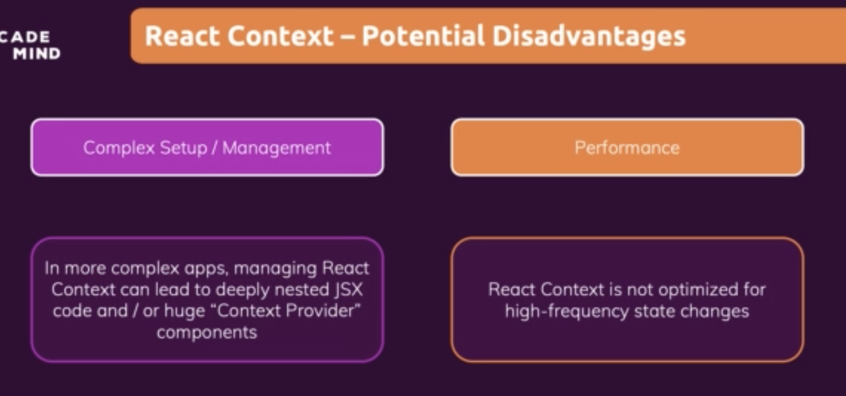

## How Redux Works?

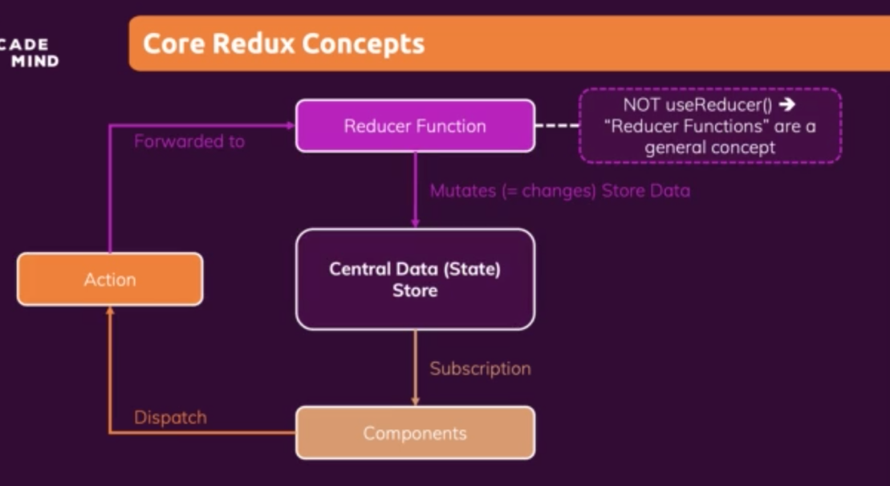

## Redux Core Concept

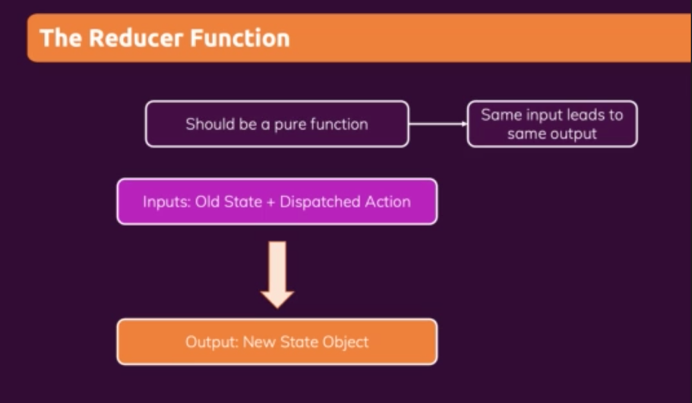

## Redux Demo

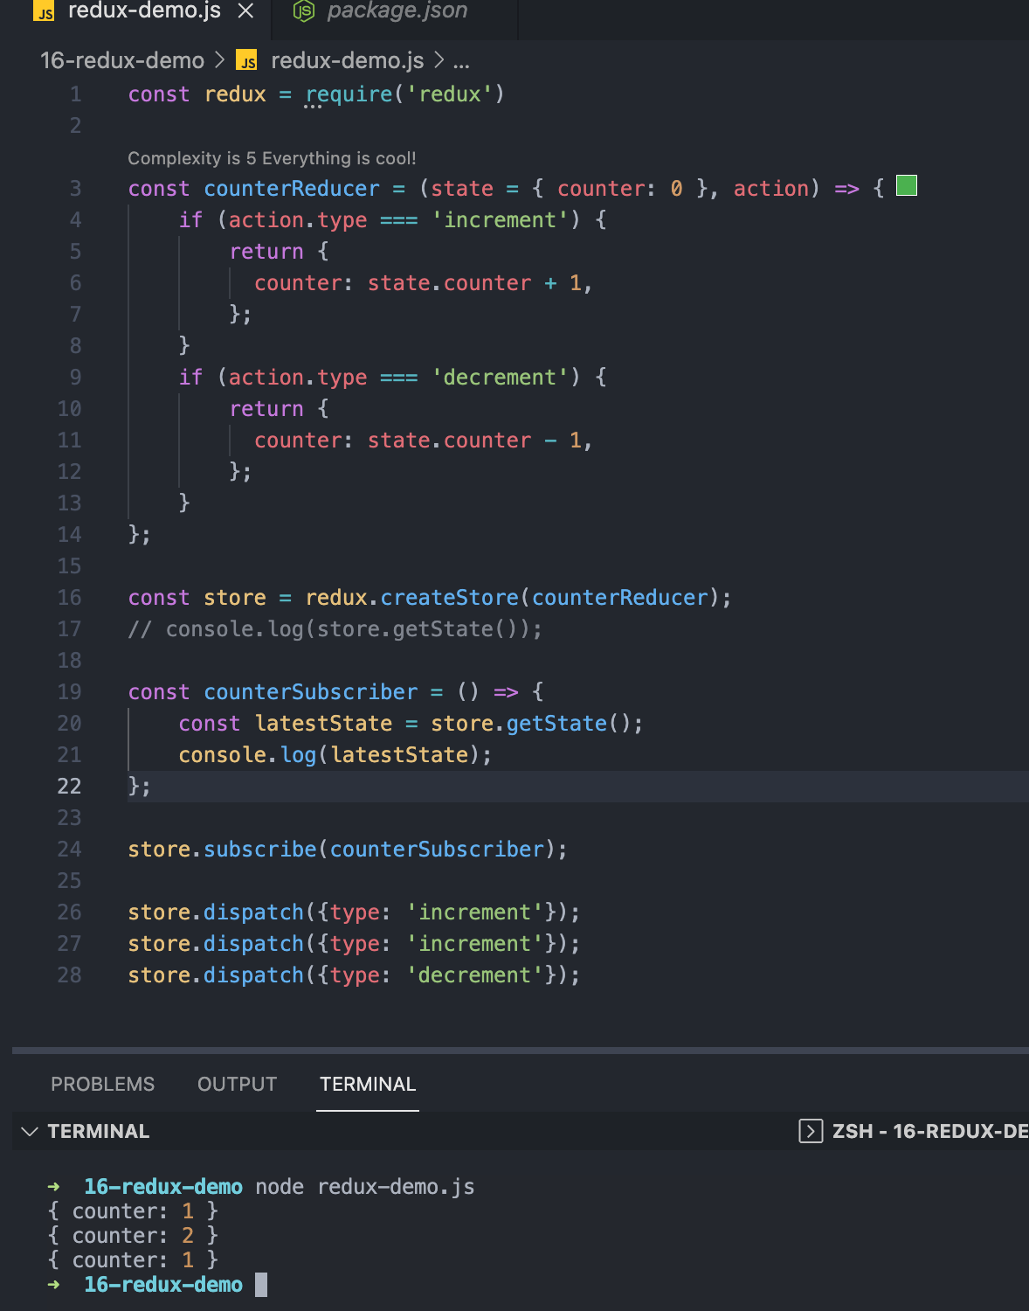

## Required redux package for react project

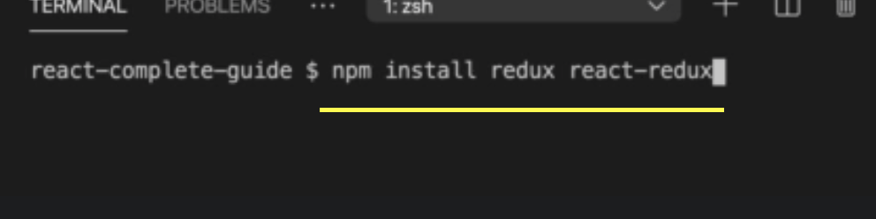

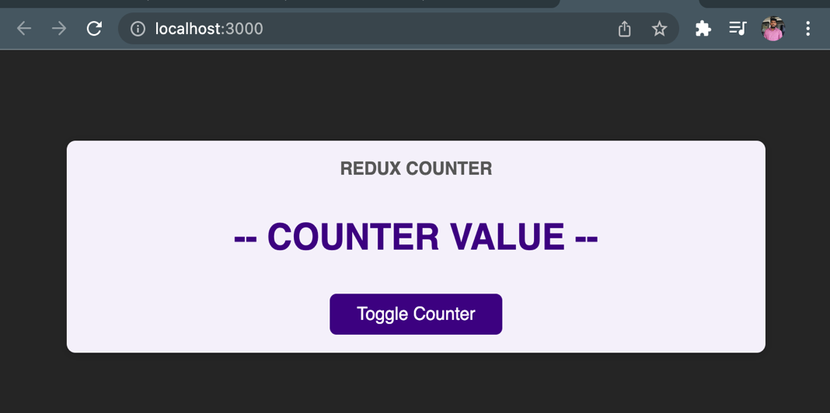

## Registering the redux store in react app

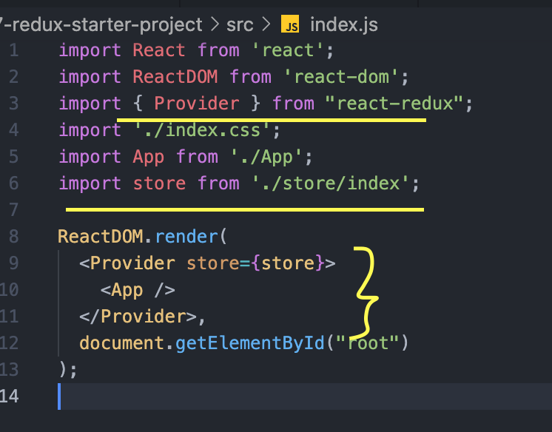

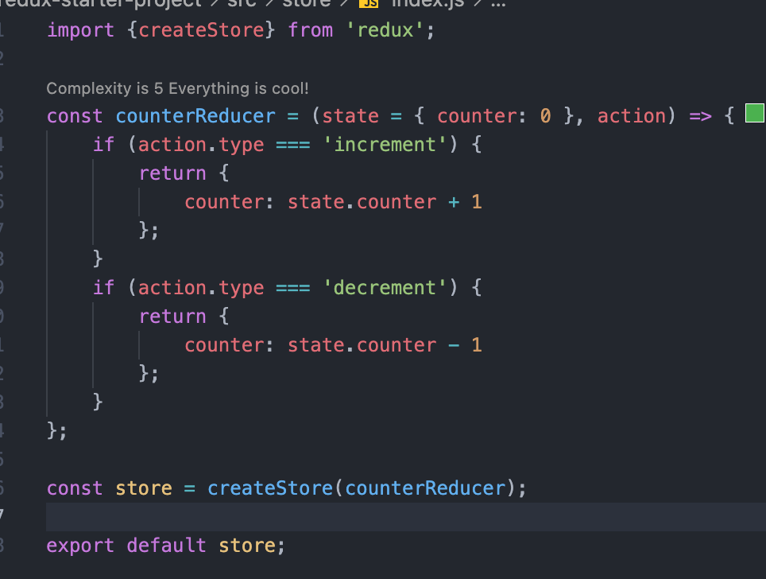

## Use the redux store in react component

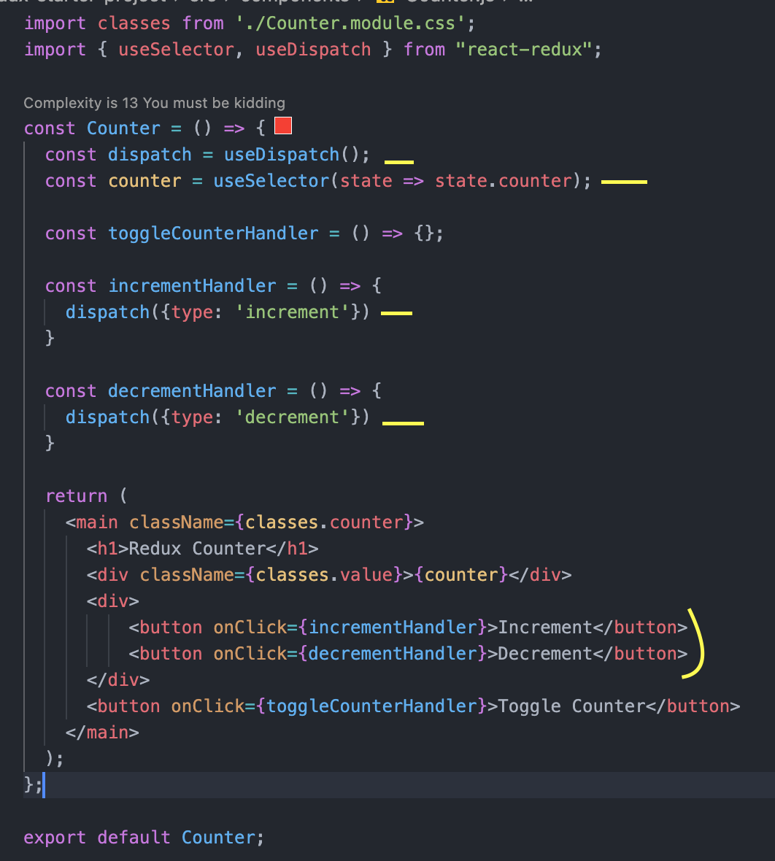

## Use the redux store in react class based component

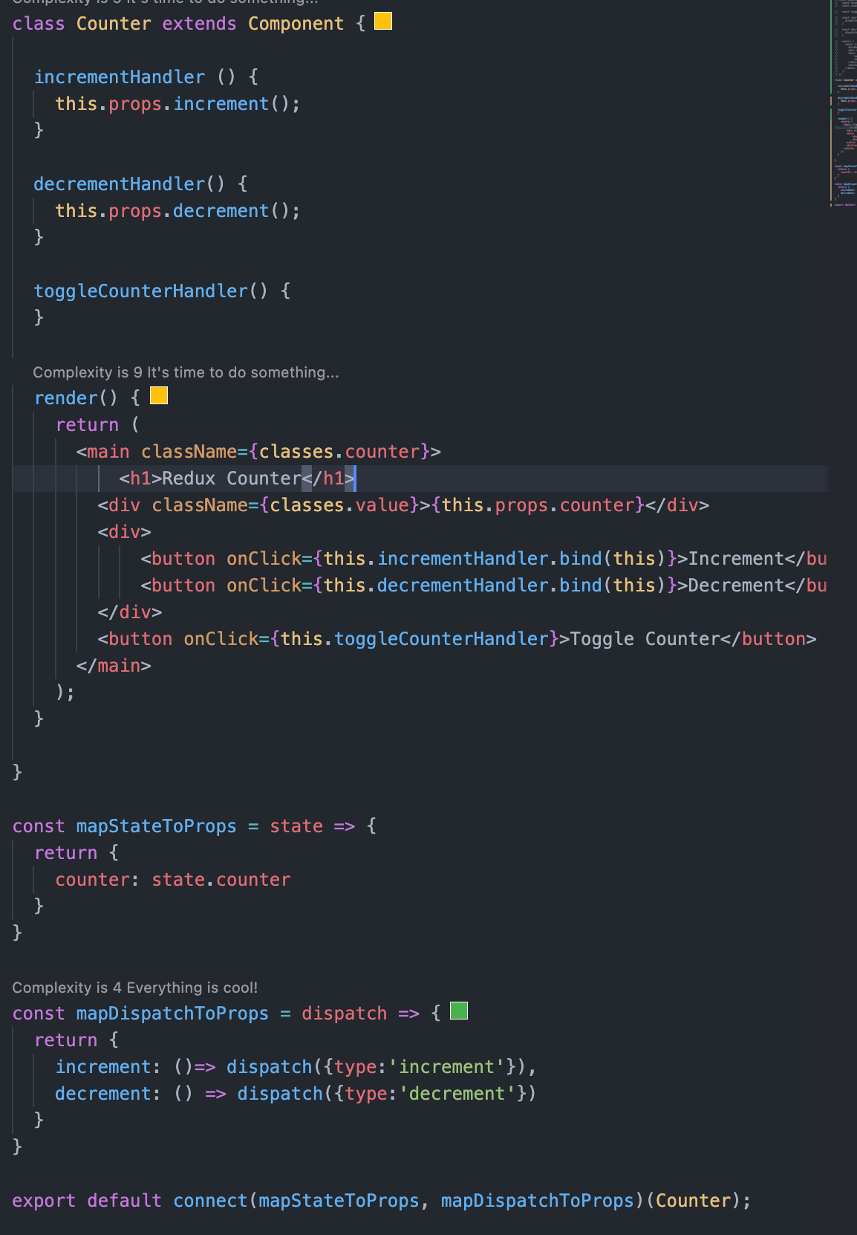

## Counter App Demo

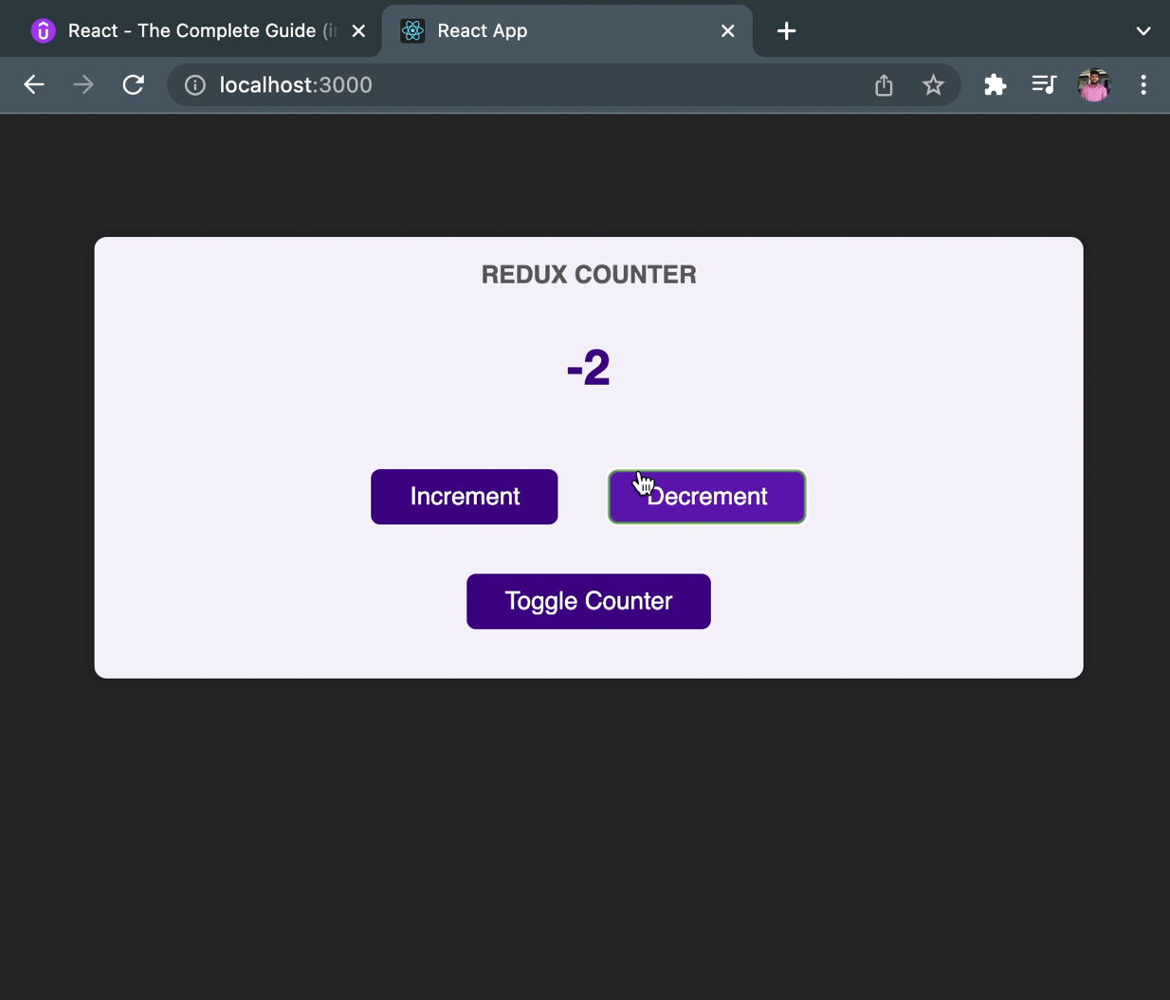

## Passing data via dispatch action

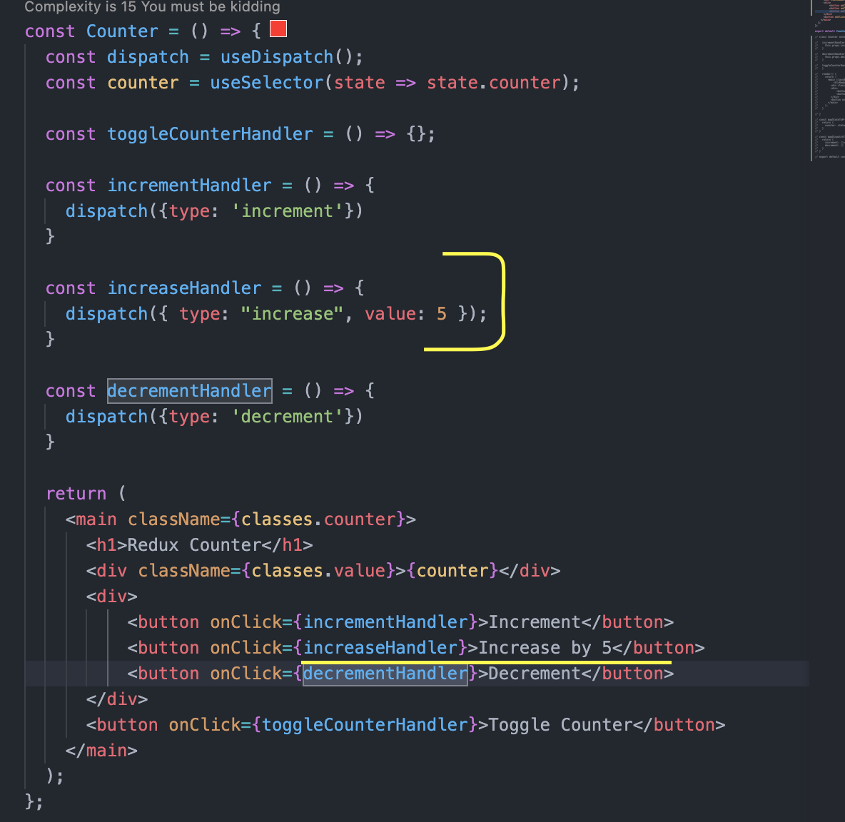

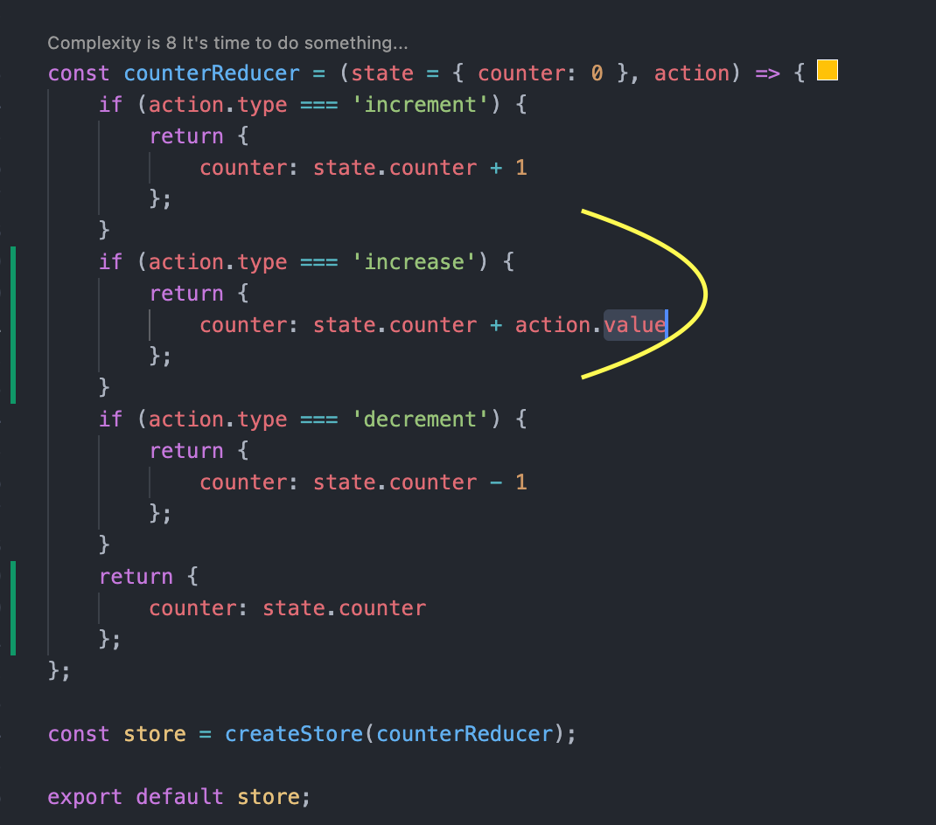

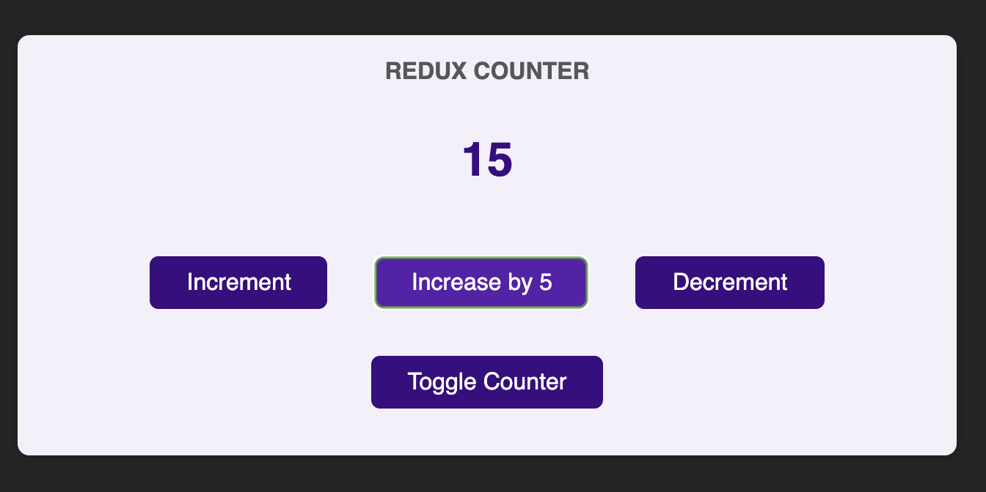

## Working with multiple state in redux

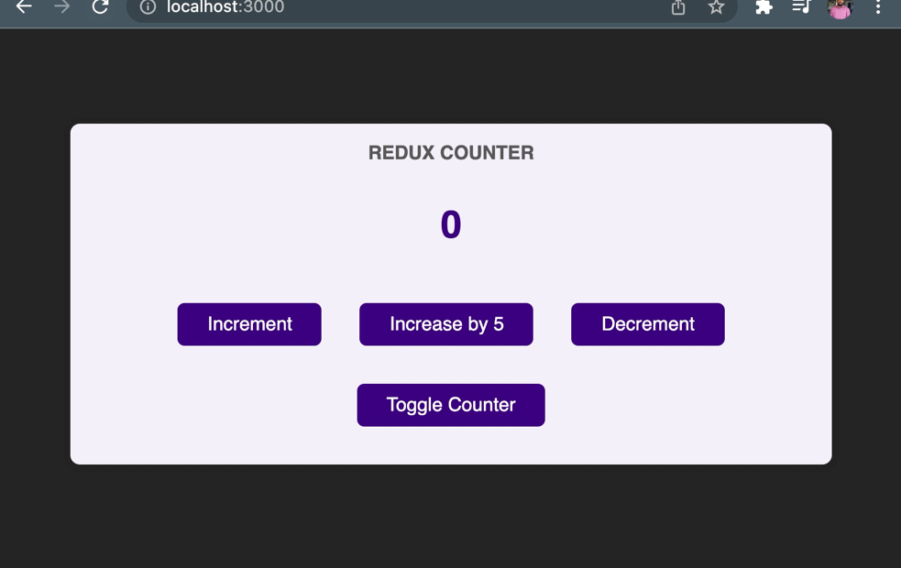

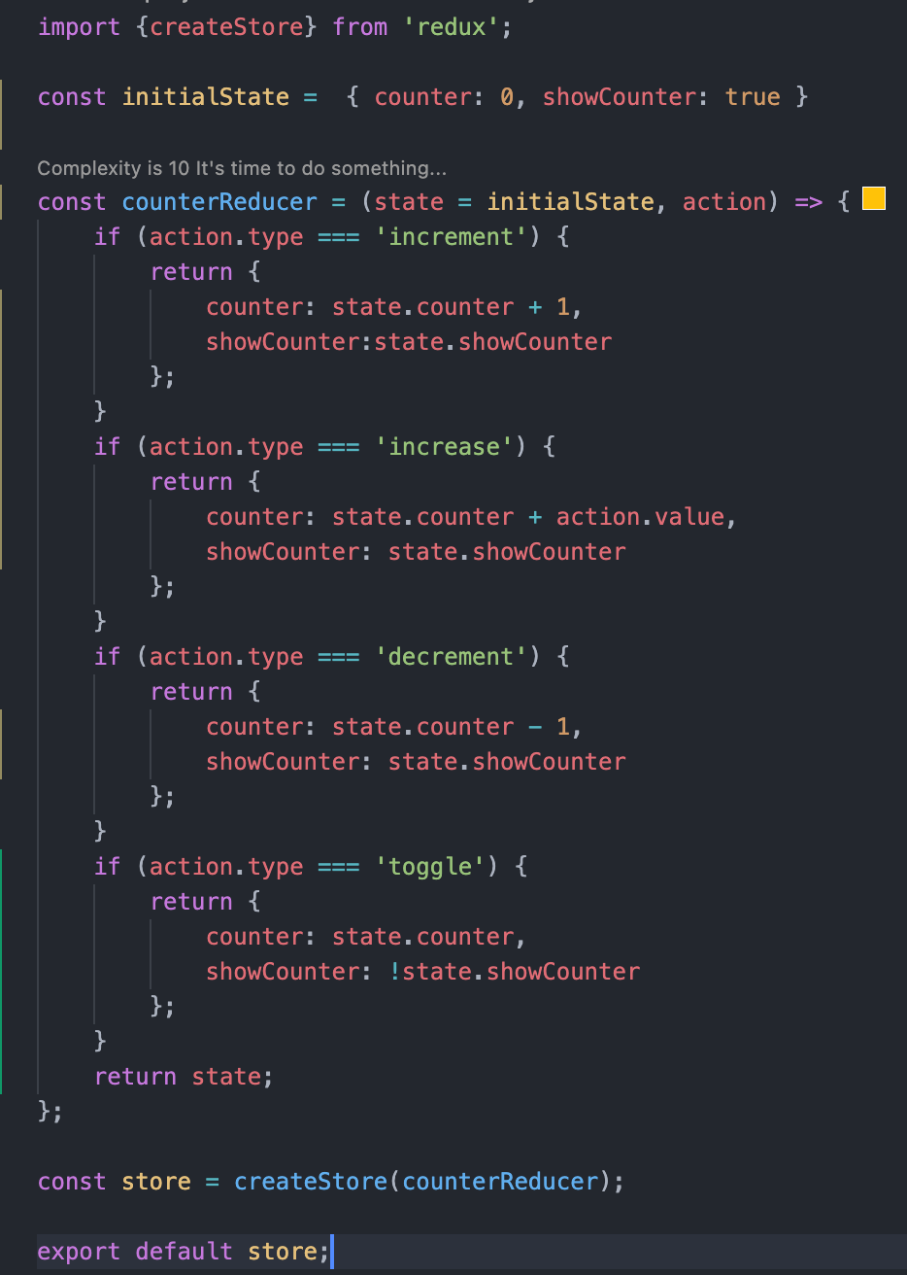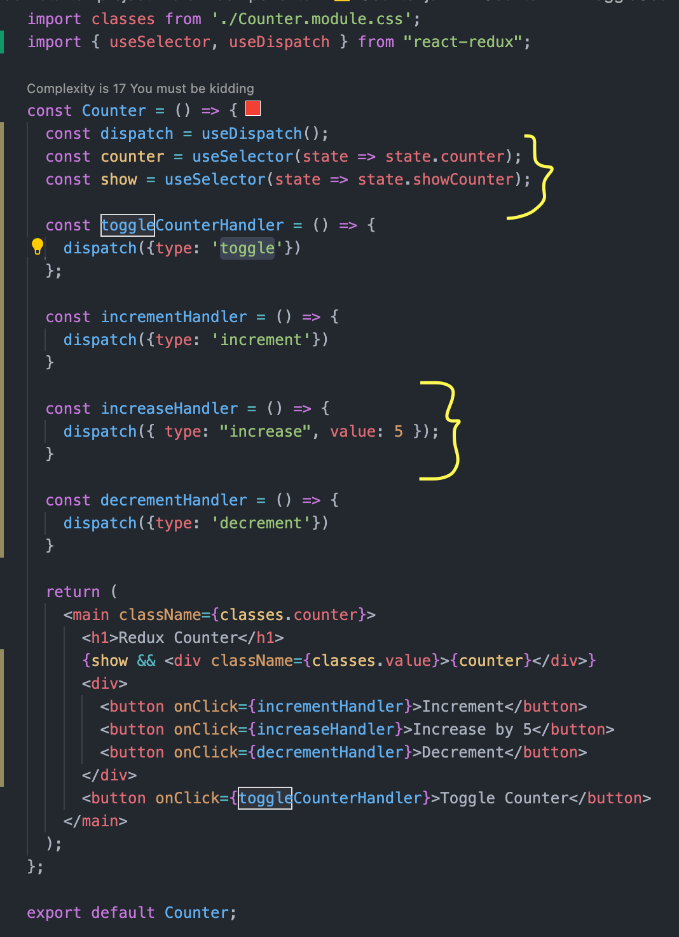

Never mutate the state when working with redux like below. Always overwrite the state.

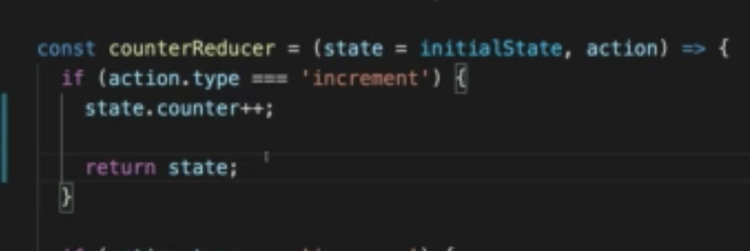

## Redux Challenges & Introducing Redux Toolkit

Using constant for action type

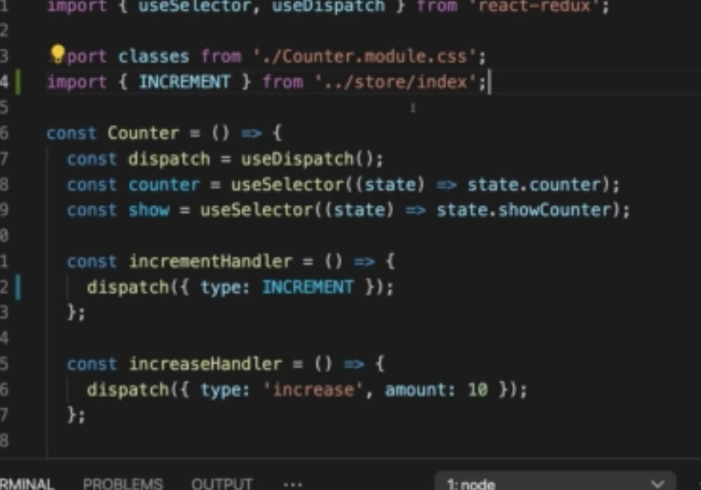

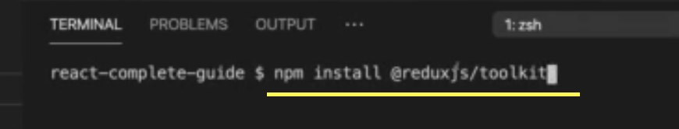

## Redux Toolkit Example

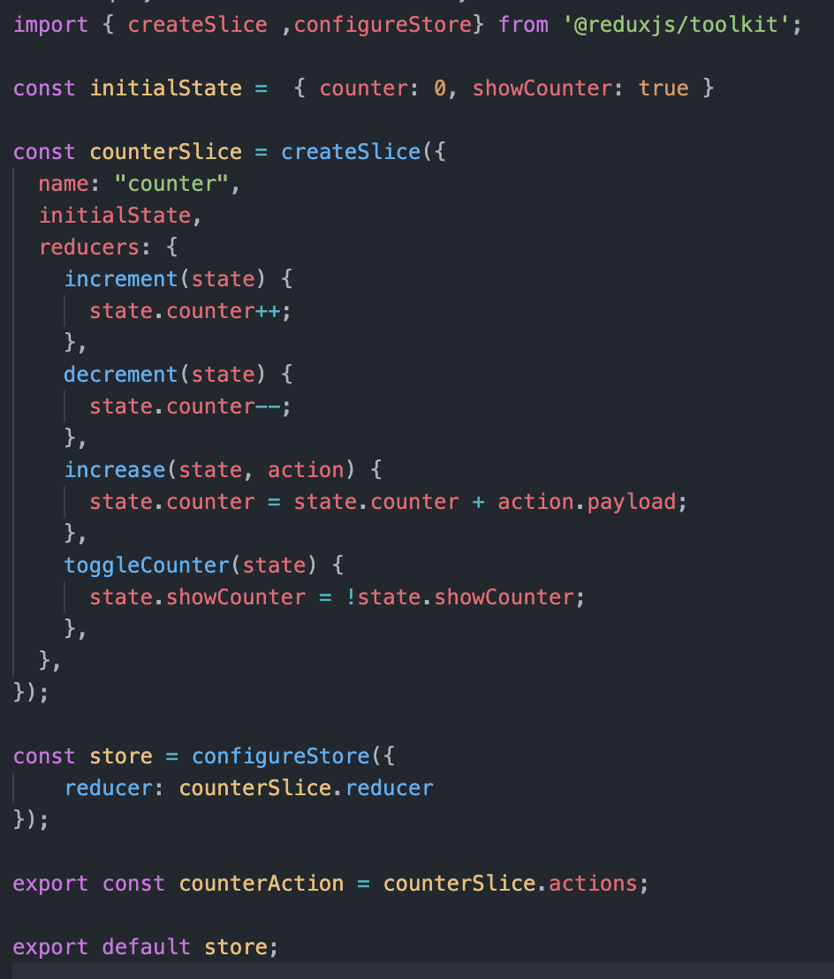

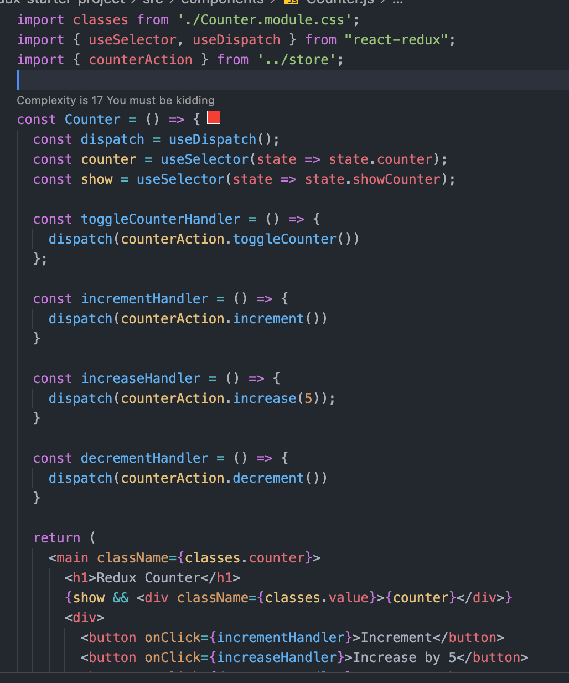

## Using Multiple States

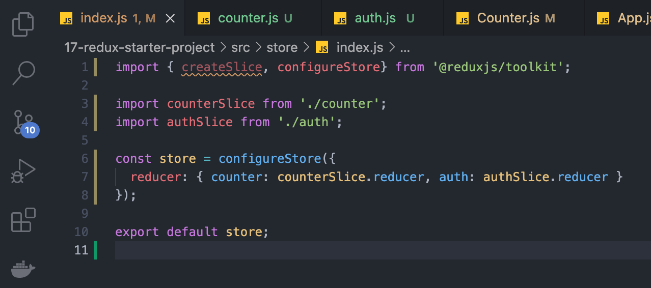

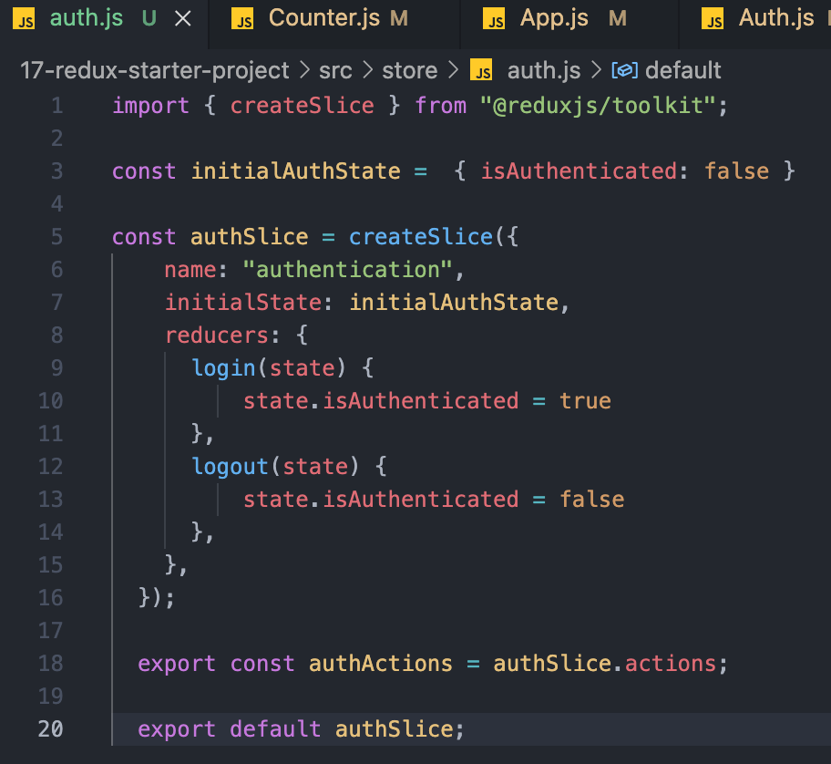

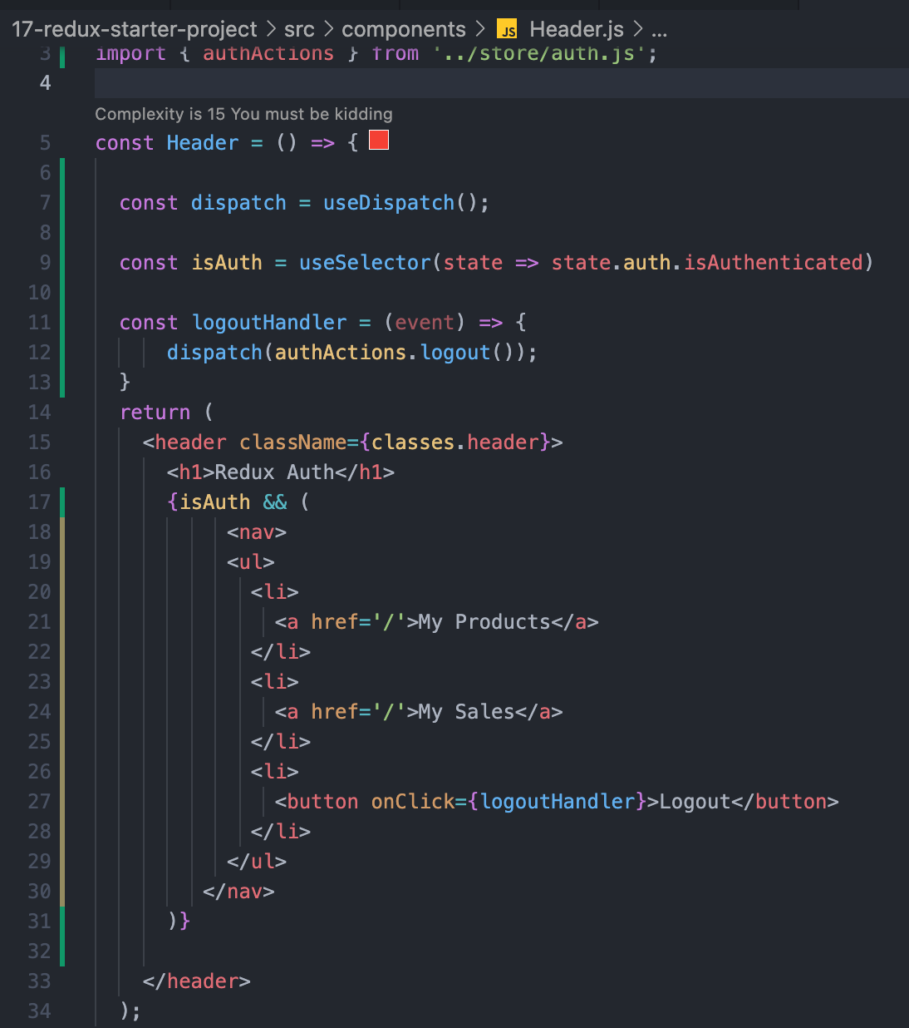

# Advanced Redux Concept

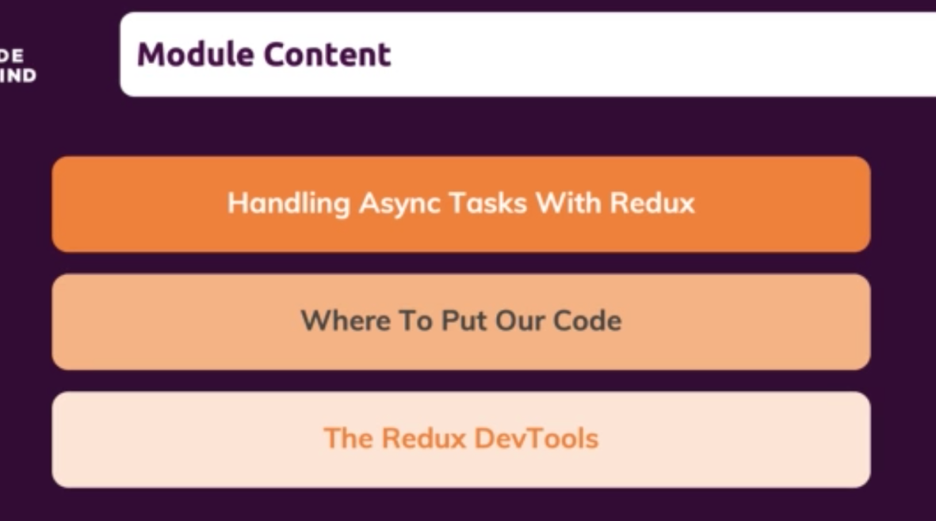

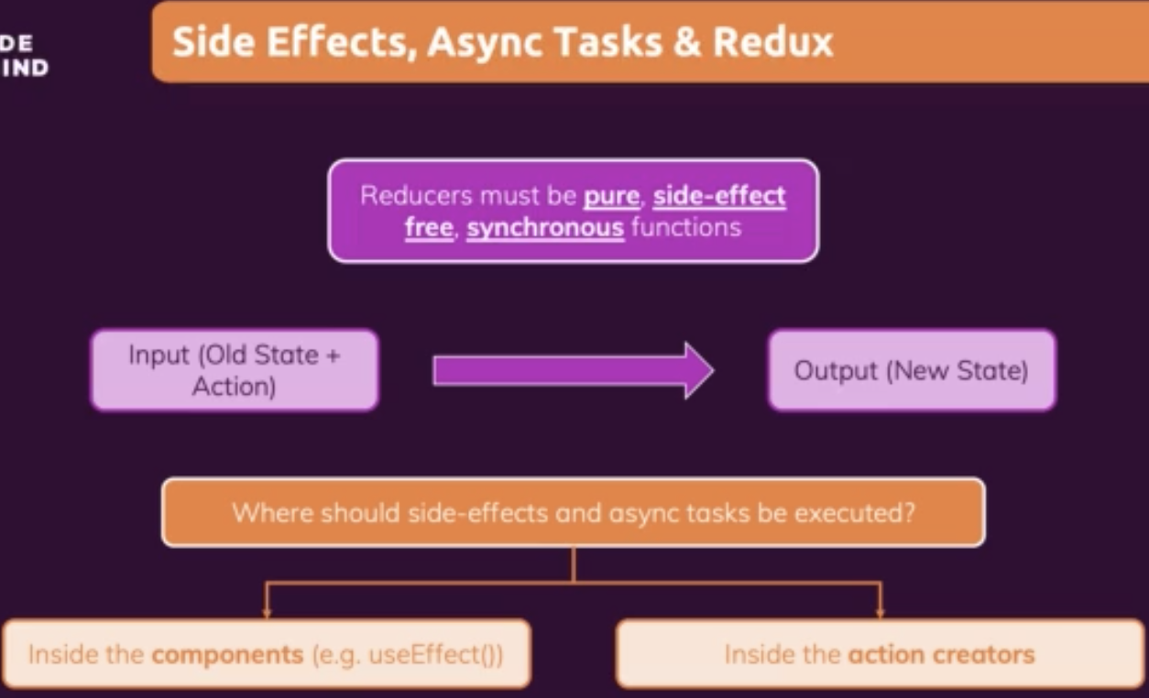

npm install @reduxjs/toolkit

npm install react-redux

## Using asynchronous code with Redux

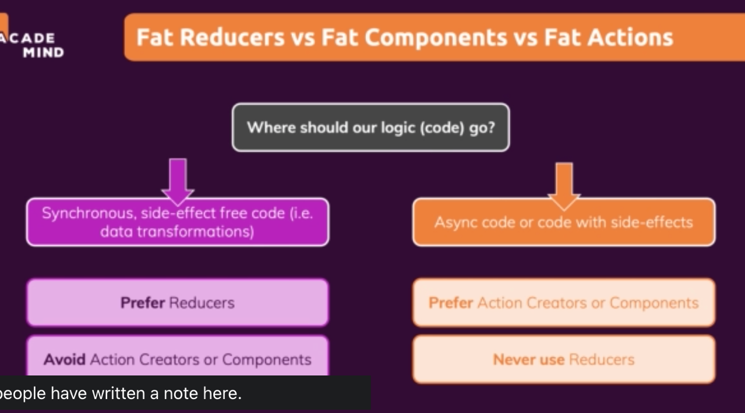

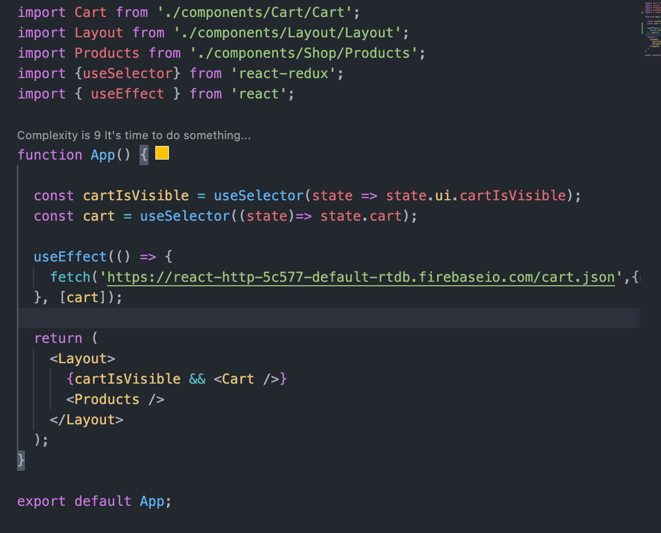

Adding the notification.

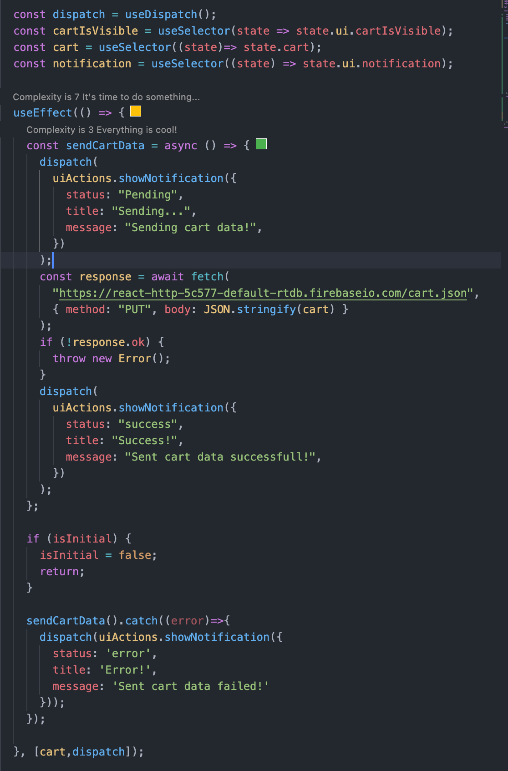

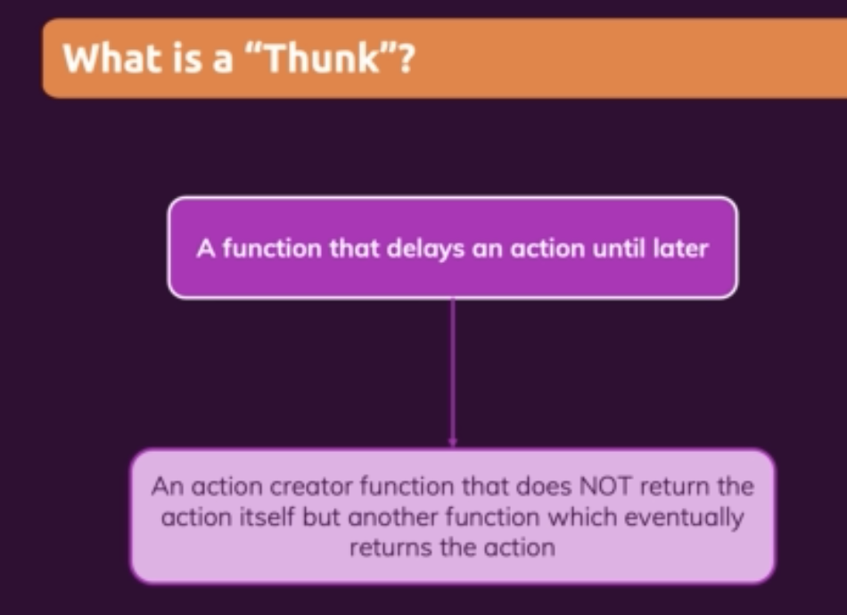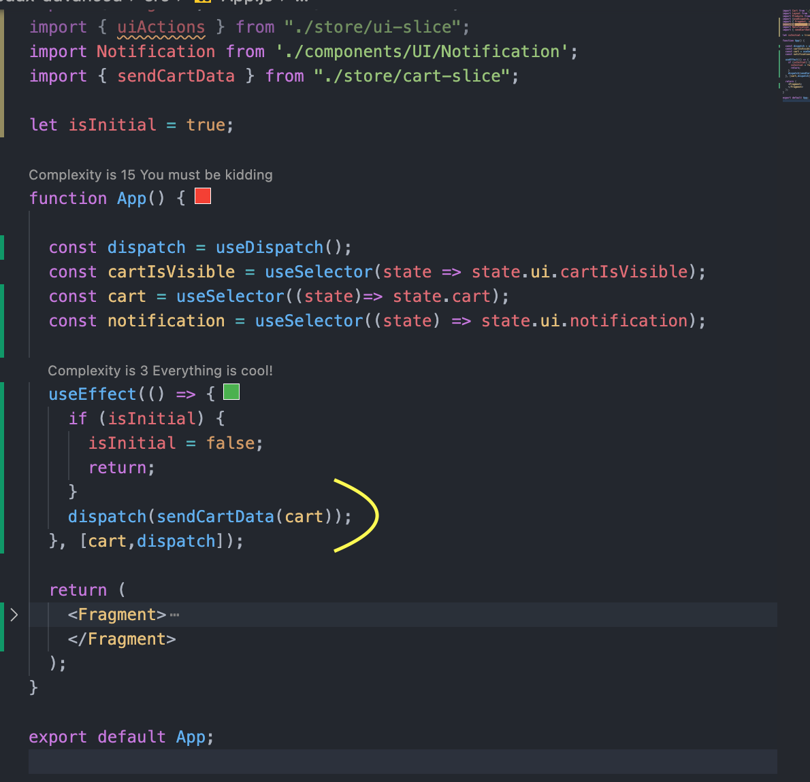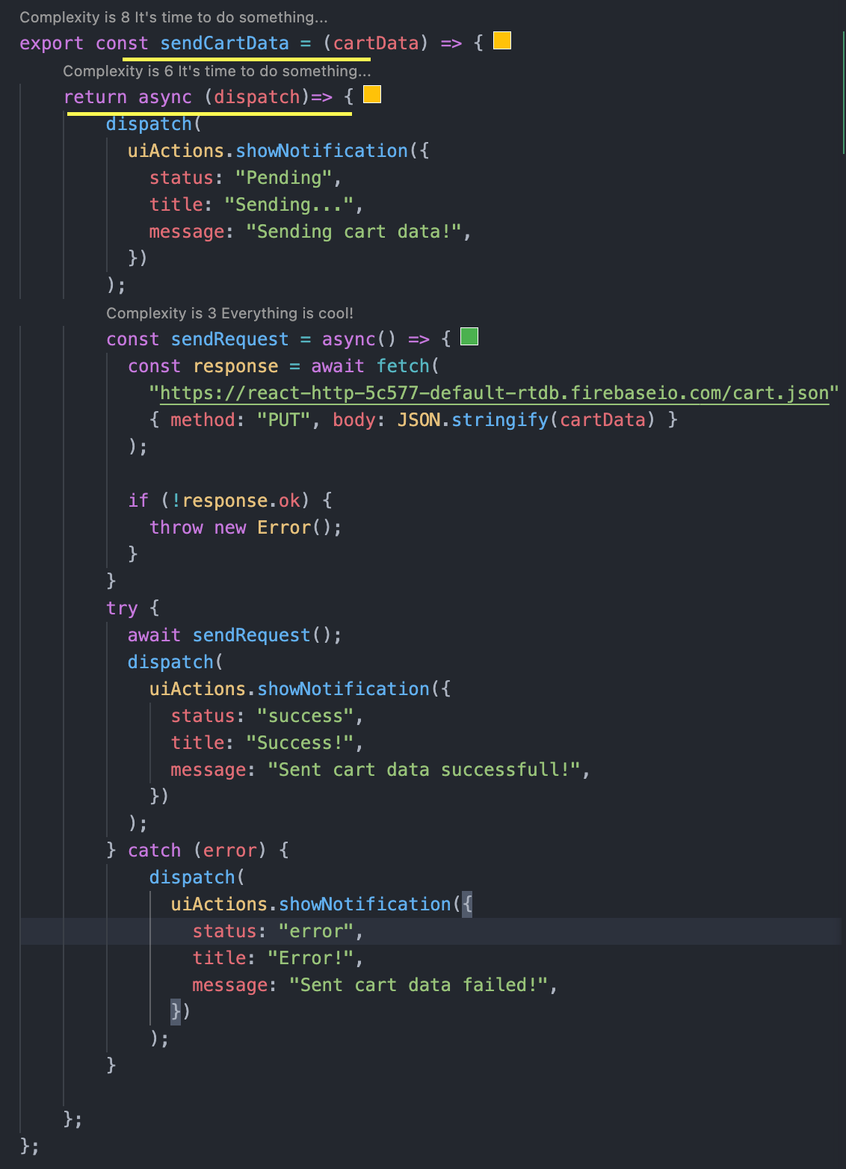

## React Dev Tool

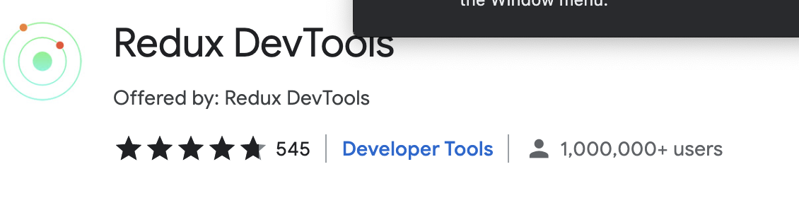

# React Router



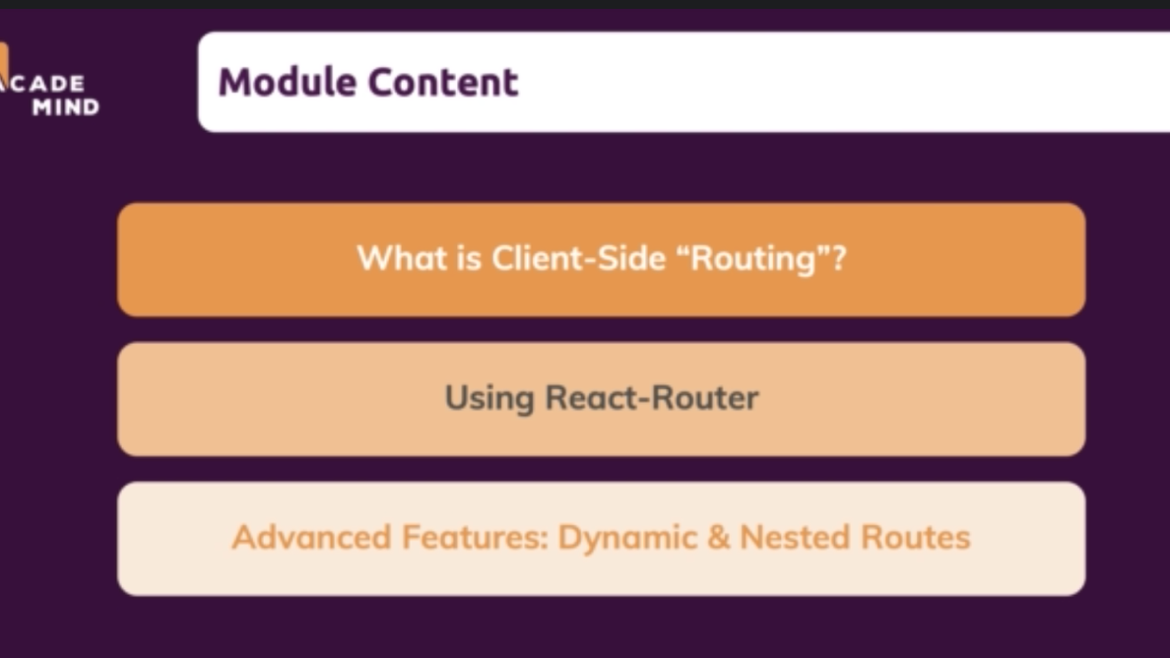

## Why routing?

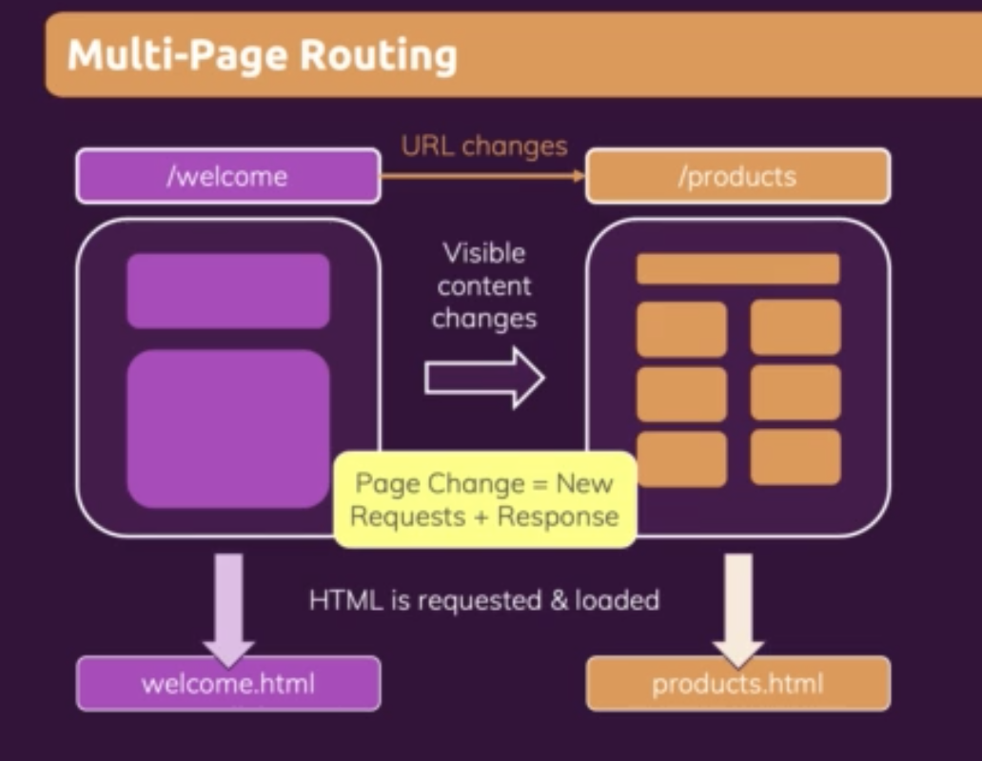

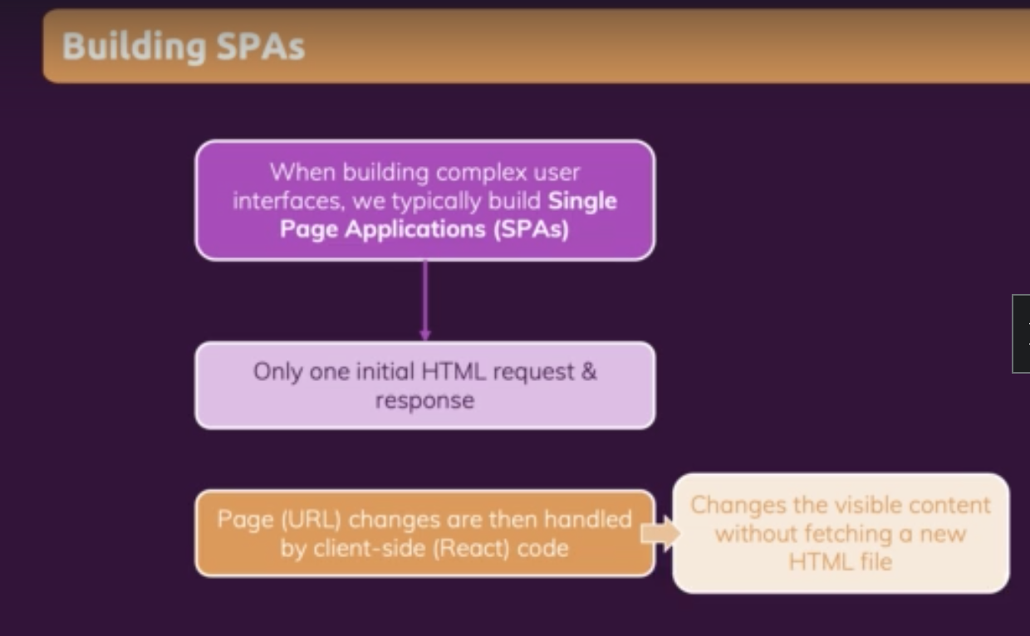

## Router Basic

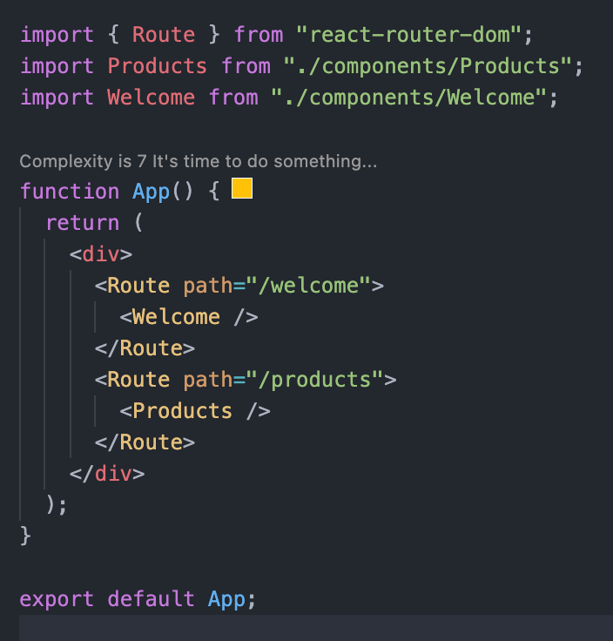

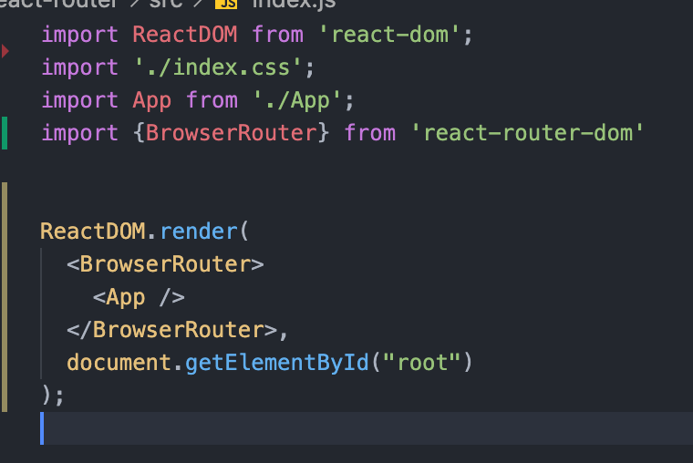

## Using Link to navigate to Route

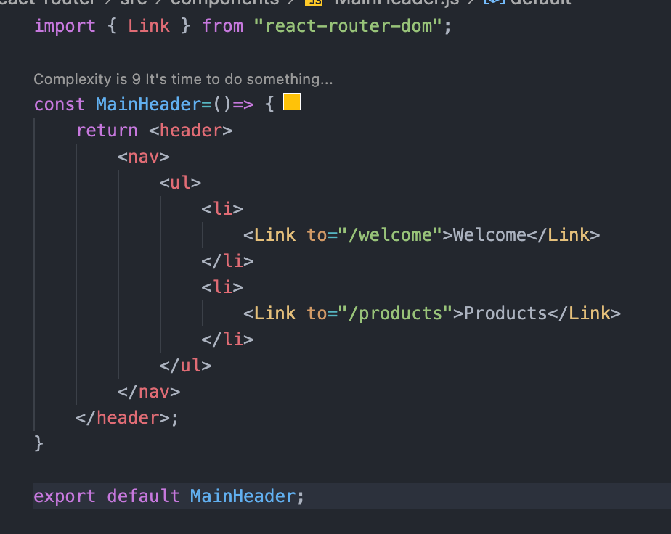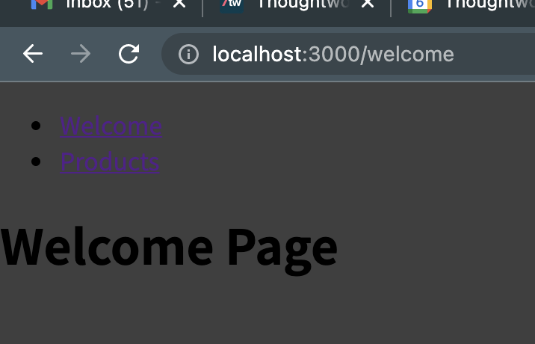

Using the Link will prevent the page reload.

## Using NavLinks to navigate to Route

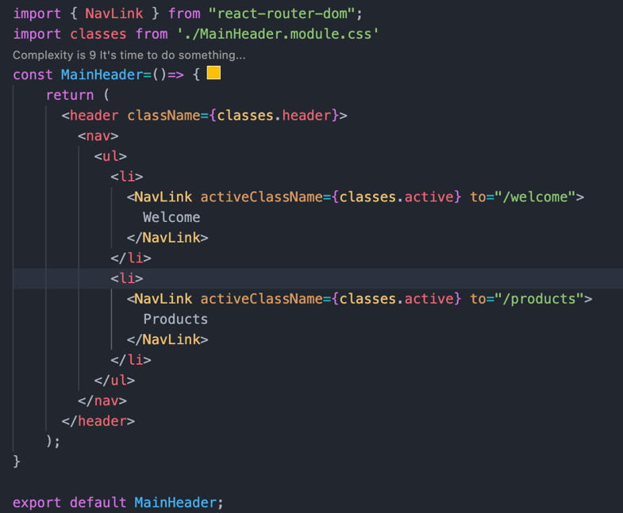

NavLink is like Link. It helps to add a CSS class to active link.

## Route Param

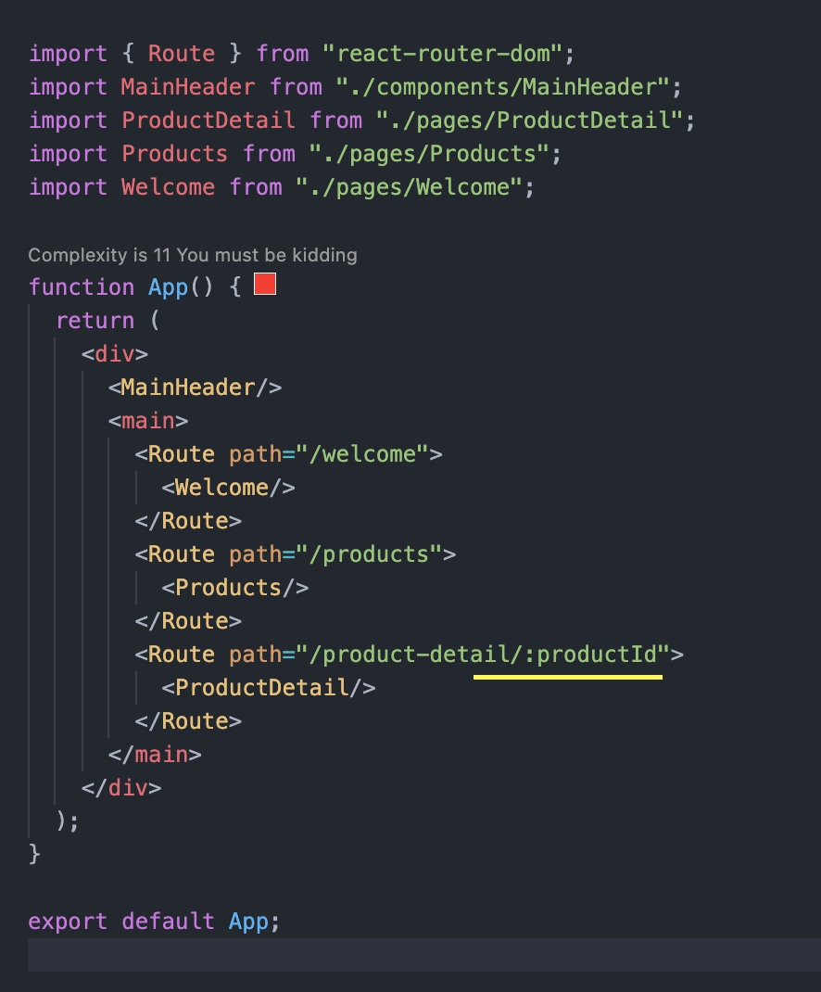

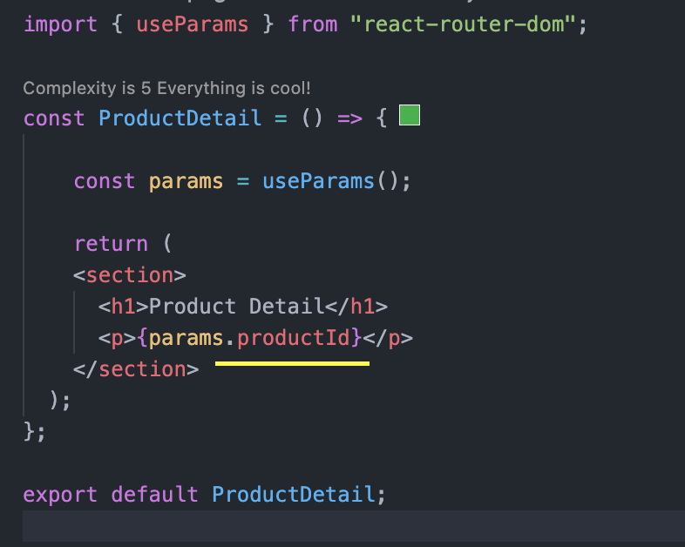

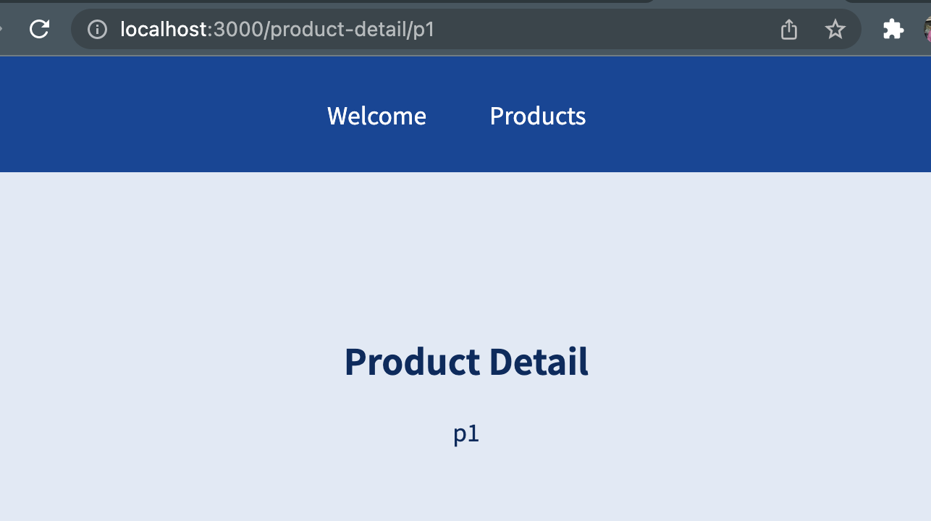

## Using “Switch” and “exact” for configuring routes

Switch considers the <Route> orders

Whichever <Route> matching first only that will be displayed.

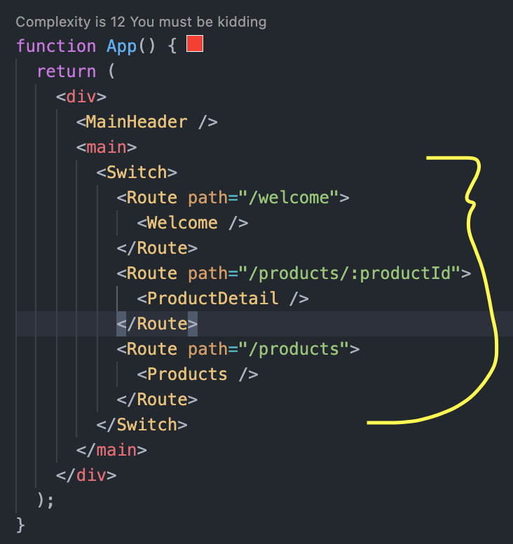

If we don’t want the <Switch> to consider the order, we can use “exact”.

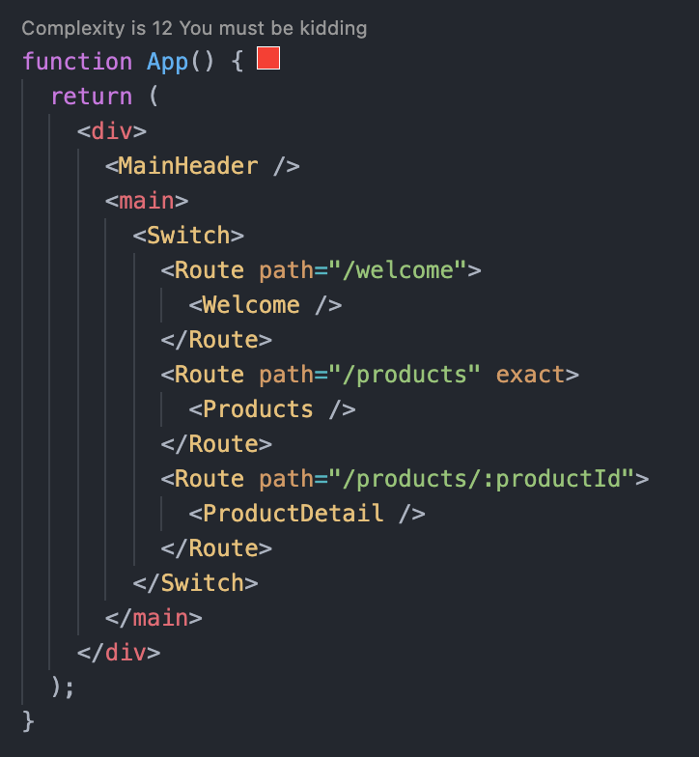

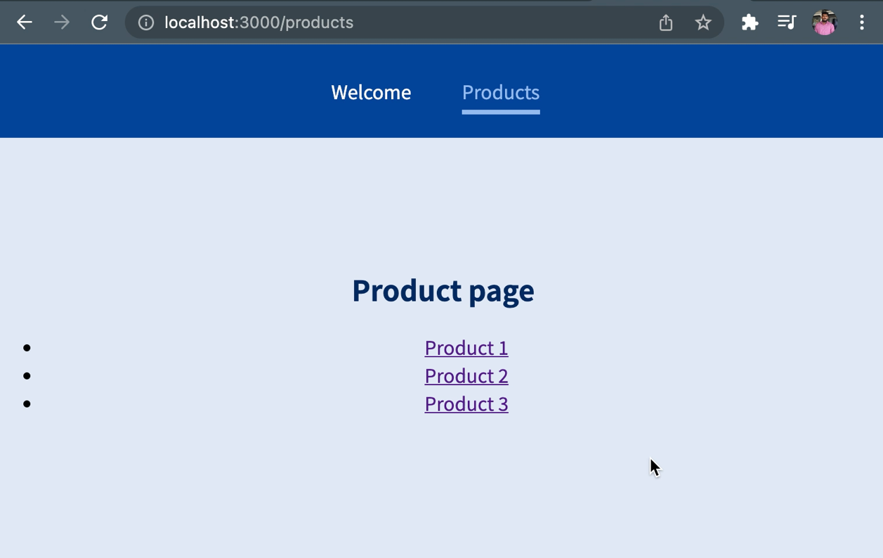

## Working with Nested Routes

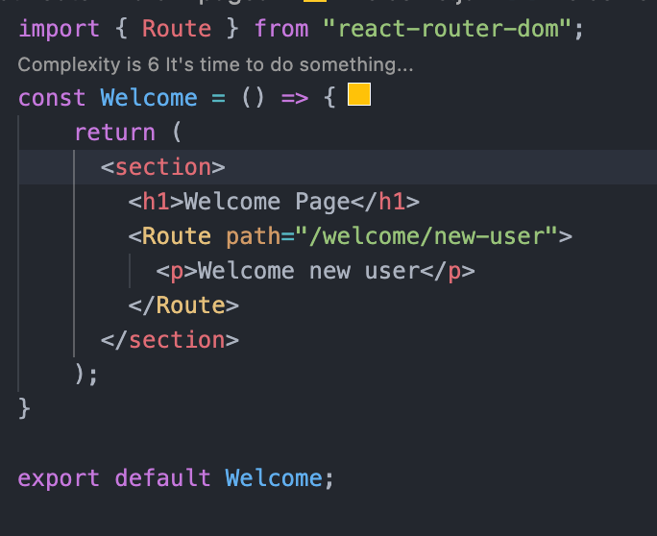

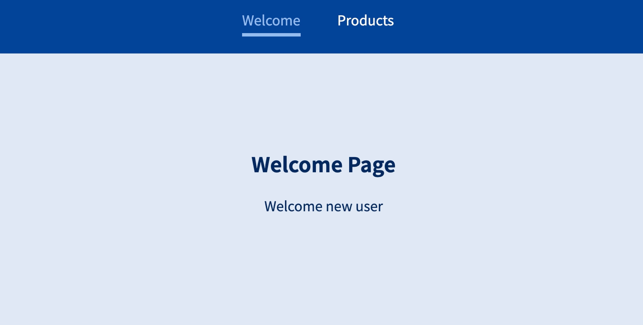

## Using Redirect

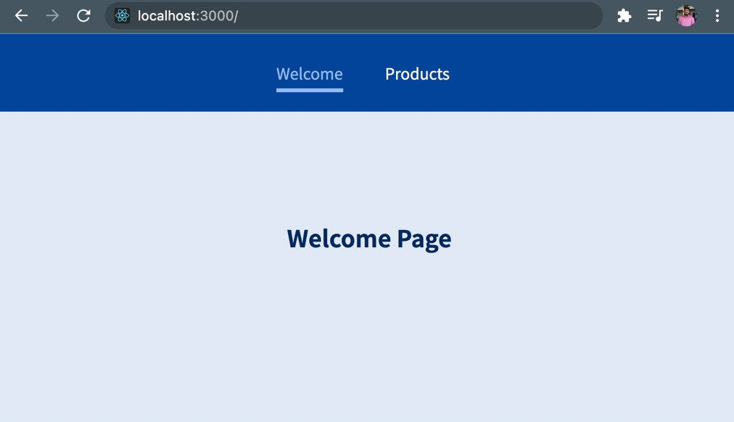

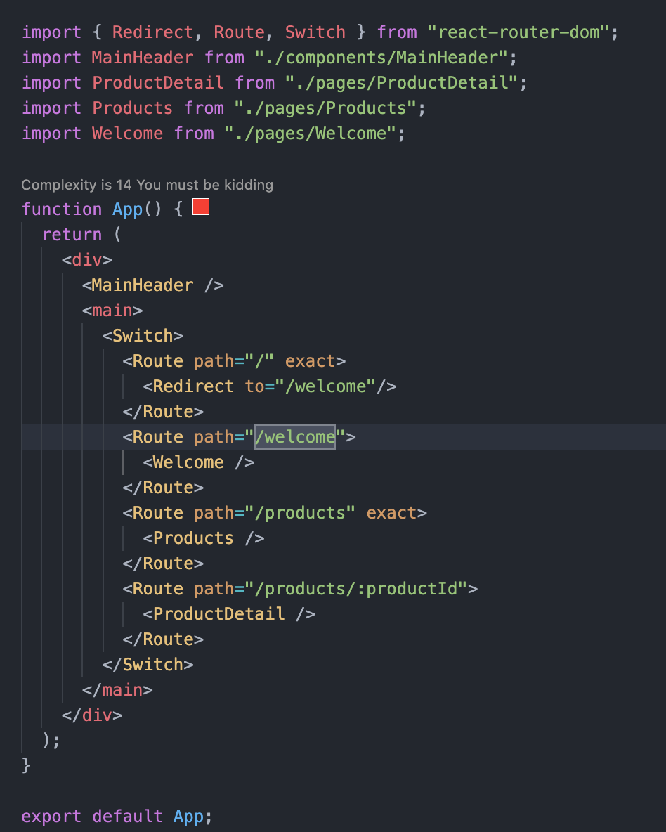

## Route for handling unknown URL paths

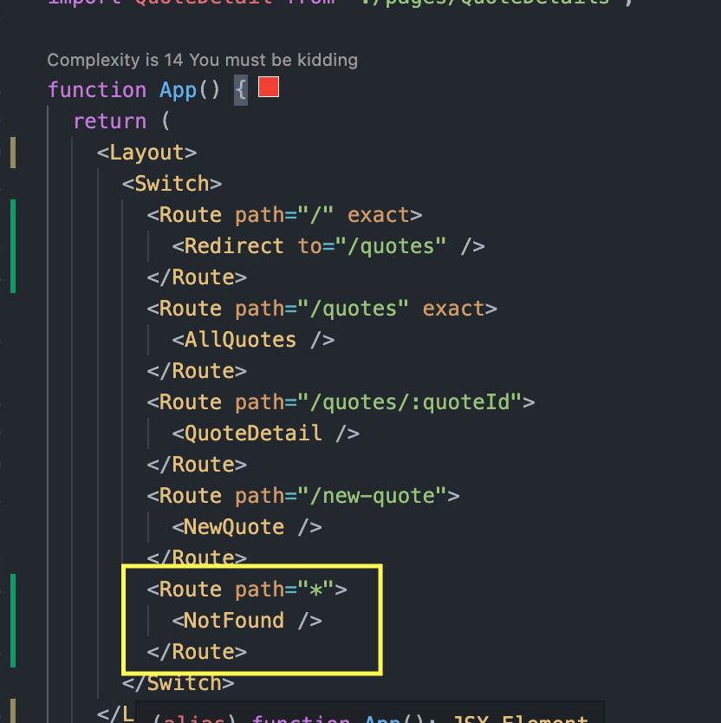

## Programmatic Navigation

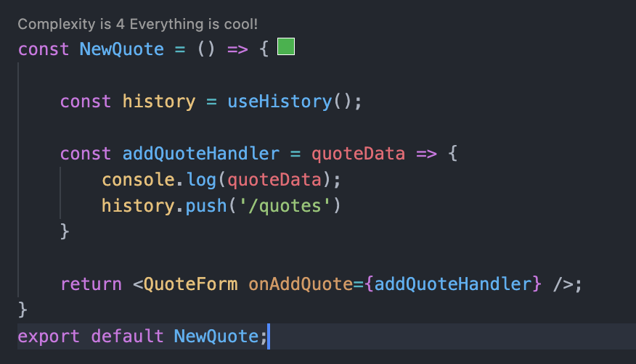

## Quote App Implementation So Far

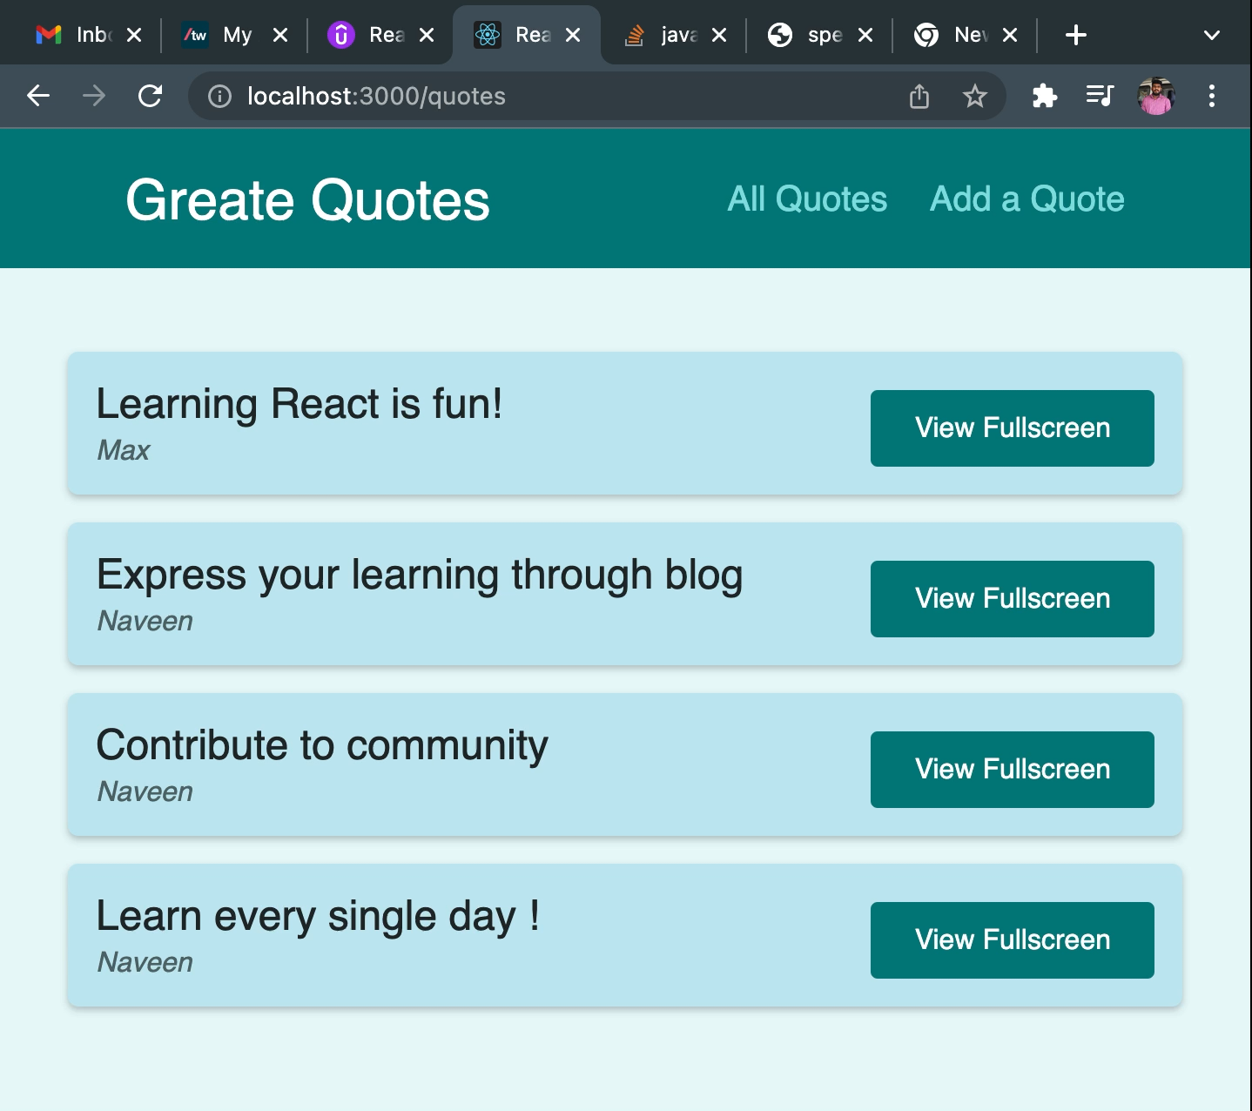

## Prompting User on Navigation

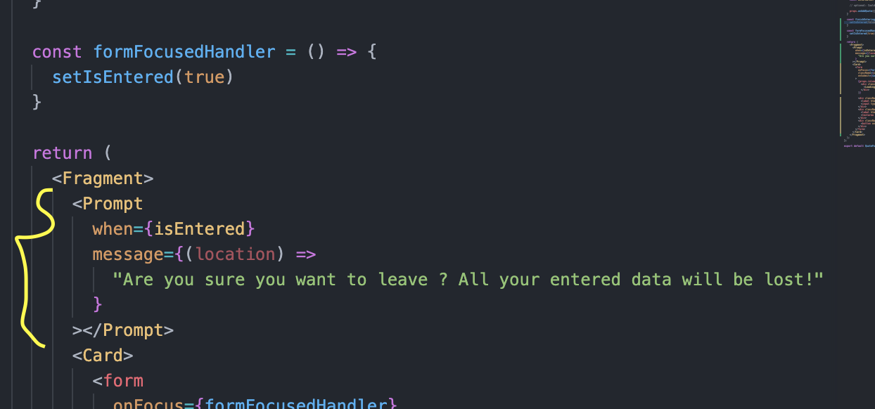

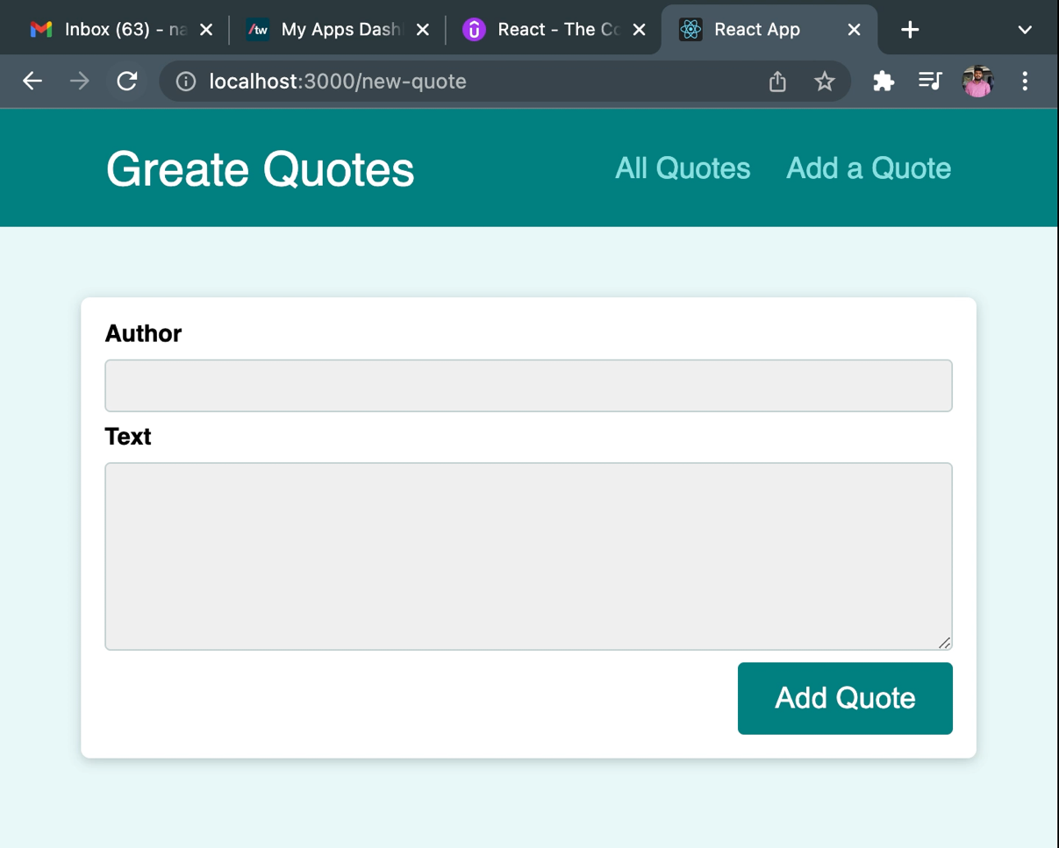

## Working with Query Parameters

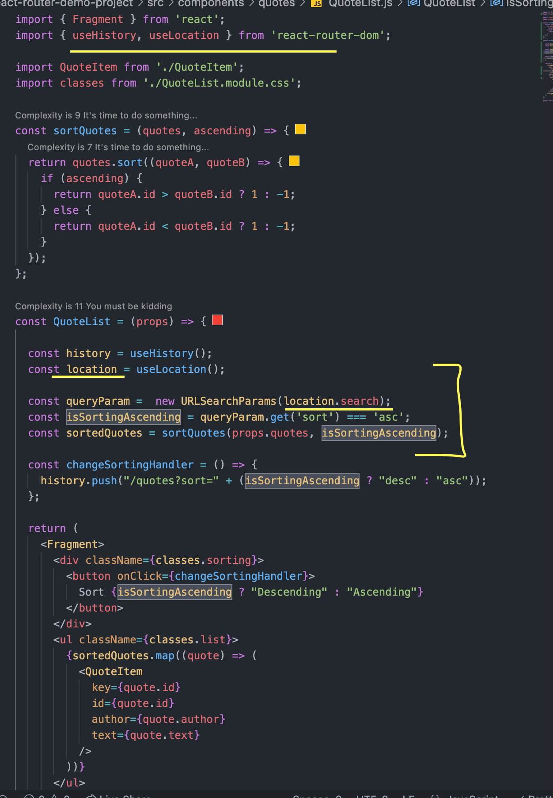

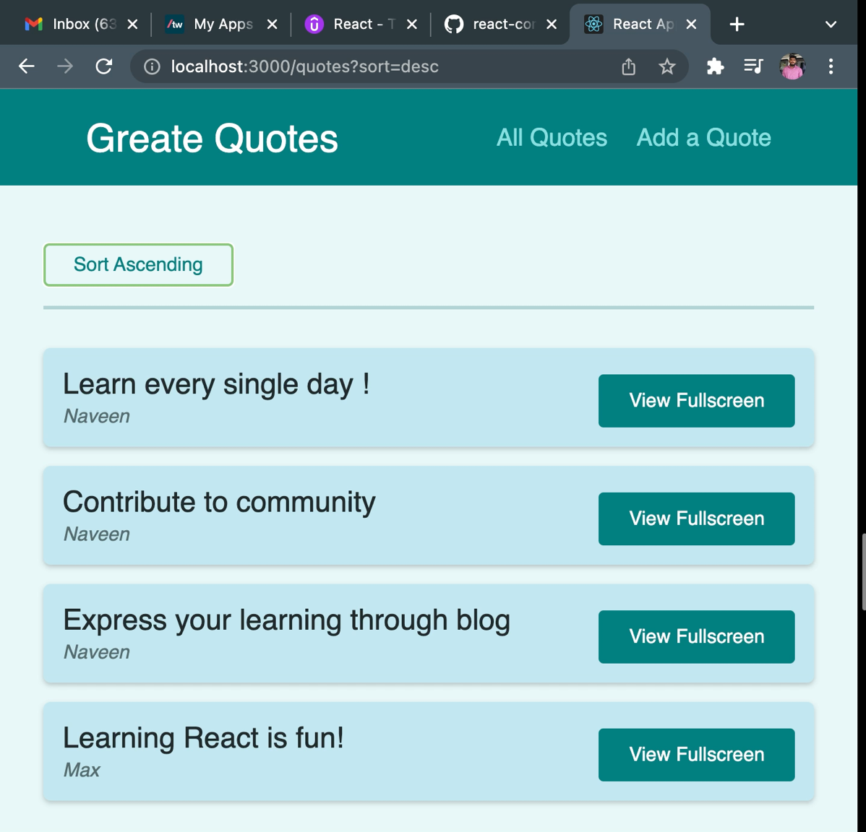

## Removing the component based on URL

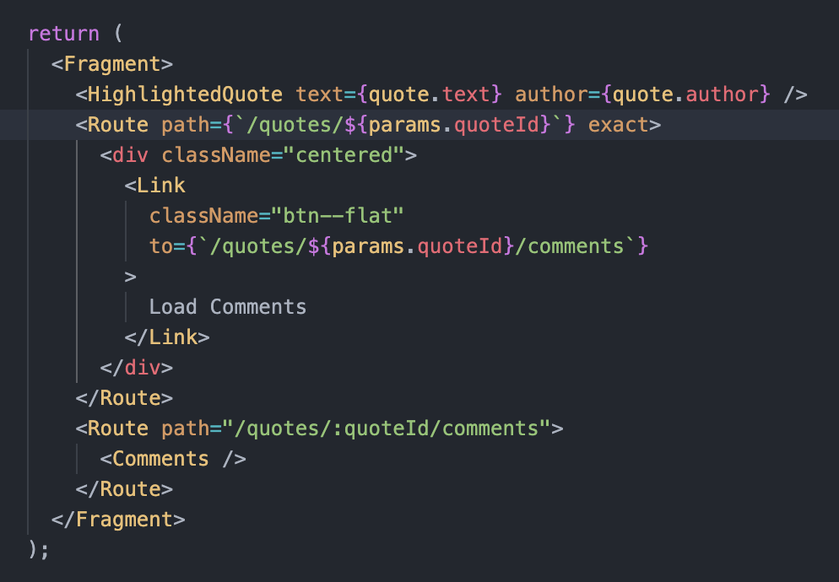

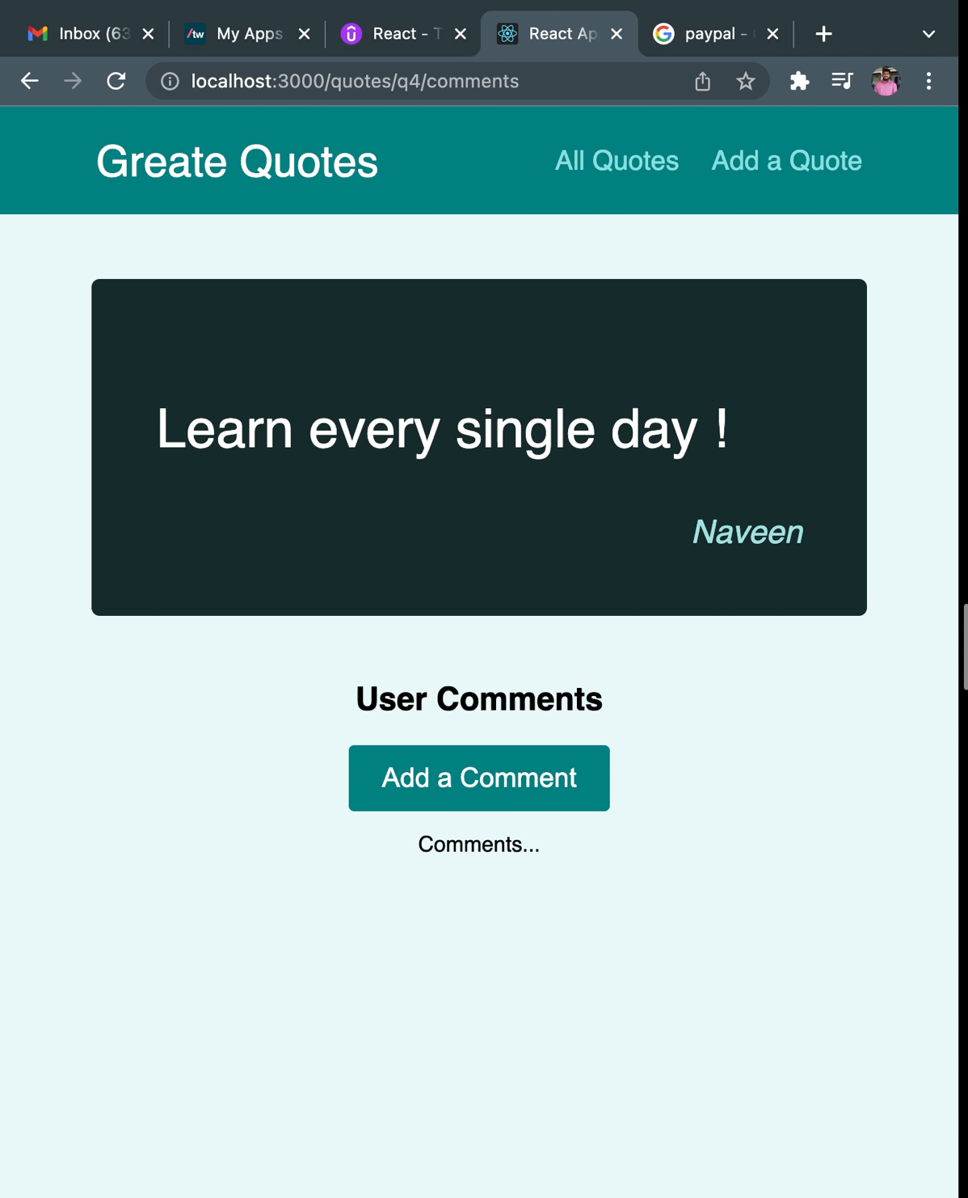

## Writing more flexible route code

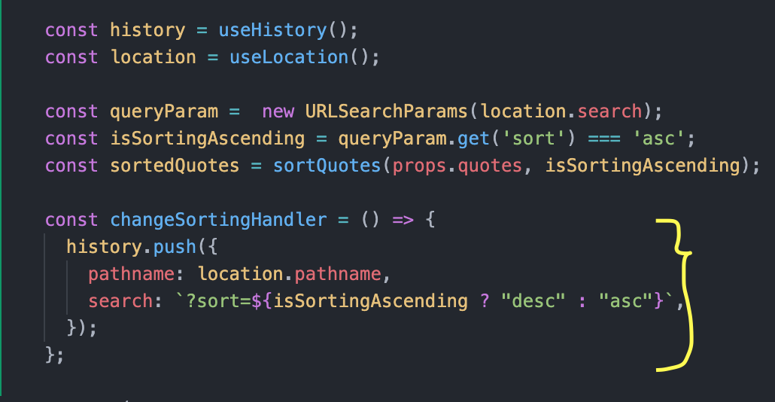

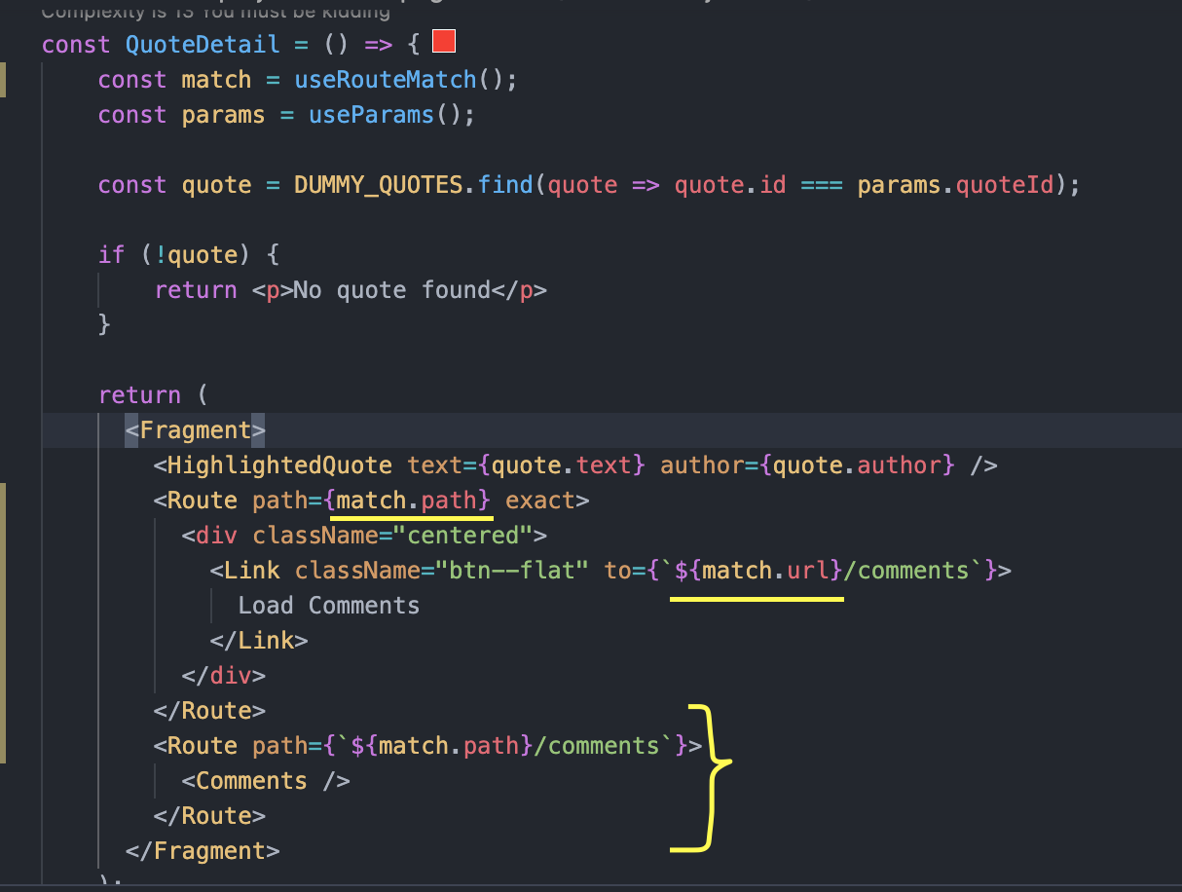

## React Router 6

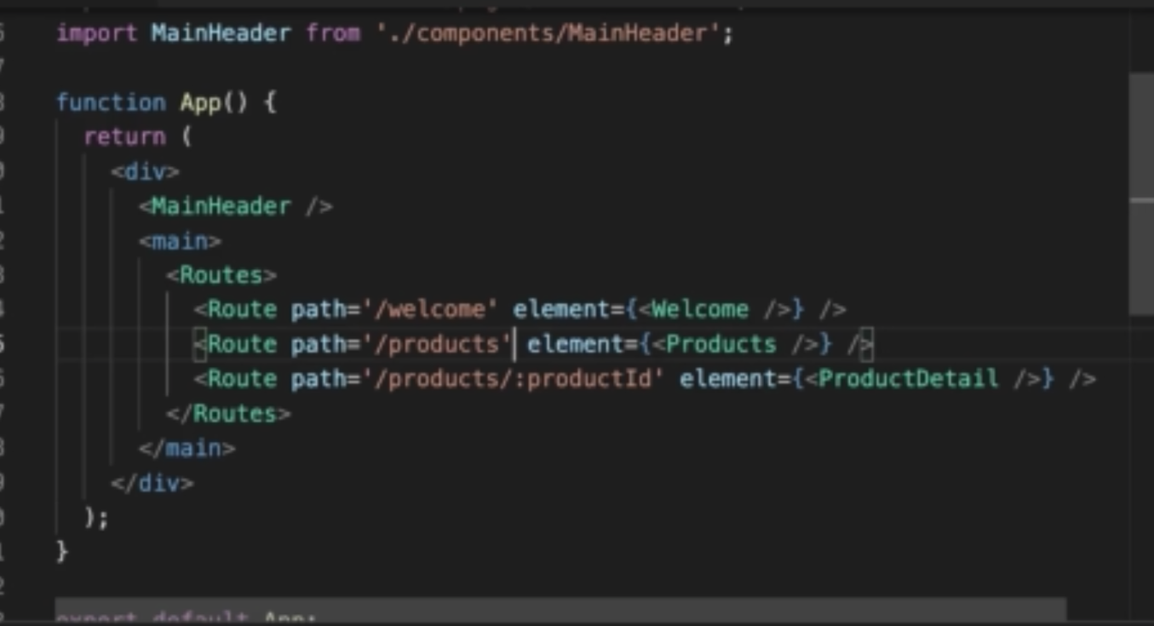

### Switch changed to Routes

### Exact has been removed

### element is introduced in Route tag.

### Order of the Routes does not matter

NavLink activeClassName has been removed, the alternate is given below,

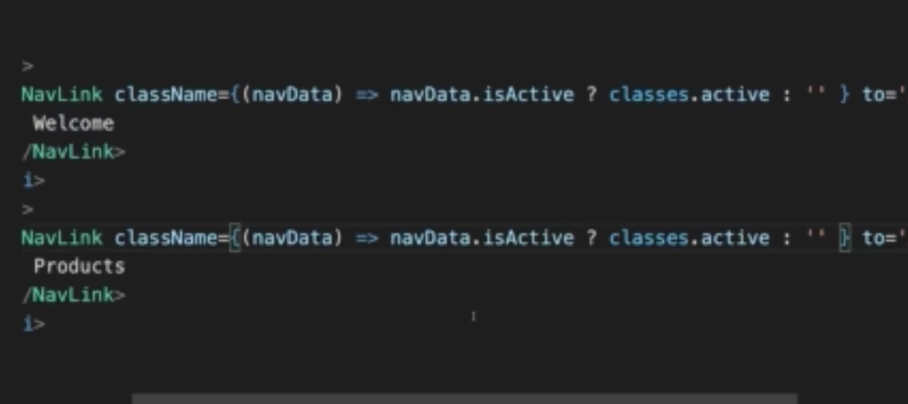

Redirect changed to Navigate, Pls refer below,

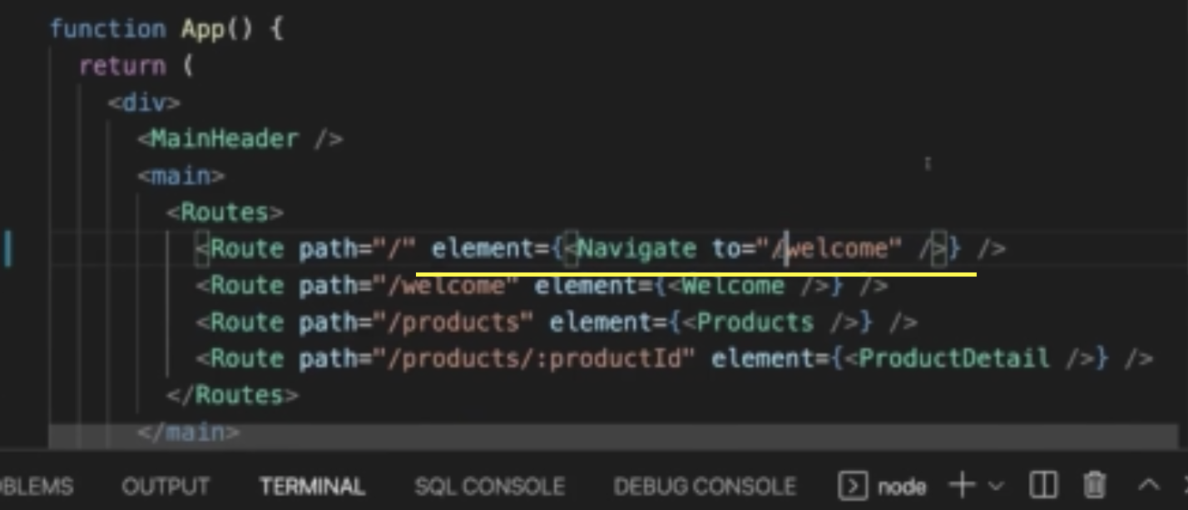

We can add “replace” prop along with “to” prop. It will replace the component while navigating.

In version 6, Route tag is mandatory to enclosed with Routes.

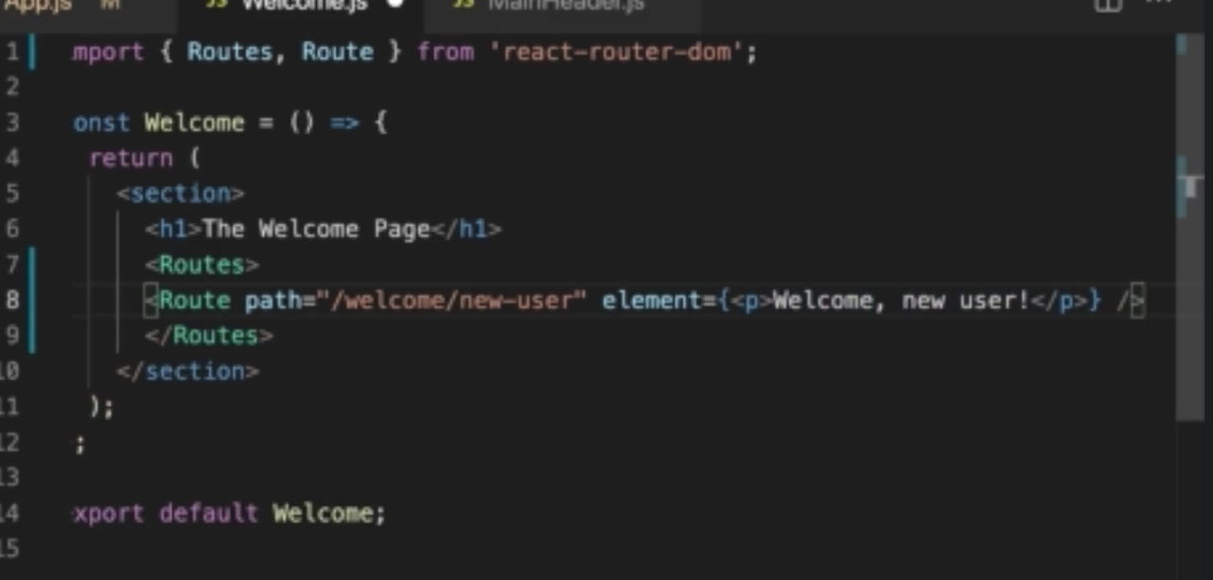

While adding the nested routes, no need to specify the parent path. It is a relative path.

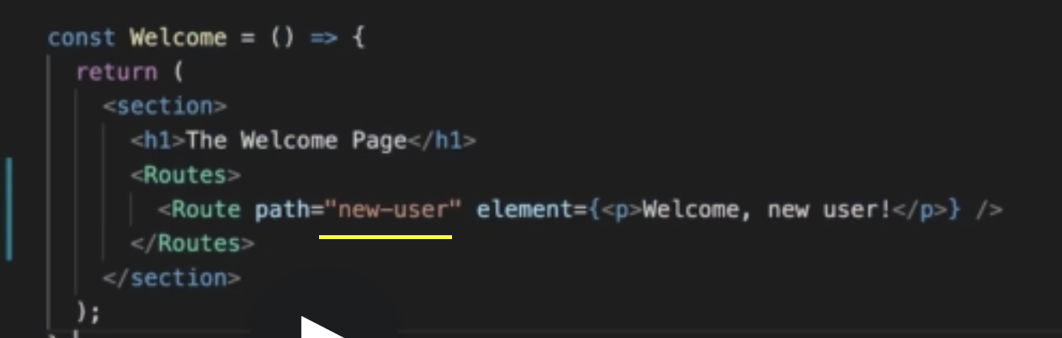

### Alternate way specifying the alternate route

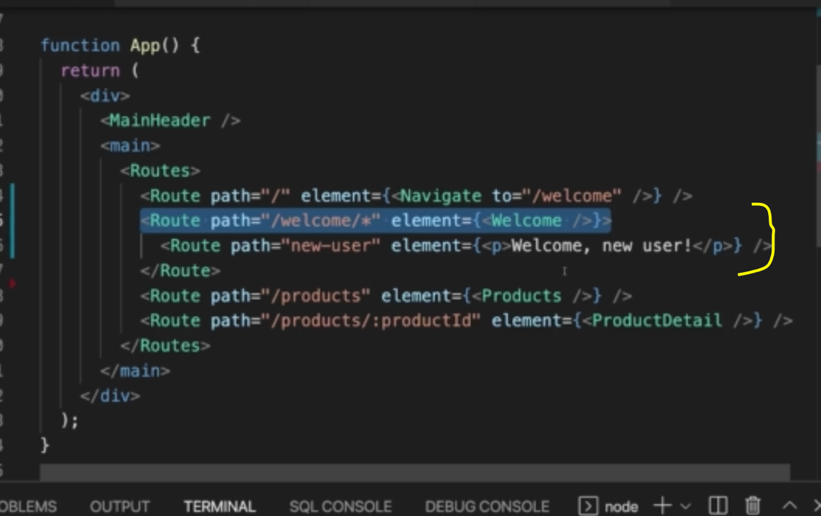

Using Outlet as placeholder for nested Route element

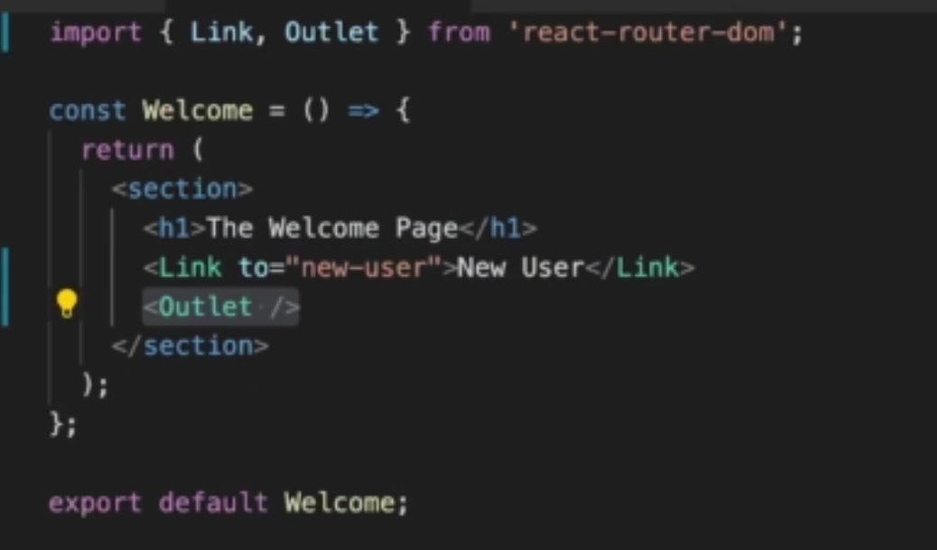

### useHistory changed to useNavigate

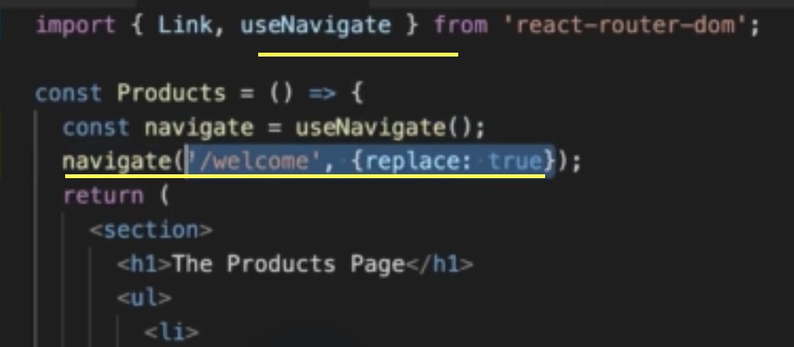

We can specify number for navigate back and forth.

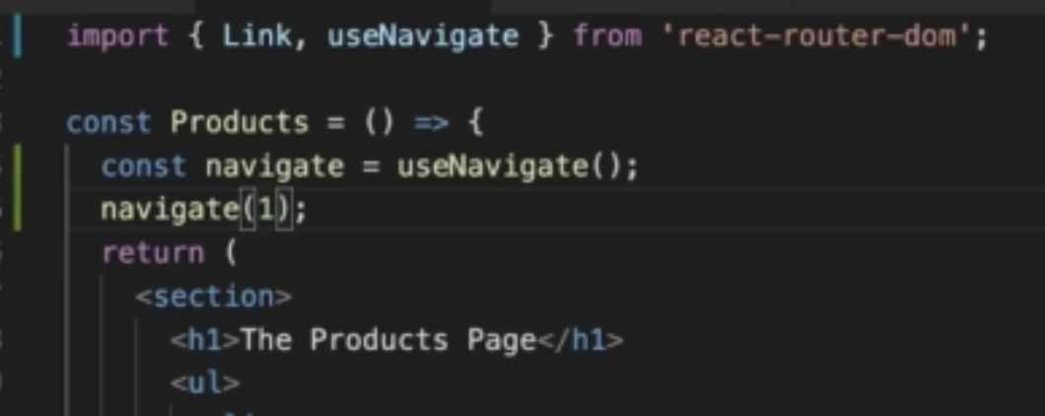

### Promt is removed.

# Deploying React App

## Deployment Step

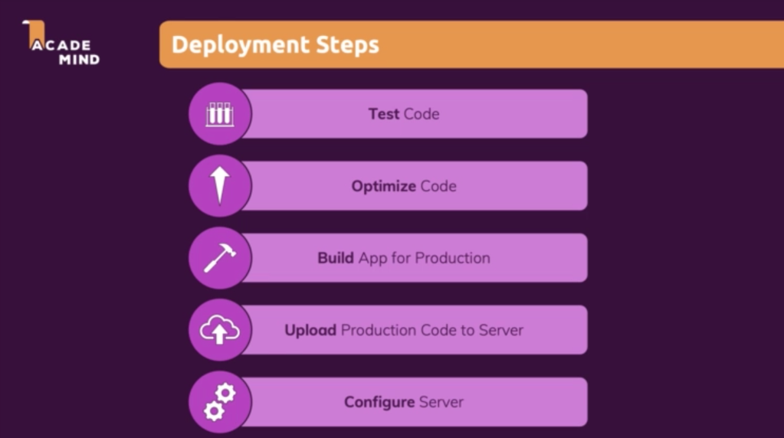

## Deployment Optimization



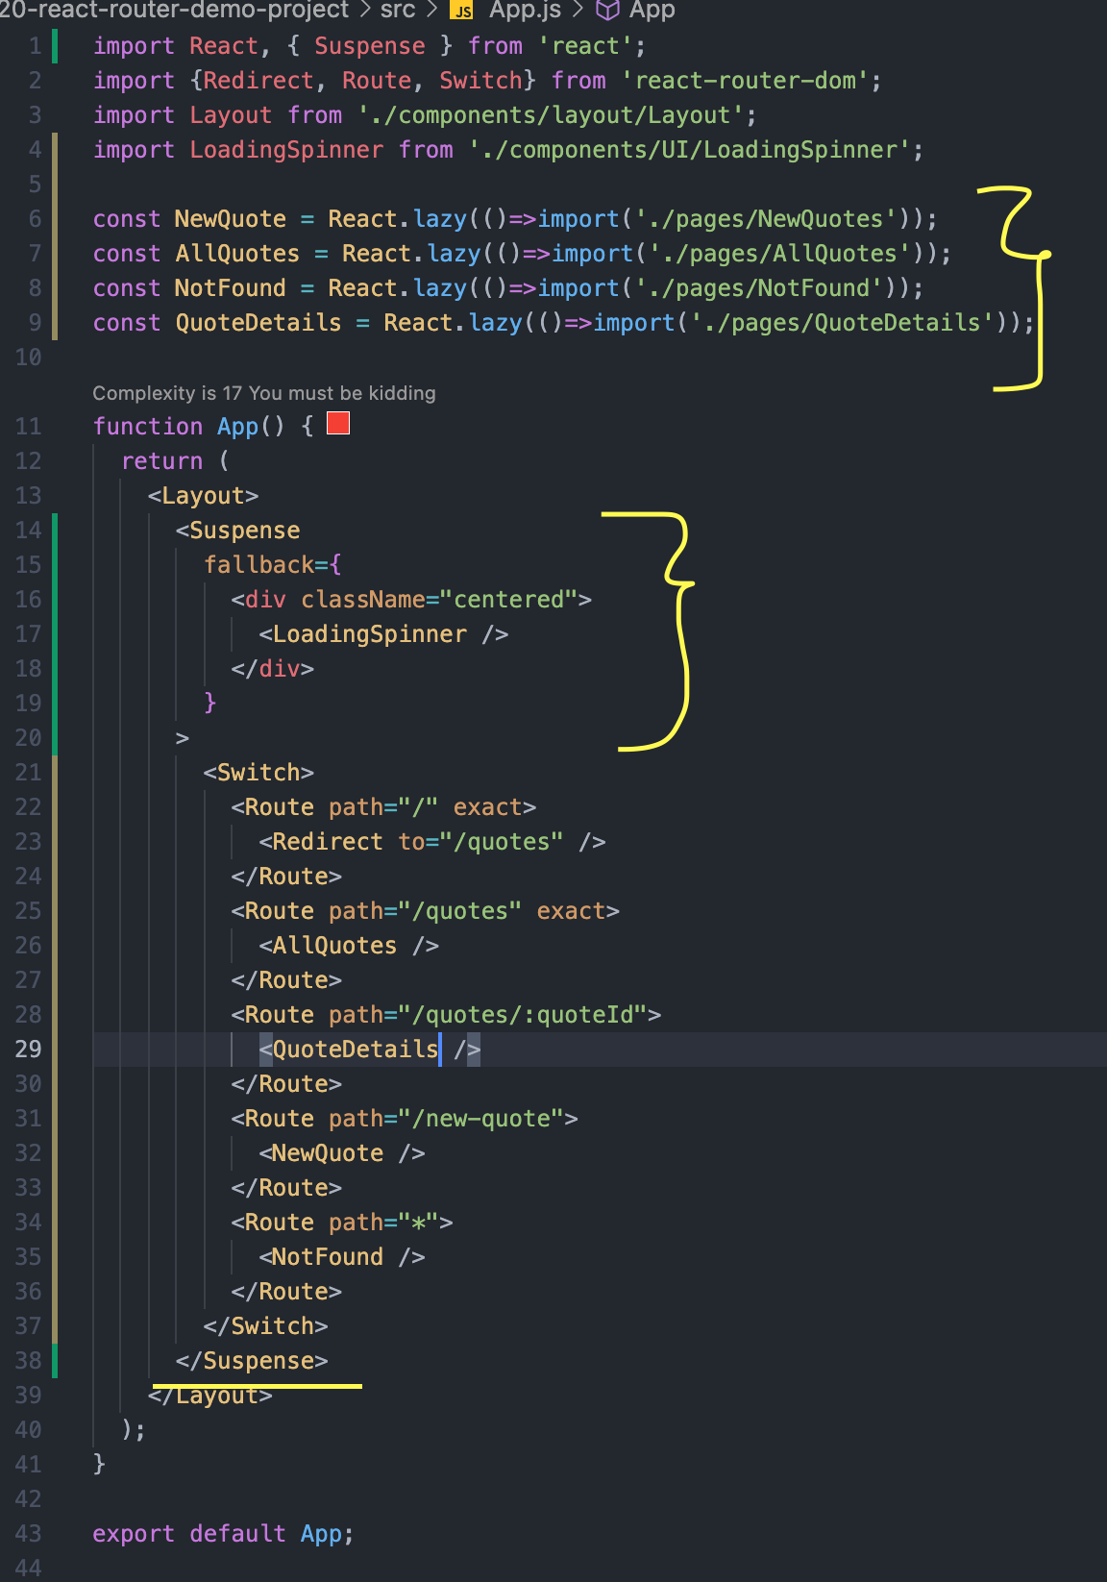

## Building the code for production

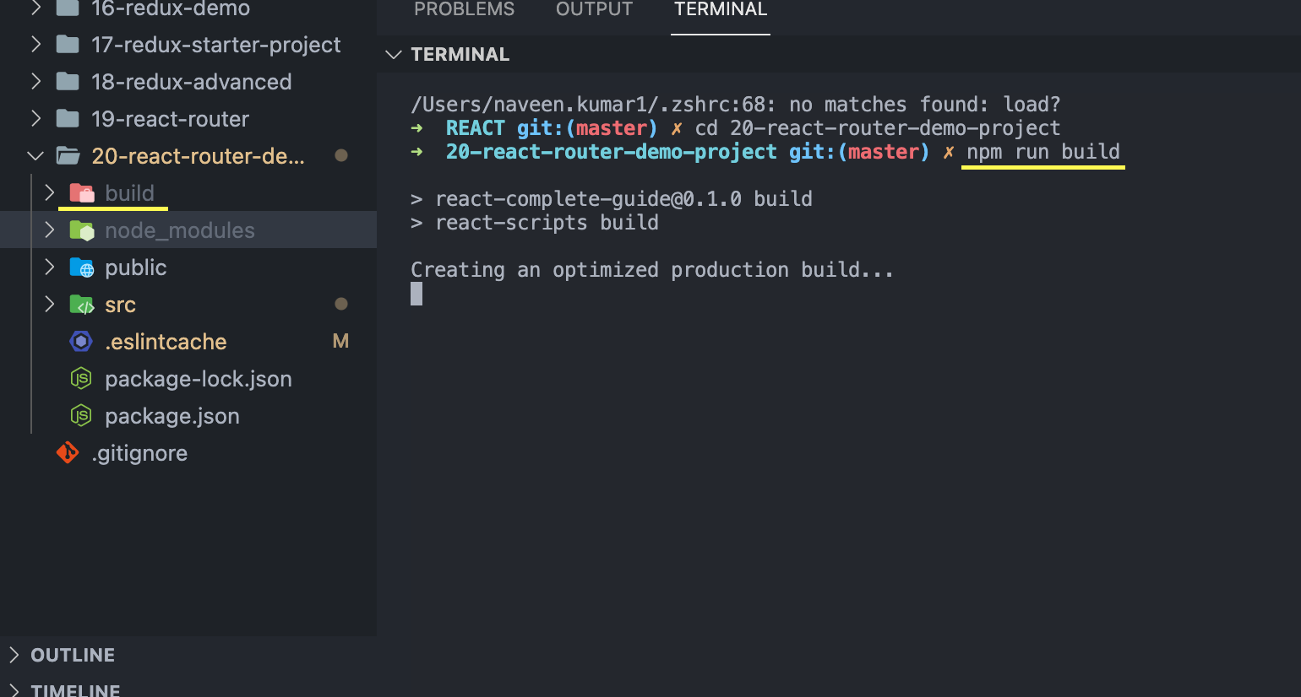

## Upload Production Code to Server



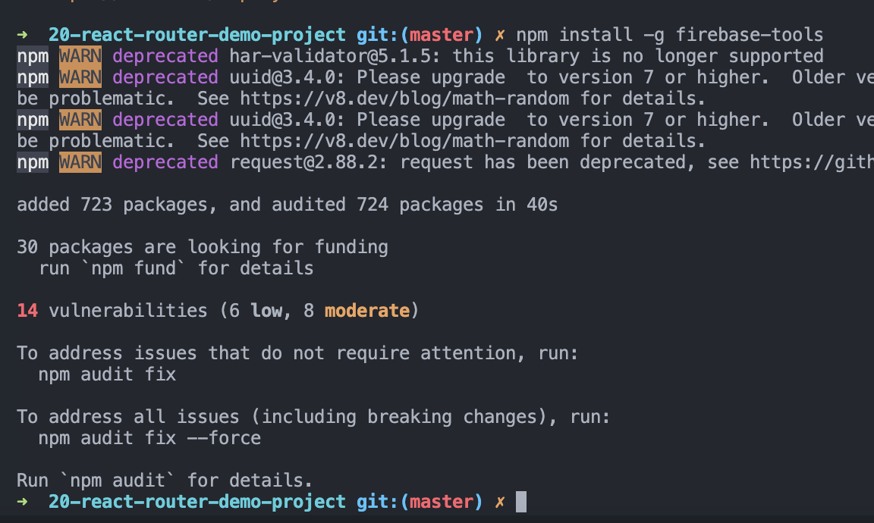

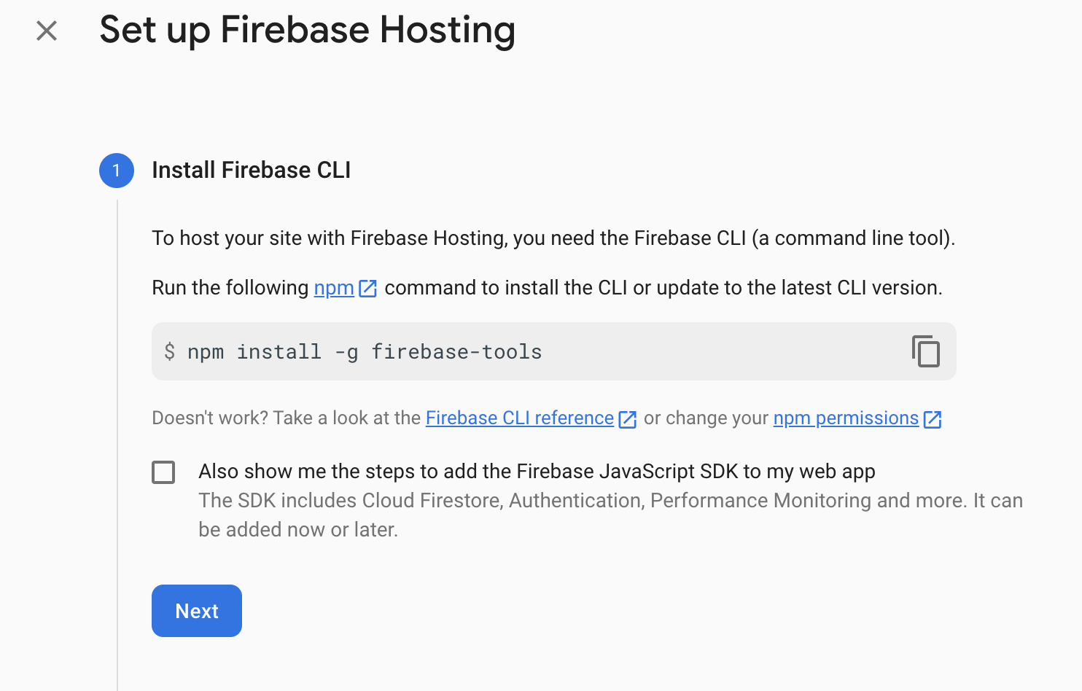

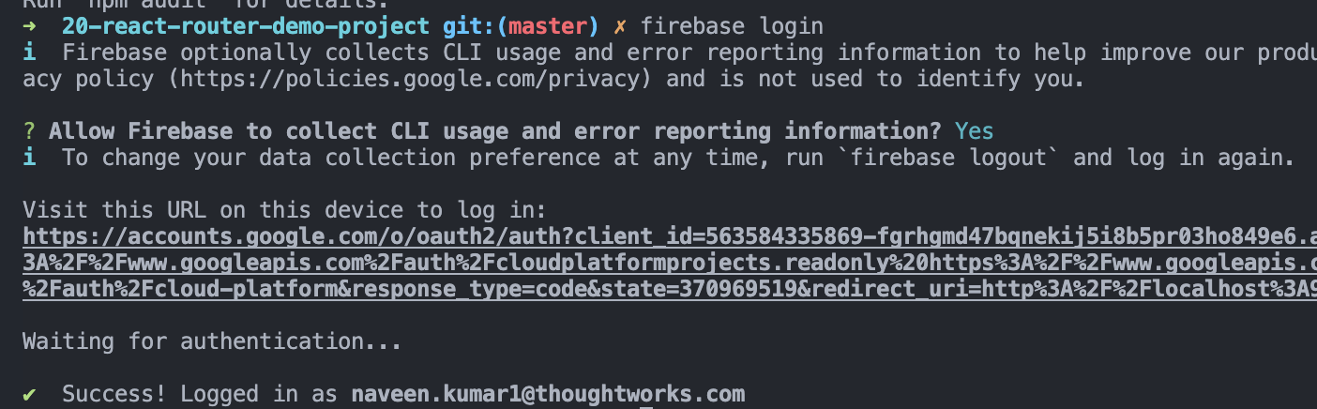

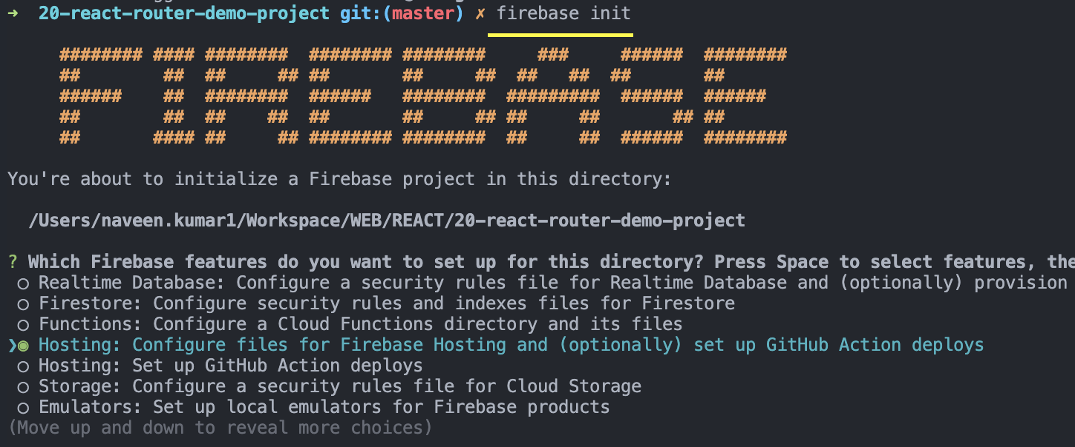

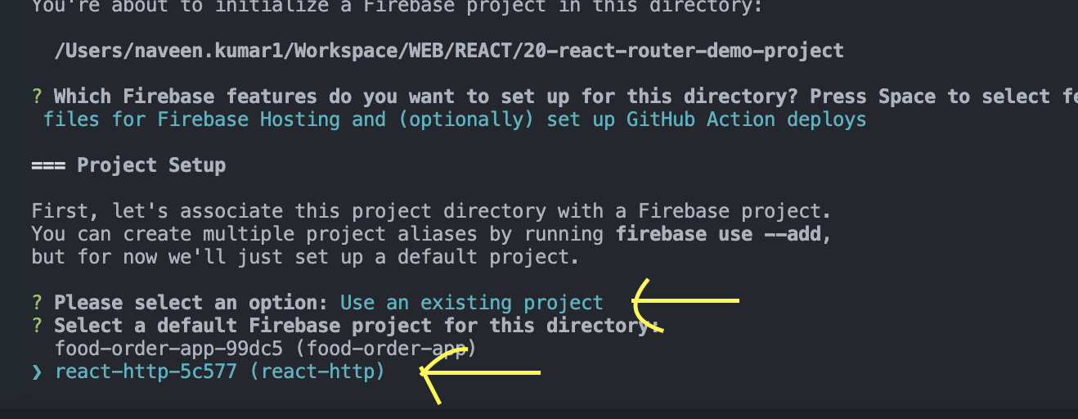

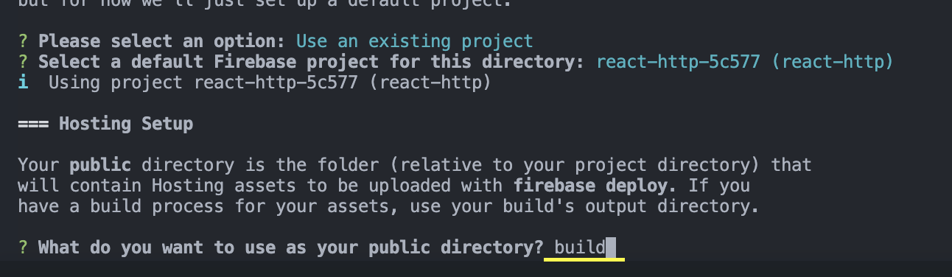

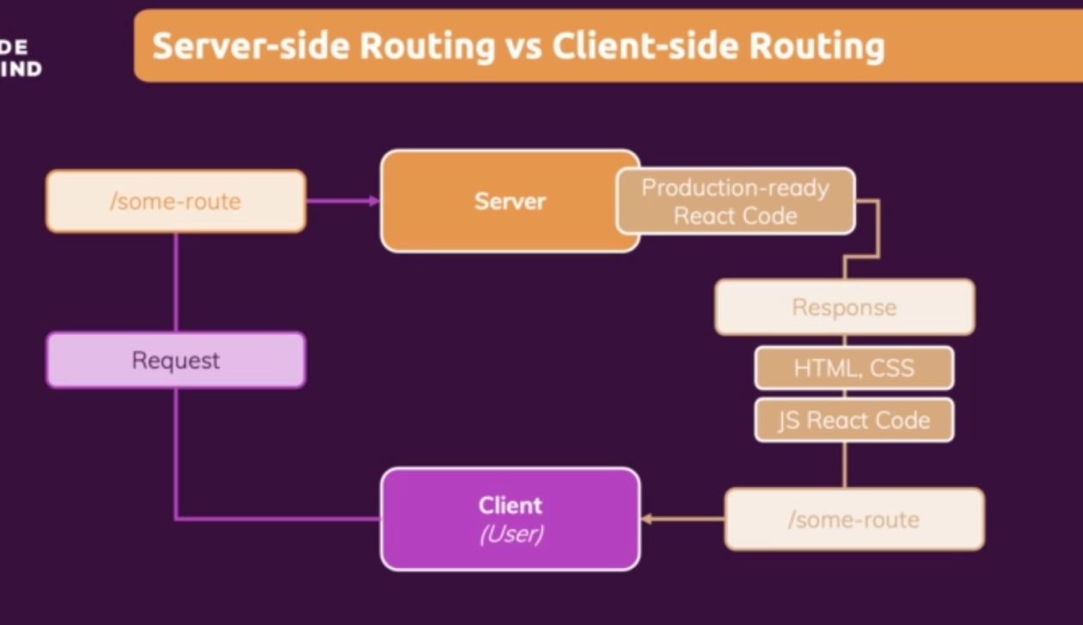

Since we are having a single page application, we need to configure the server accordingly, otherwise server will consider the new url as separate request.

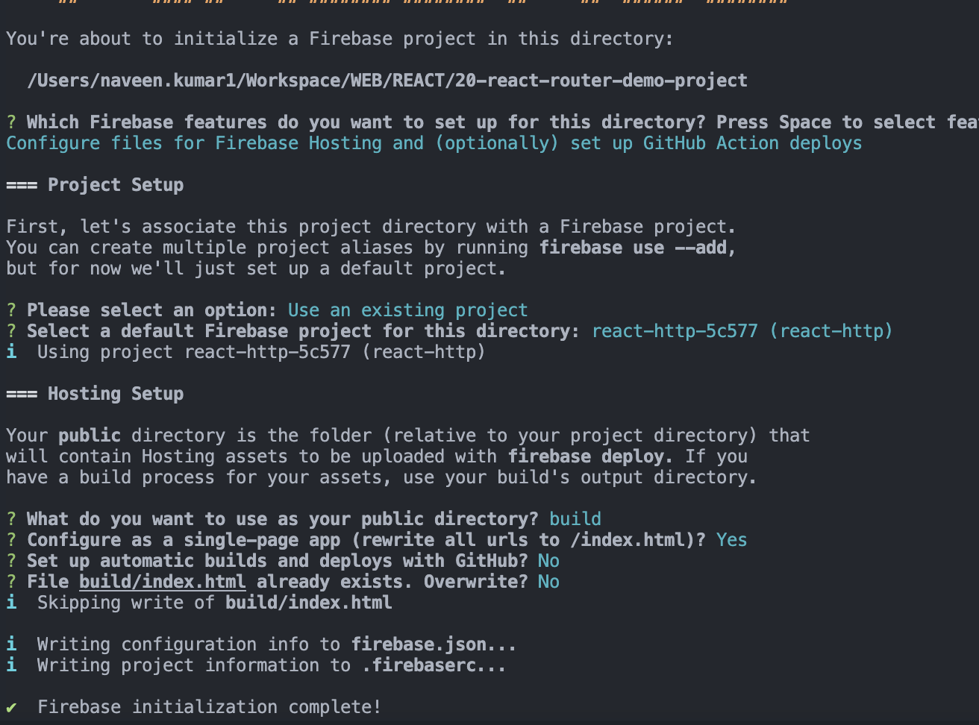

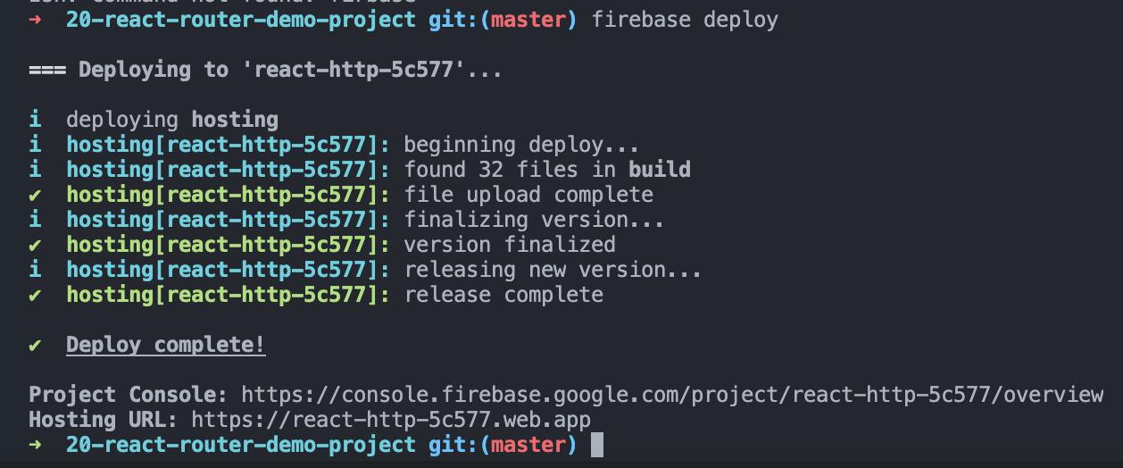

# Adding Authentication to React App

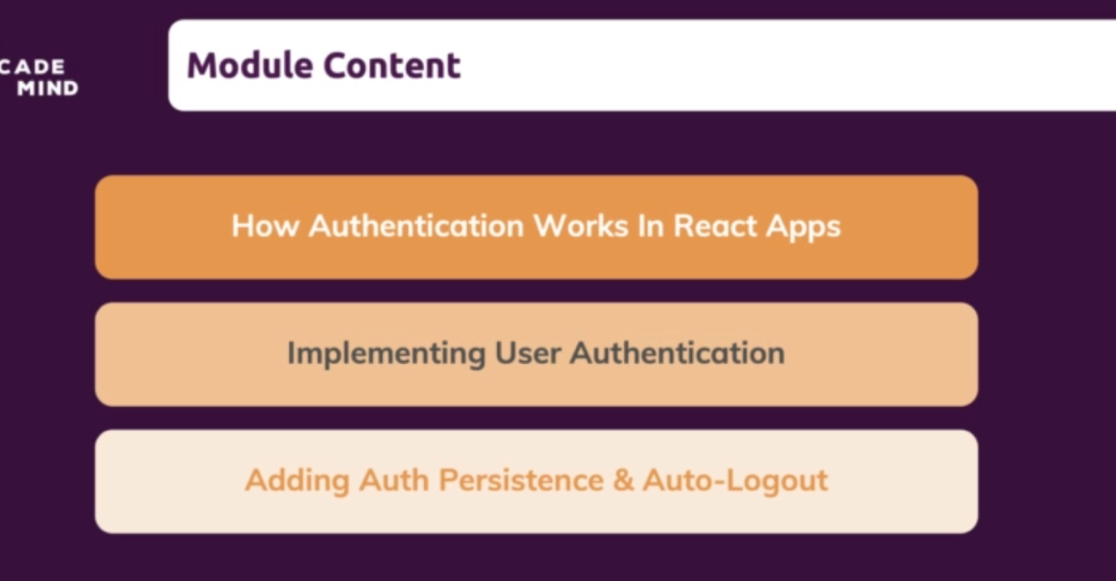

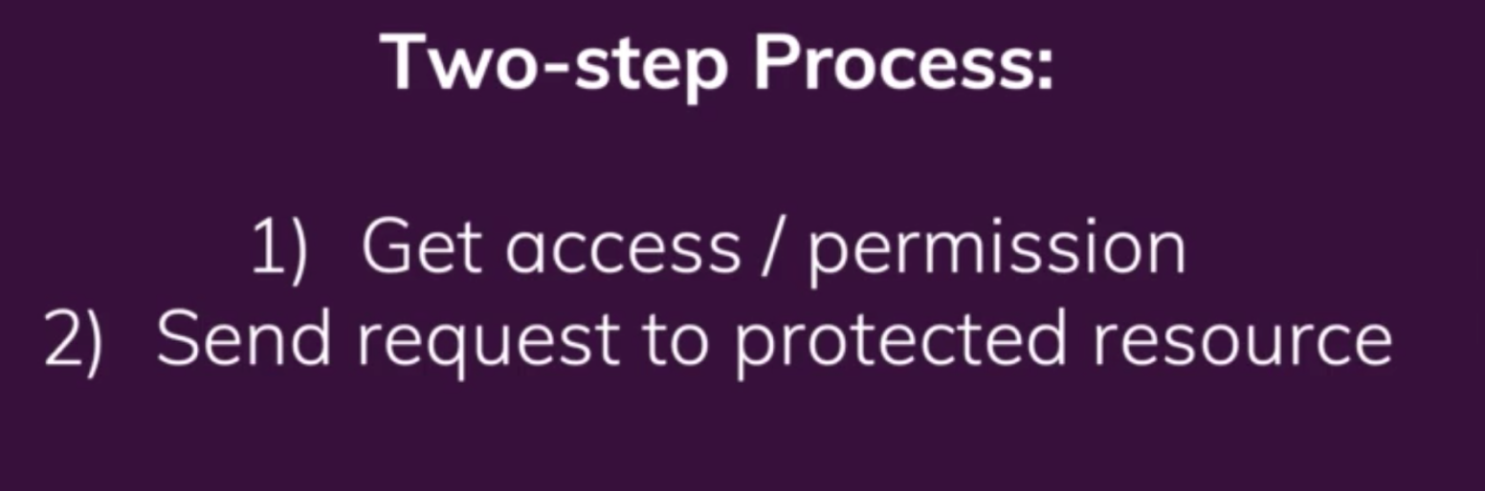

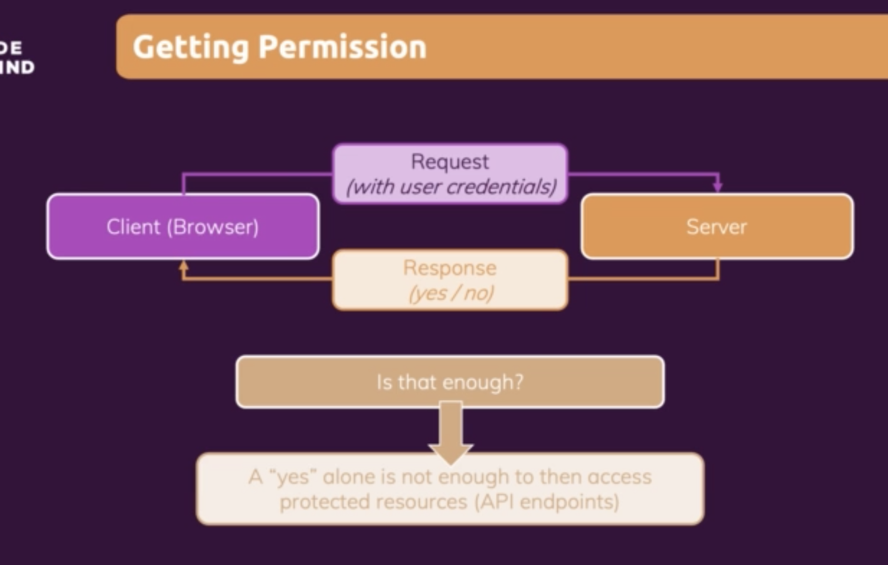

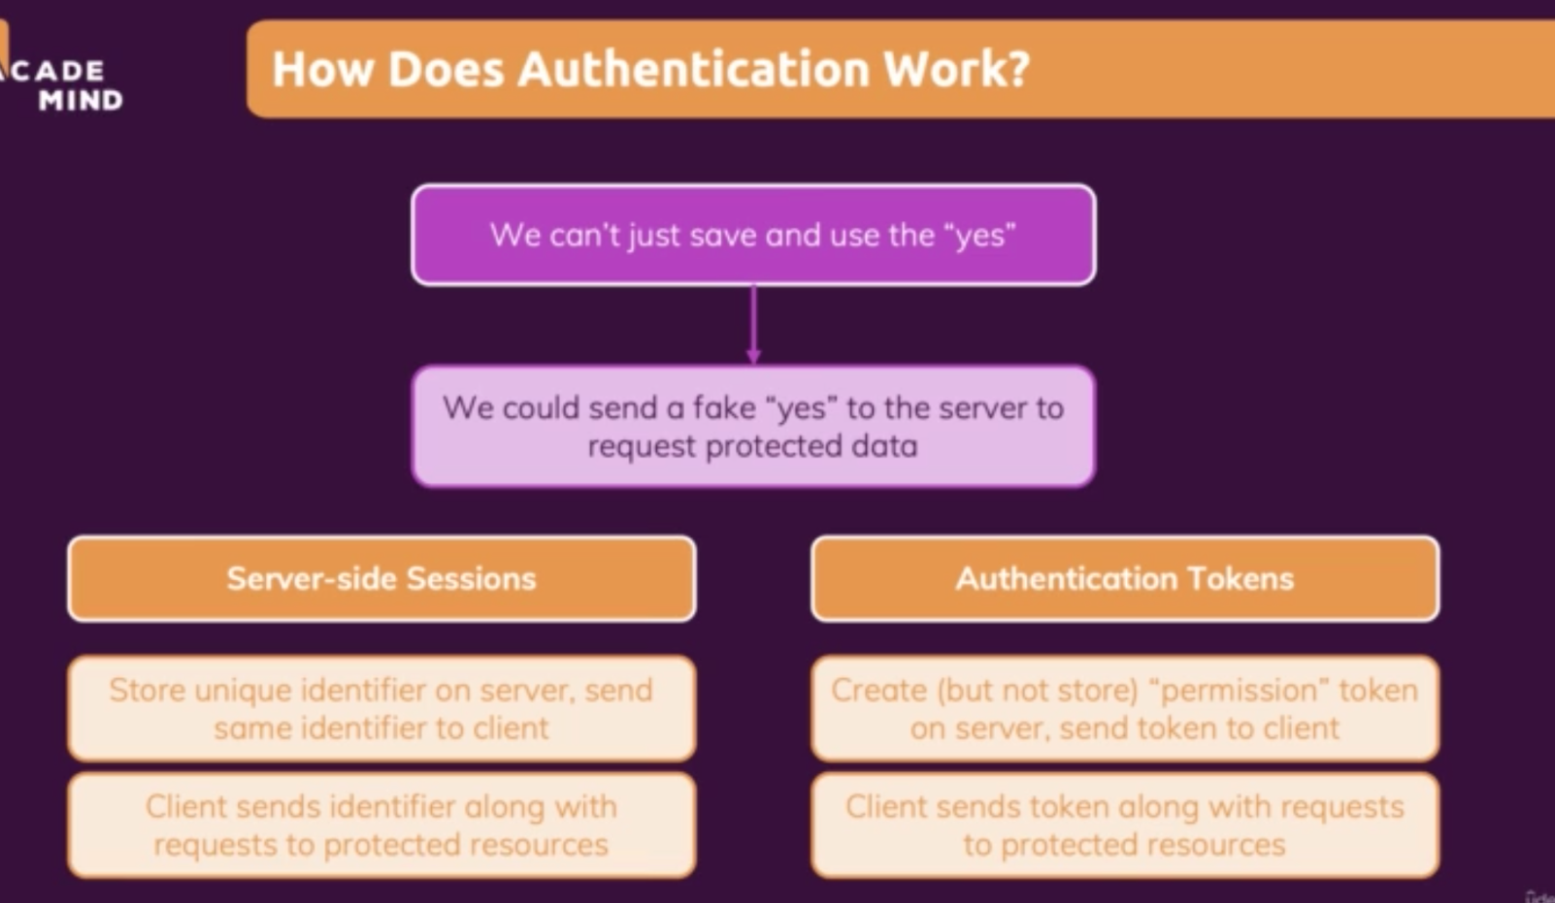

## Adding User Signup

<https://console.firebase.google.com/project/react-http-5c577/authentication/providers>

Choosing an authentication from firebase project.

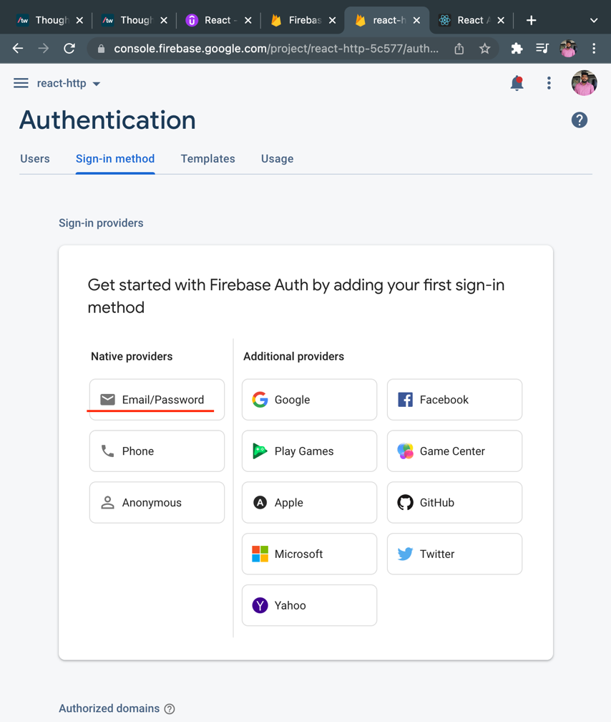

Saving the authentication type.

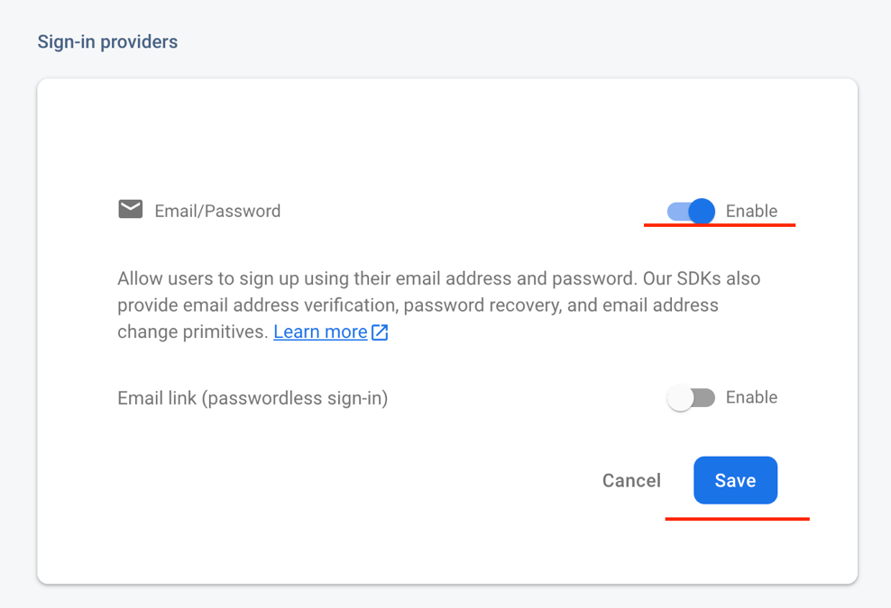

Sign-in provider.



Firebase Auth Rest API

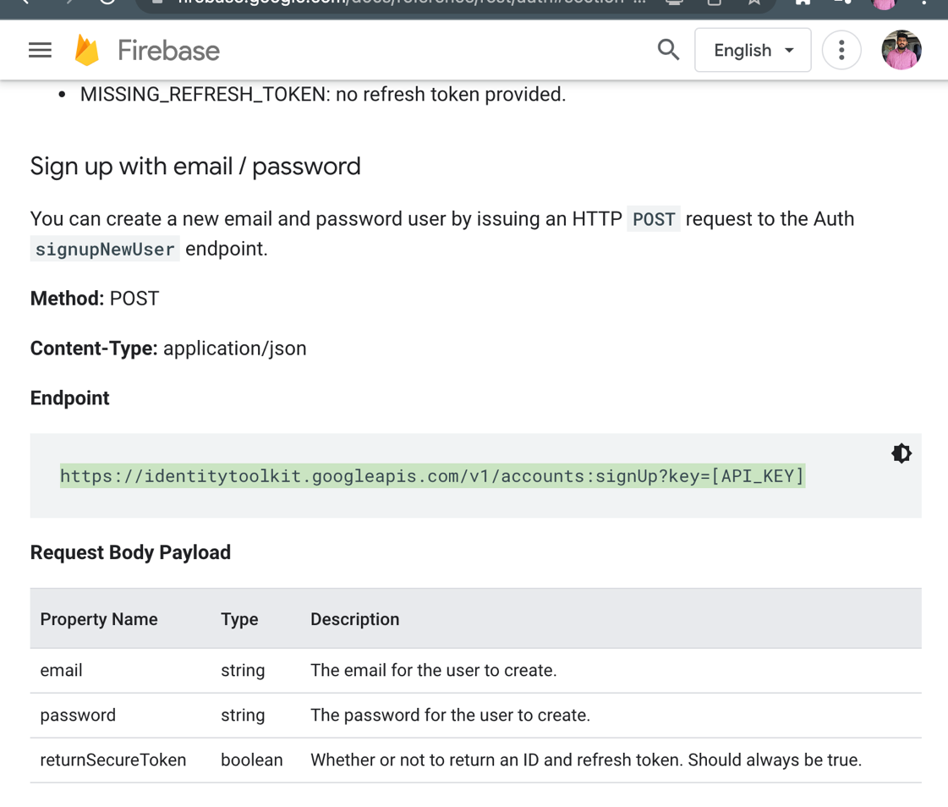

Web API Key from firebase project setting for sign up

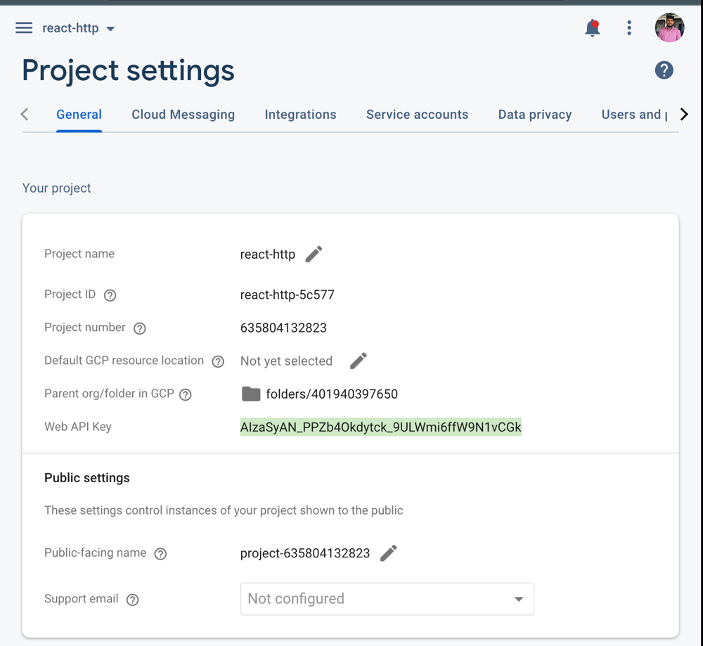

Sending a request to firebase on submitting the form, as we can see we are using the web api key we copied from firebase project setting.

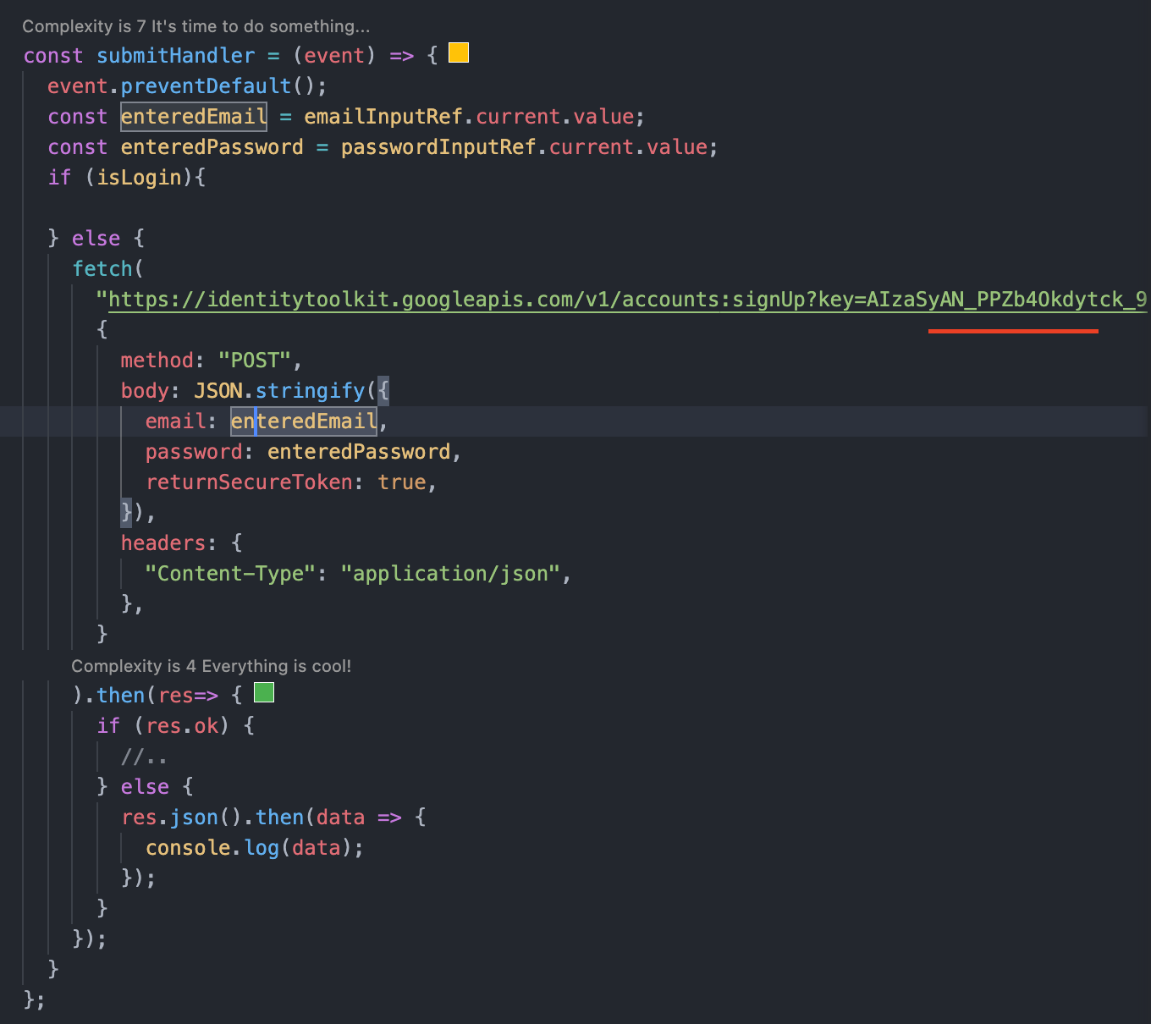

## Adding User Sign In

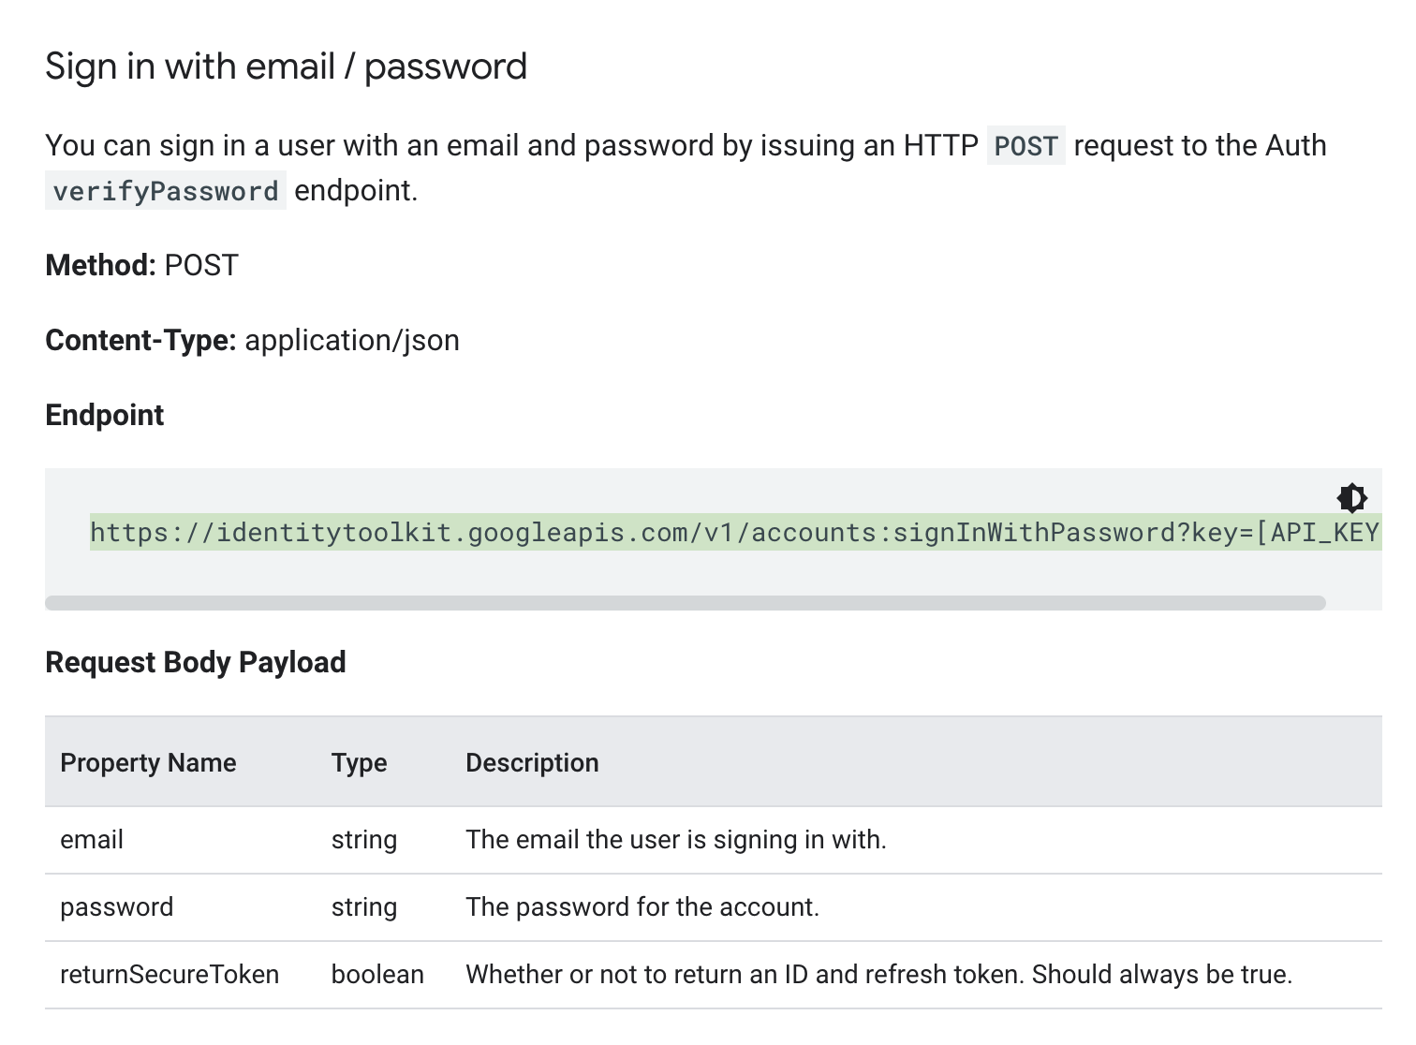

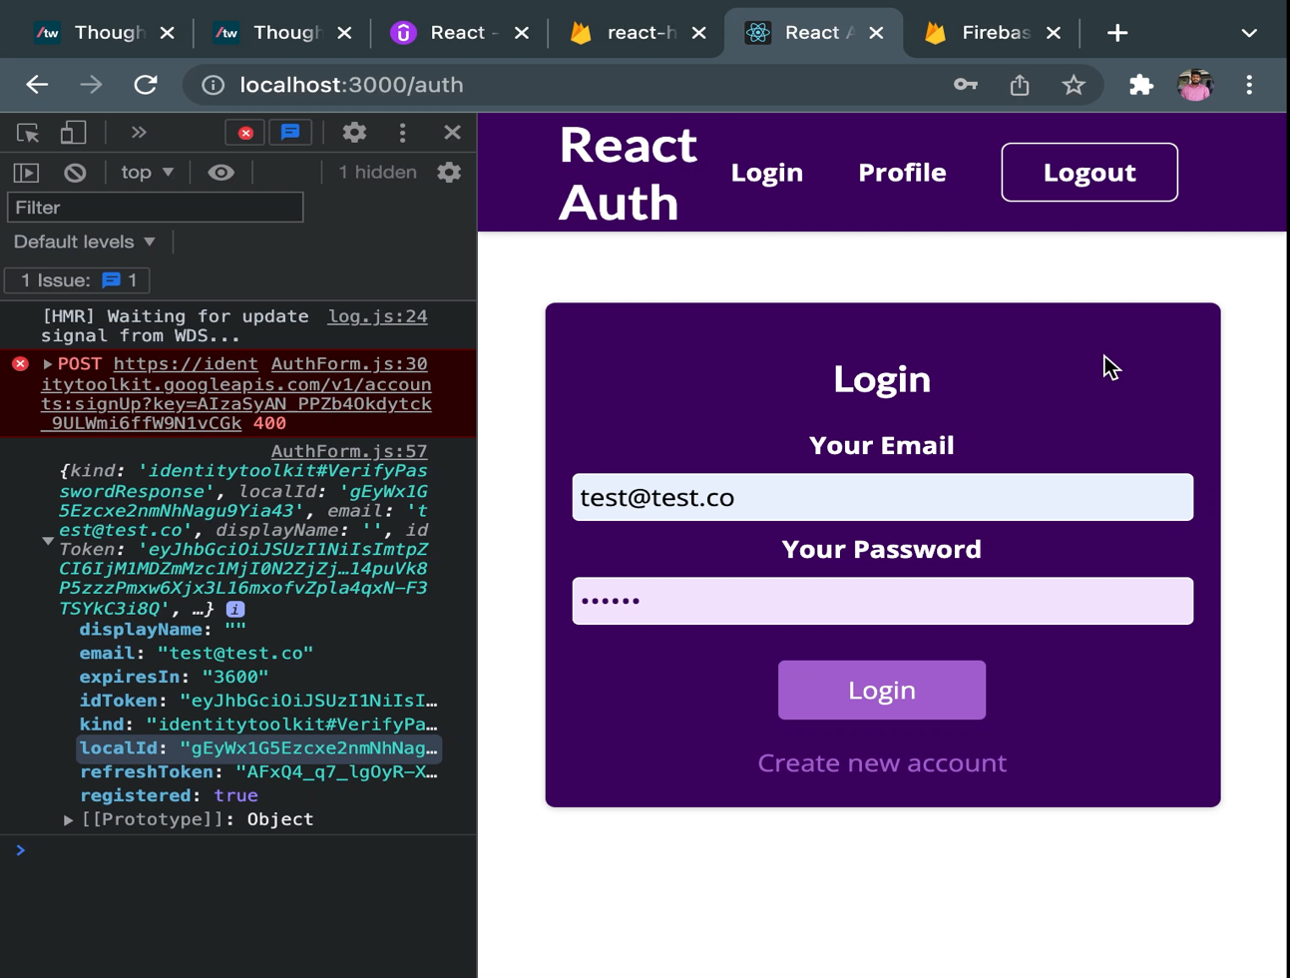

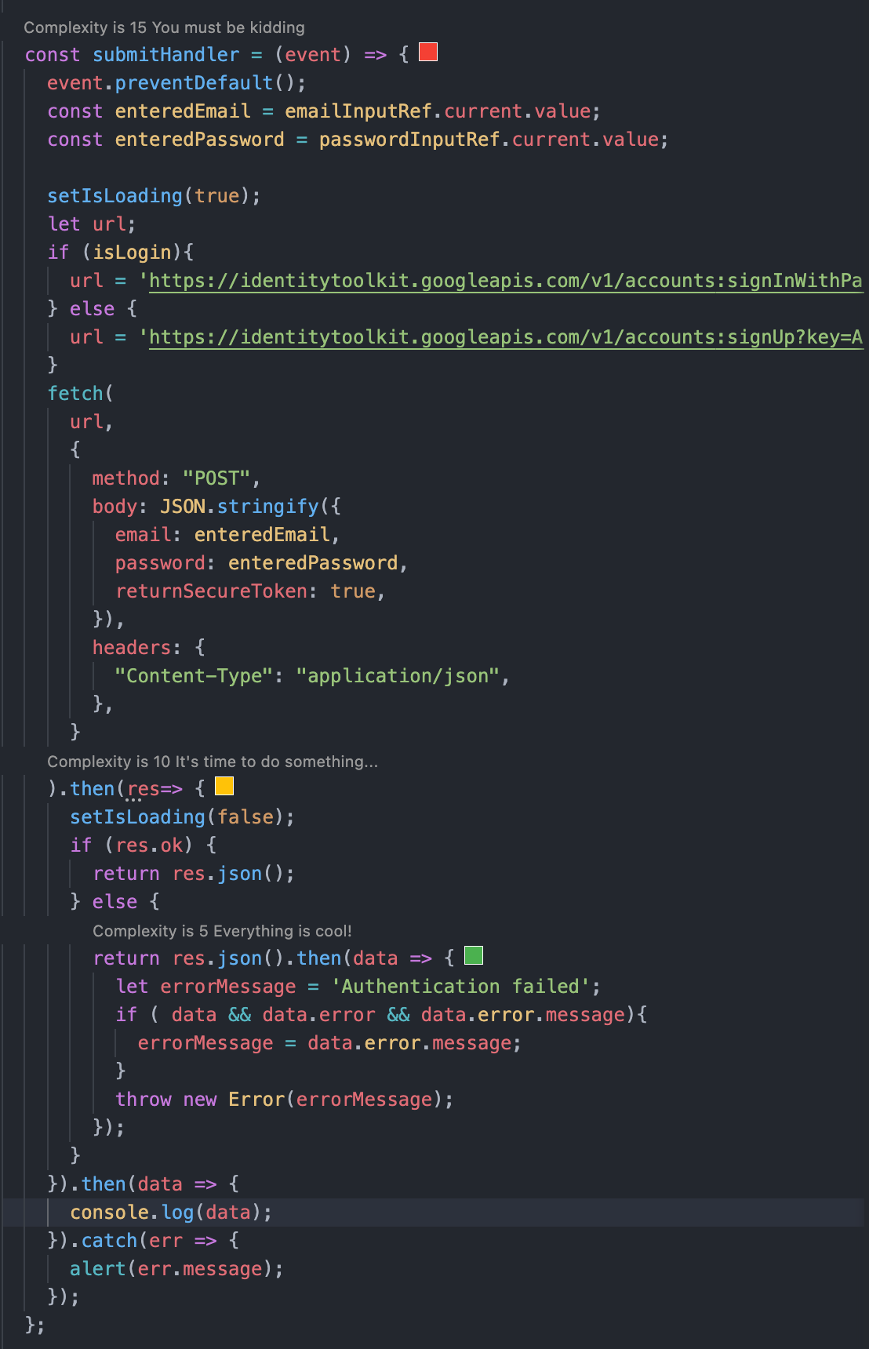

## Redirecting the login page after the password change

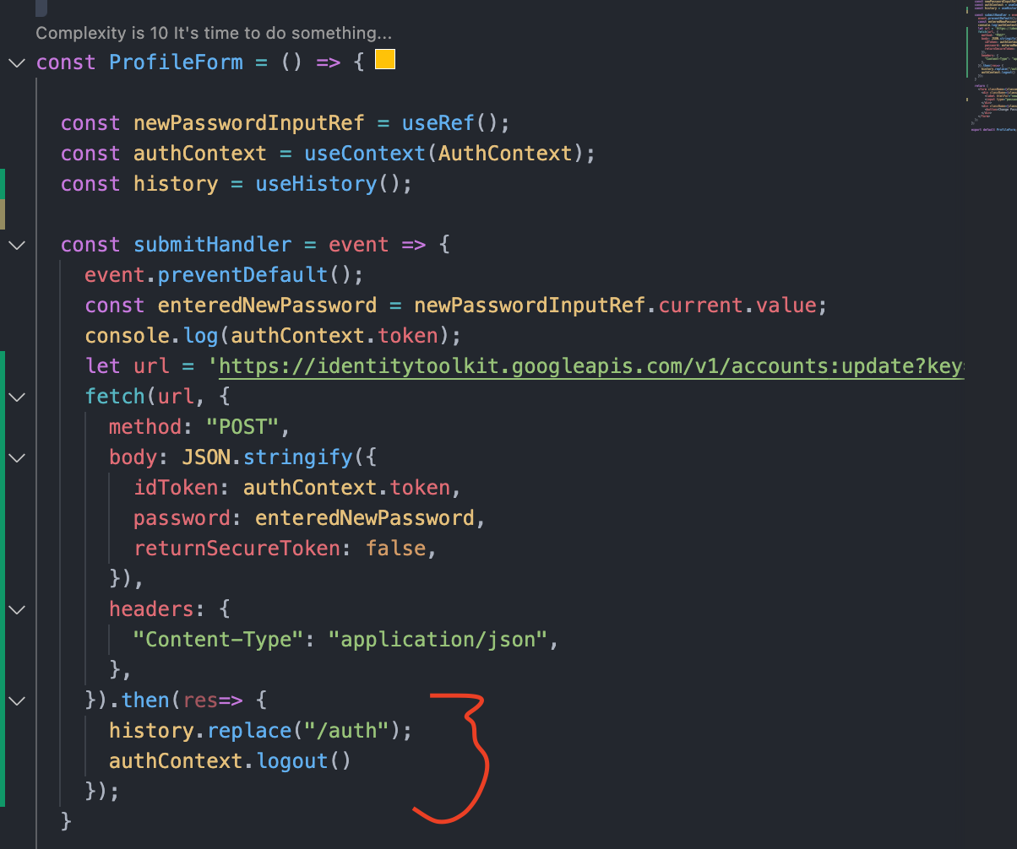

## Protecting Frontend Page

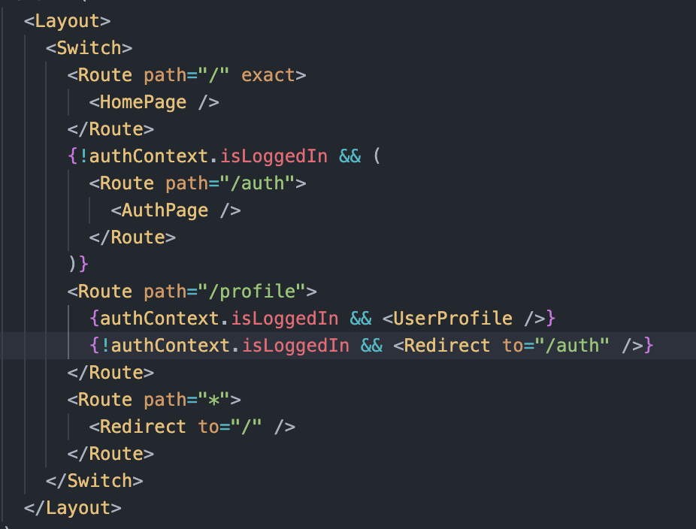

## Storing login token in storage browser

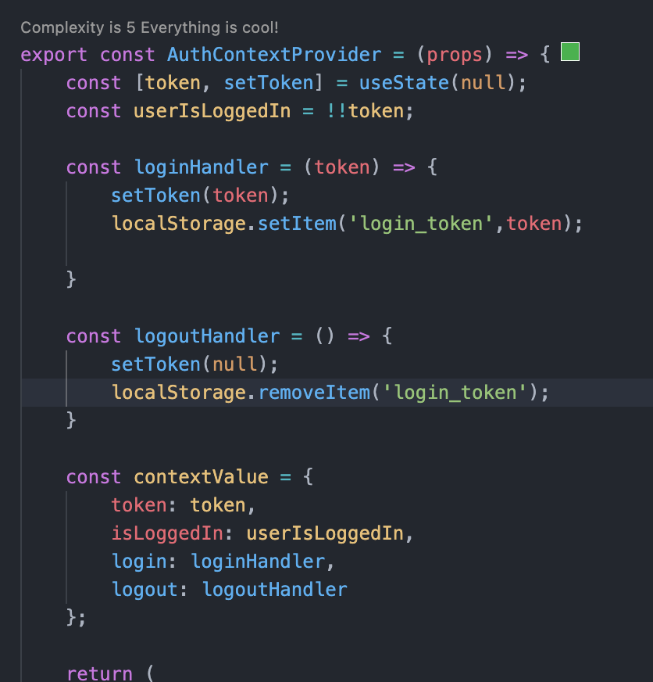

## Auto logout

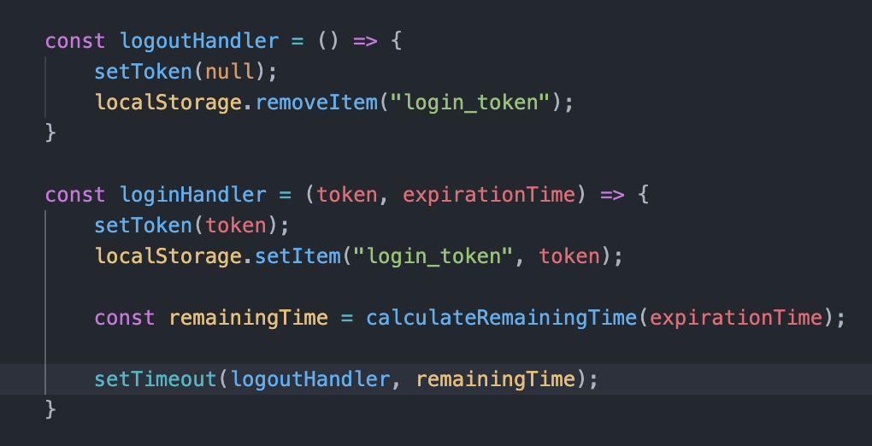

## Handling the timer while logout

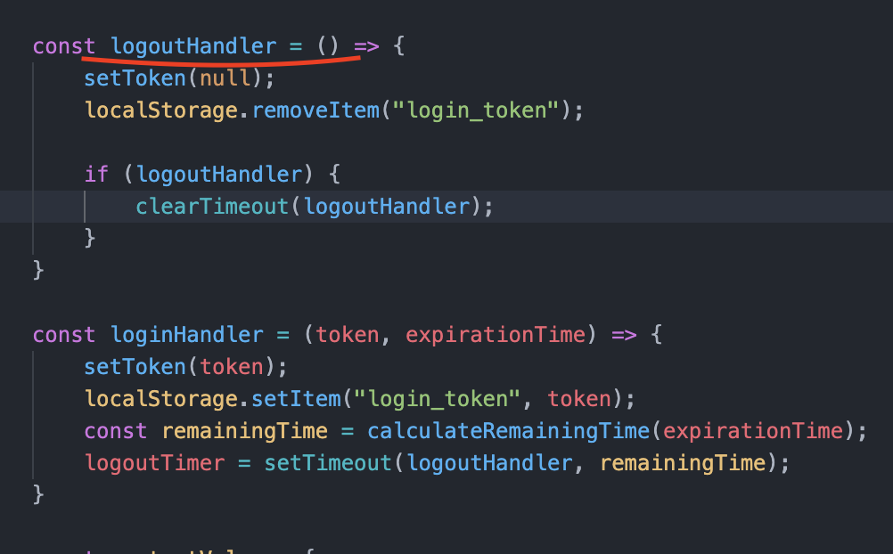

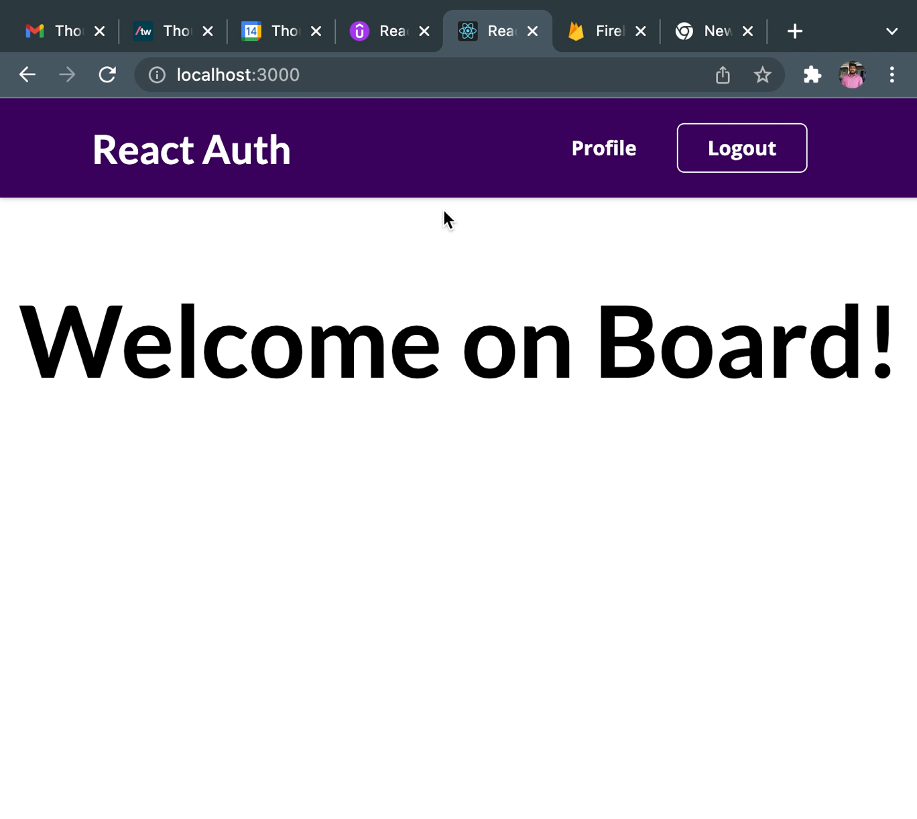

# Next JS

## Why Next JS?





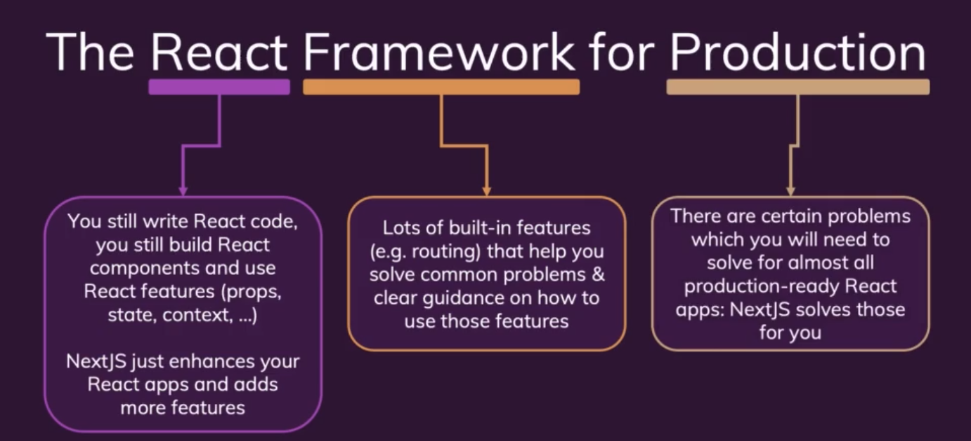

## Next JS Key Feature and Benefits

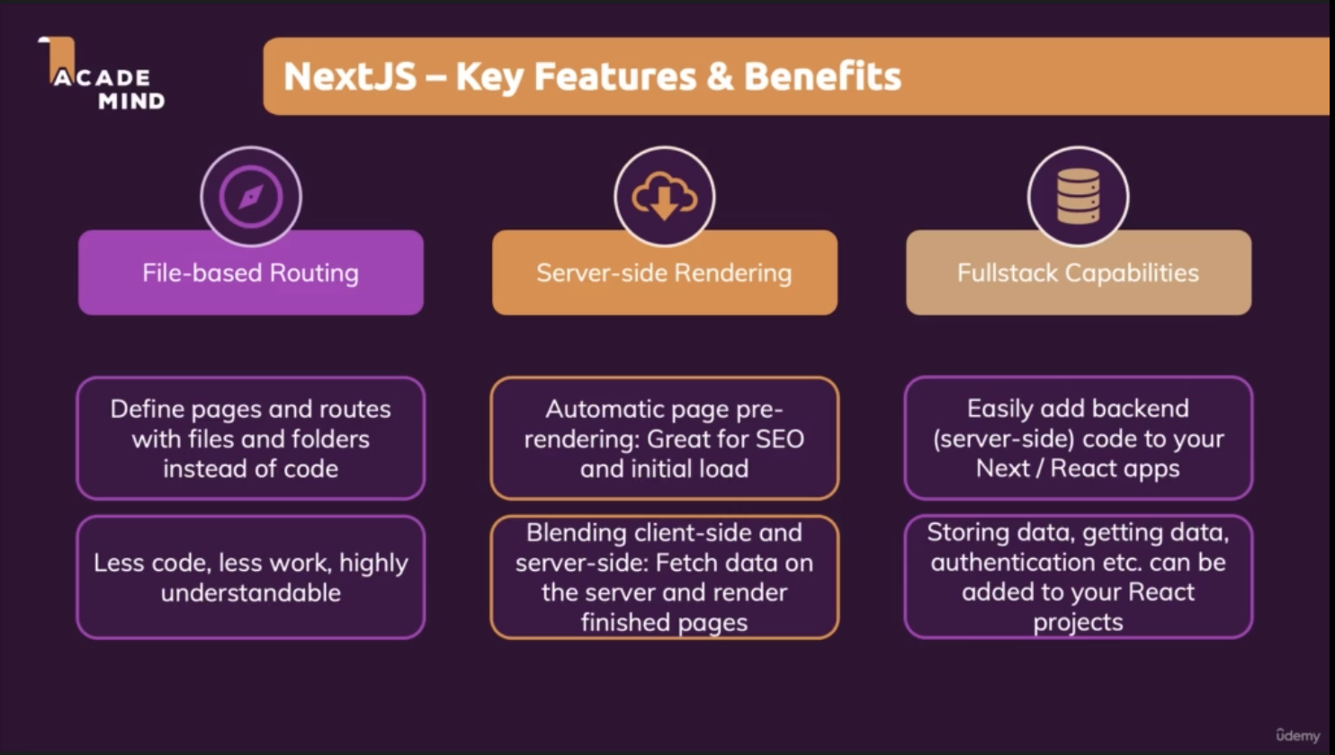

## Create Next JS Project

npx create-next-app

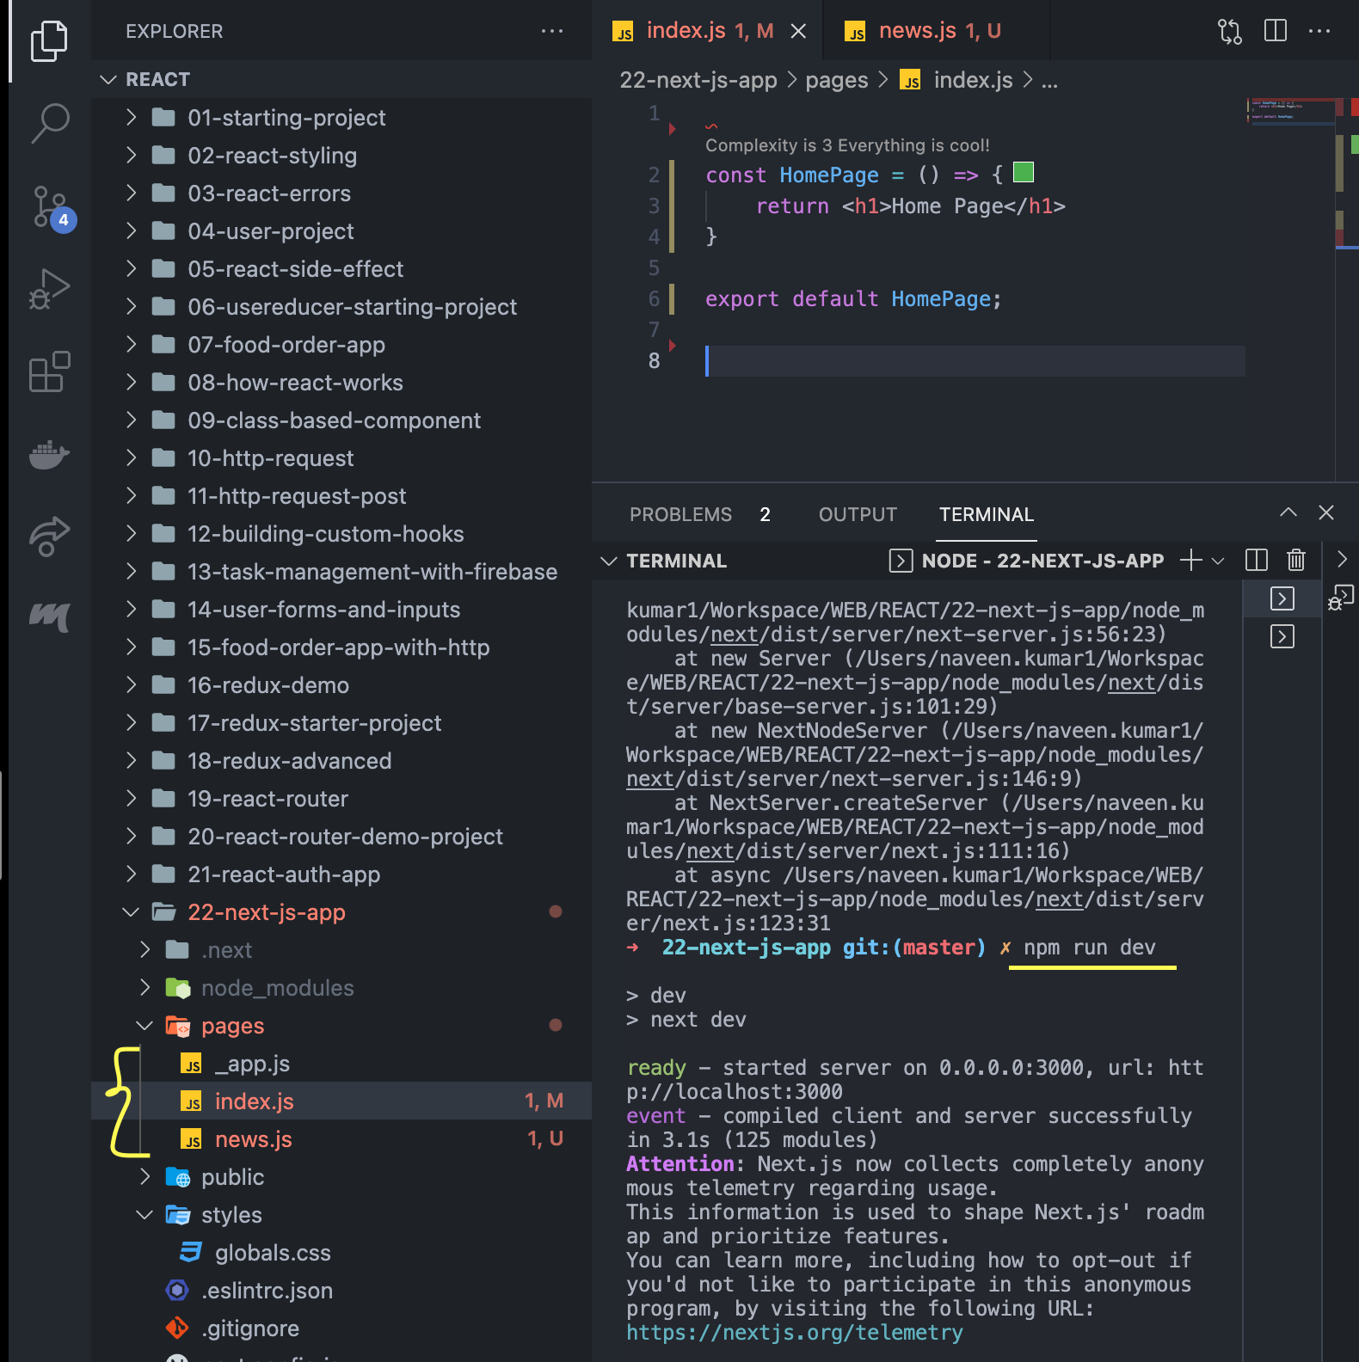

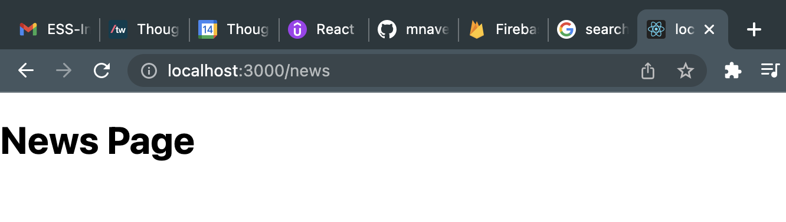

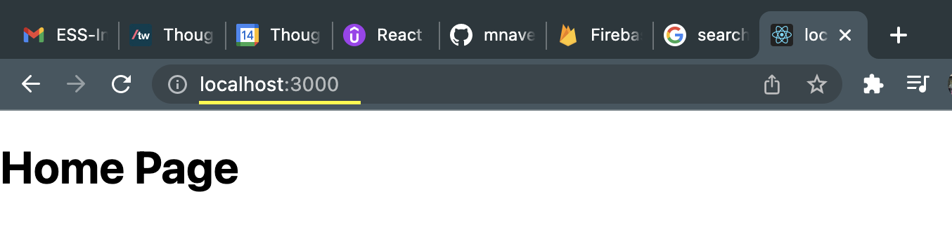

## Nested Pages

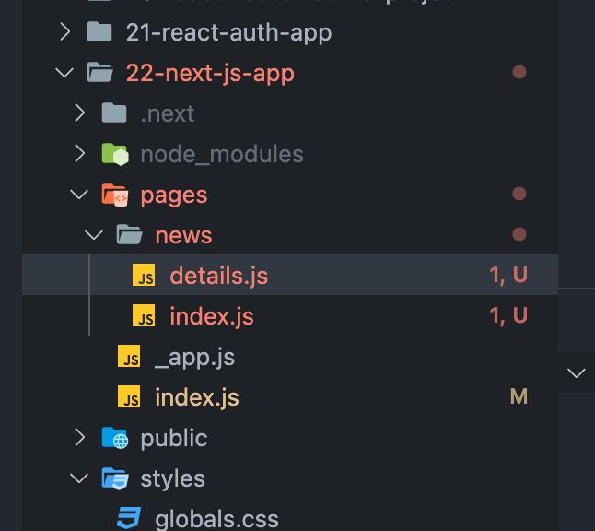

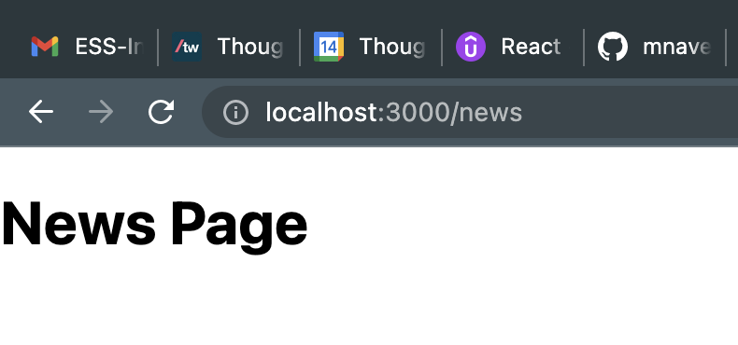

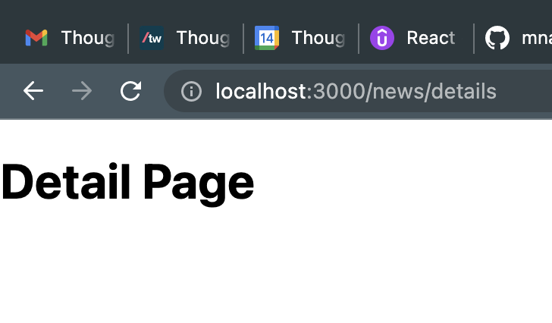

## Dynamic Page

Create the file name with square bracket. Here, newsId is a placeholder. Now this placeholder accept any values.

domainname/news/1

domainname/news/2

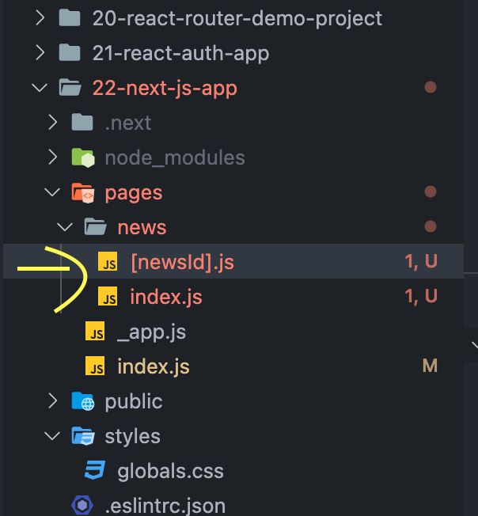 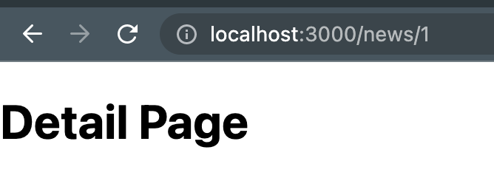

## Extracting a Dynamic Parameter Value

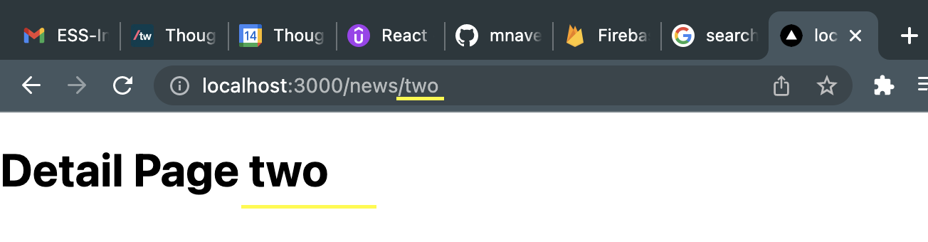

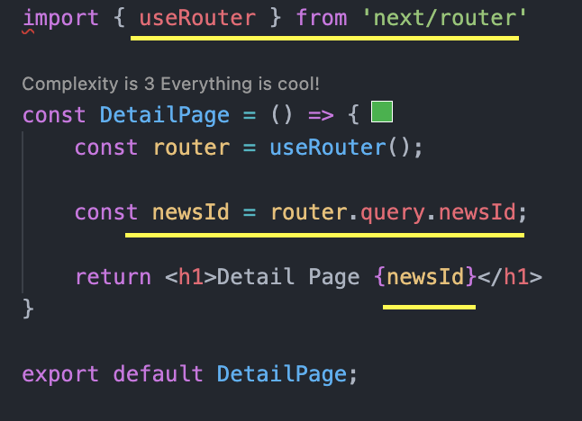

## Linking between Pages

Normal way – using anchor element

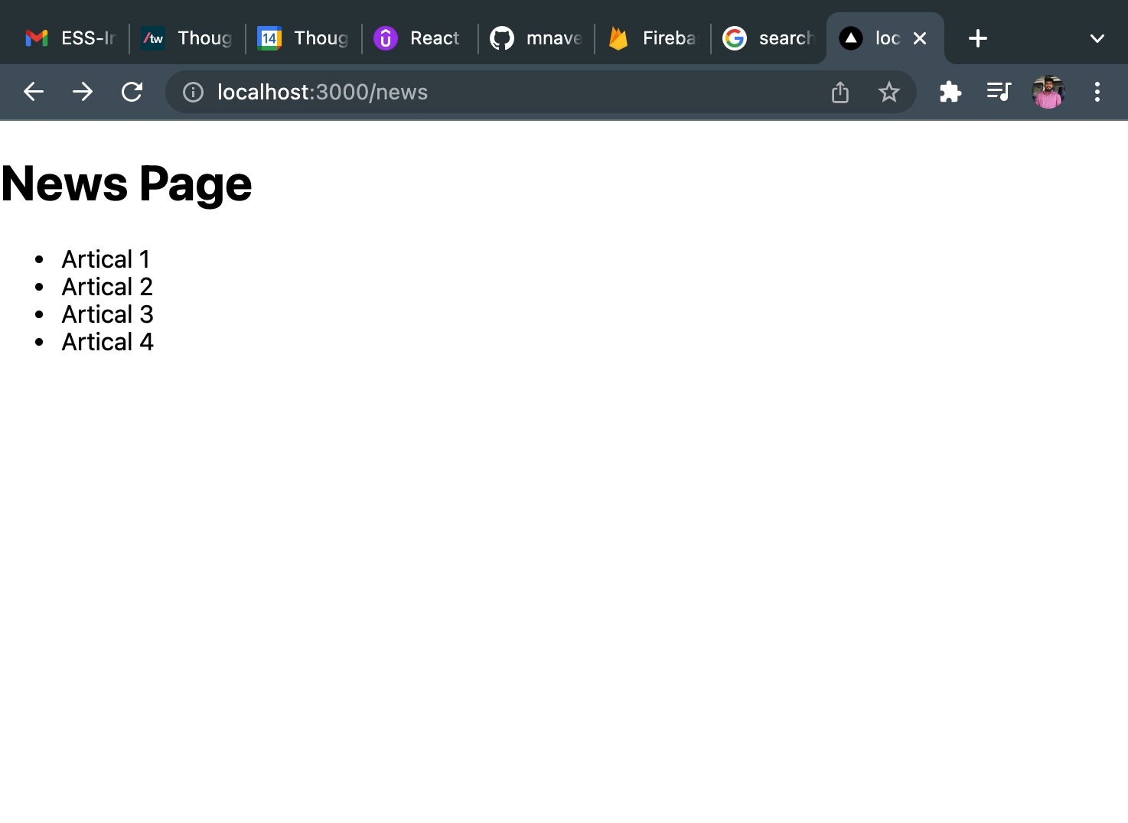

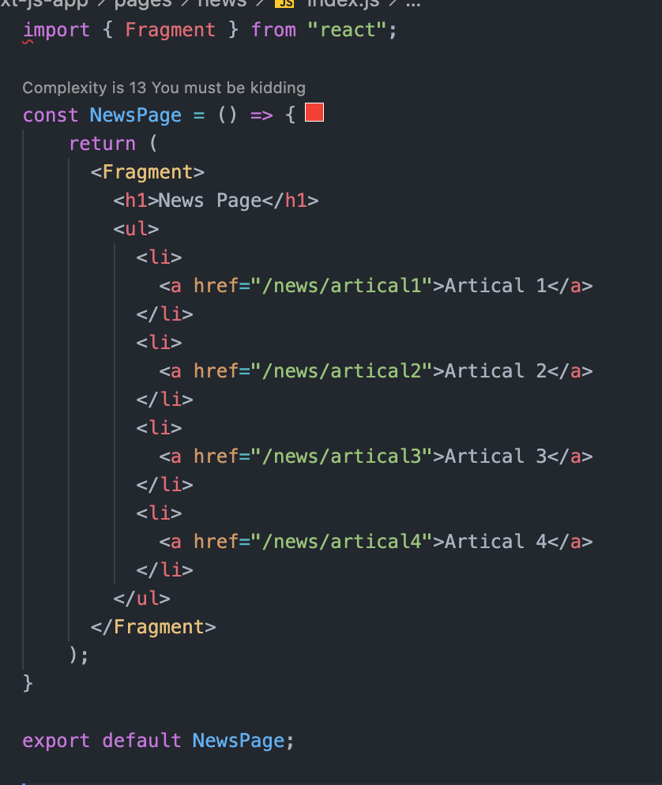

Disadvantage:

* Not a single page application
* Every time page loads when clicking the link.

## Other way – using Link from next js

This approach gives a single page application.

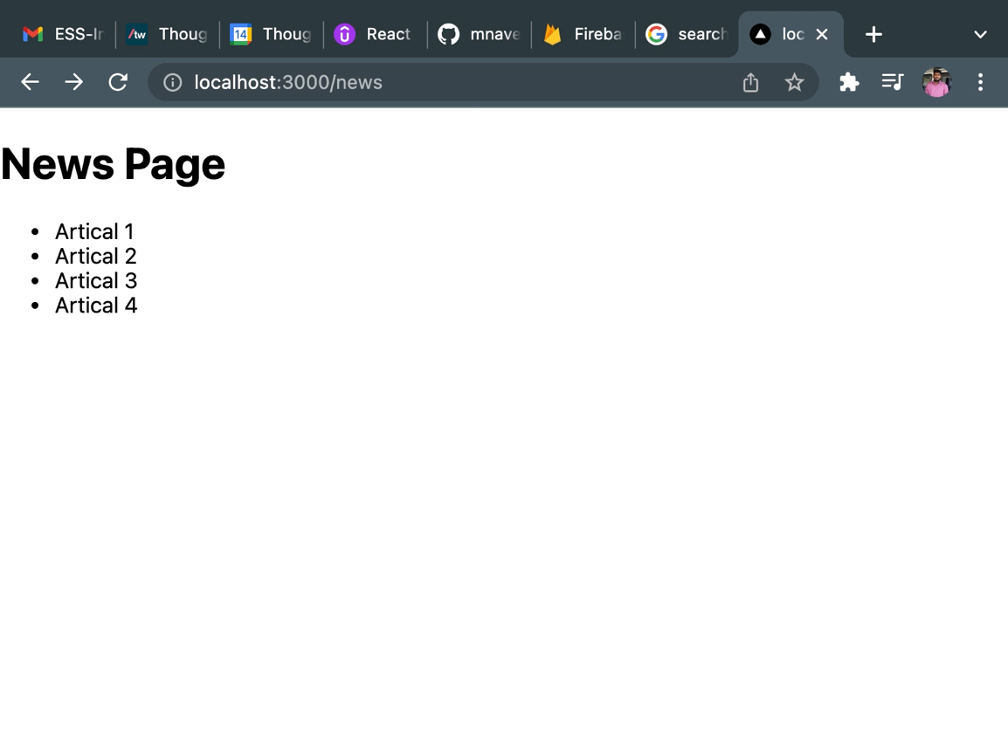

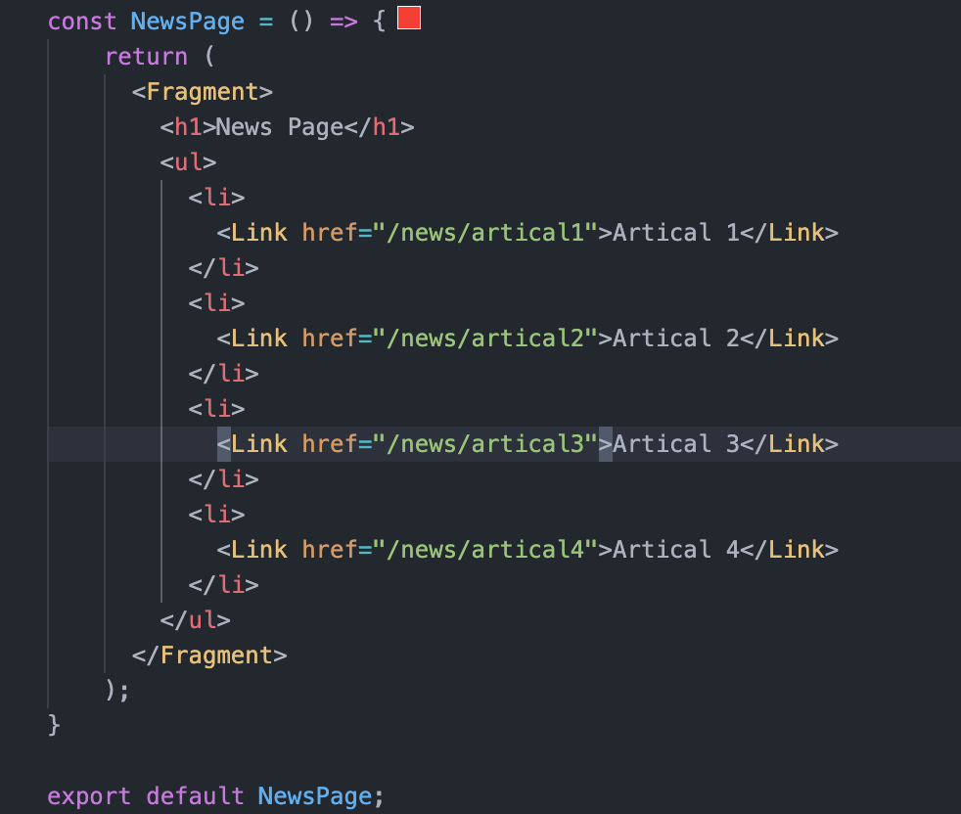

## Preparing project pages

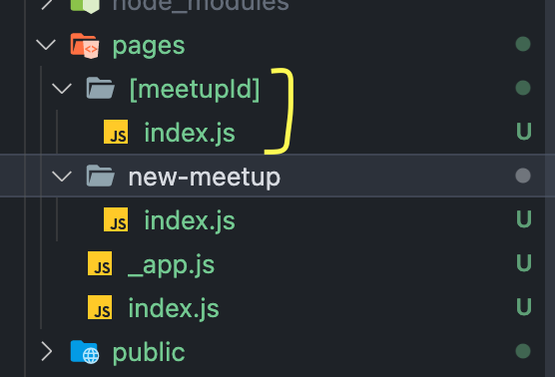

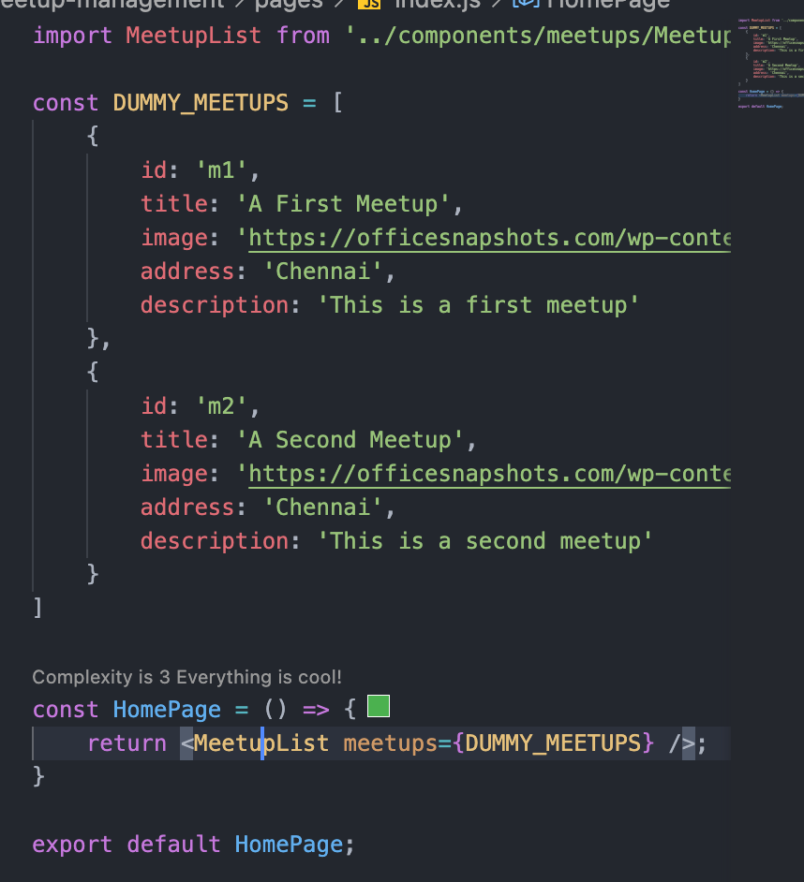

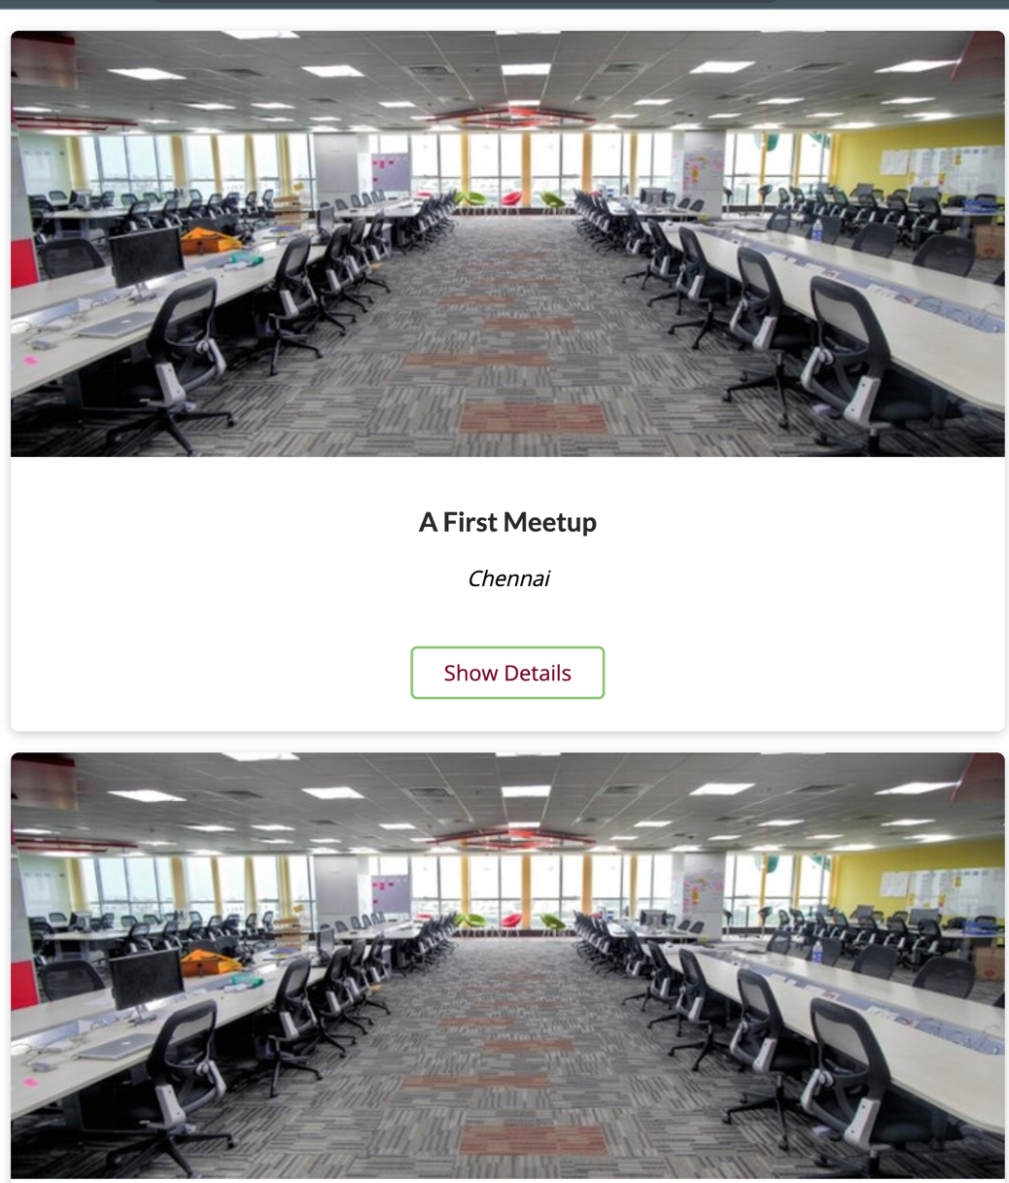

## Adding a new meetup form

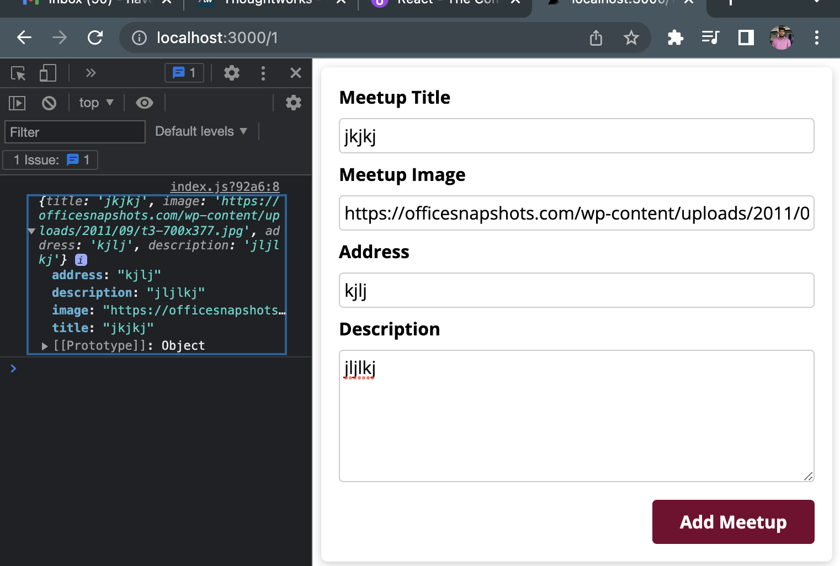

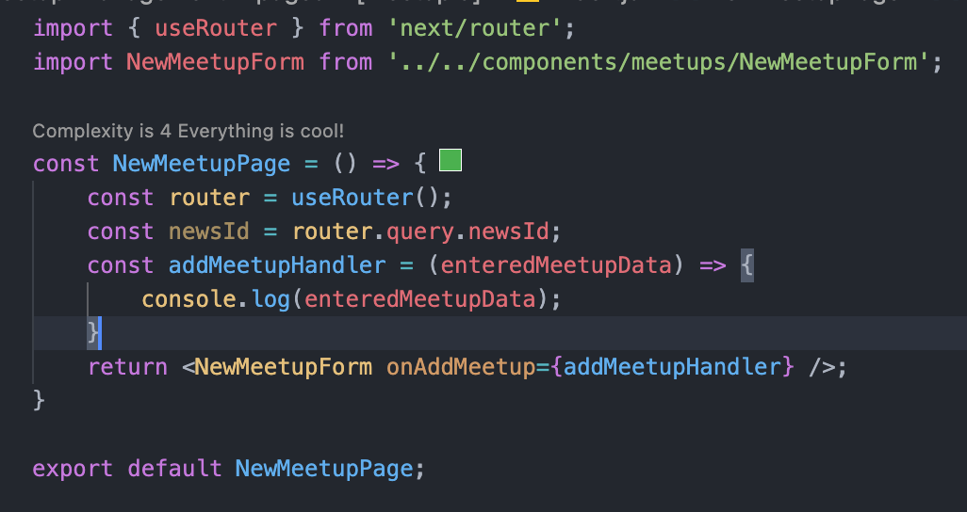

## Adding a Navigations

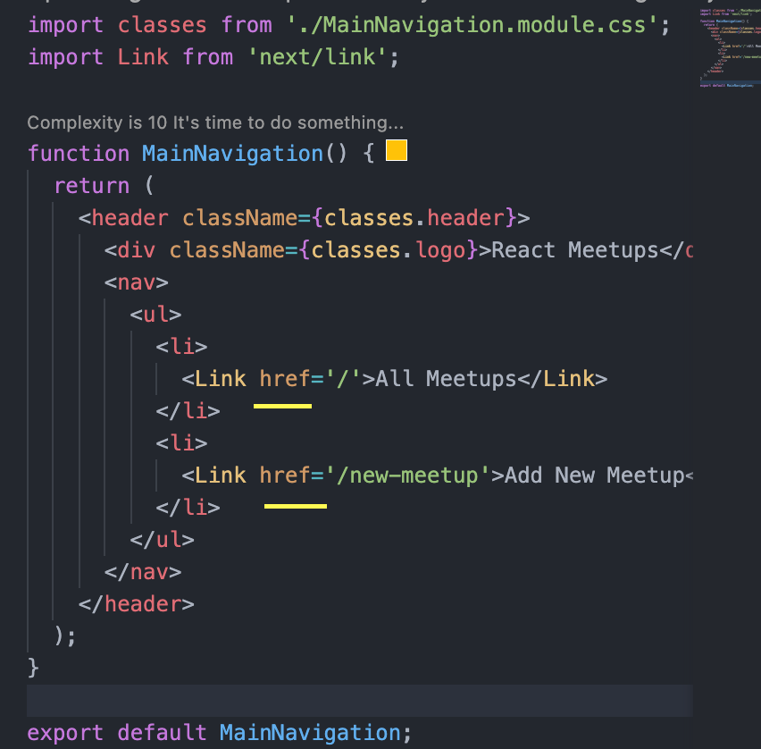

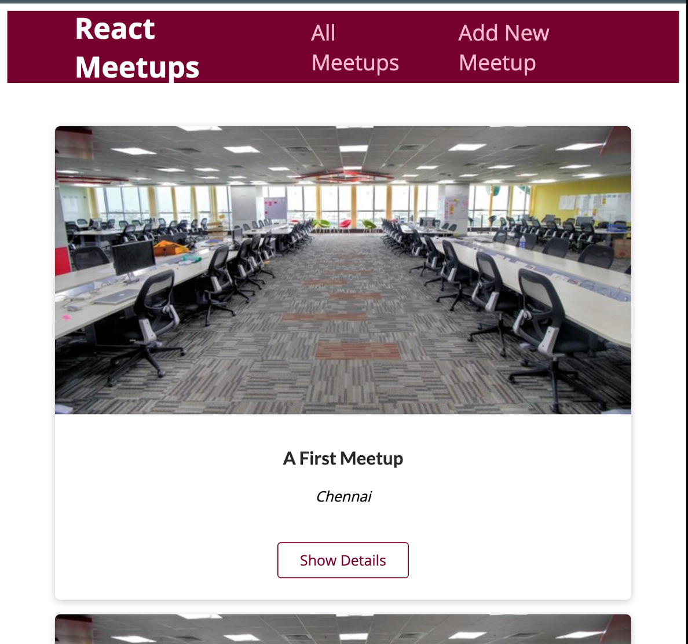

## Adding a navigation bar to entire pages

This is where _app.js file comes in handly in next js project. When we want change something which should through the app we can use the _app.js file.

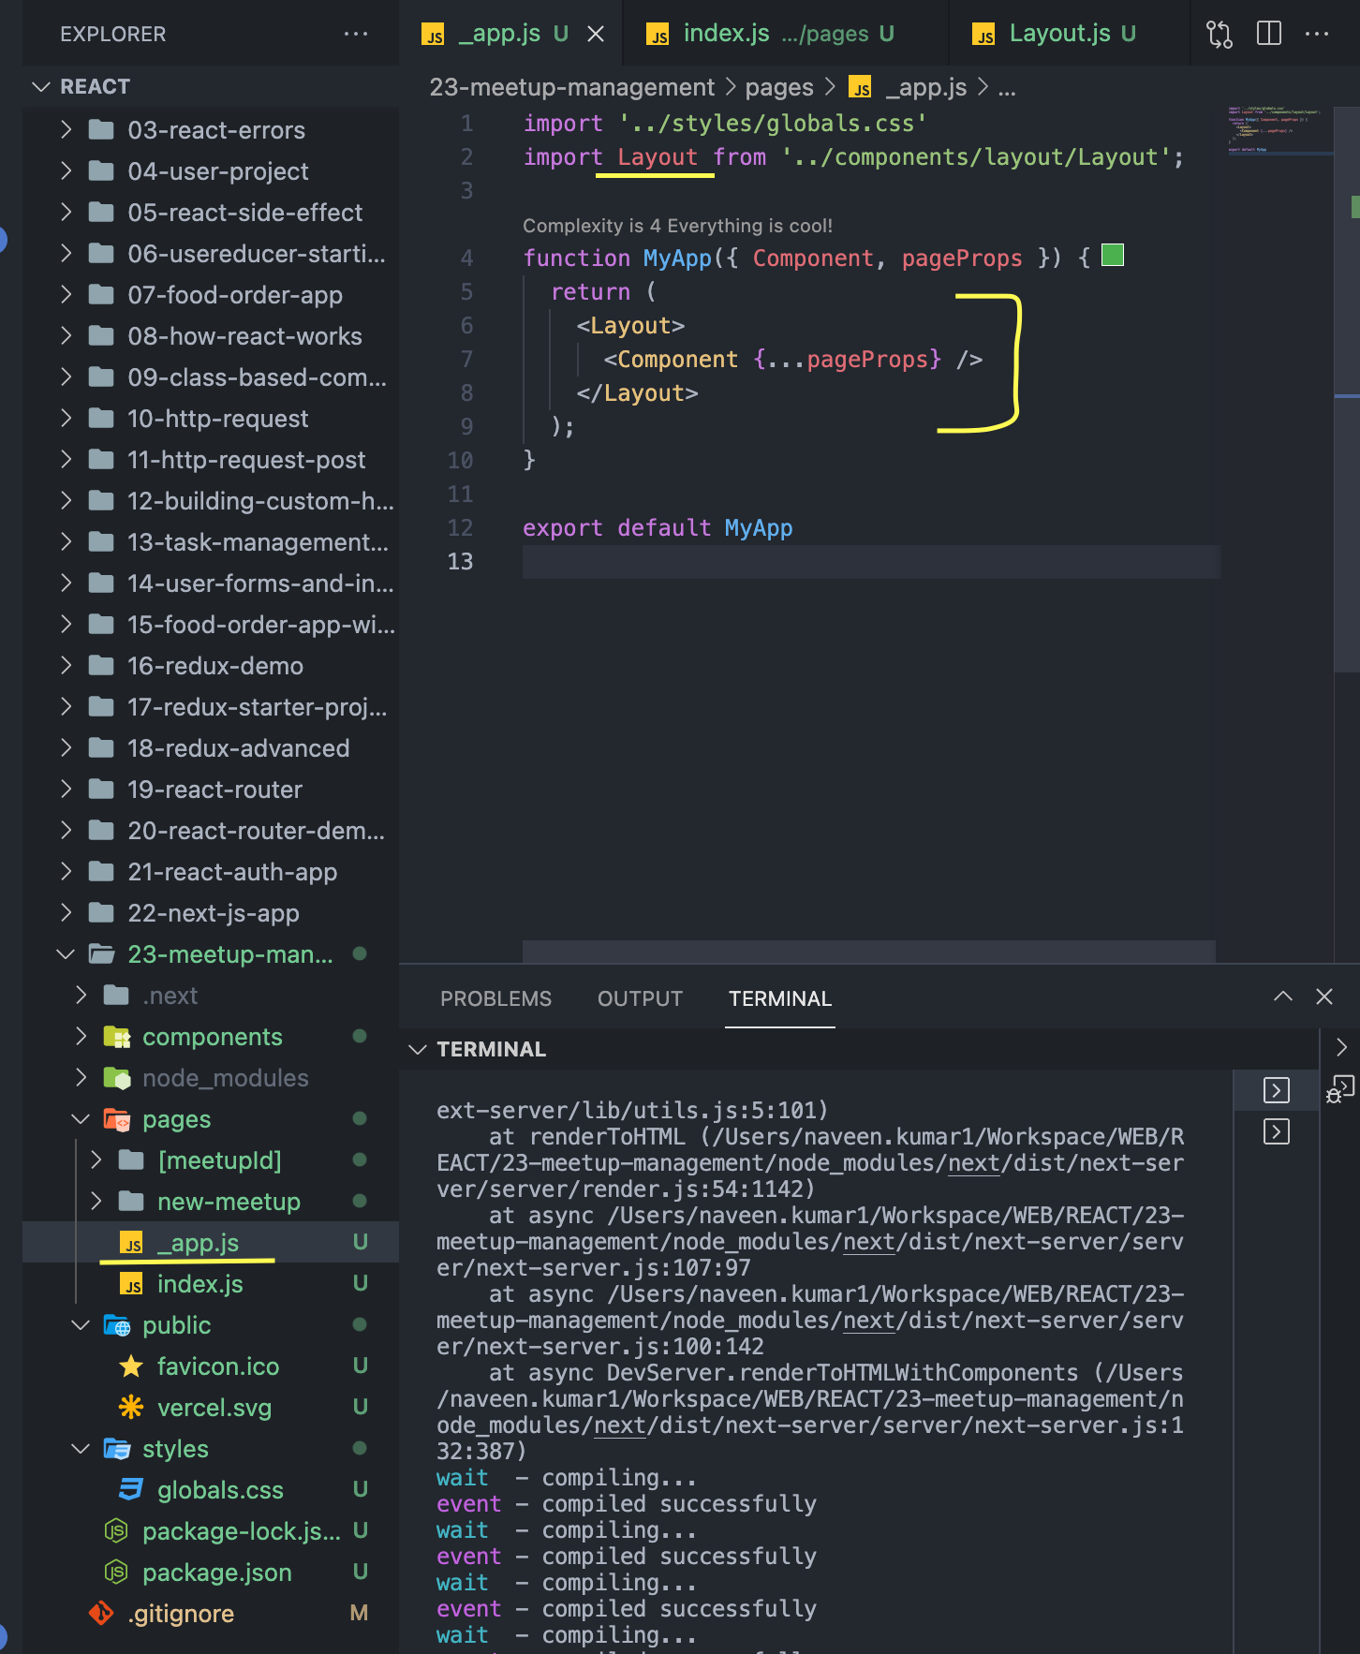

## Meetup App - Implementation so far

Next JS helps fetch the data for pre-rendering.

## Data Fetching for static pages

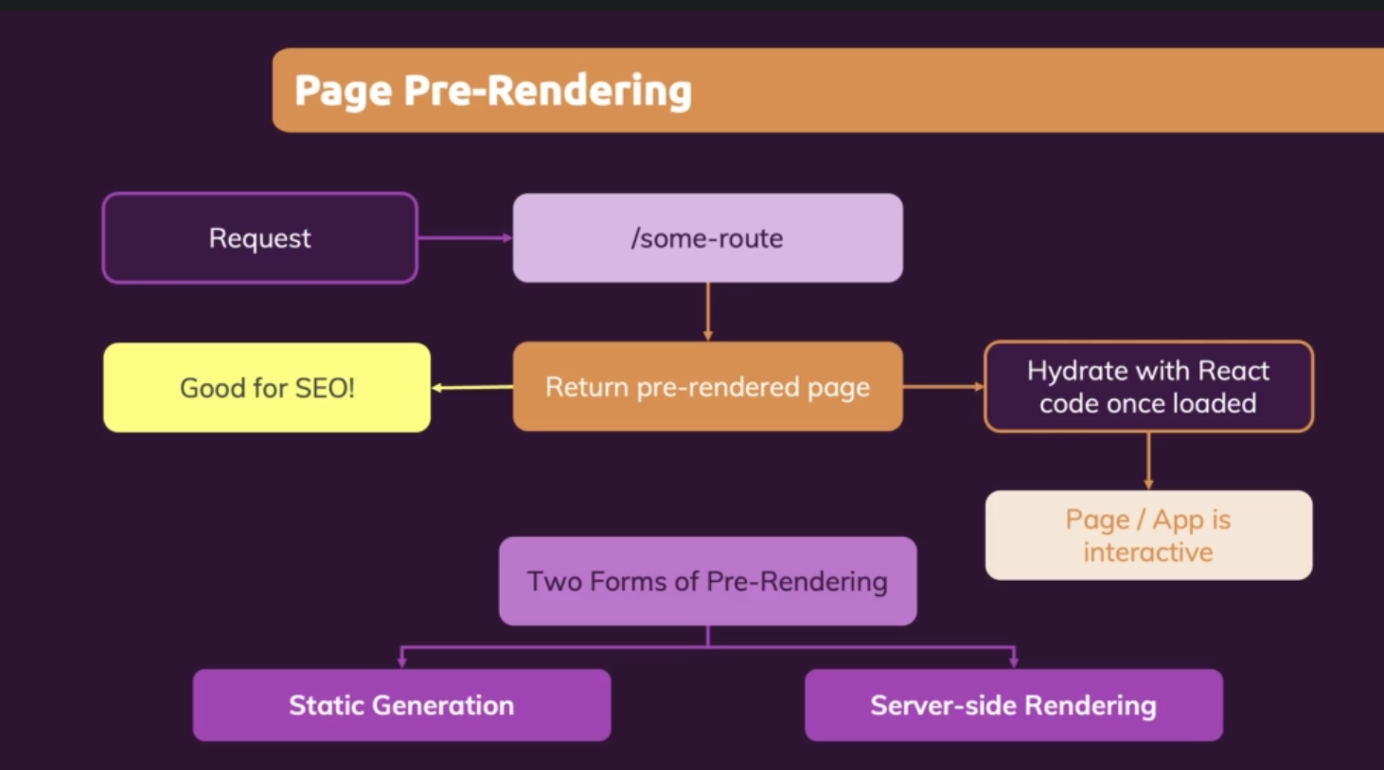

## Static Site Generation (SSG)

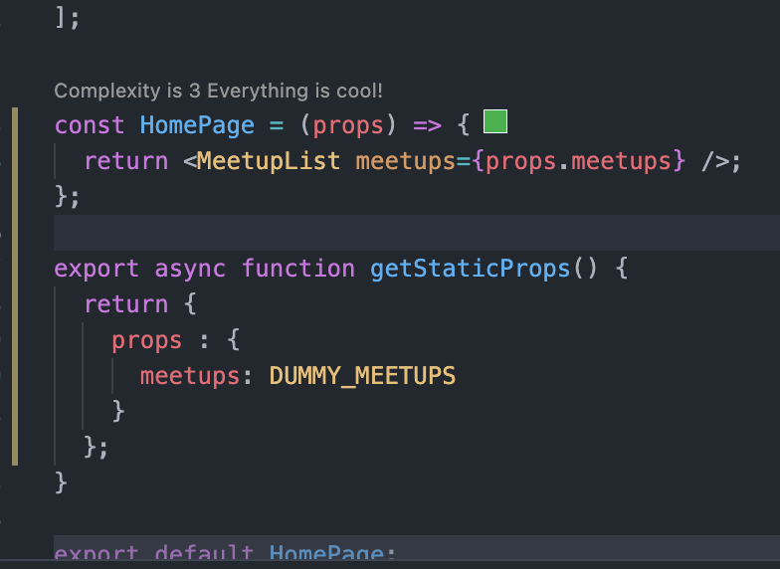

getStaticProps() will be executed the before the component function. It is used to provide the data which component function requires. Also, this special function will be executed when during the build process.

## Regenerate the code

revalidate attribute in return statement of getStaticProps function, helps to regenerate the props value every once in server side for given duration.

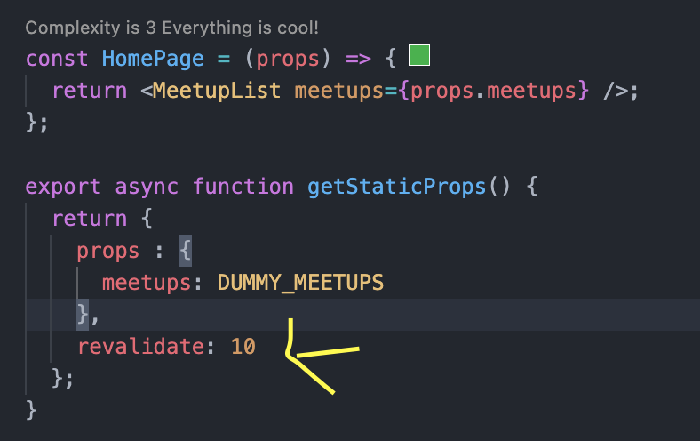

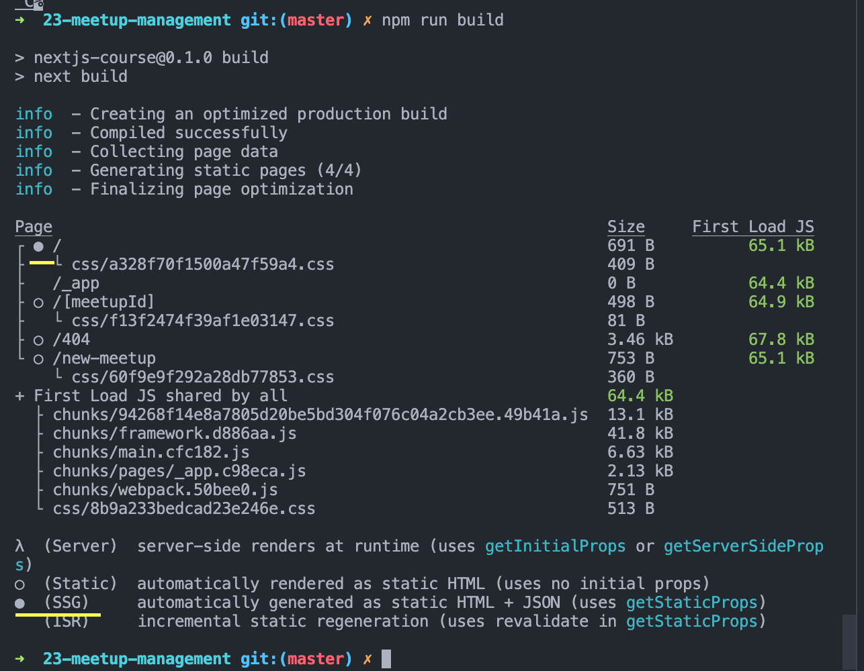

## Server-Side Rendering (SSR)

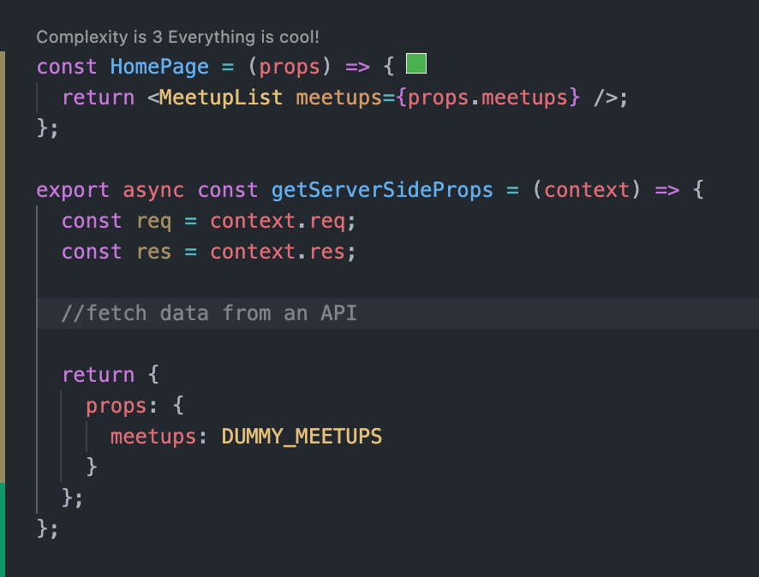

Server-Side Props will be regenerated for every incoming request.

## getStaticPaths()

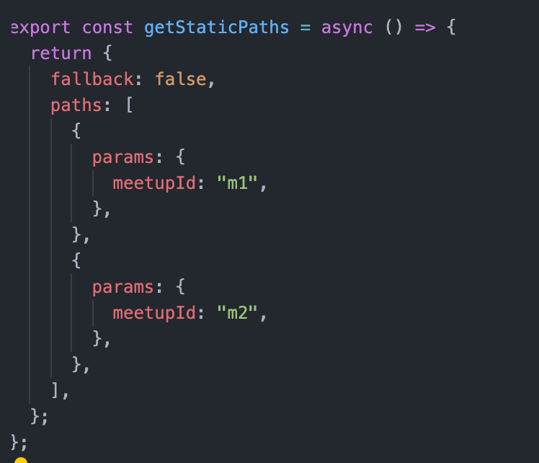

getStaticPaths() tells, for which path, static side generation should happen.

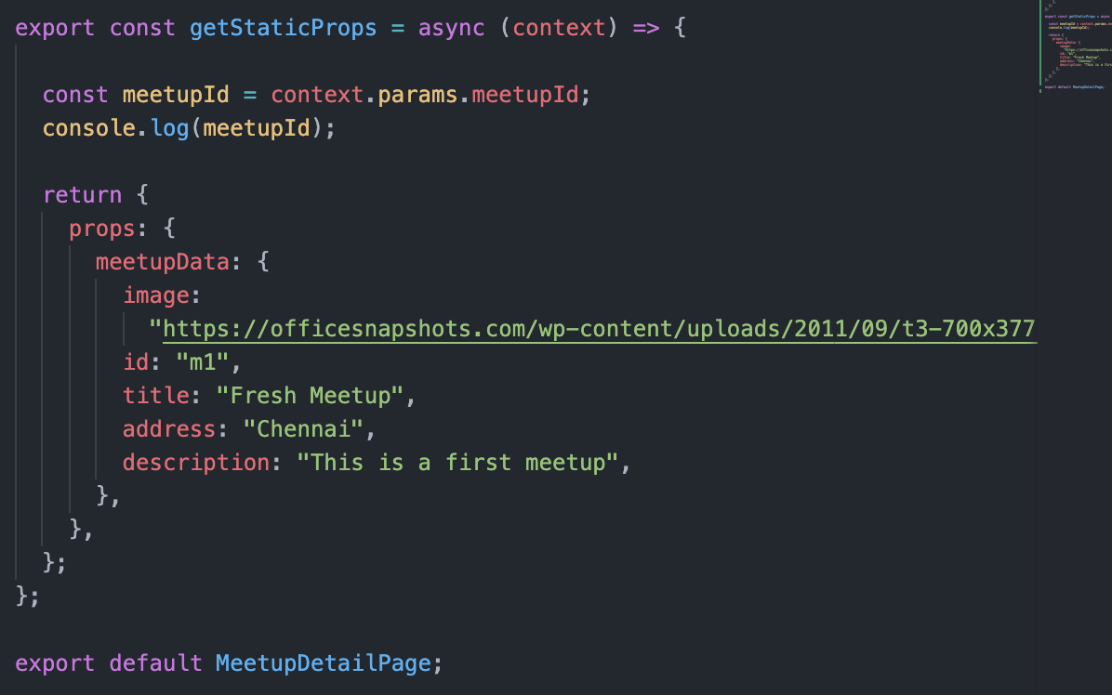

## Working with MongoDB

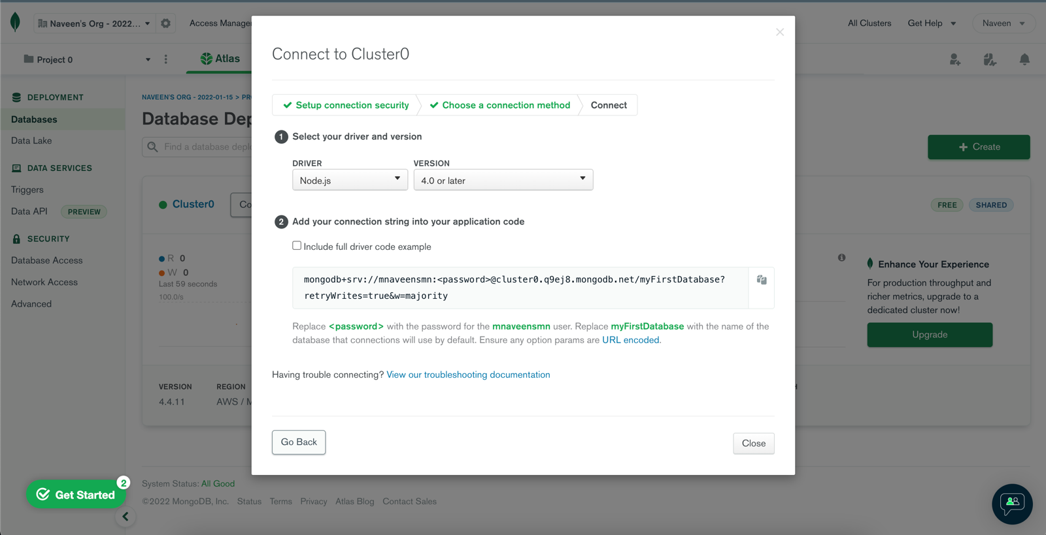

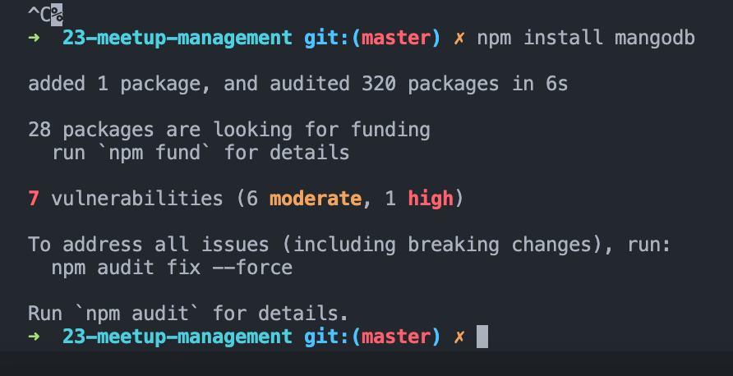

Collection – Tables

Documents – Entries in Tables – Row

## Inserting data to MongoDB

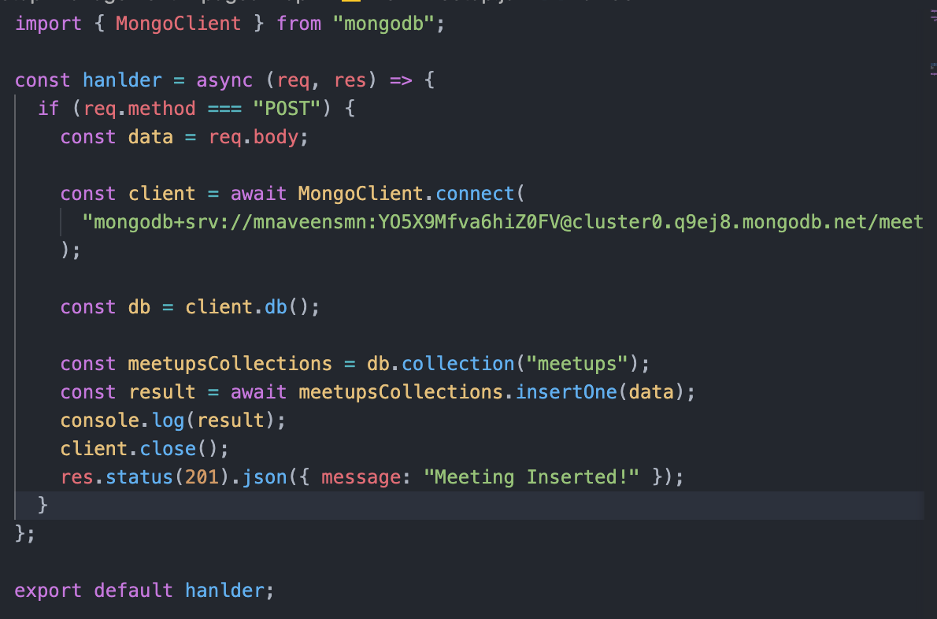

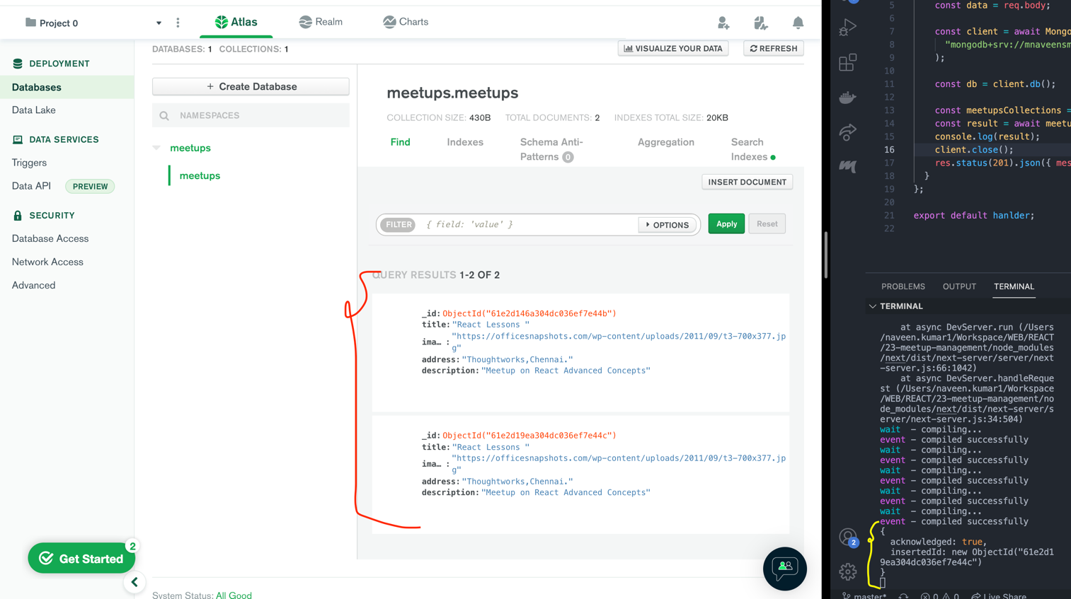

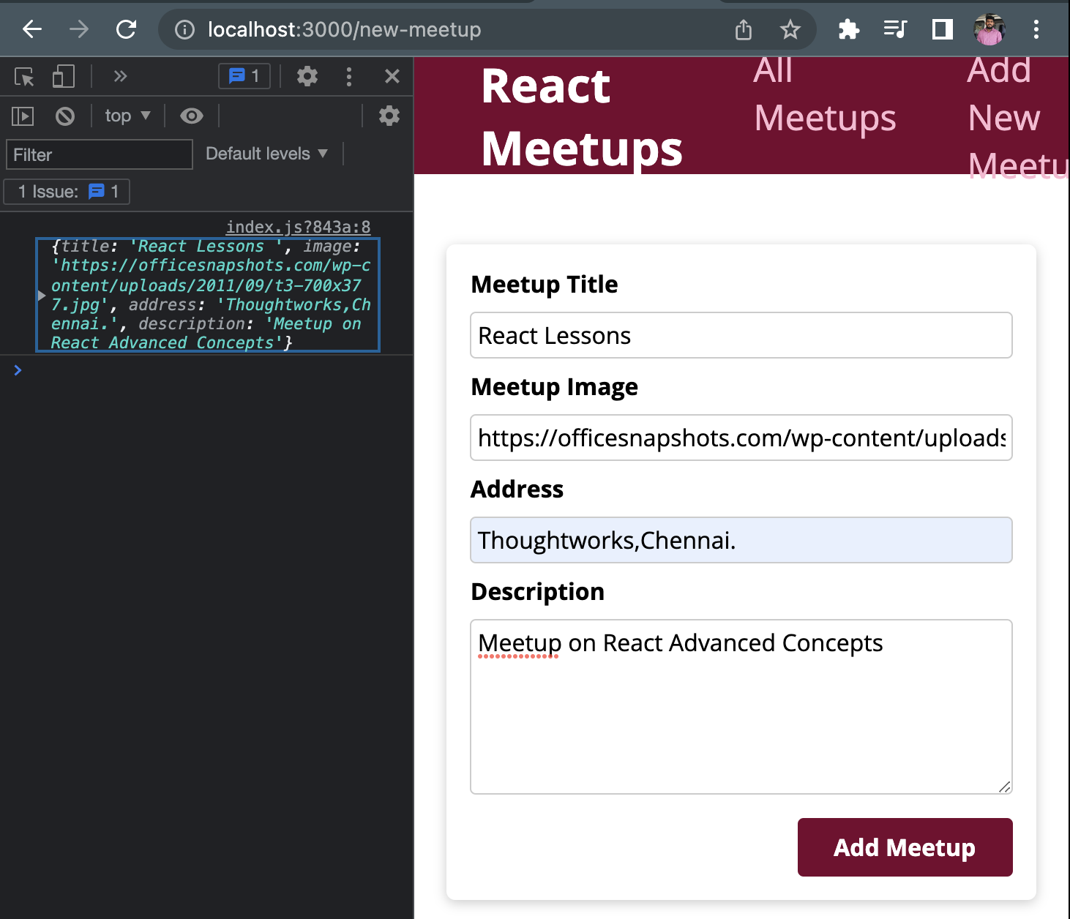

## Loading Data from MongoDB

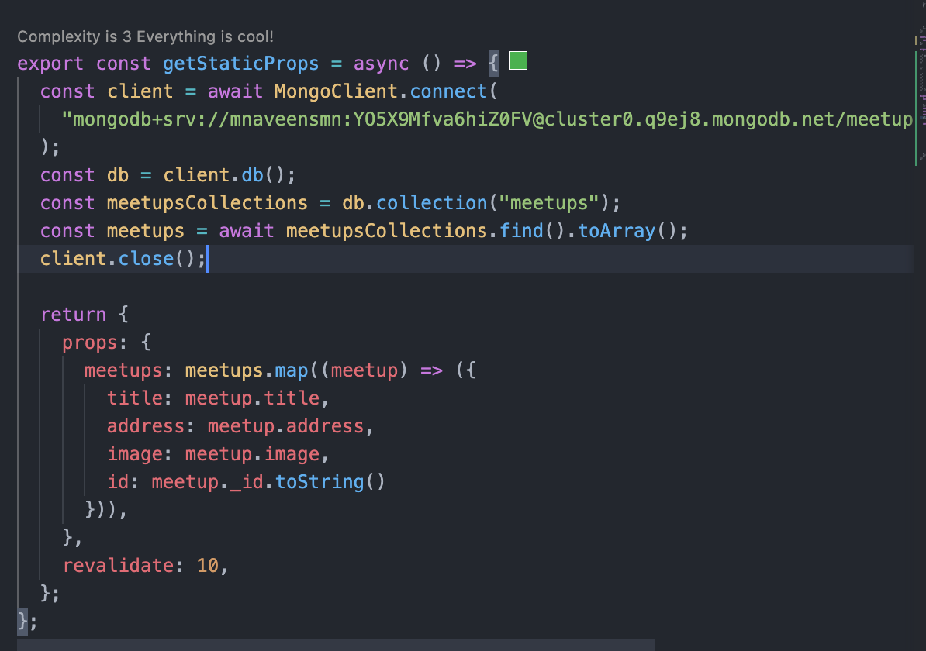

## Loading a Dynamic Data in MeetupDetails page

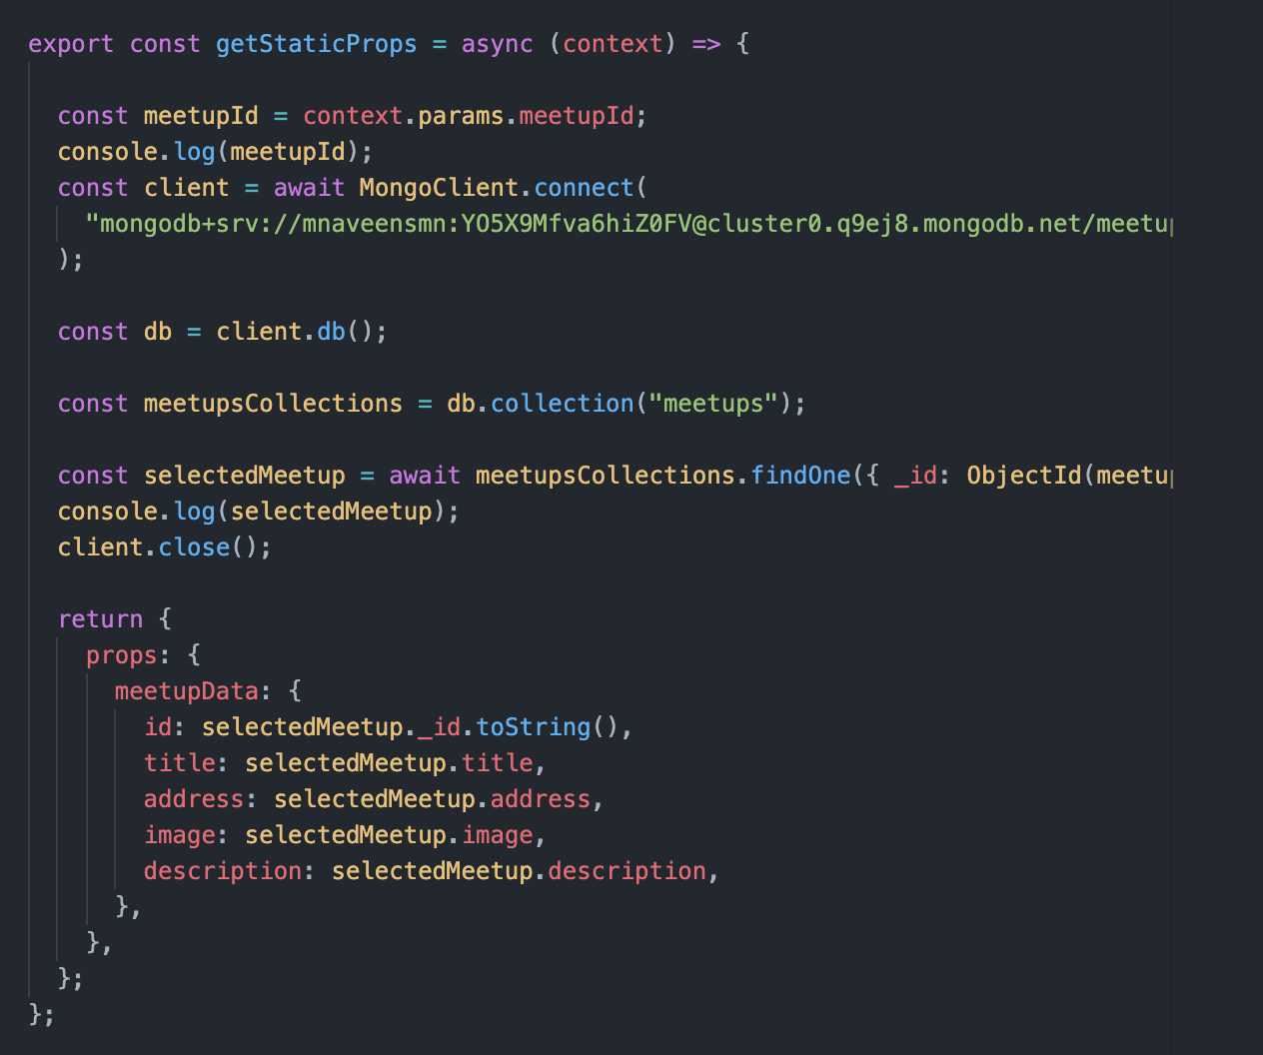

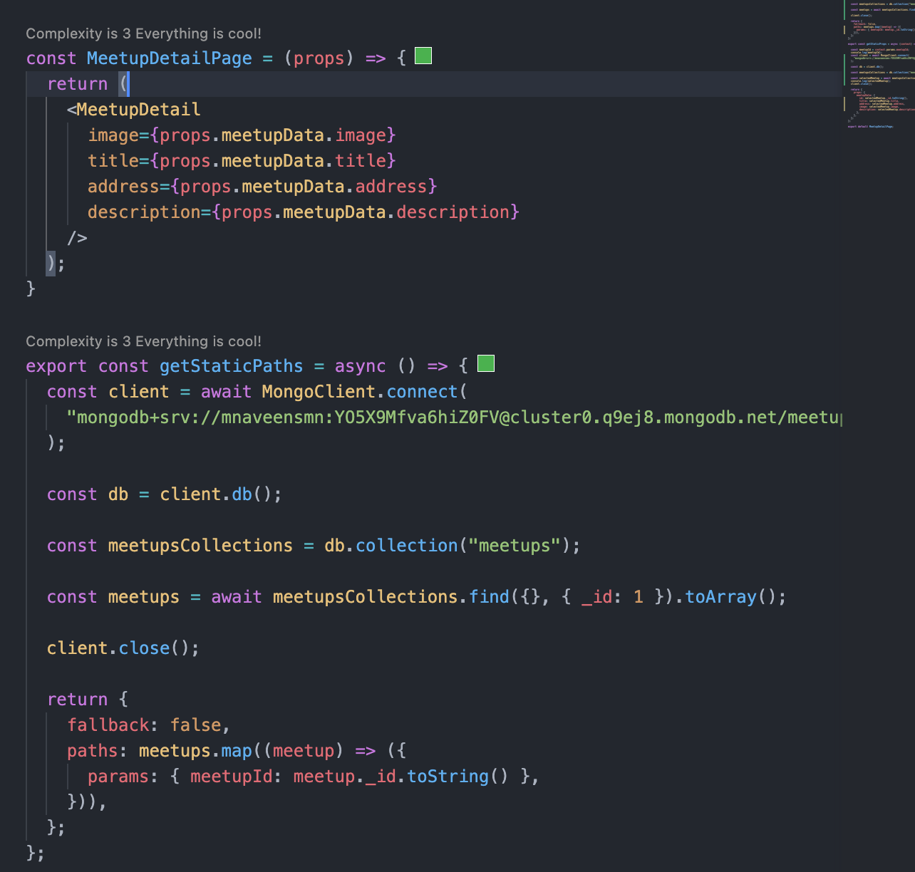

## Adding a Meta Data to Page before Deployment

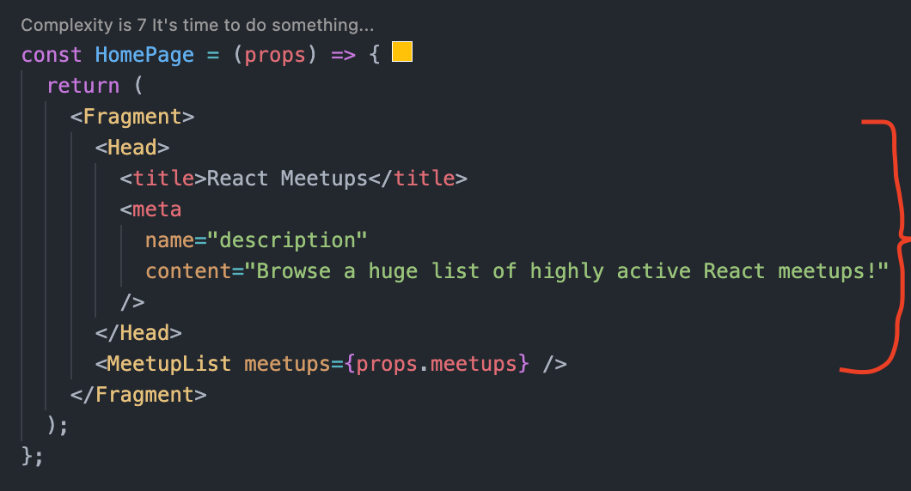

# Animation

## Preparing the project for adding animation

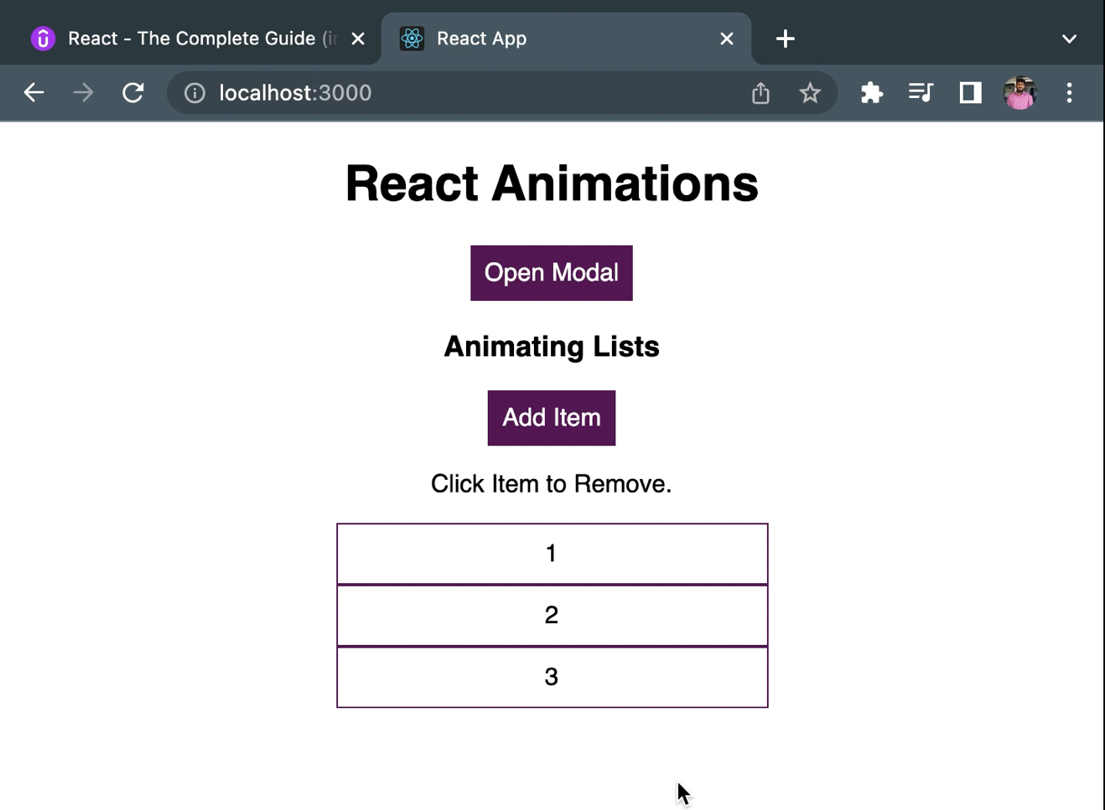

## Animating the model pop up

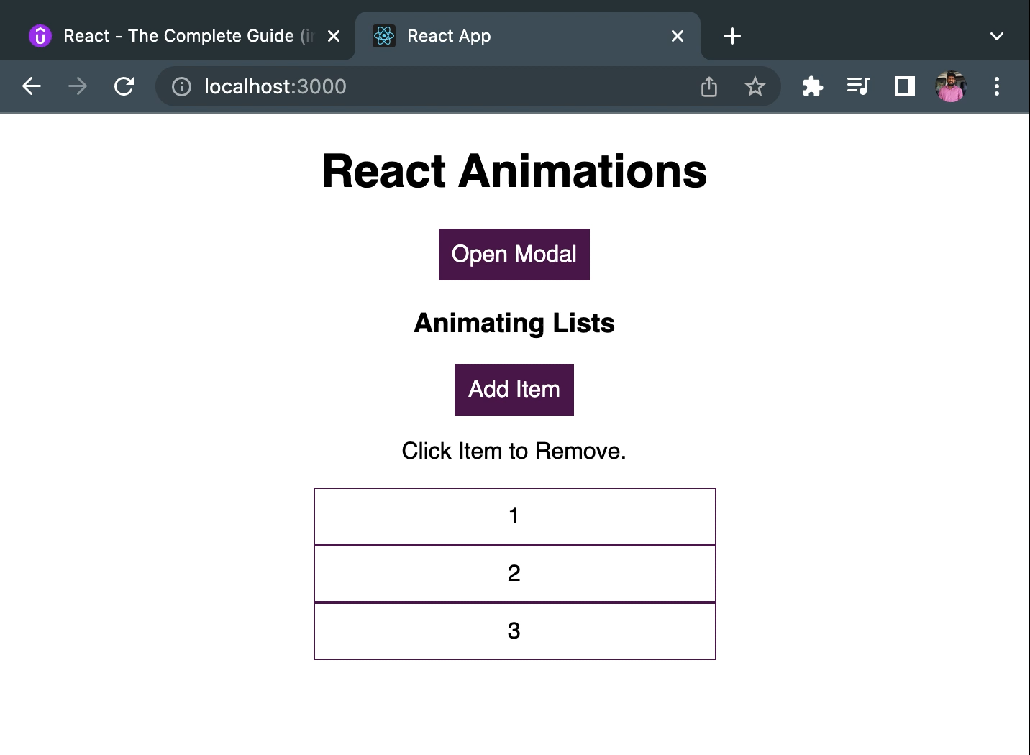

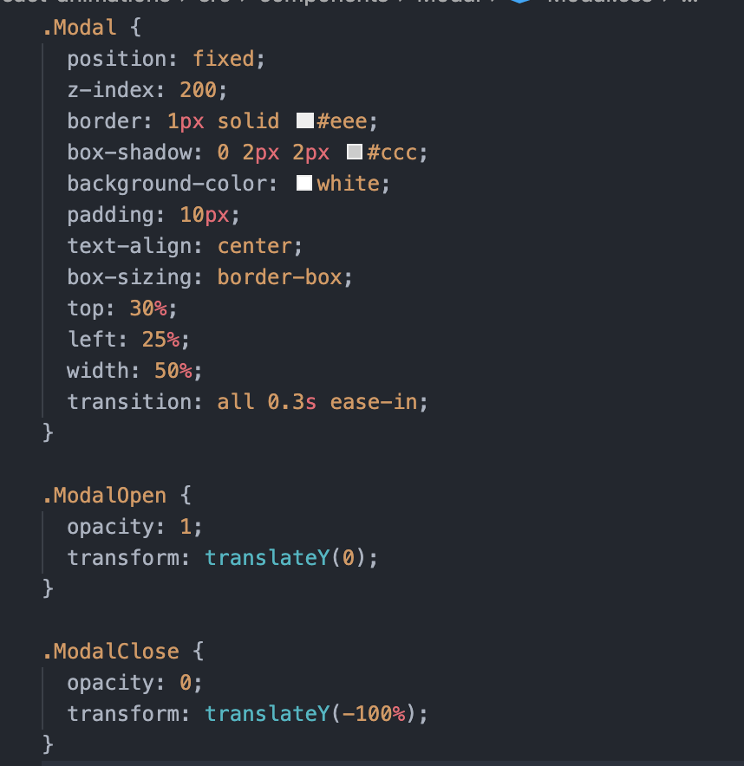

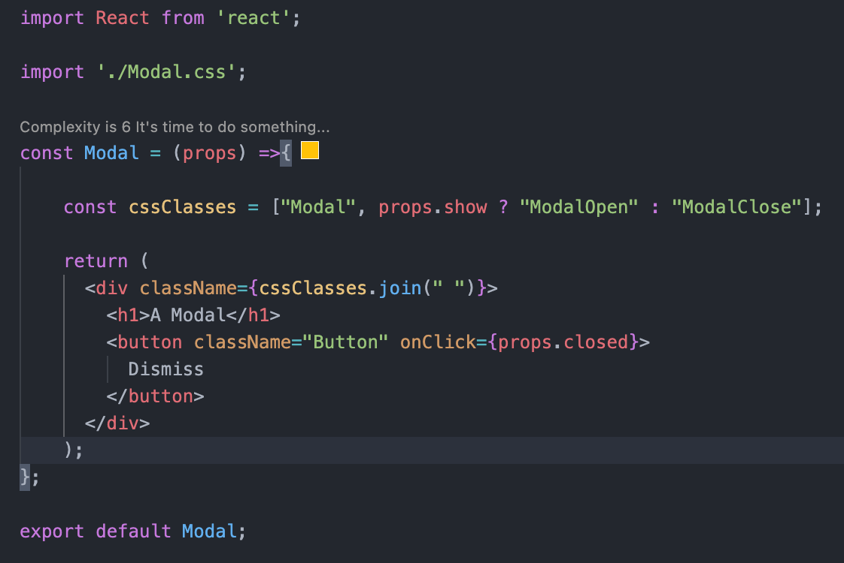

## CSS Animation Property

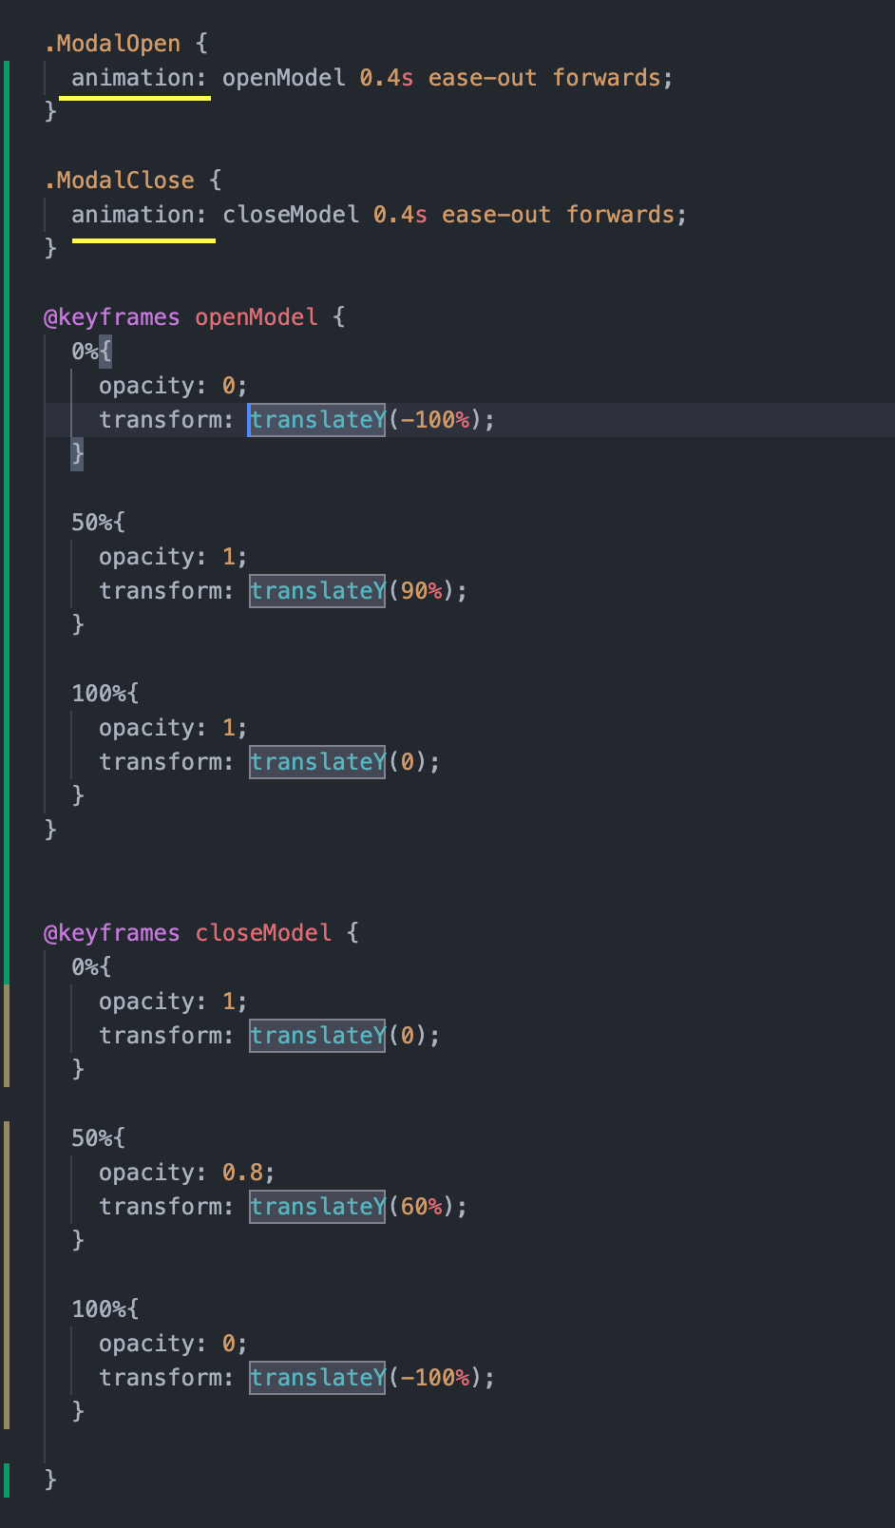

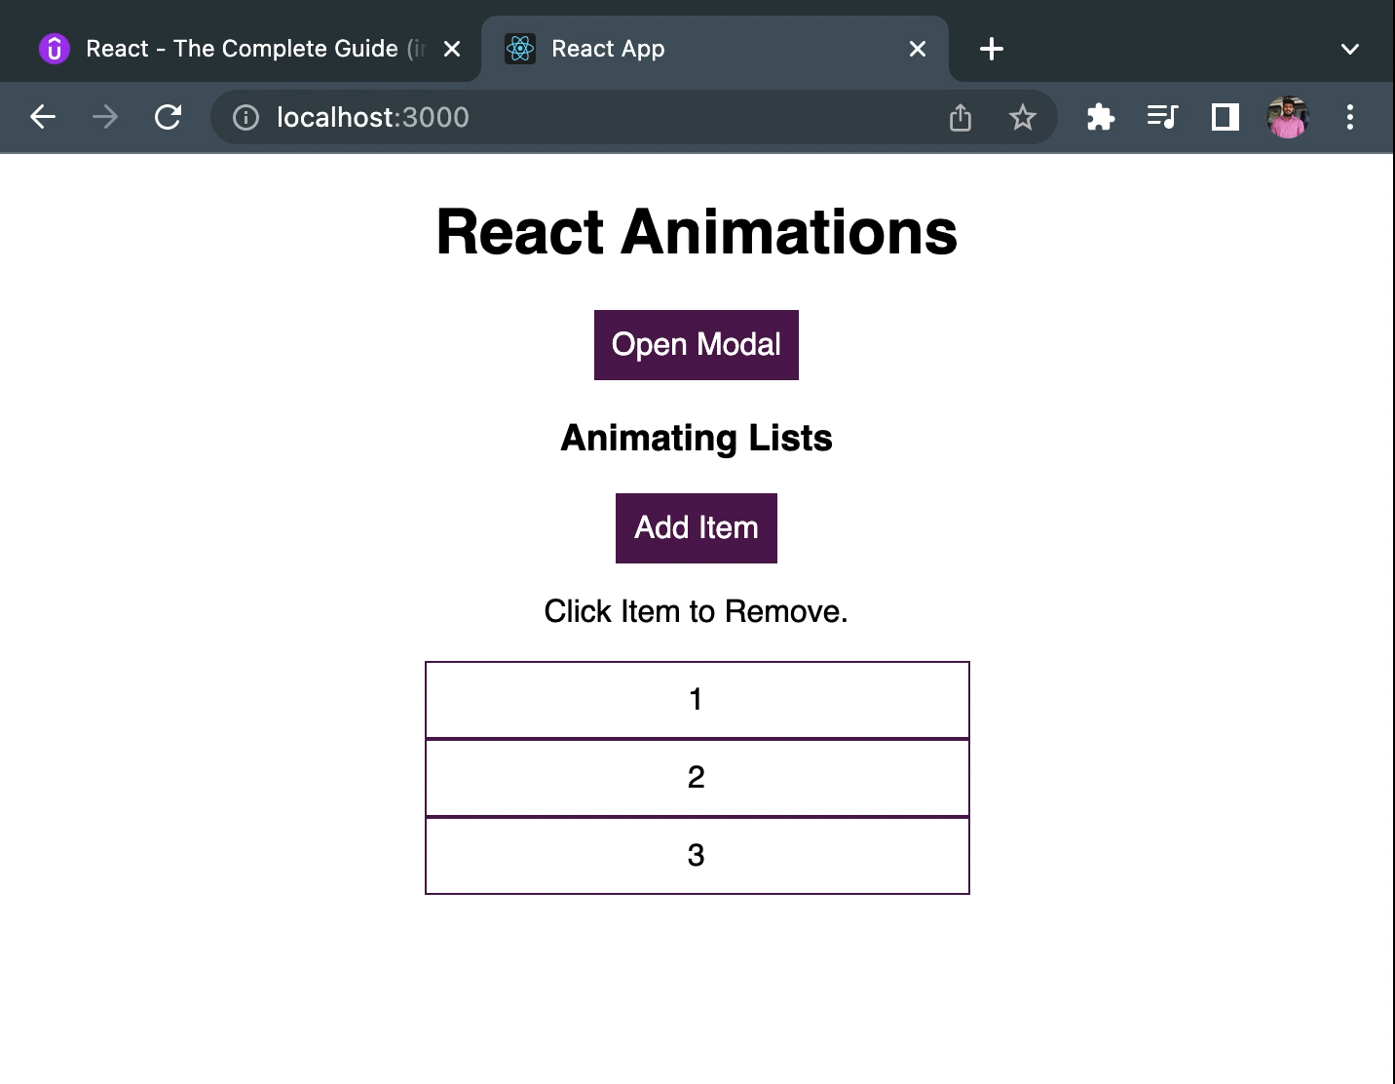

## Using ReactTransition group

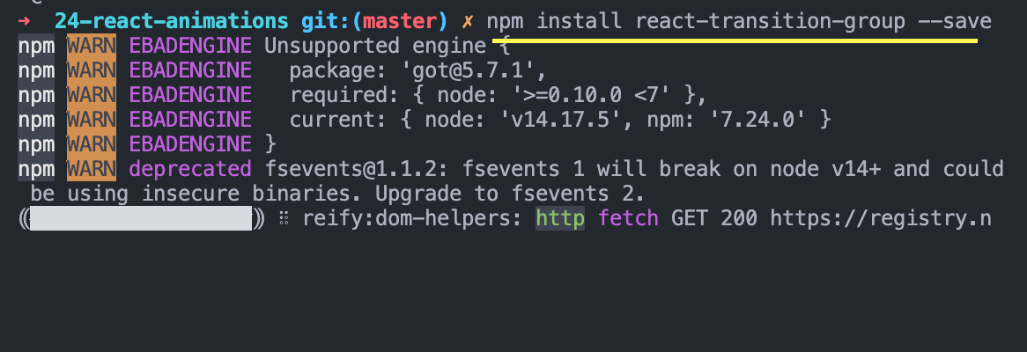

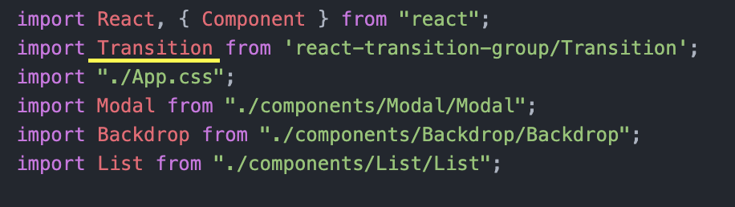

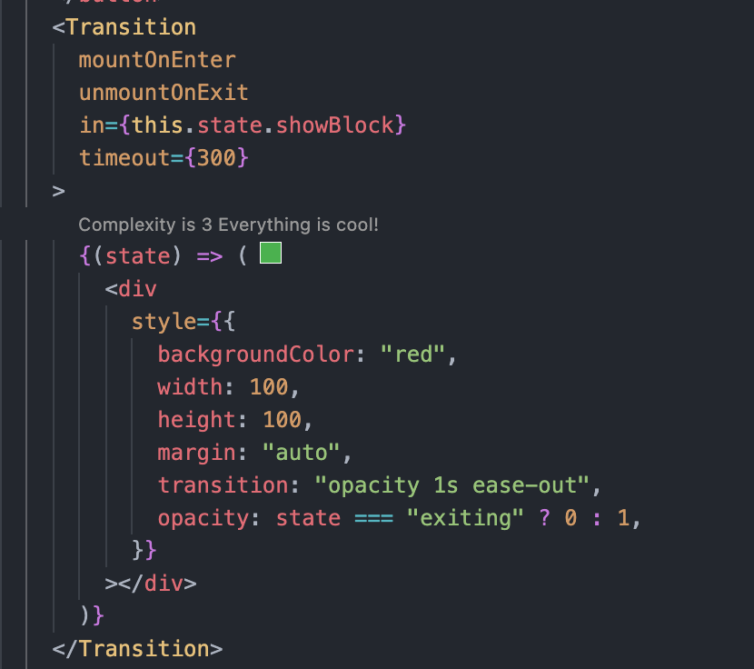

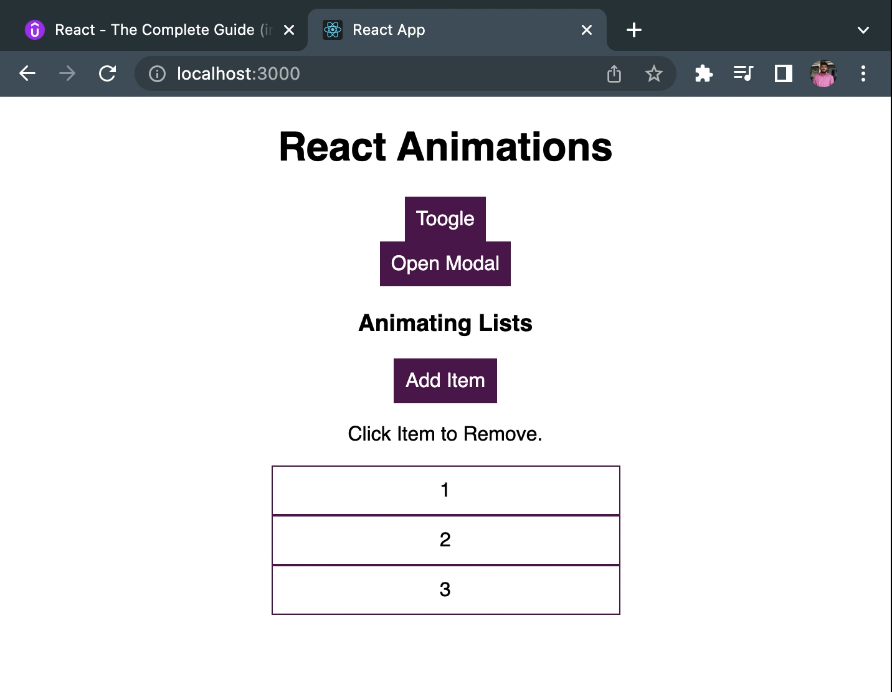

## Adding Transition to Model Popup

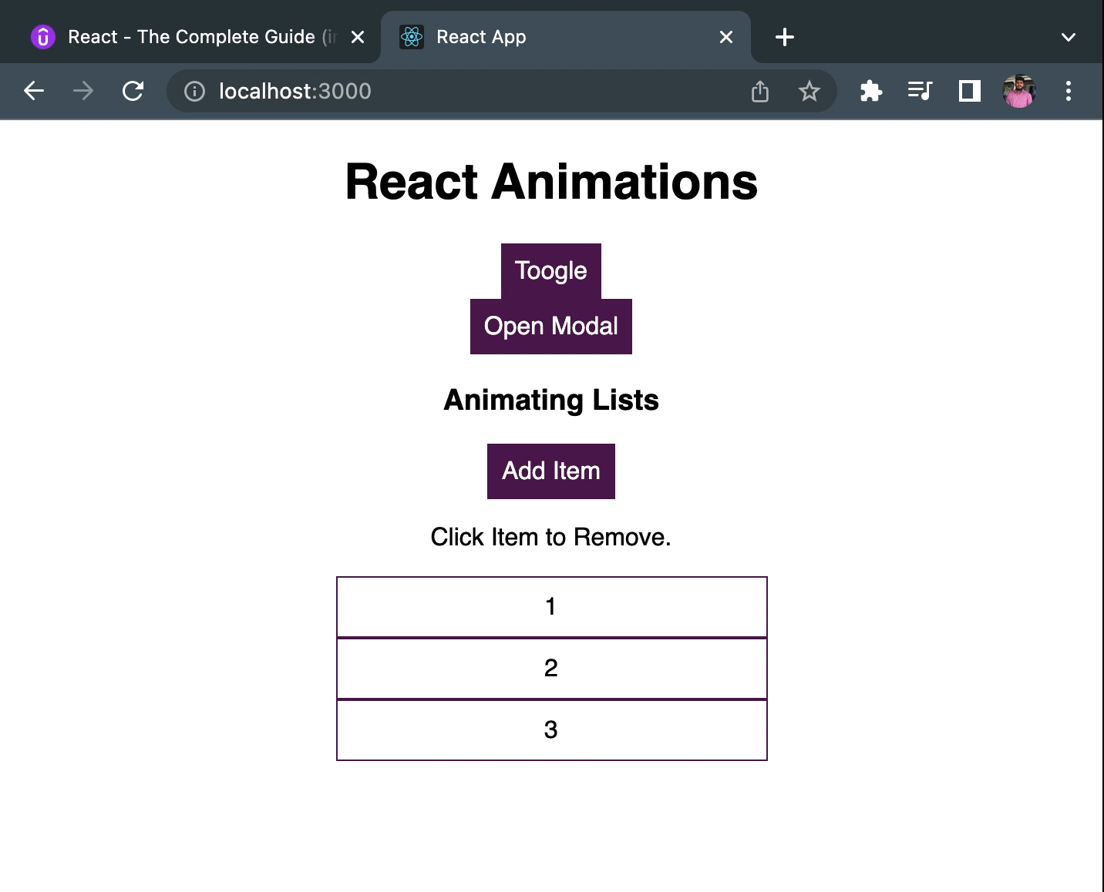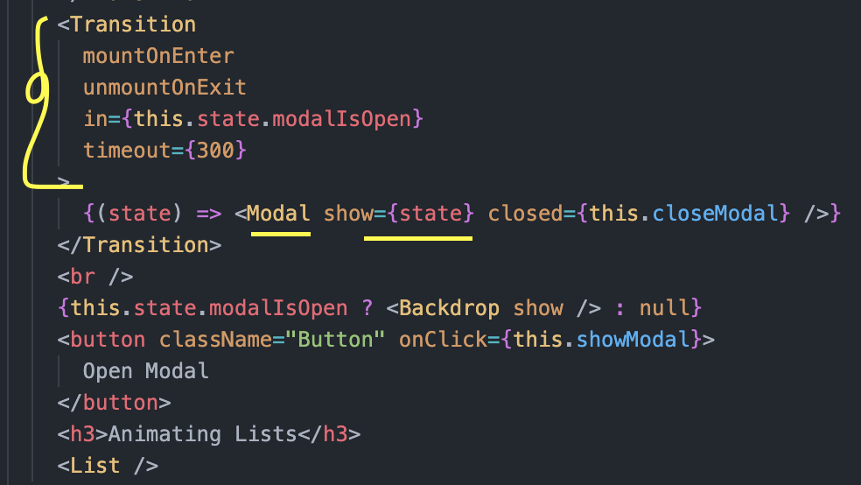

## Wrapping the Transition Component

It will work the same way as the previous demo video.

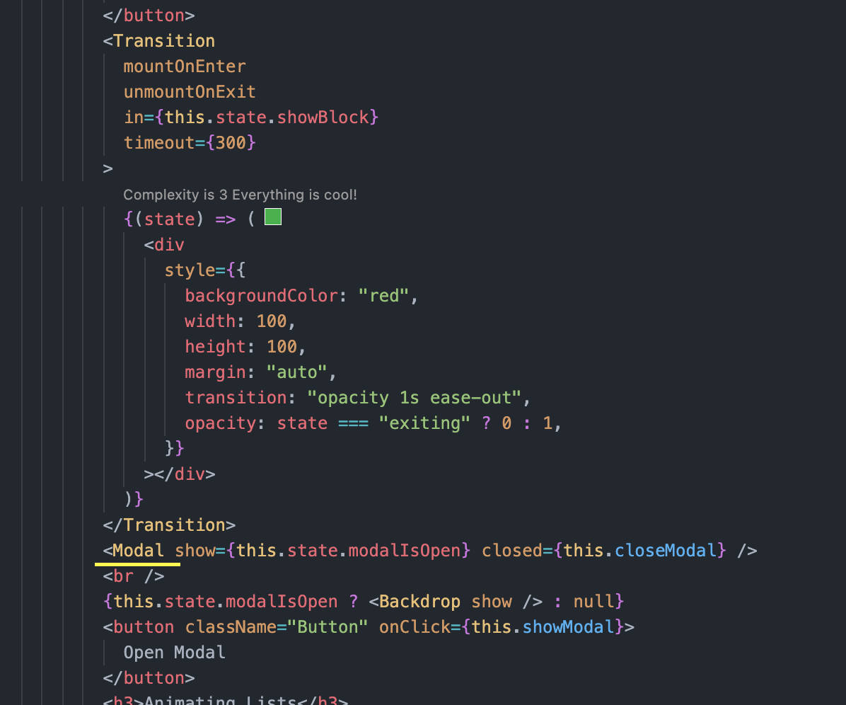

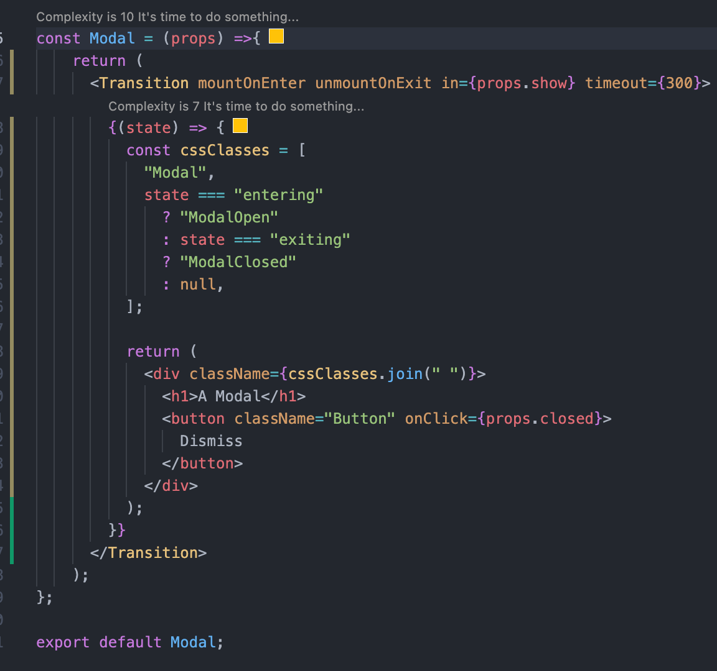

## Animation Timings

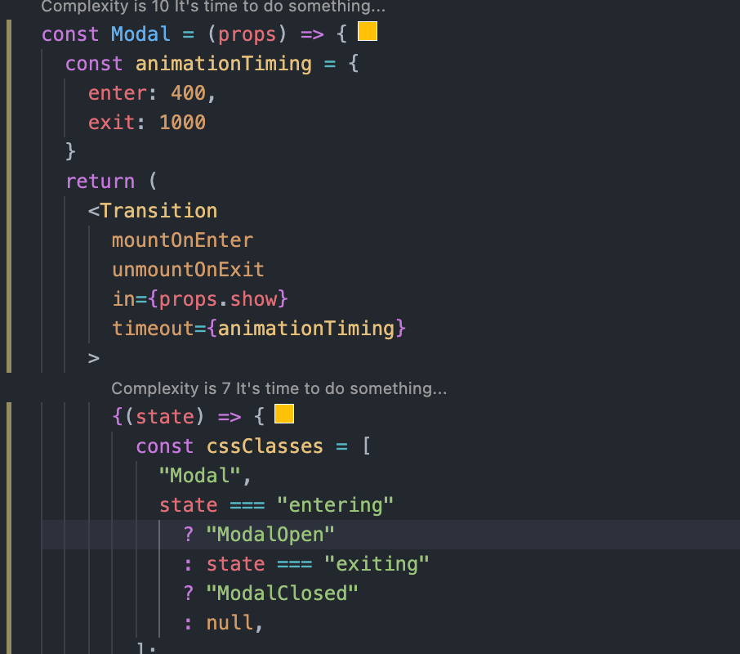

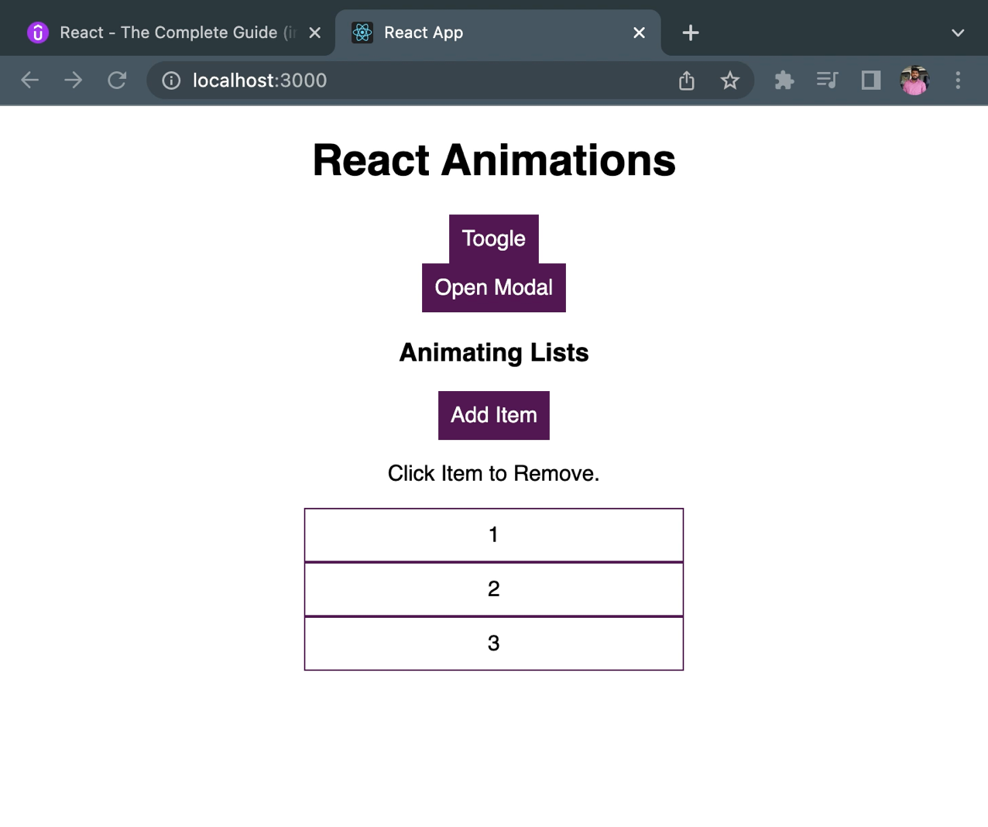

## Transition Events

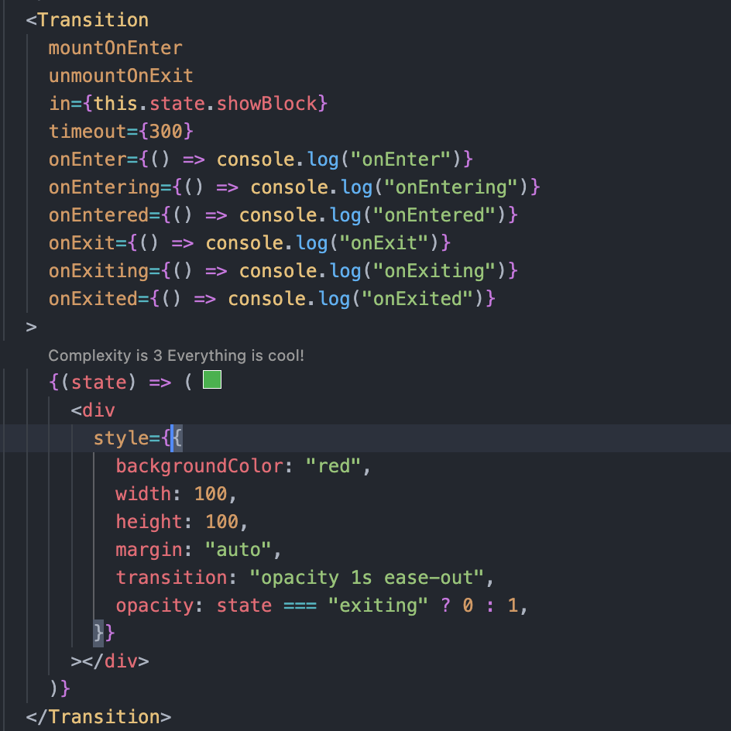

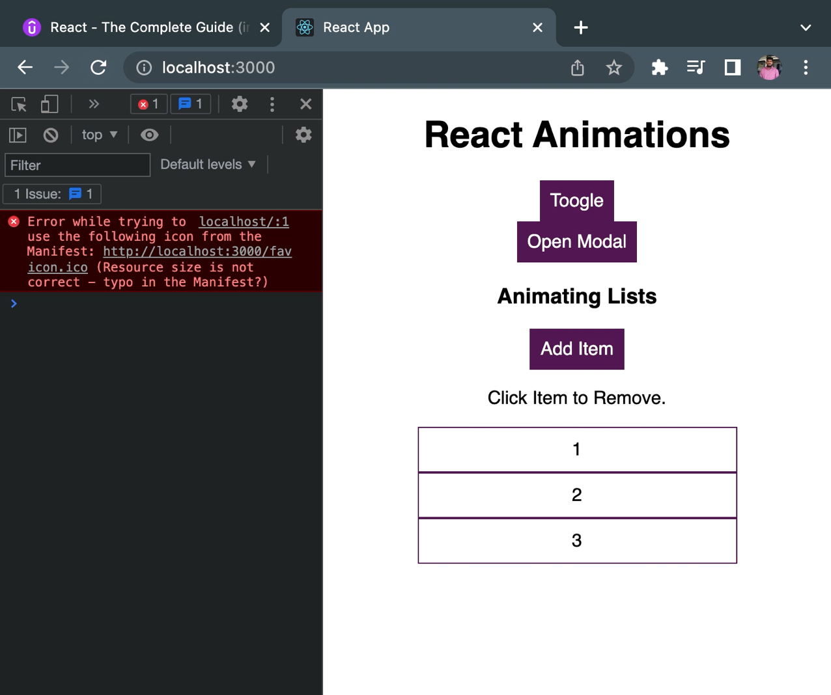

## CSSTransition component

Handling the animation through different CSS class names which will be applied on different events.

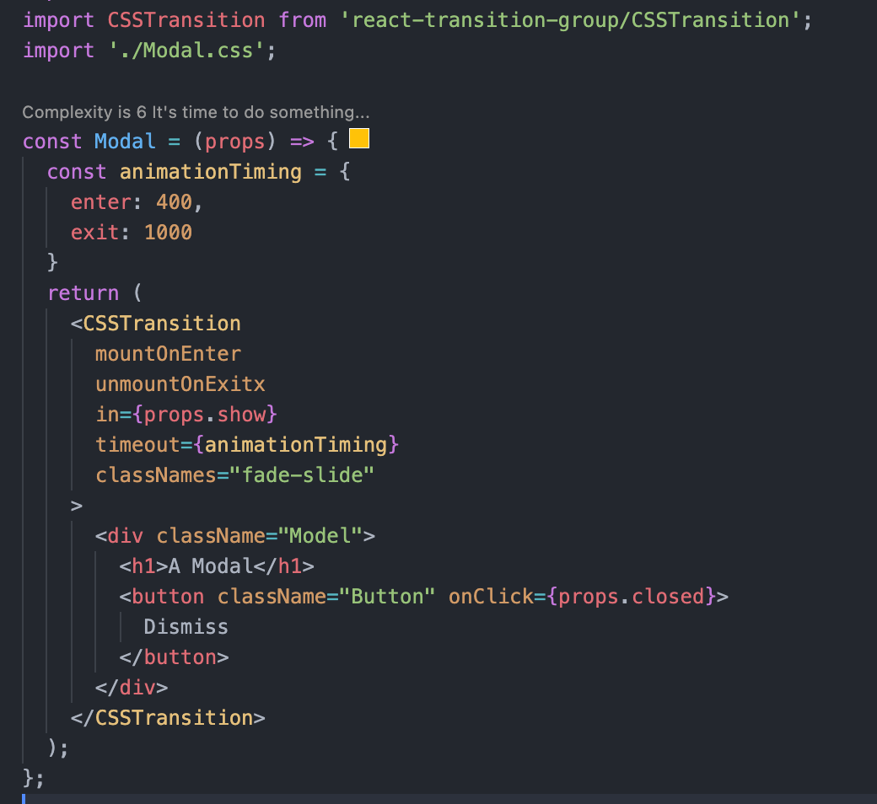

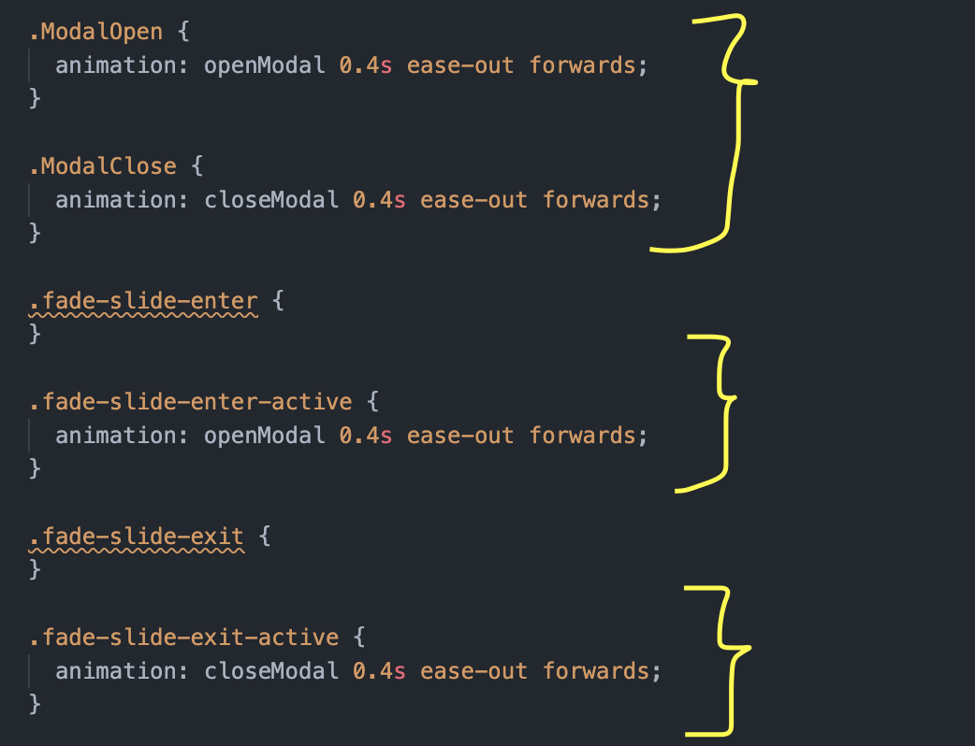

## Using a classnames in CSSTransition component

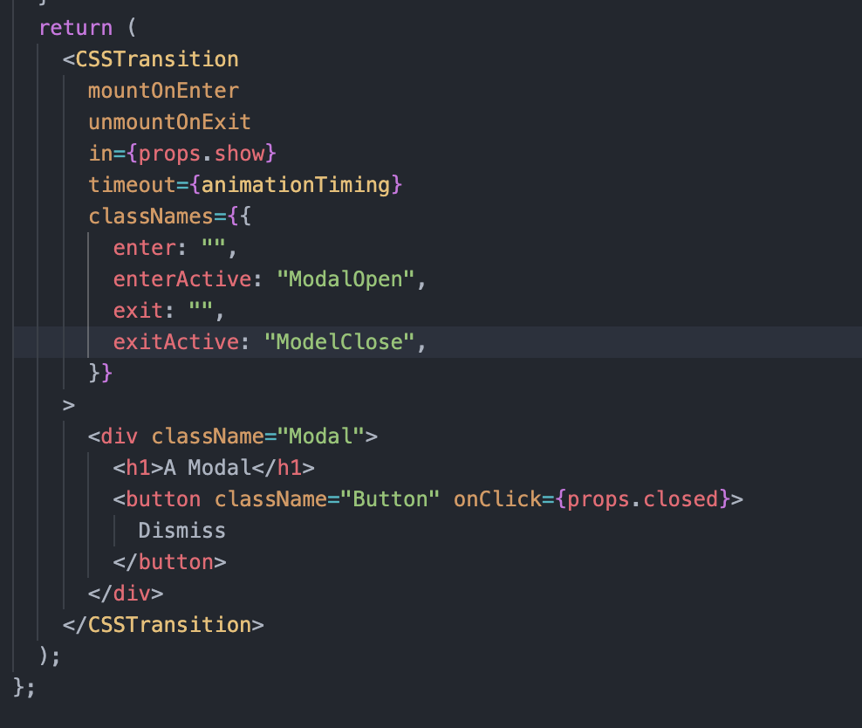

## Using TransitionGroup to manage multiple transitions

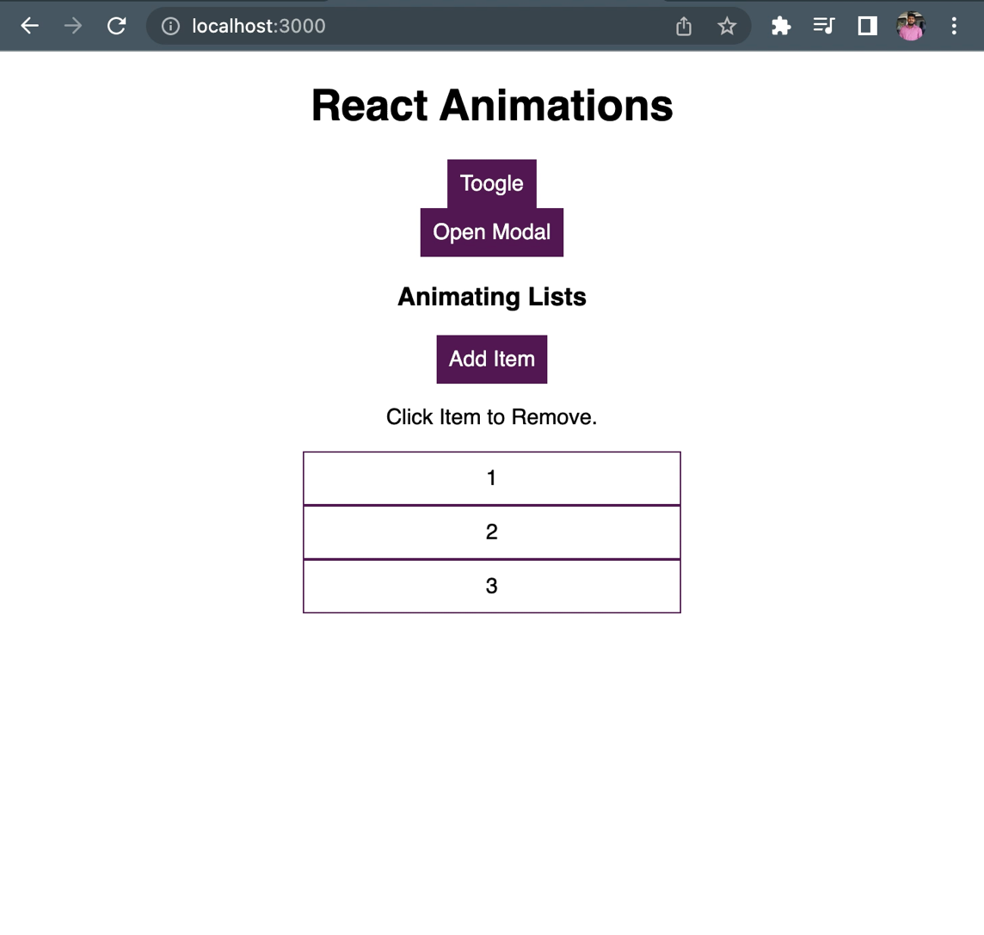

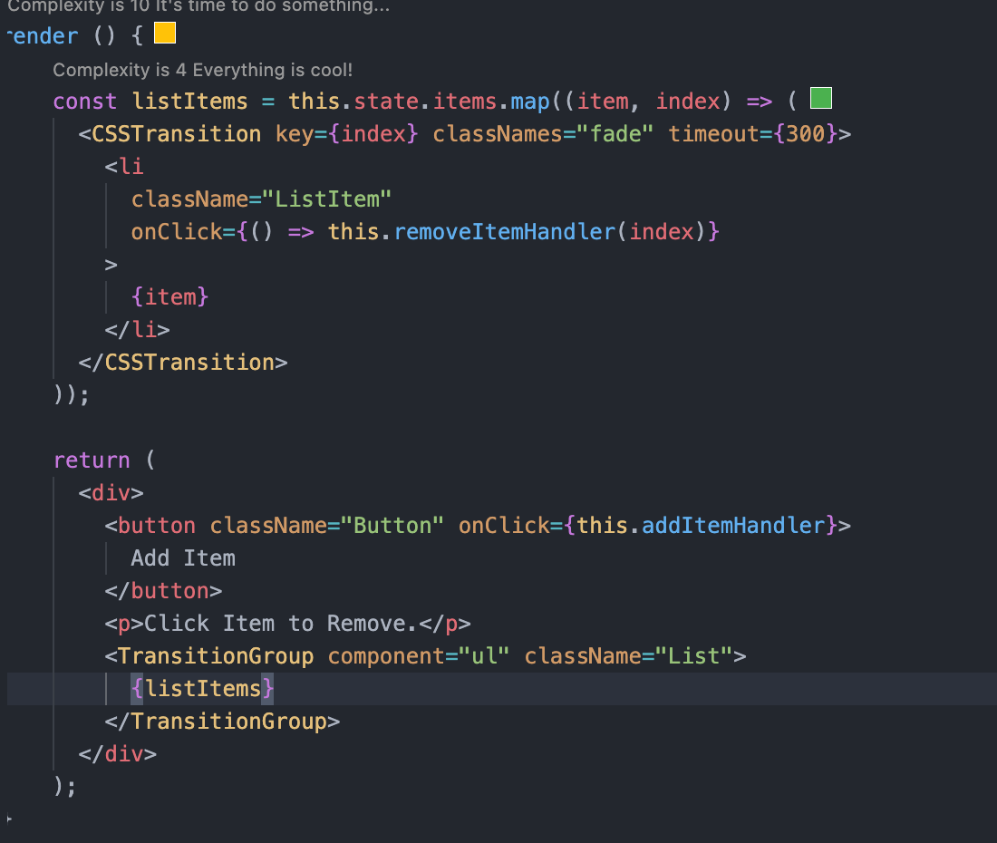

## Other React Animation Library

React Move

React Route Transition

# Replacing Redux with React Hooks

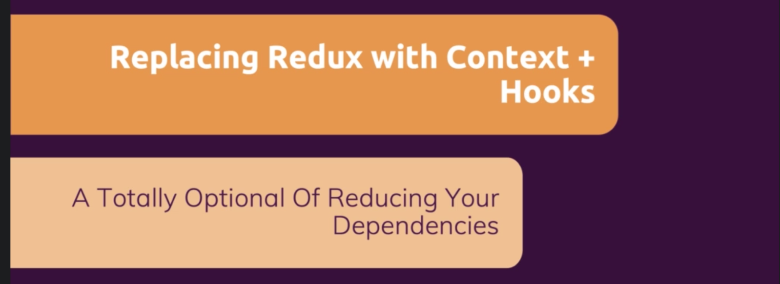

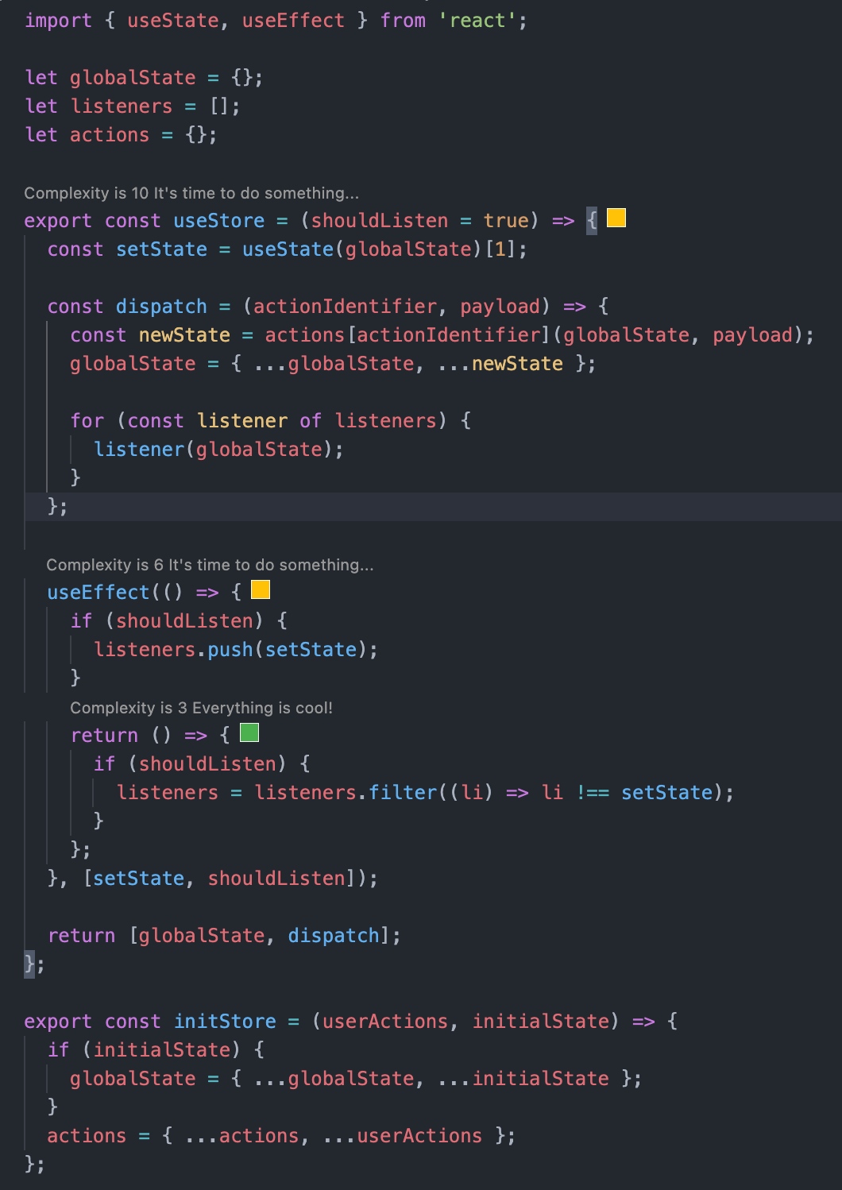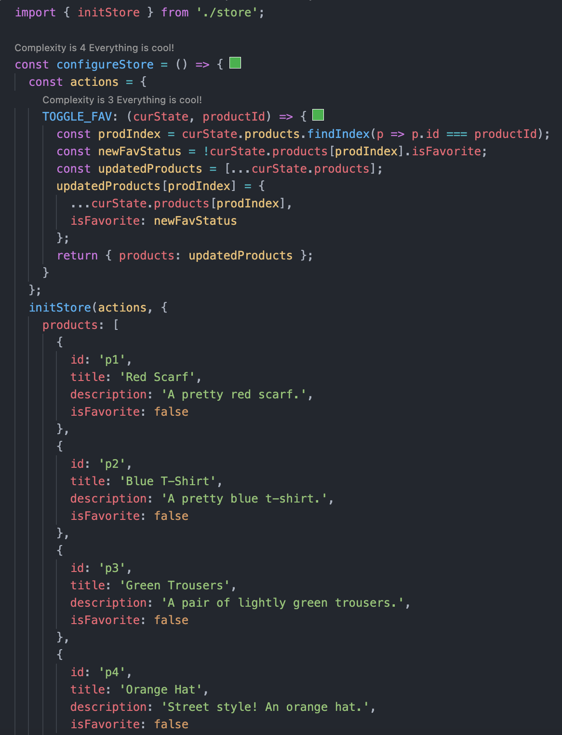

# Testing React App

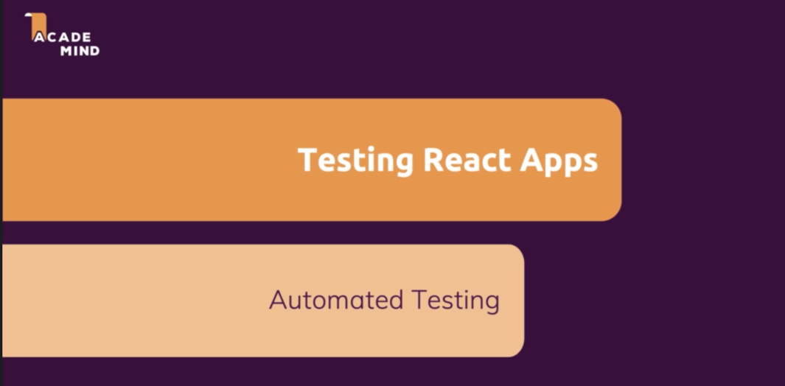

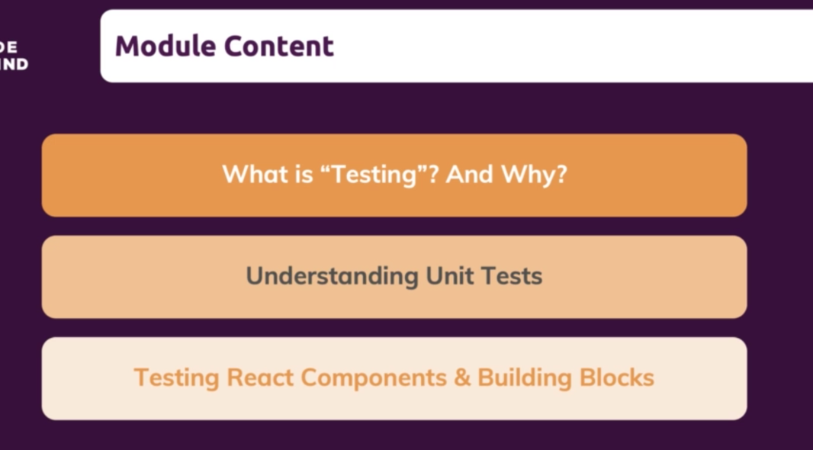

## What is Testing?

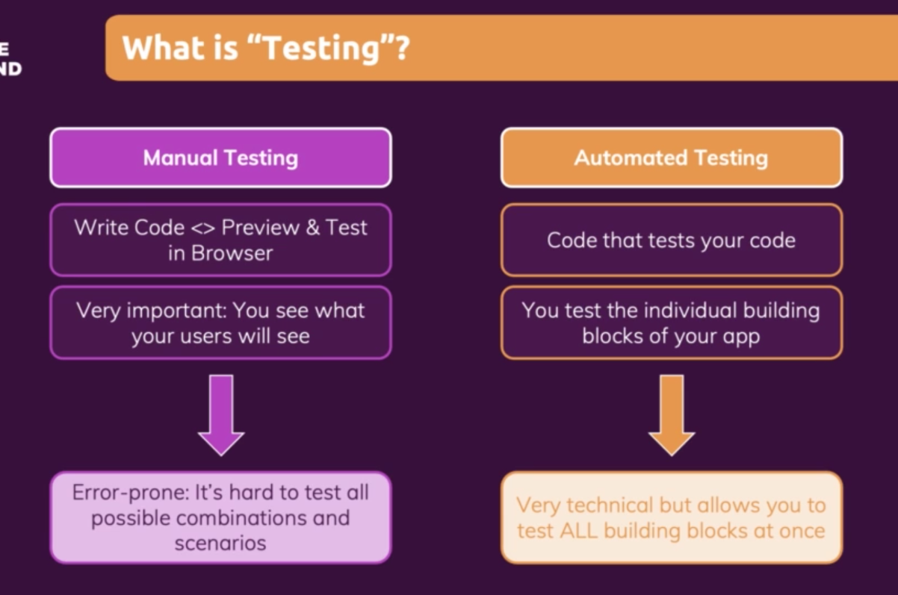

## Different Kind of Test

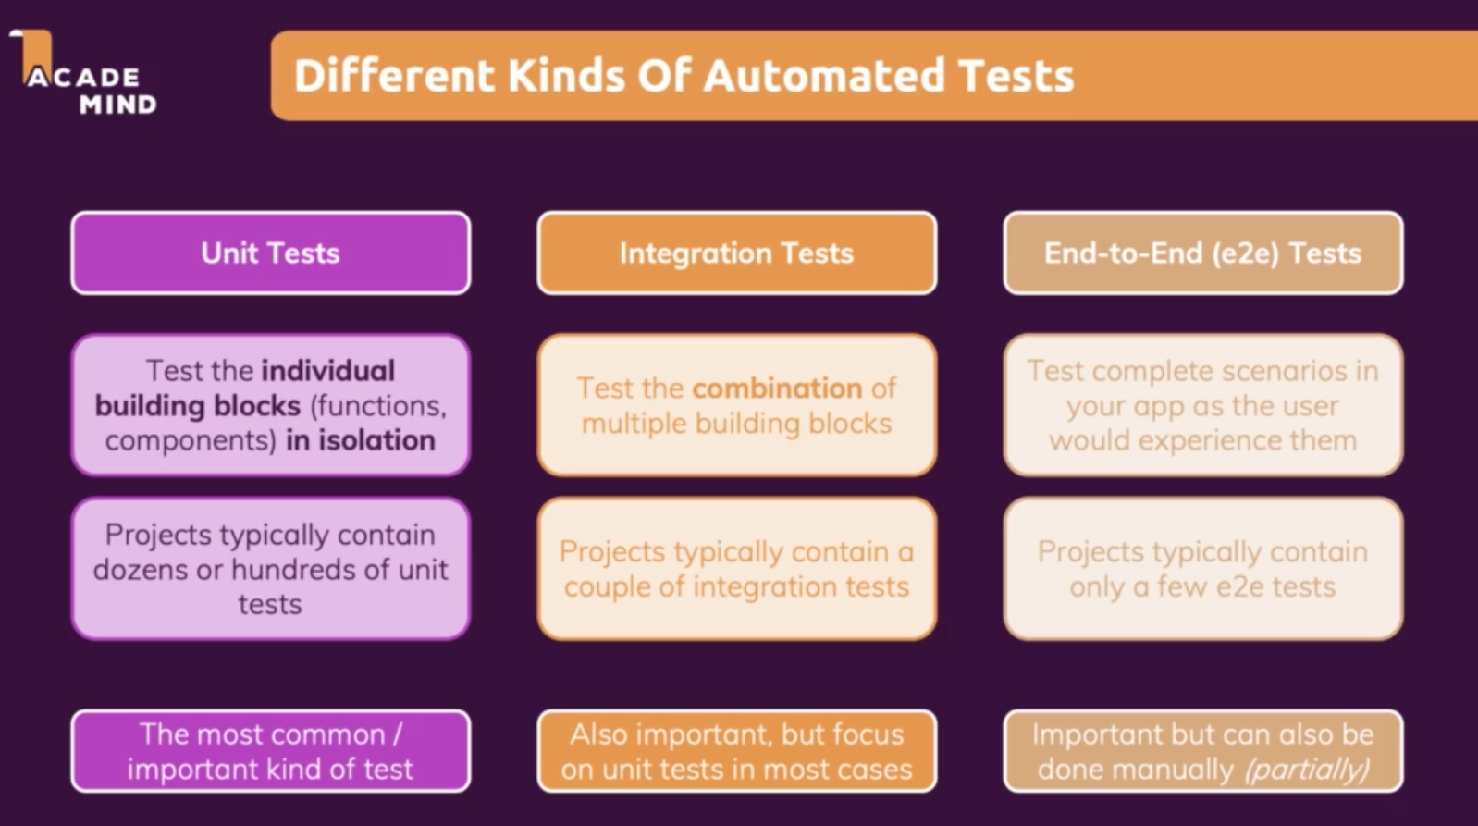

## What to test ?

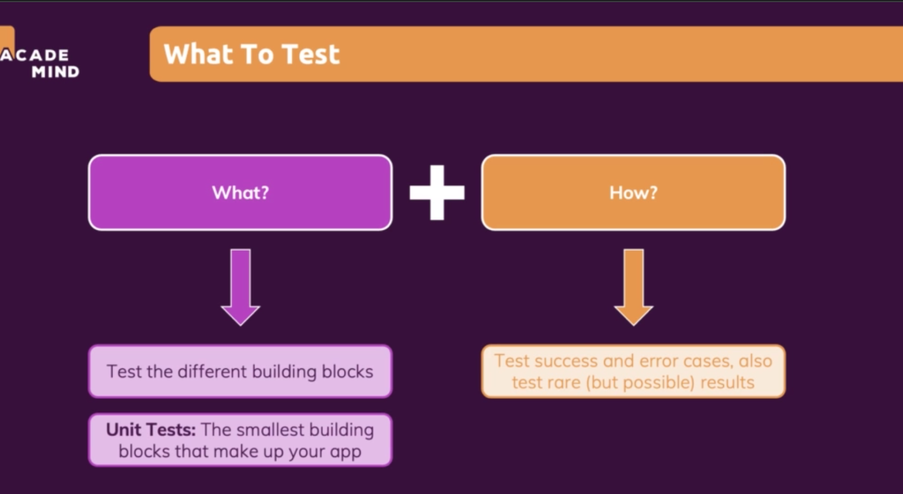

## Running the test

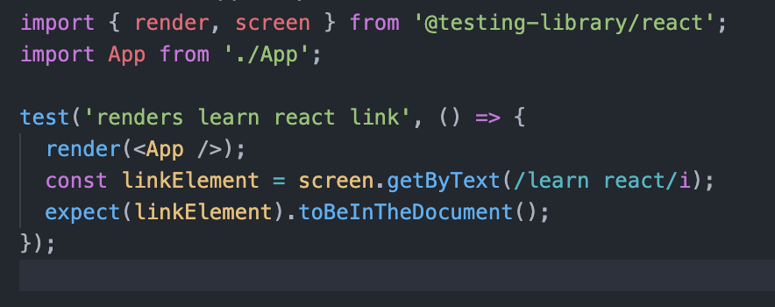

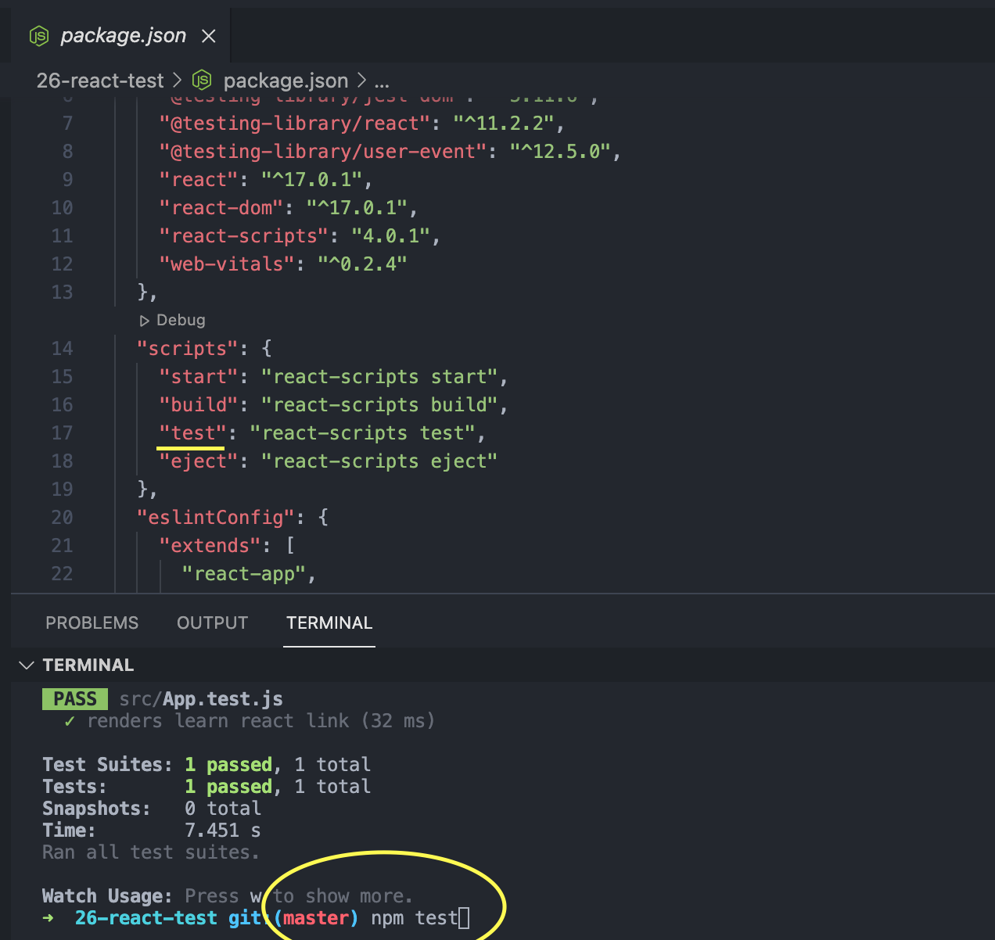

## Writing a test

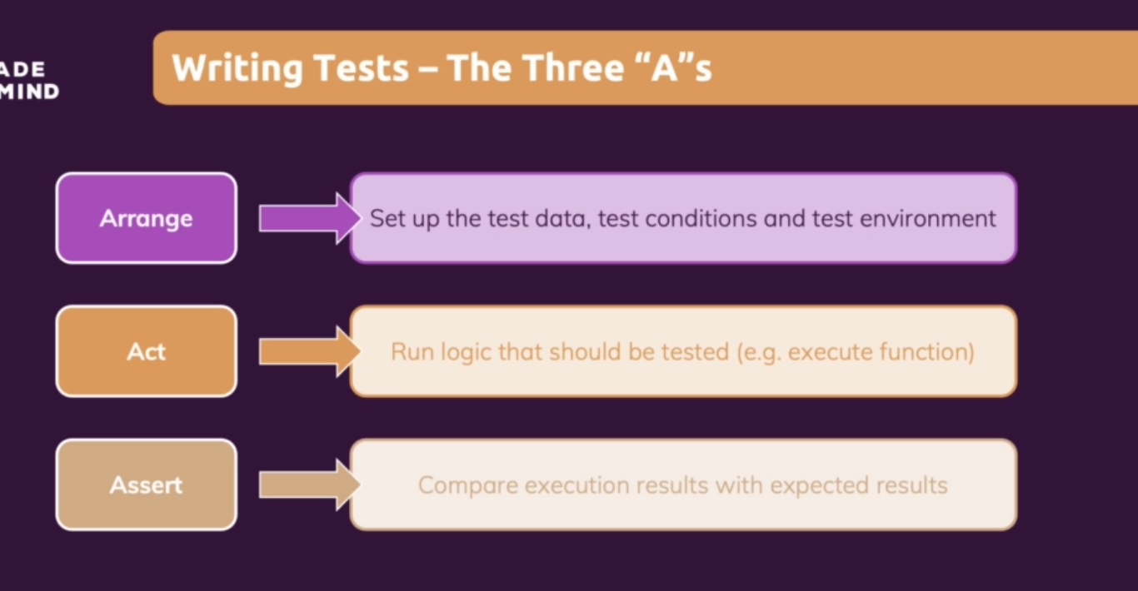

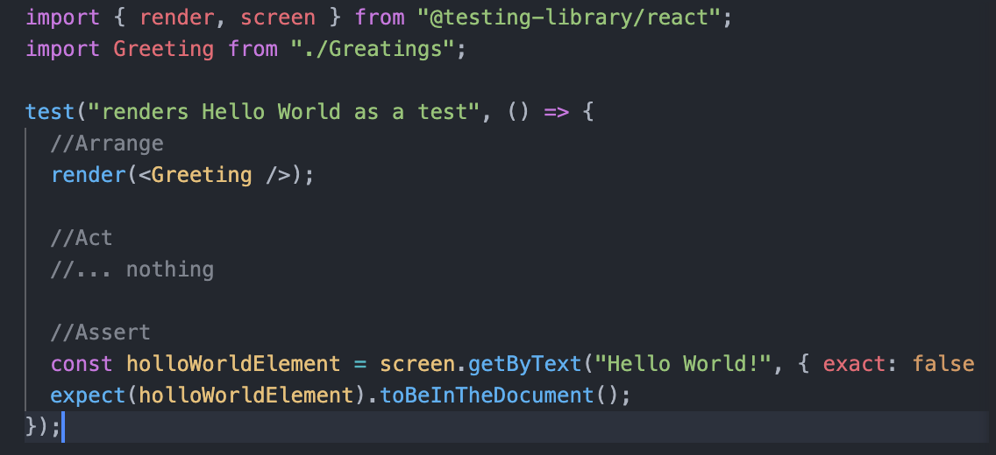

Here exact is true out of the box.

## Grouping test together with Test Suites

Describe function use to combine the test together.

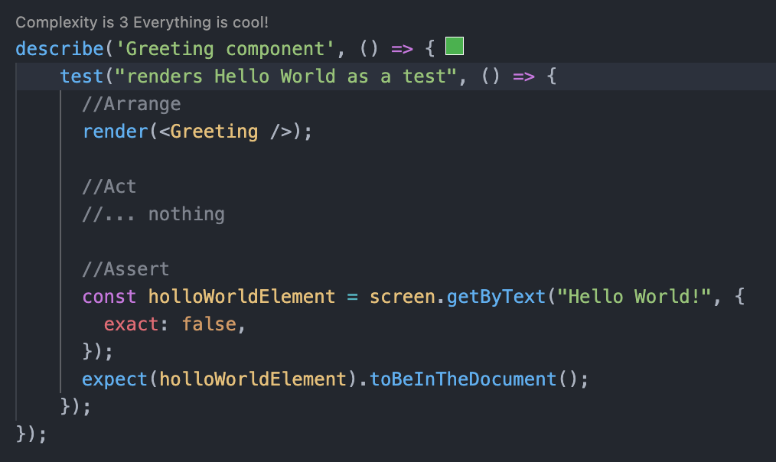

Testing User Interaction and state

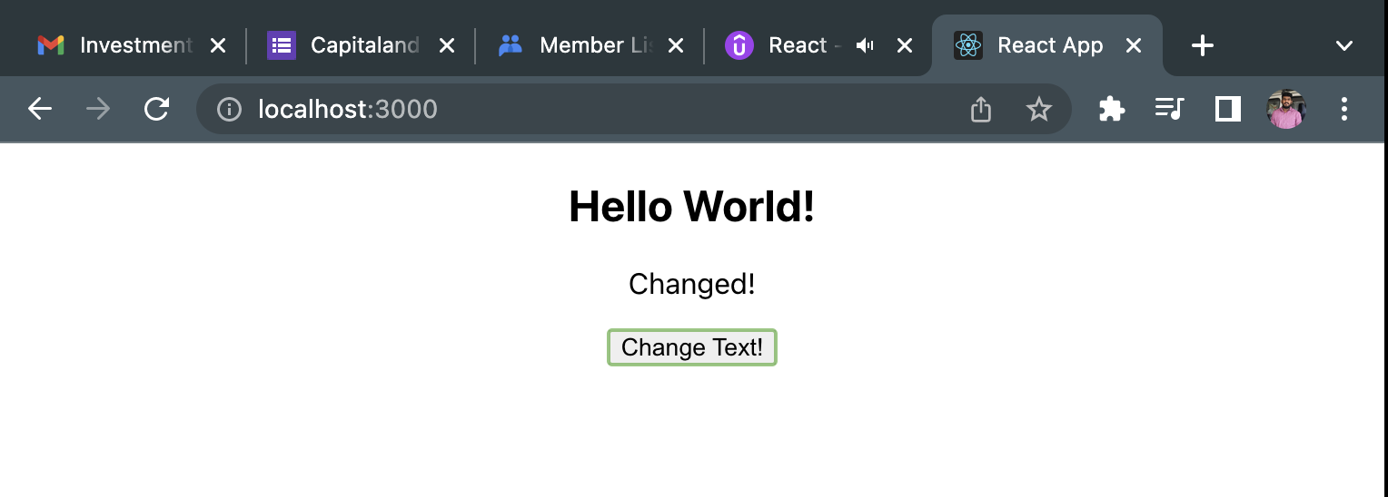

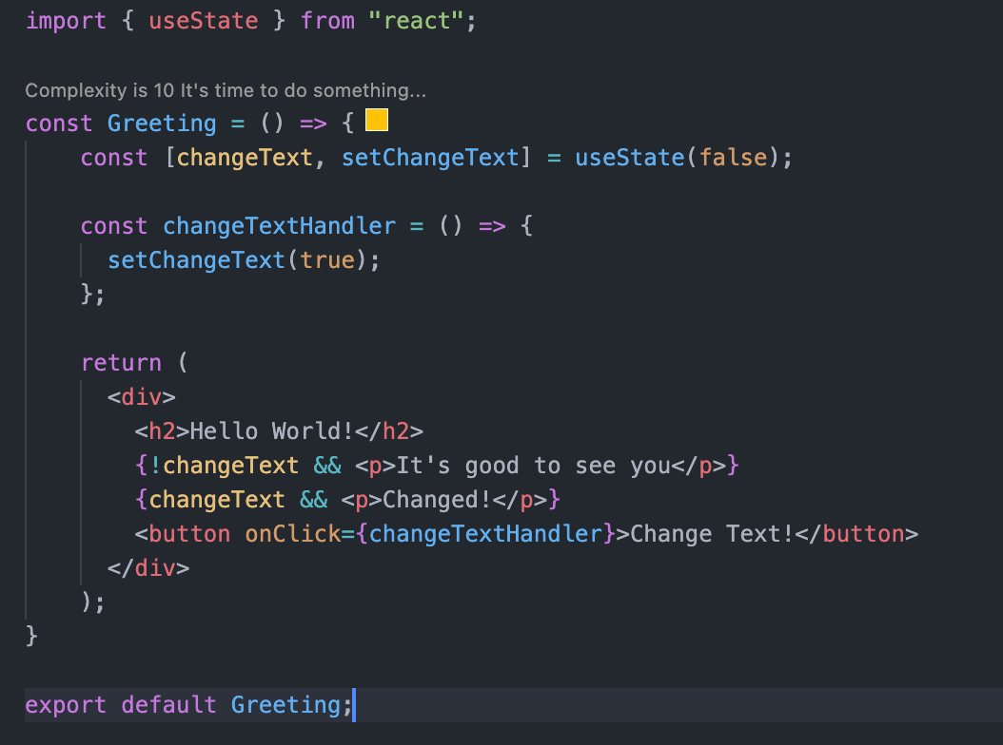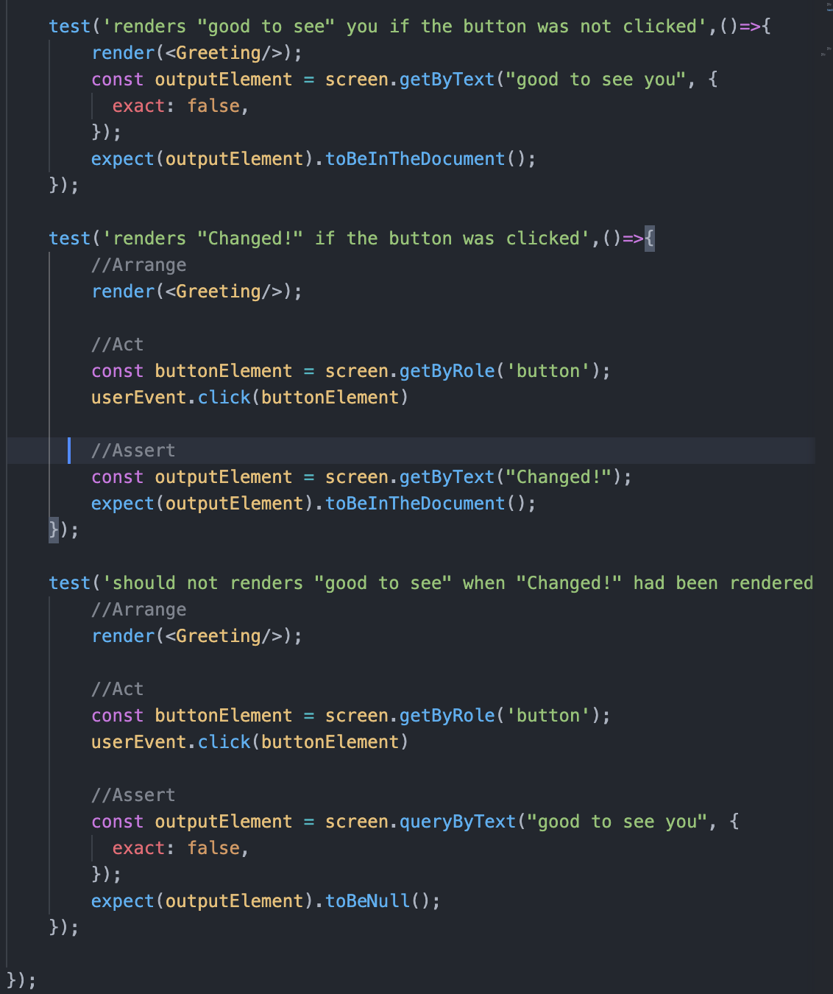

## Testing connected component

Here “Output” component will be rendered part of the Greeting component.

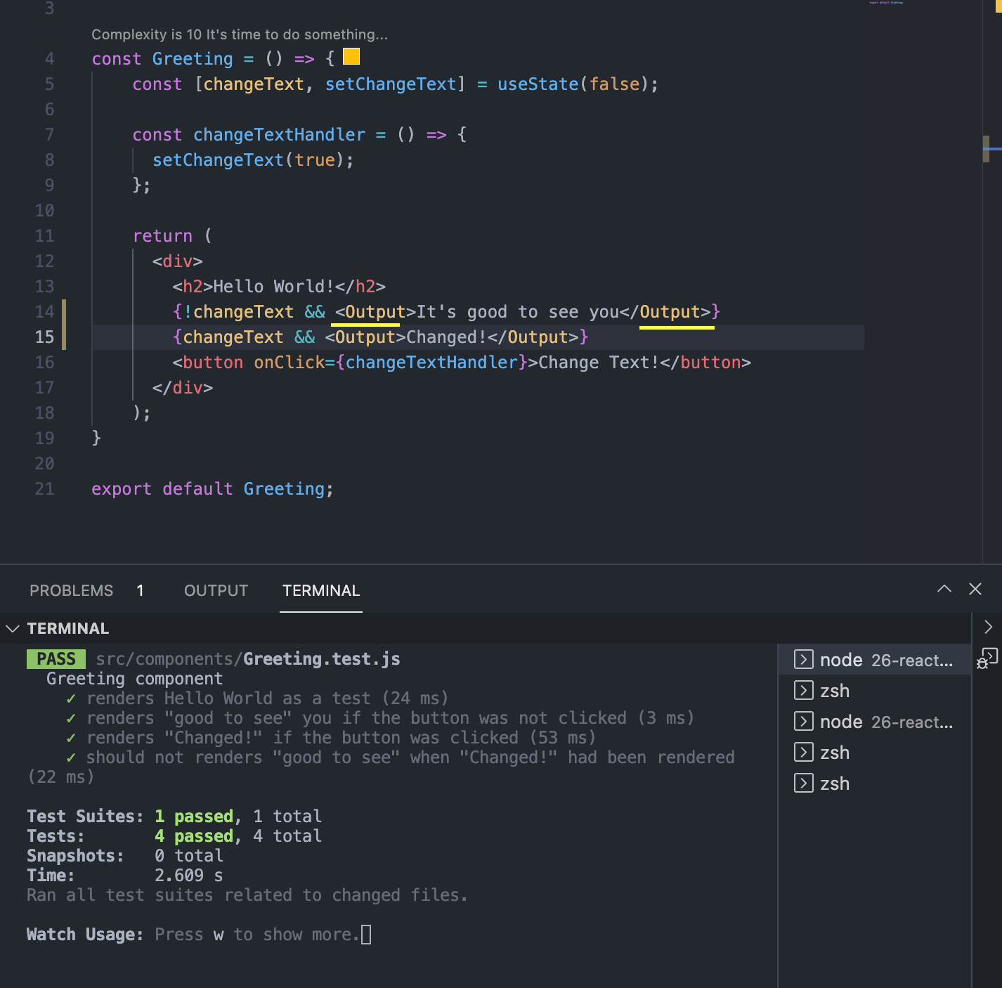

## Testing Asynchronous Code

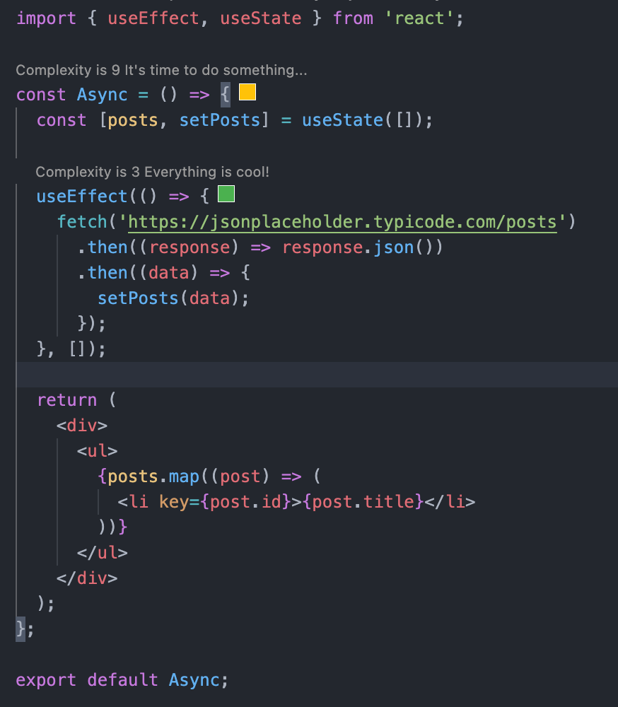

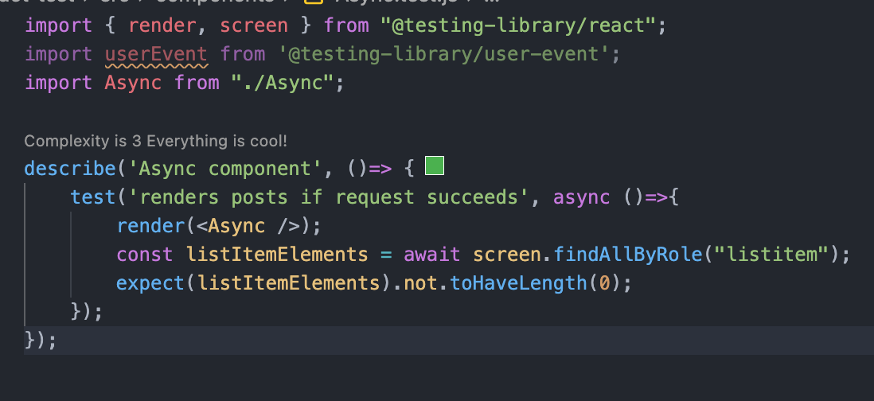

## Working with Mock

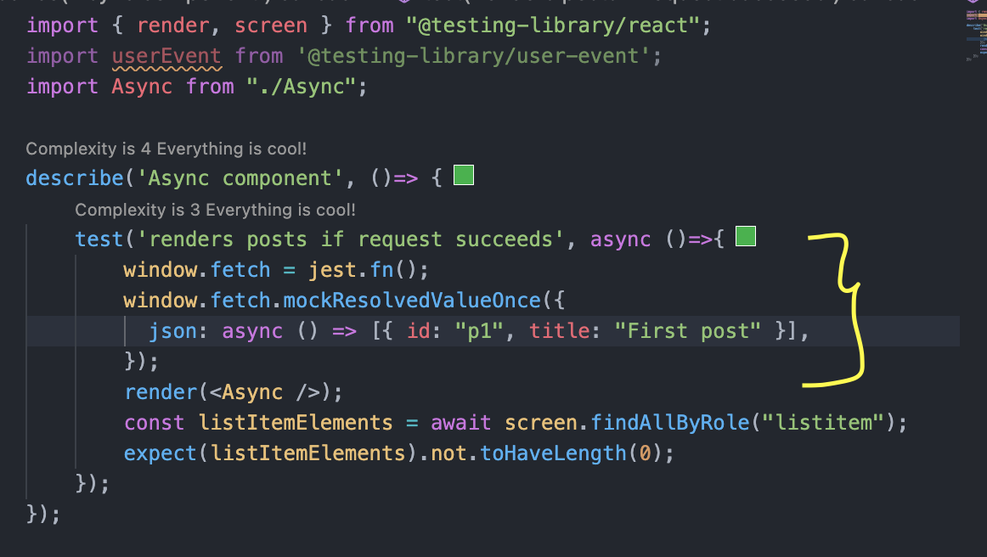

<https://www.w3.org/TR/html-aria/#docconformance>

# React + Typescript

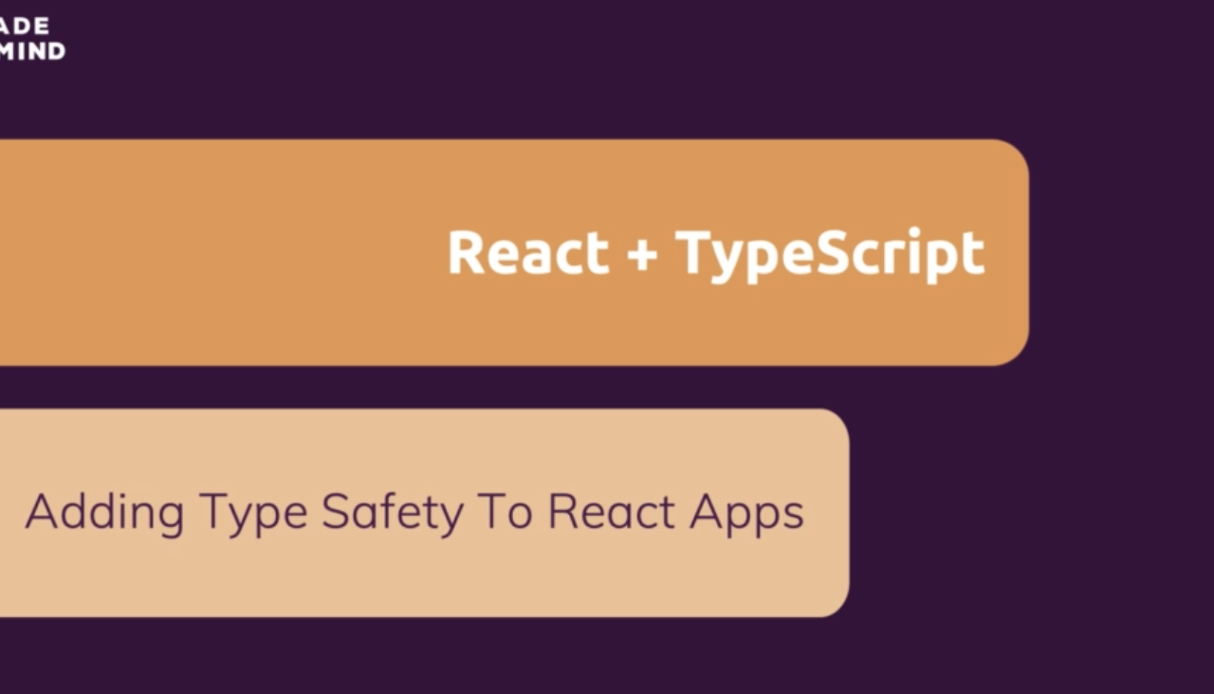

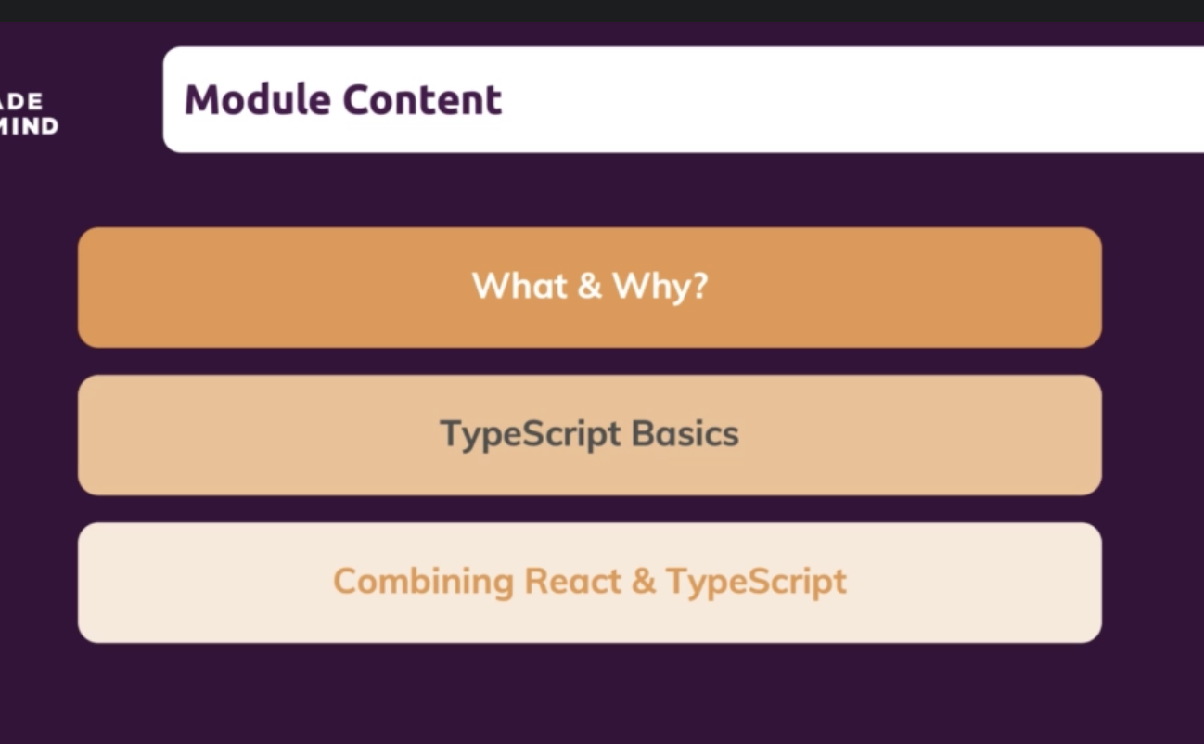

# What and Why?



Extends the core JavaScript

JavaScript is dynamically typed. No need to specify a variable type ahead of time. JavaScript will recognize the type and act accordingly.

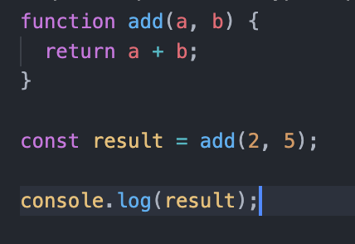

Typescript is statically typed. We need to specify the type of a variable ahead of time. Since the Typescript is statically typed, the application becomes less error prone.

As we can see in below JavaScript (dynamically typed language) example, variable “a” and “b” accepts both numbers and string.

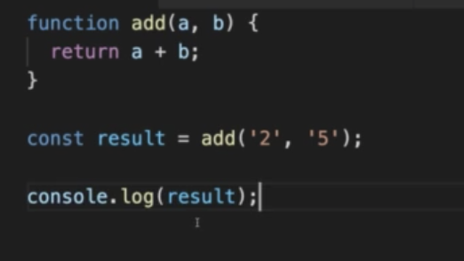

As we can see in below Typescript (dynamically typed language) example, variable “a” and “b” accepts only numbers. That’s the reason we are getting an error in line number 5 because of string is being passed in place of number.

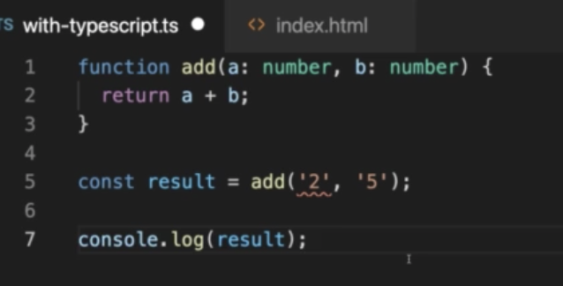

## Installing Typescript

### npm init -y

Create a package.json file.

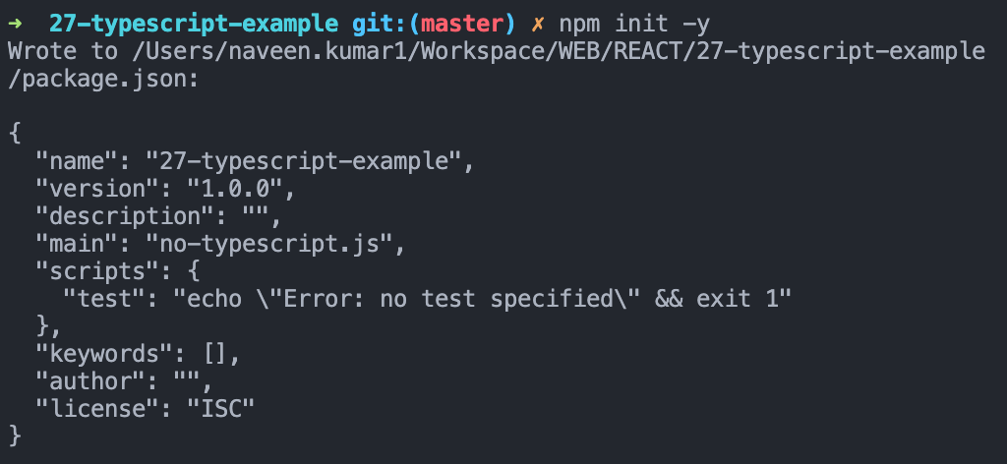

### npm install typescript

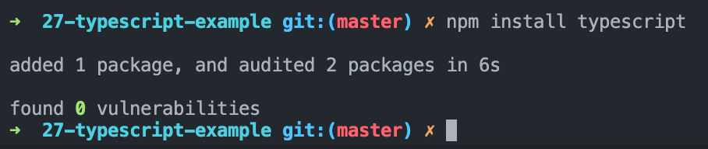

### Compiling type script to JavaScript

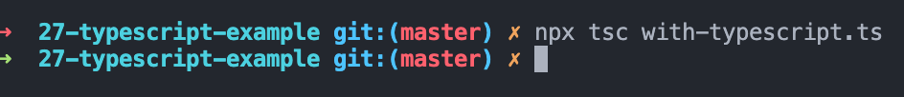

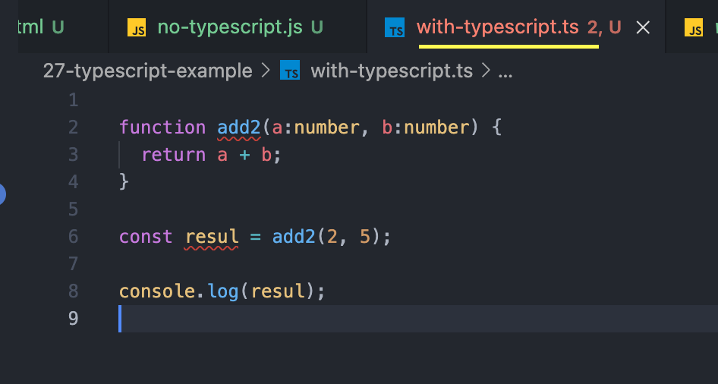

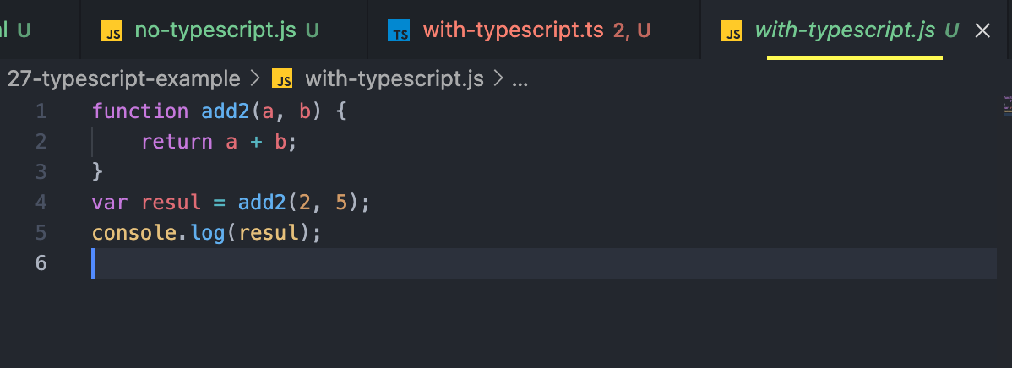

## Base Types

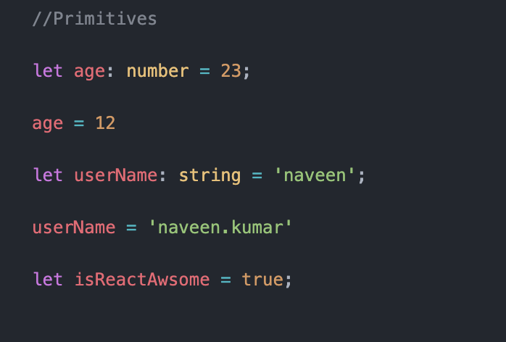

## Array and Objects

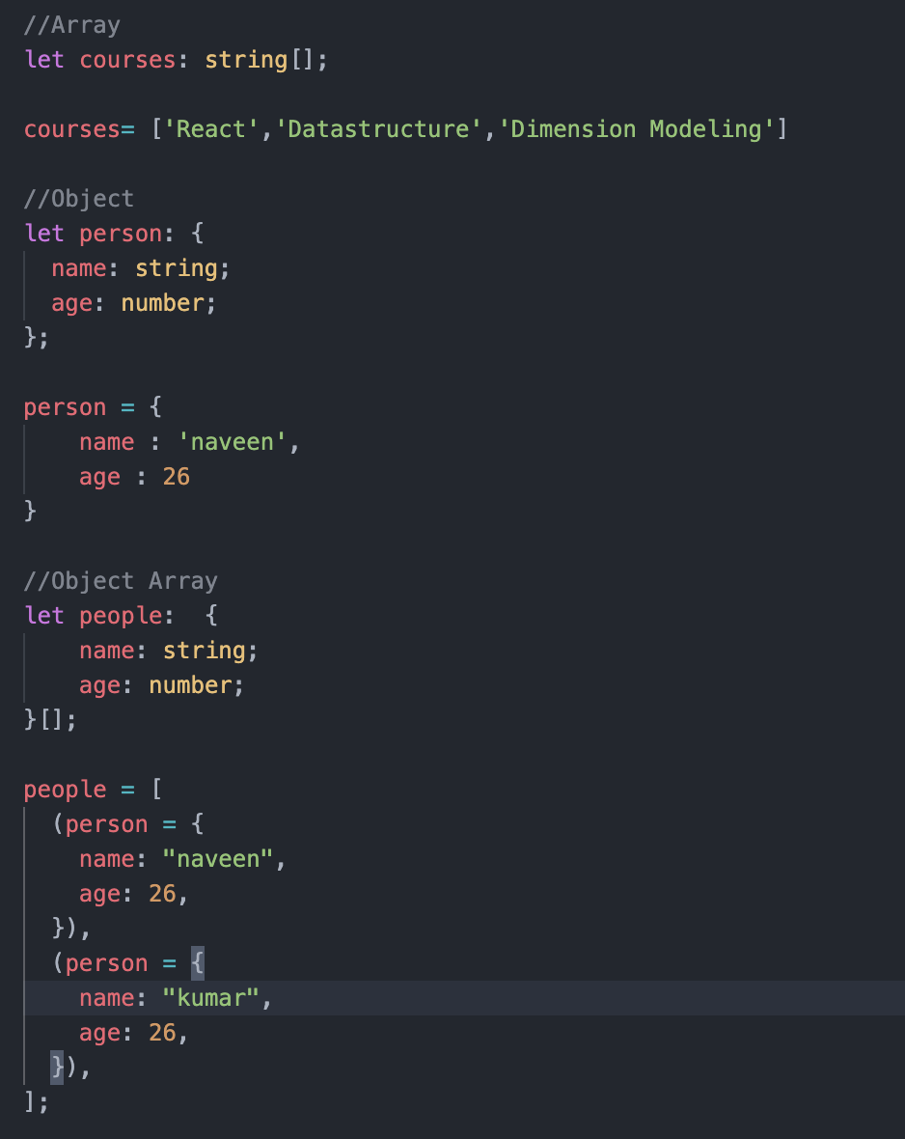

## Type Inference

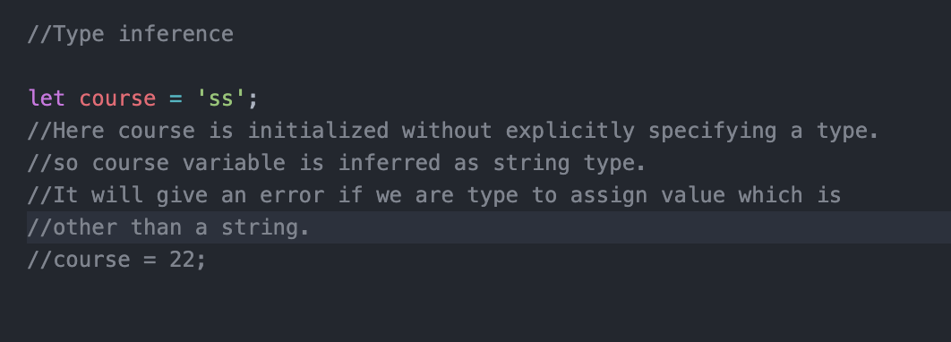

## Union Type

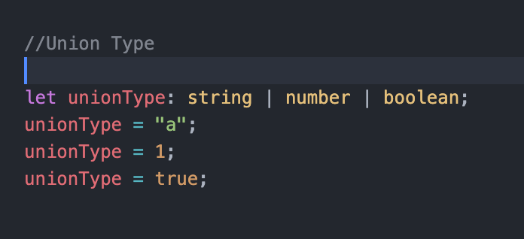

## Type alias

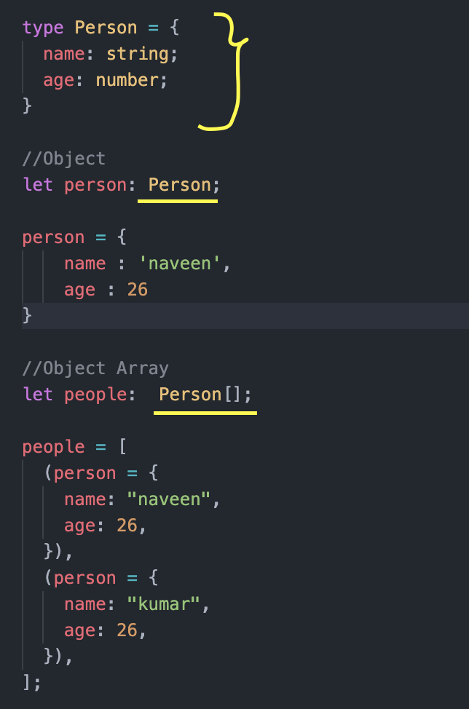

## Function and Function Types

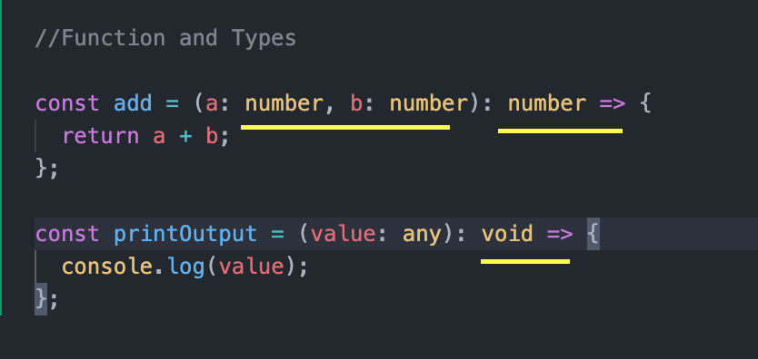

## Generics

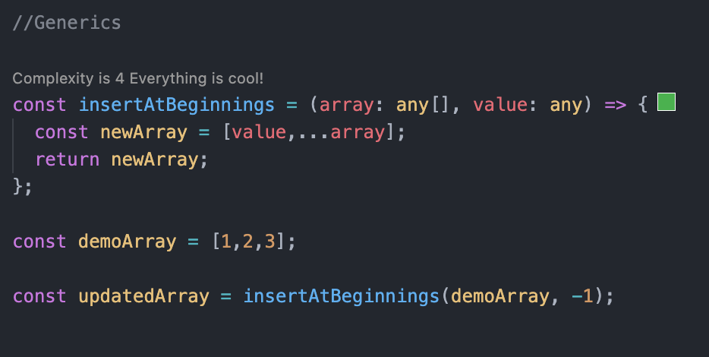

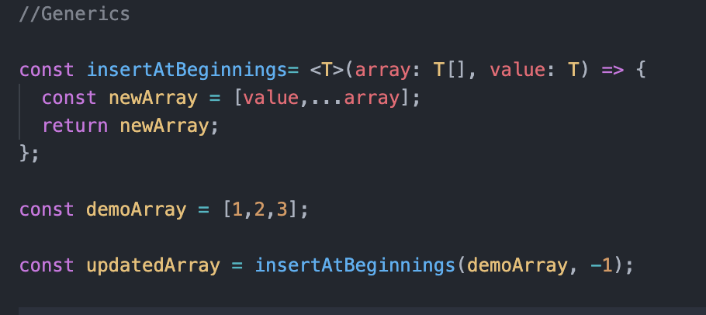

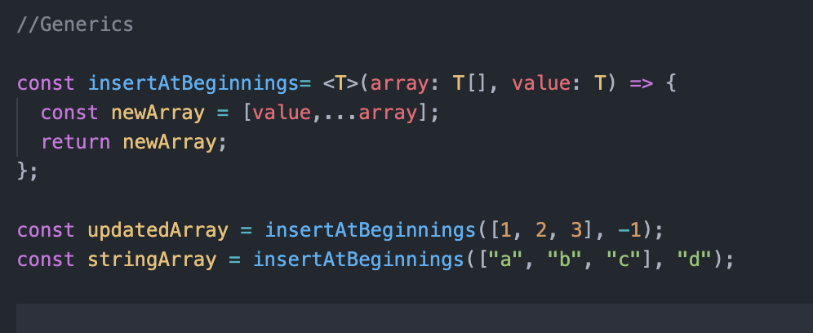

# Working with React TypeScript Project

## Creating a project

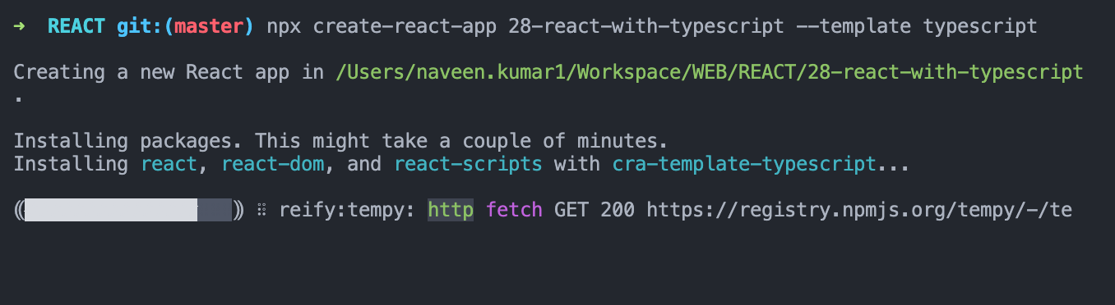

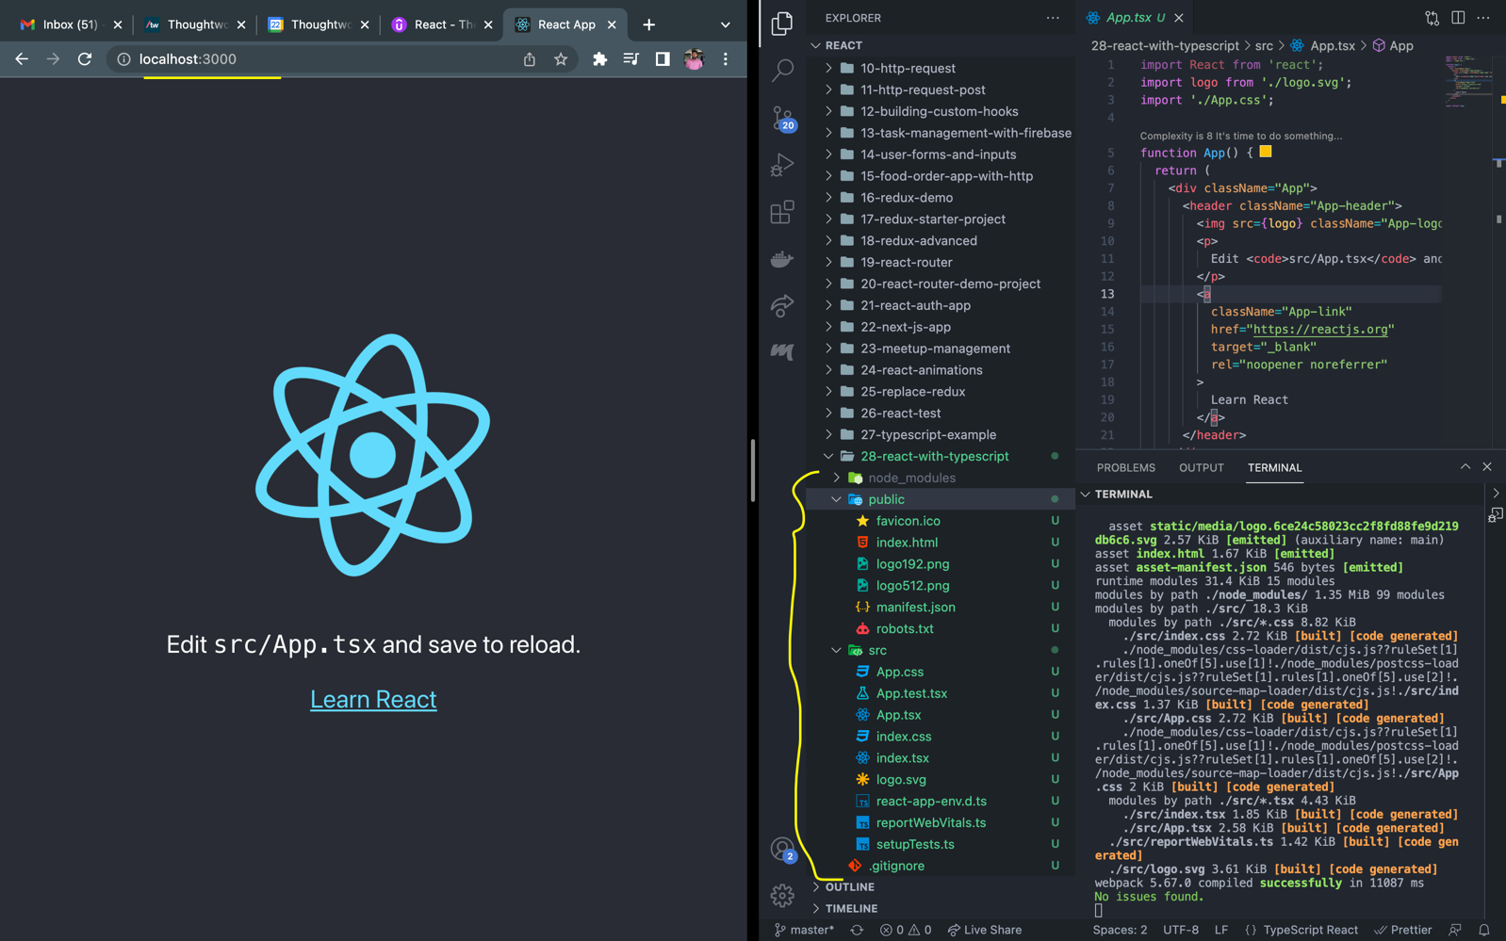

To run the typescript code, compiler internally convert the typescript code to JavaScript code. Below libraries from package.json file helps to do the conversion.

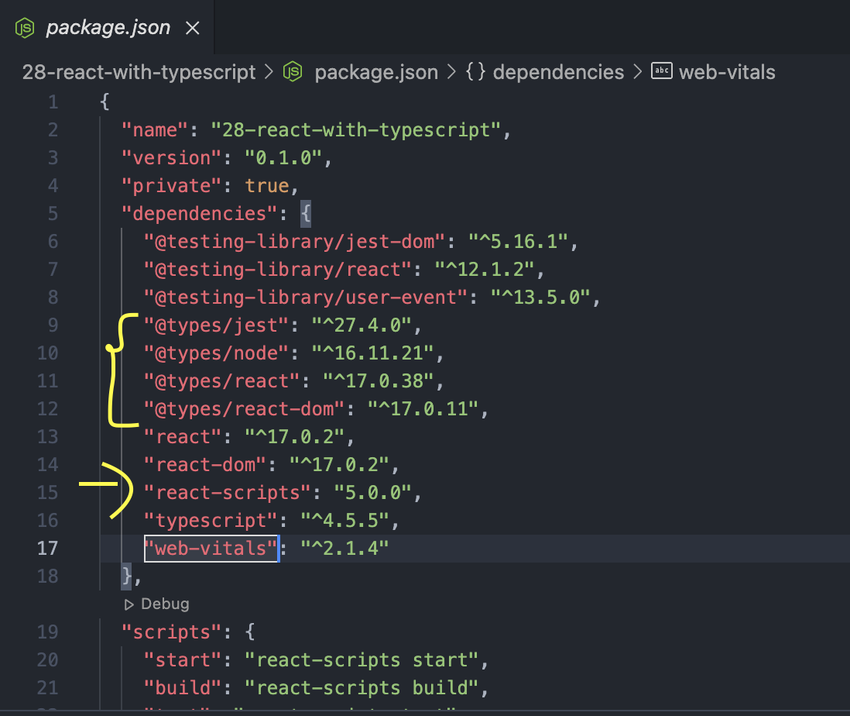

## Working with component and TypeScript

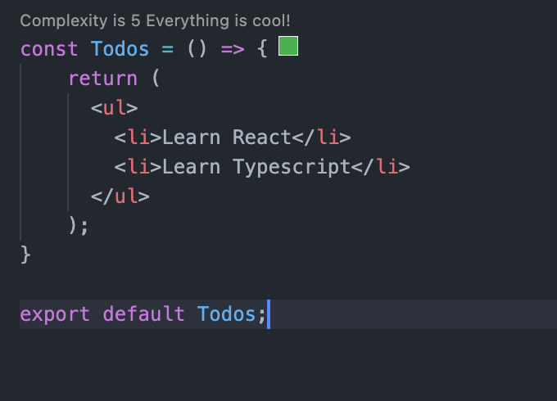

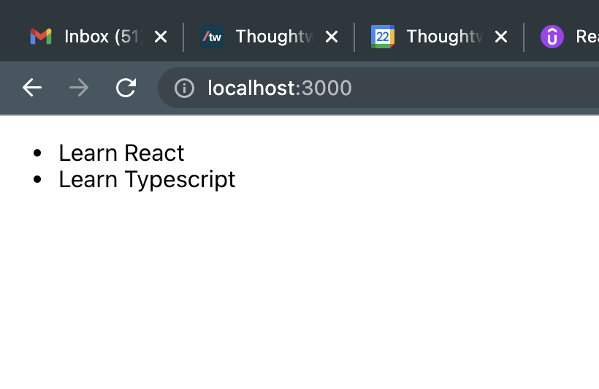

## Working with props and Typescript

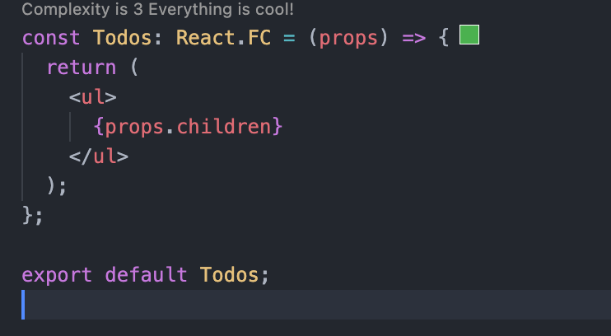

Here, React.FC is type annotation which tells that Todos is functional component. Because of this, props contain children attribute by default.

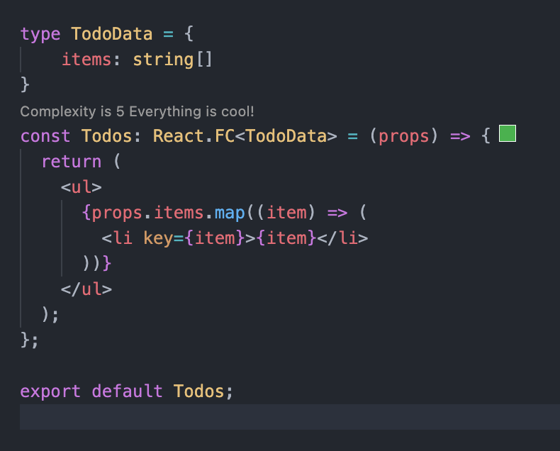

If we specify the React.FC alone, it will be more generic type. It contains only default attributes of props. Like for example children props. To specify the props attribute that we want for functional component we specifying it as React.FC<TodoData>. By specifying this, TodoData attribute will be merged with default attributes for props.

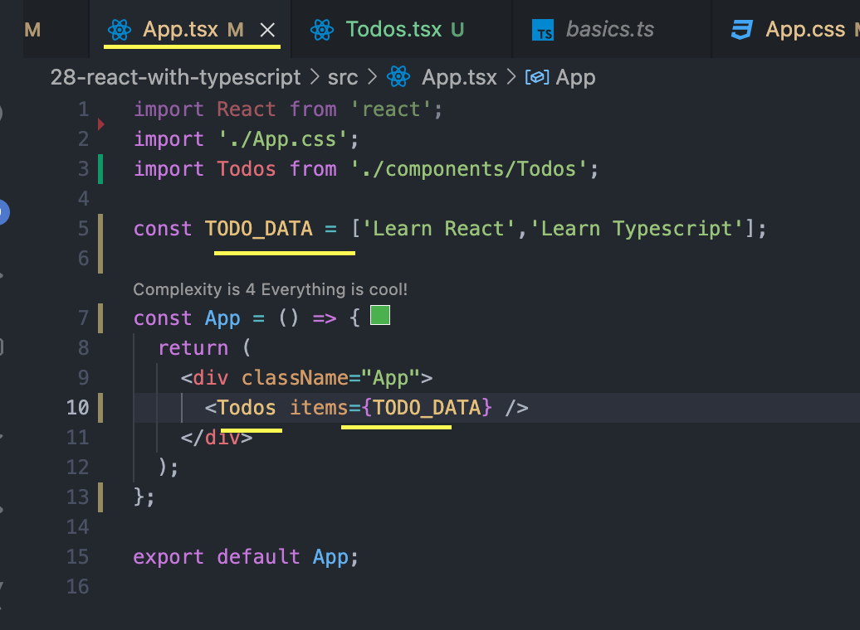

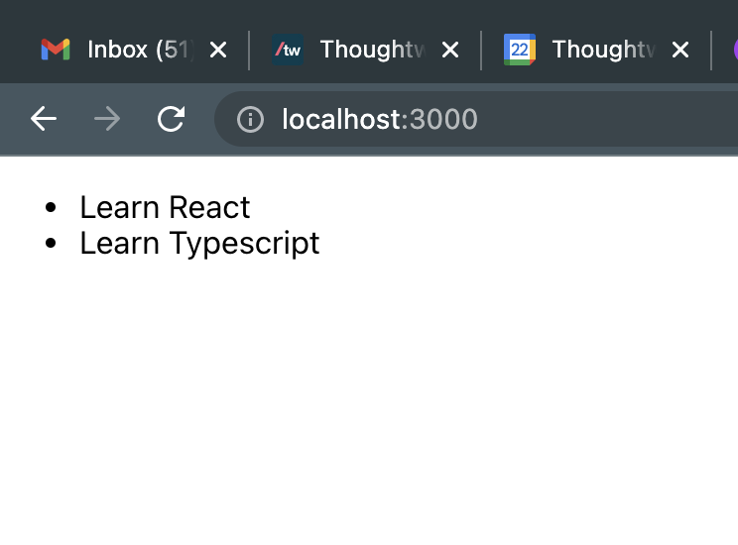

## Adding a Data Model

Adding a data model to represent a Todo data.

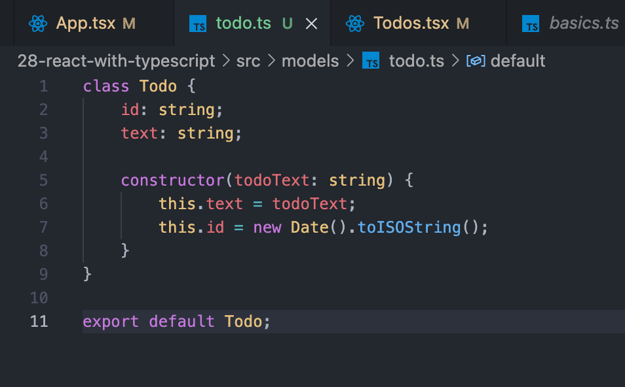

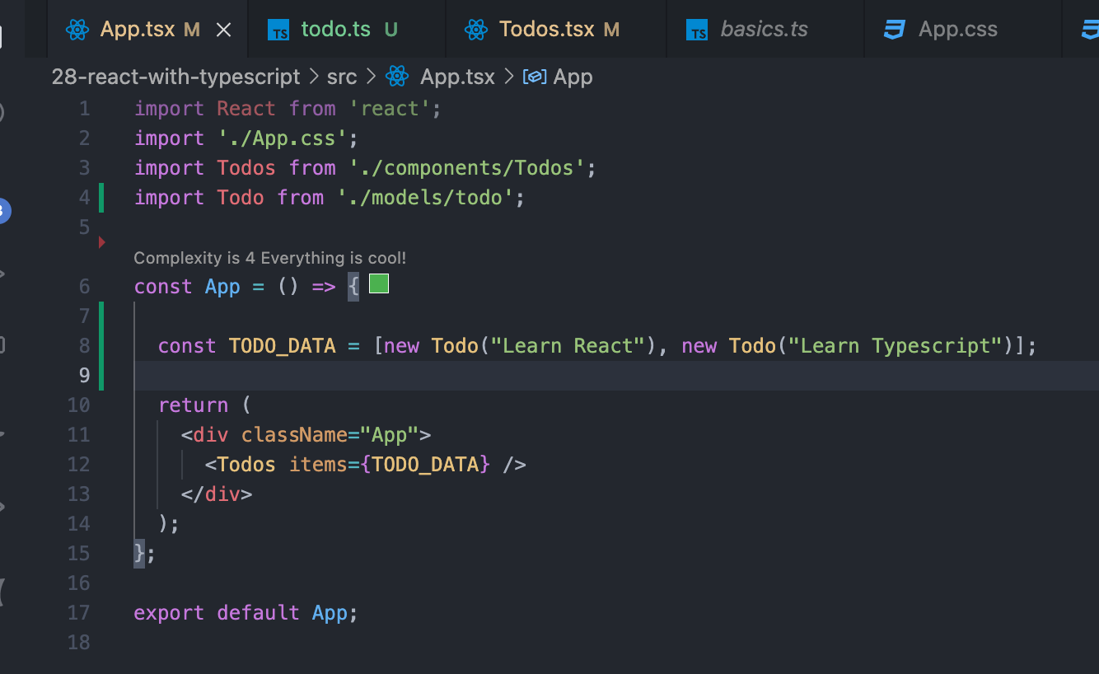

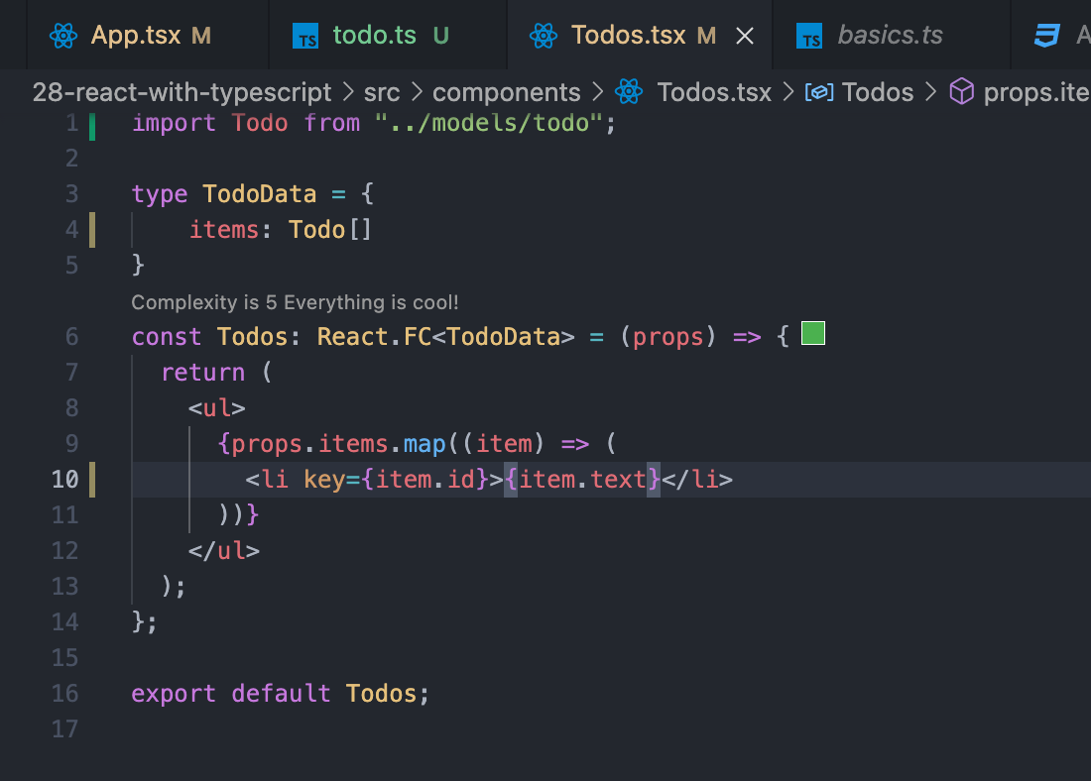

## Sperate out by Adding a TodoItem component

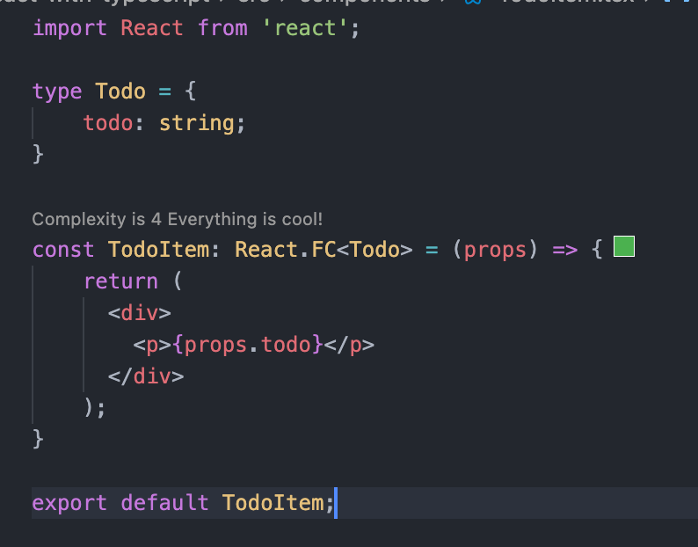

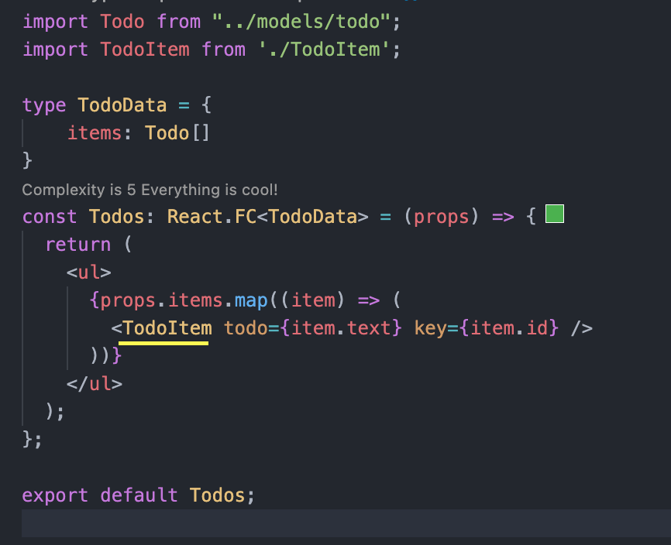

As we can in TodoItem props, key can be added even though it not specified in Todo type. “key” props is default to React.FC type annotation. So, it is merging it.

## Working with ref, useRef and Function Props

Below example also explains the way for including the props in props.

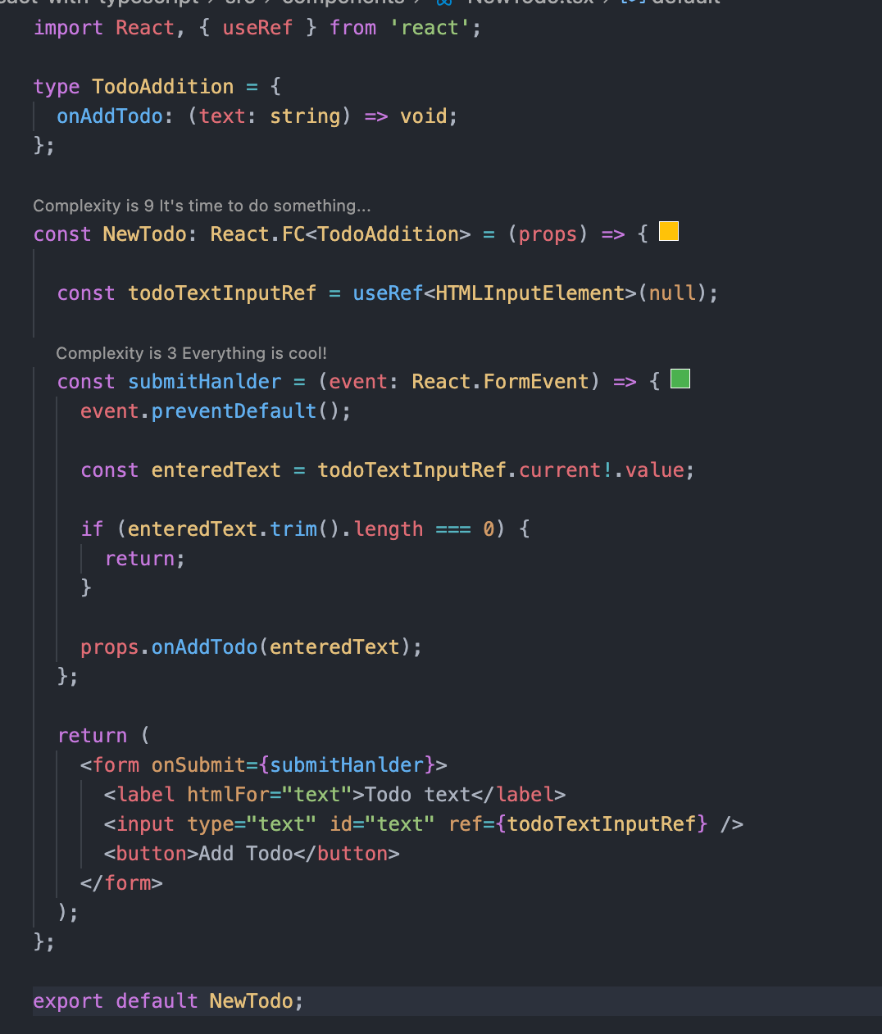

## Managing State

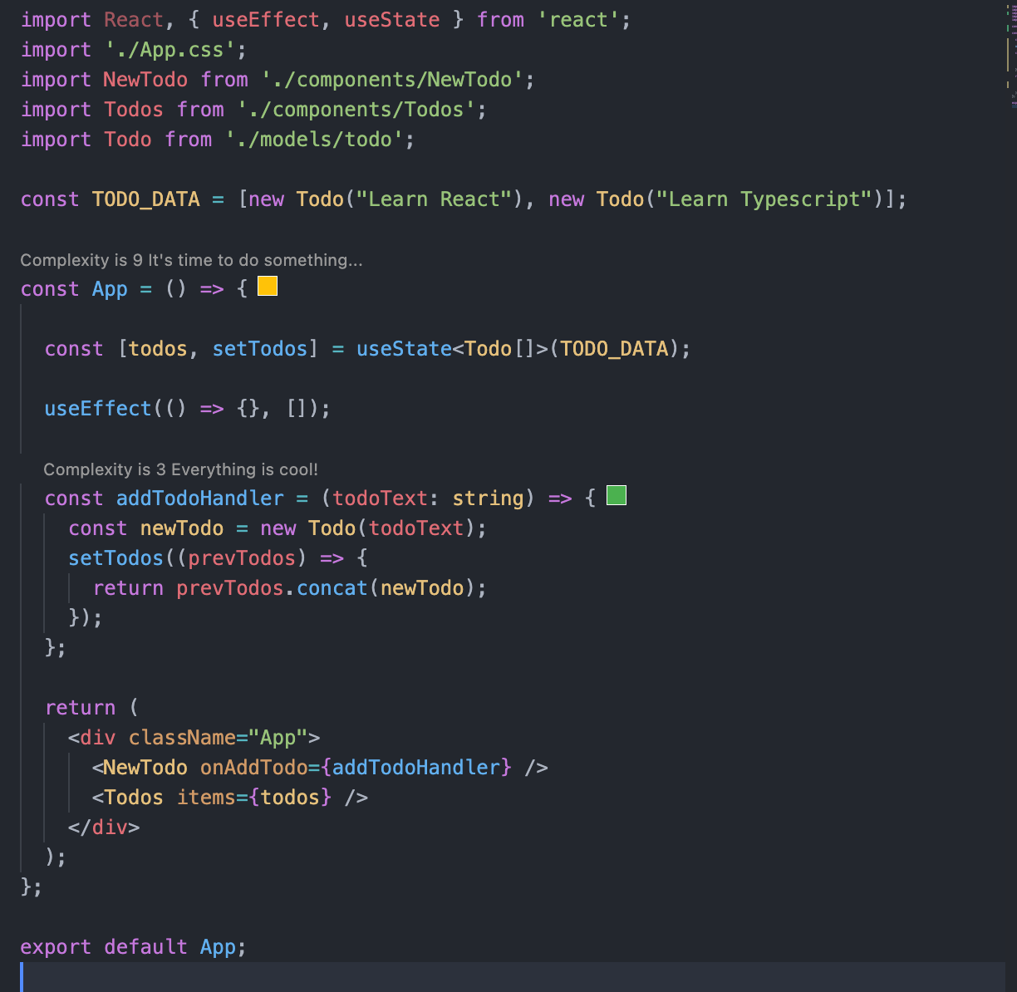

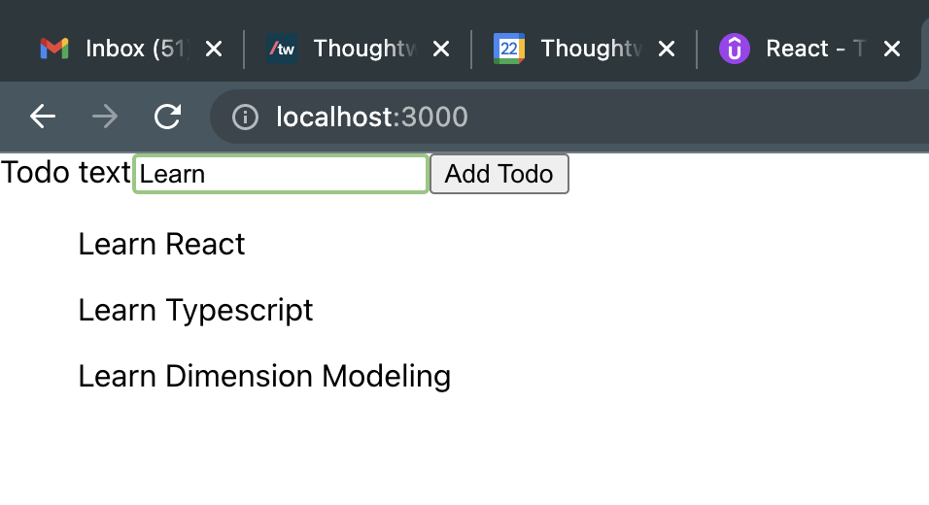

## Removing Todo Item

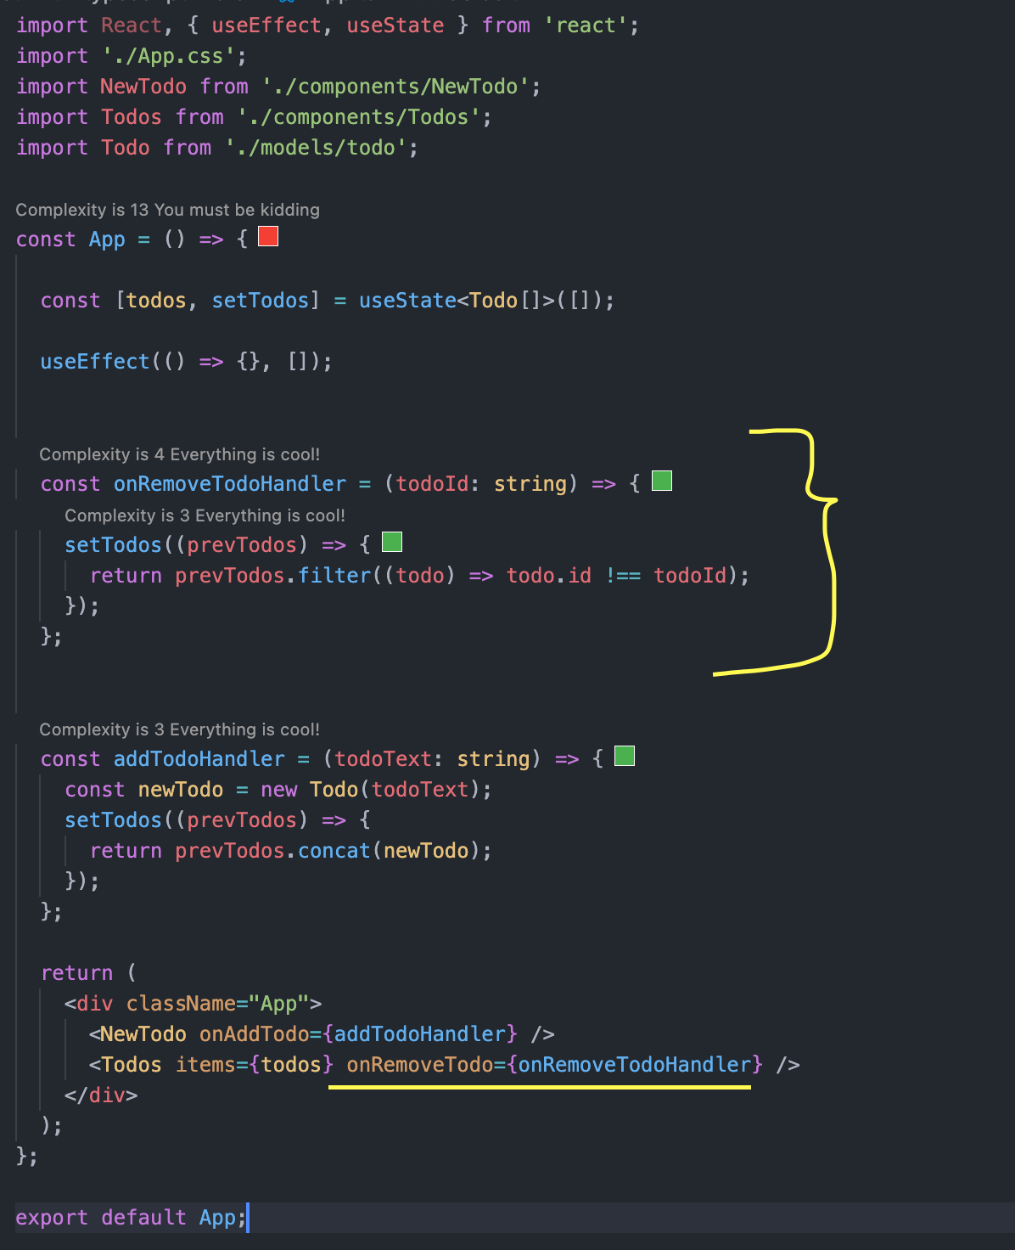

* Here we are doing the bind on “onRemoveTodo” function props.
* Here, “item.id” will be passed as “todoId” parameter which is required for onRemoveTodo function probs.
* So, this help us to provide the future parameter reference to a function.

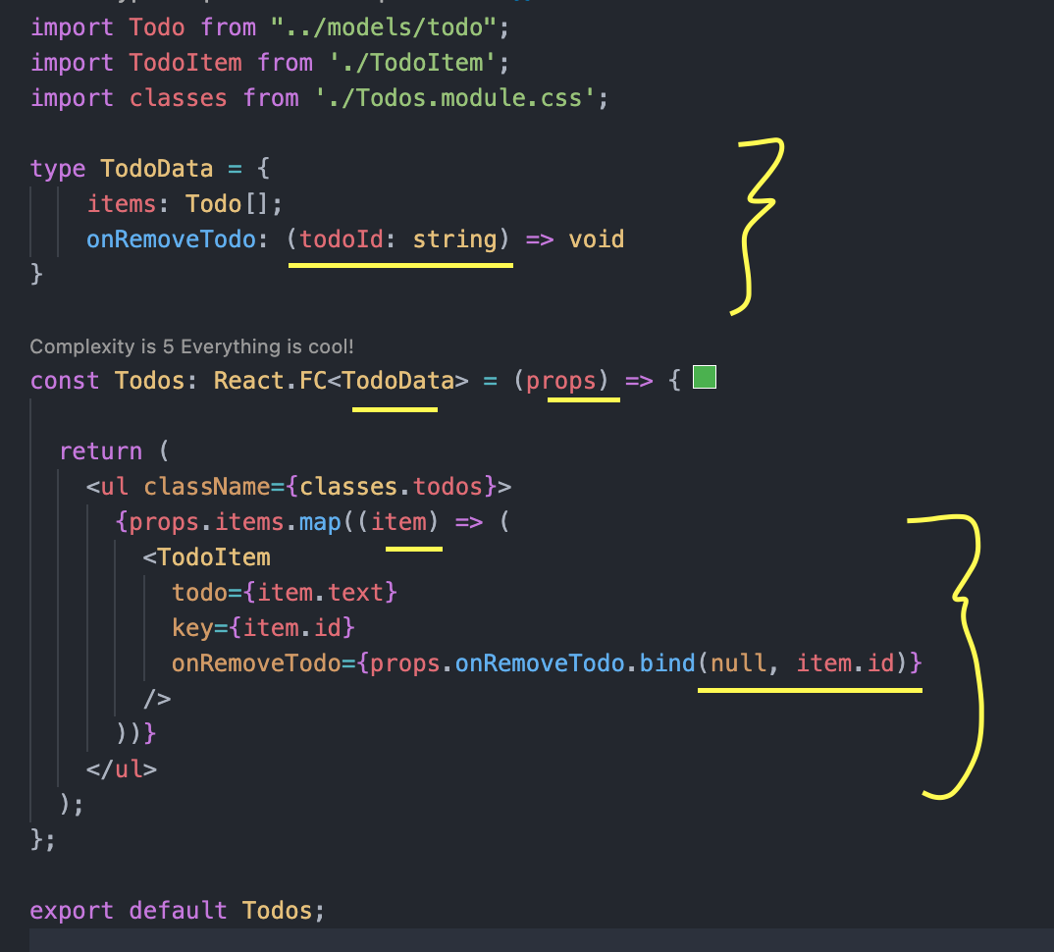

* Since we are using the bind, TodoItem does not required to pass a todo id which is required for performing the delete operation. (Beside we don’t have todo id from TodoItem component. That’s why we are following this approach)
* As we can see it the below screenshot, actual on click operation is happening in TodoItem component. But the reference of, which TodoItem has been clicked, is taken from Todos component using bind approach.

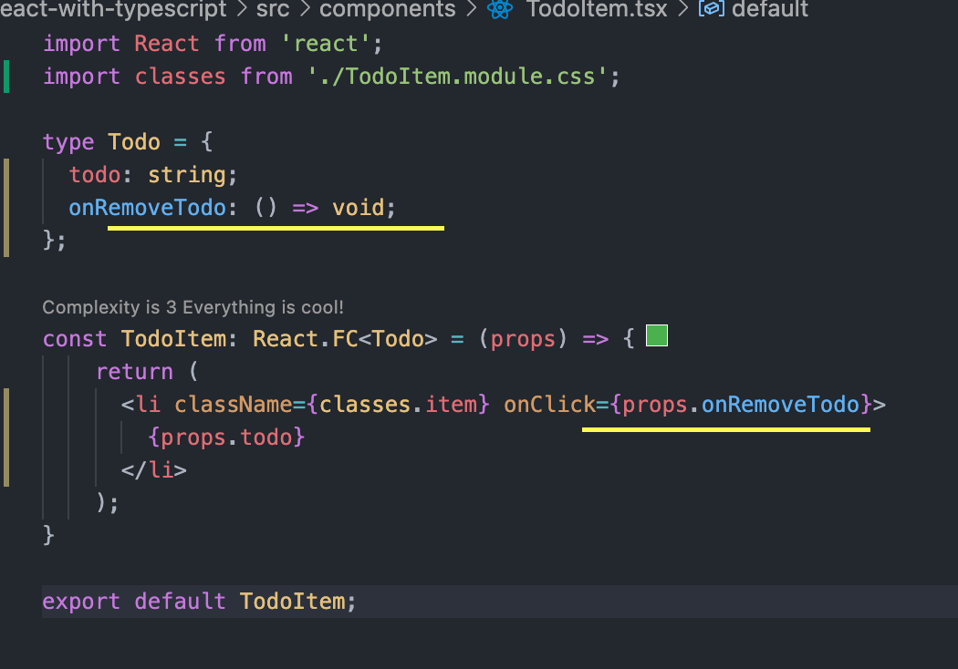

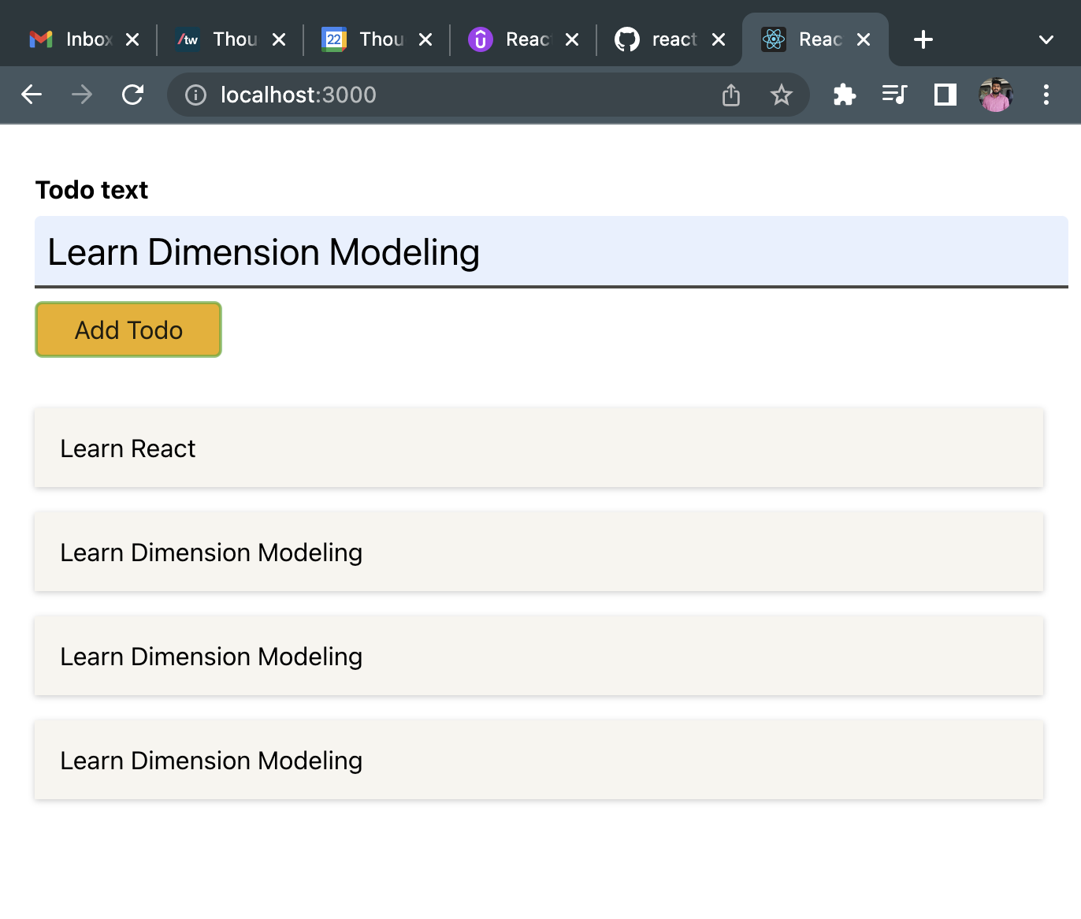

## Using Context API

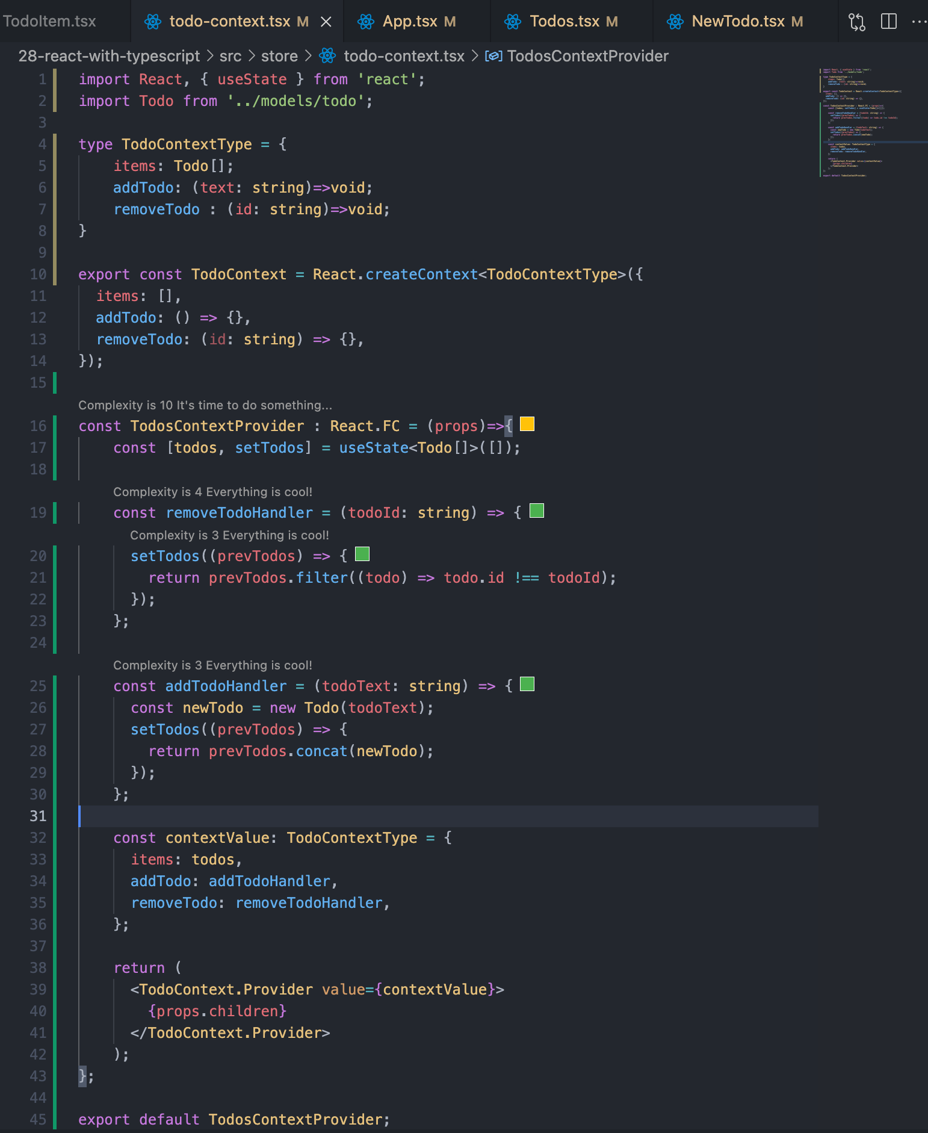

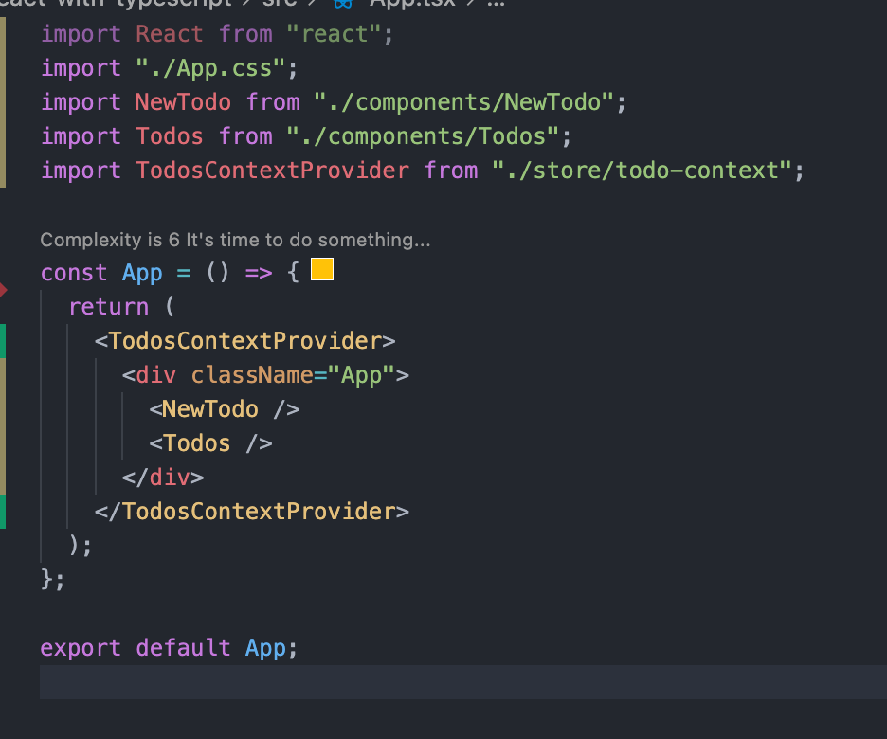

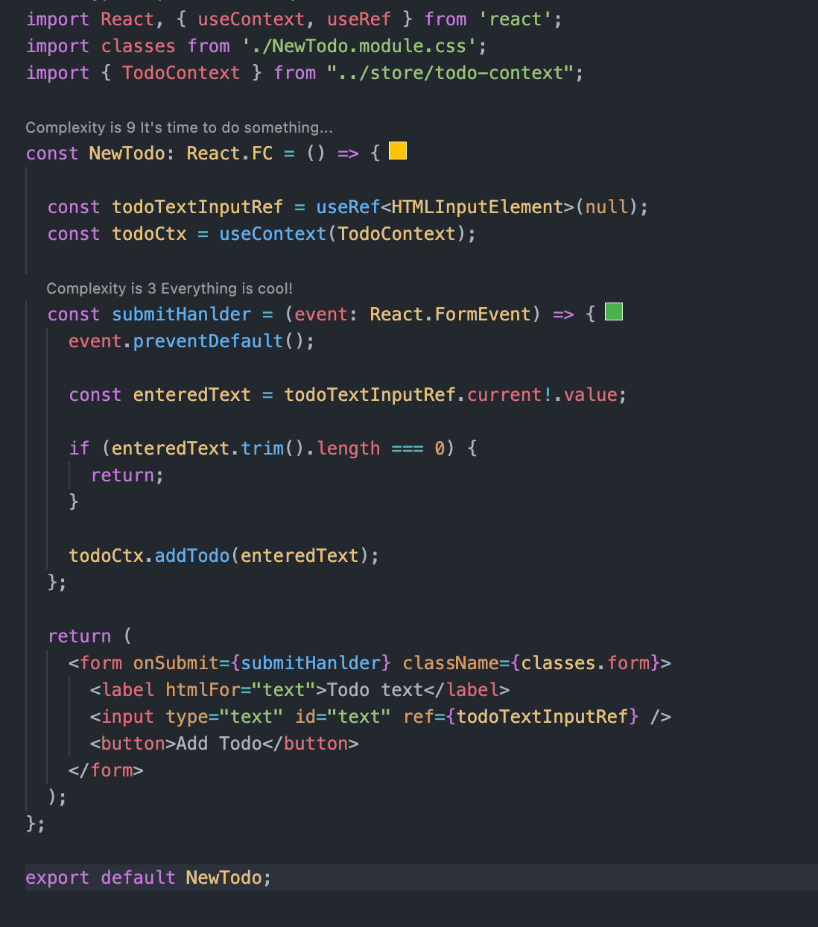

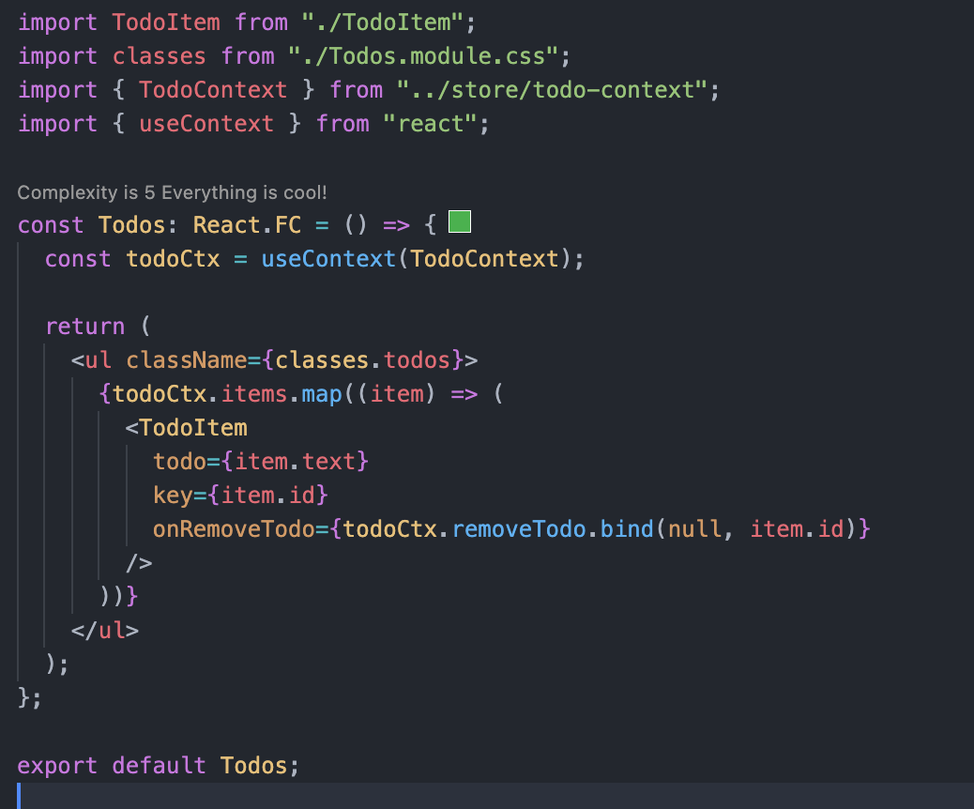

## tsconfig.json

This file take care of the configuration for typescript. Like libraries to manage etc.

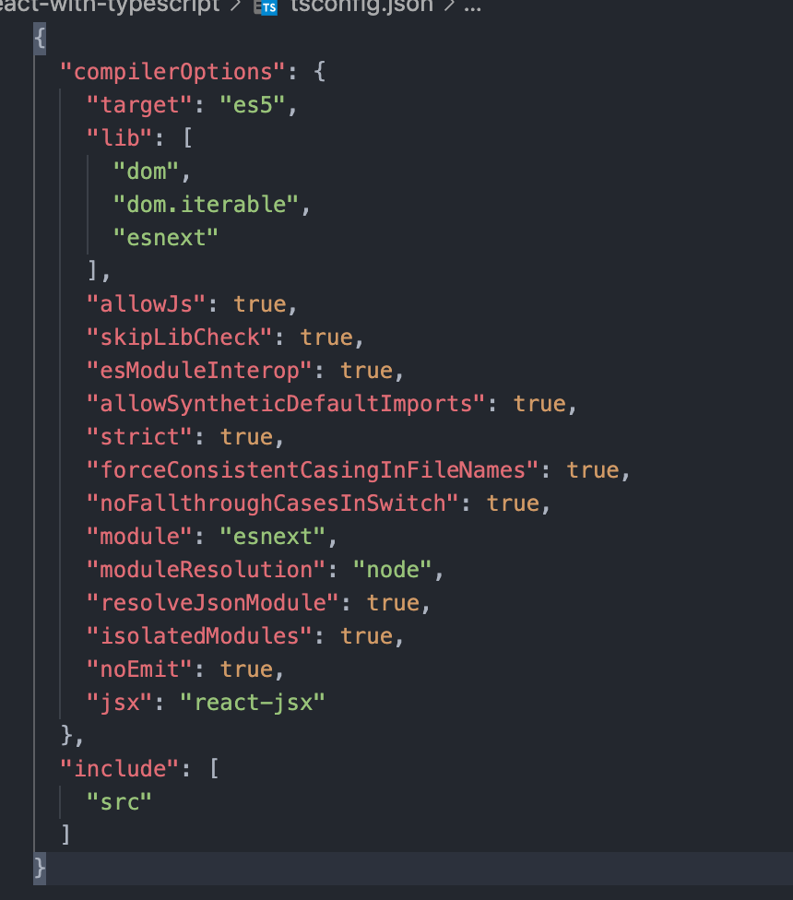

# React Hooks

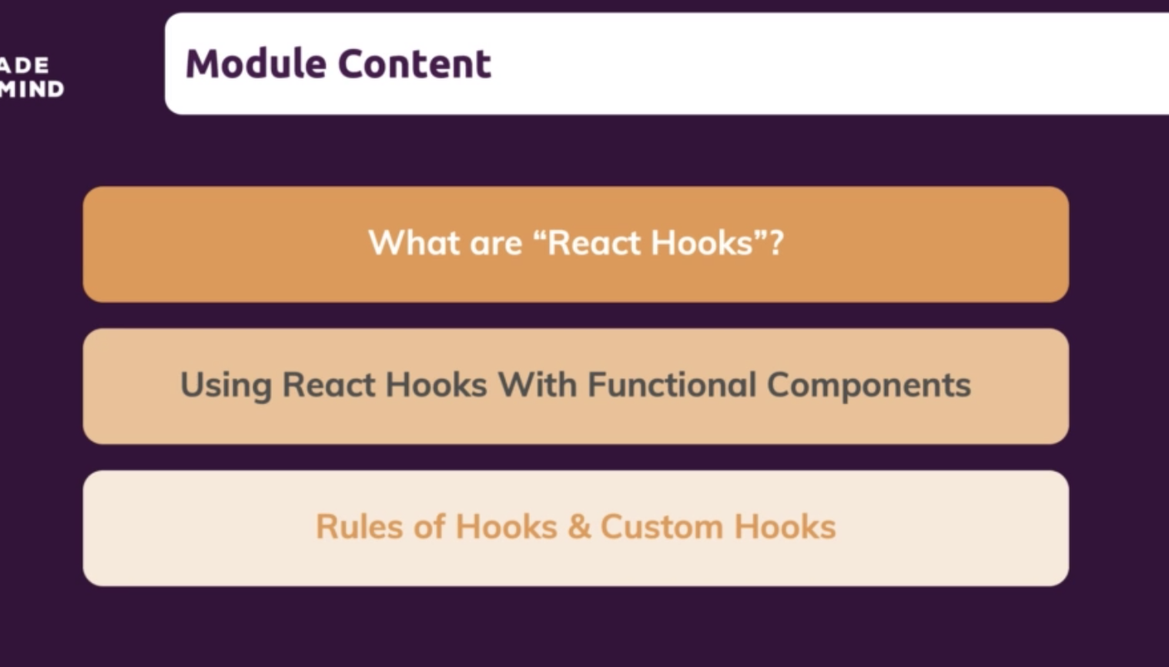

## What are React Hooks ?

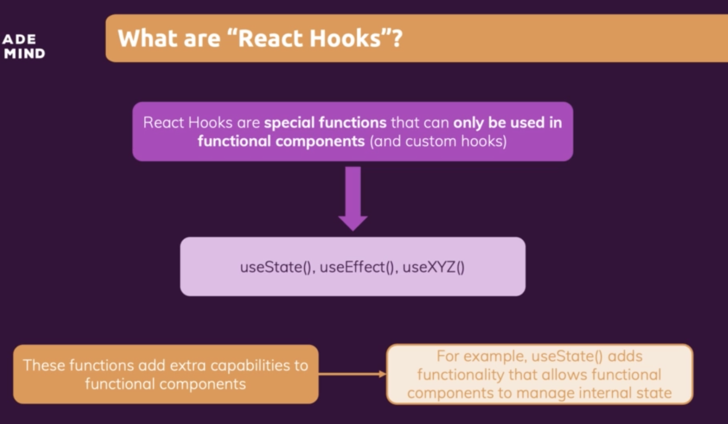

For class-based component, state is always an object.

## useState Hook

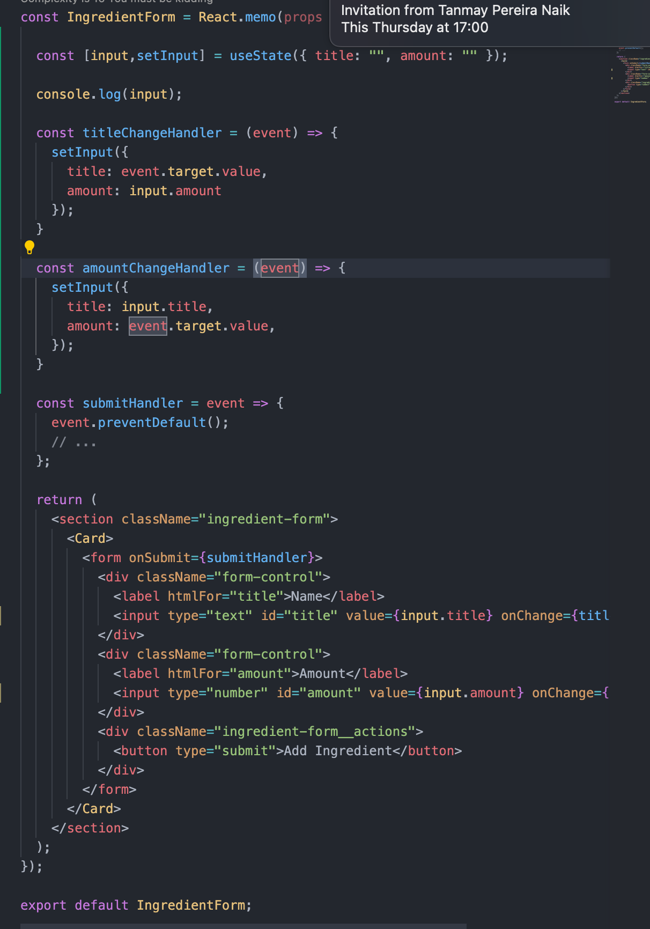

## SetStateFunction with Previous state

Here, we are getting the error because we are using the event object inside the anonymous function. Because of this reason, evet object will be locked inside the set state function. The subsequent keystroke followed by first keystroke, try to reuse the first event object which has been locked inside. This in turn cause the error.

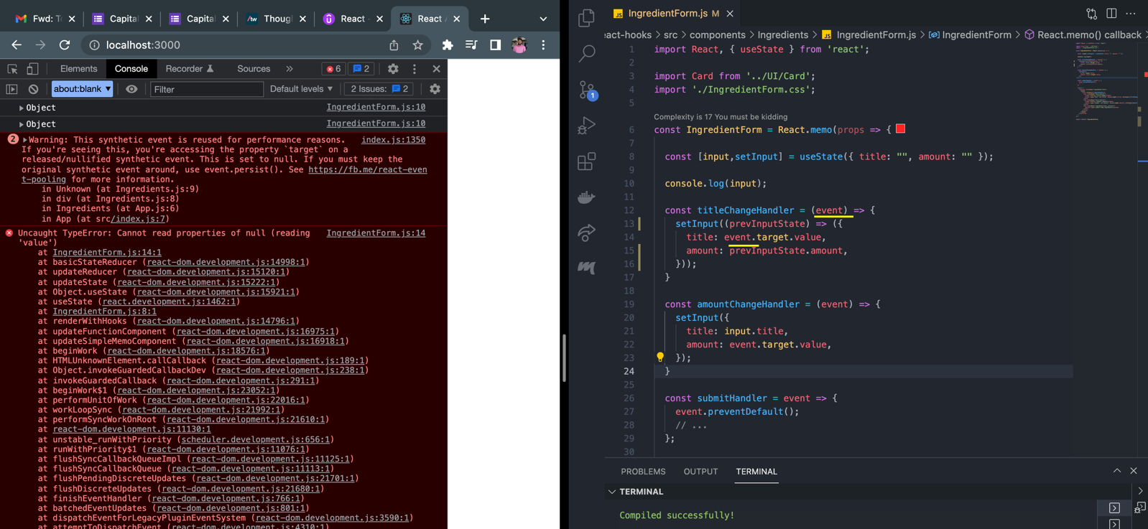

Solution is to refer to the new event object value.

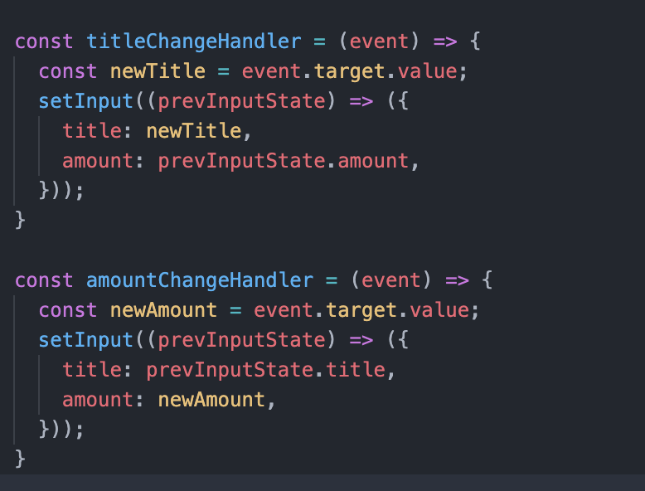

## Rules of Hooks

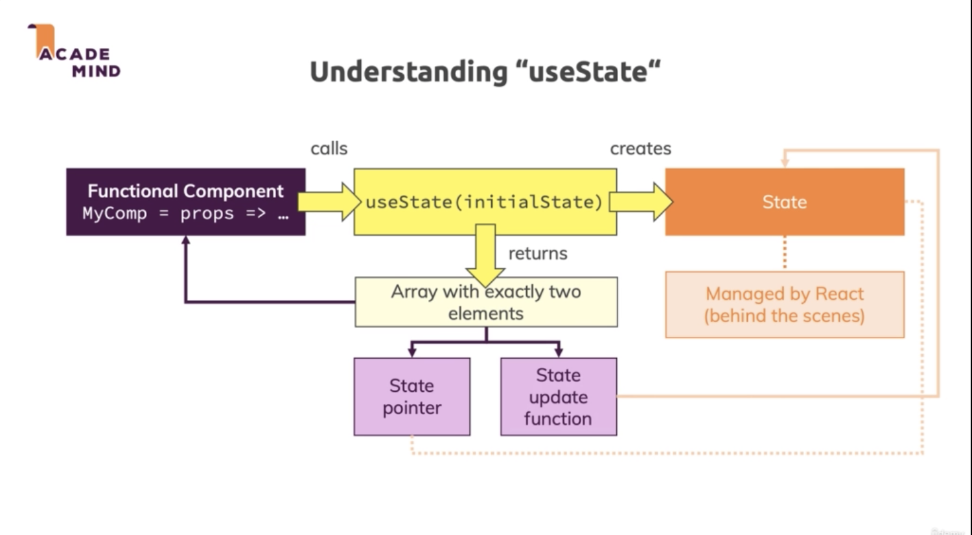

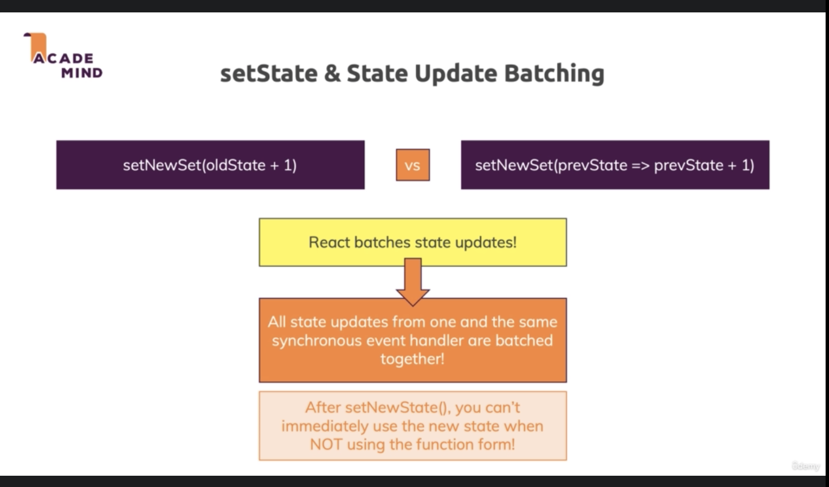

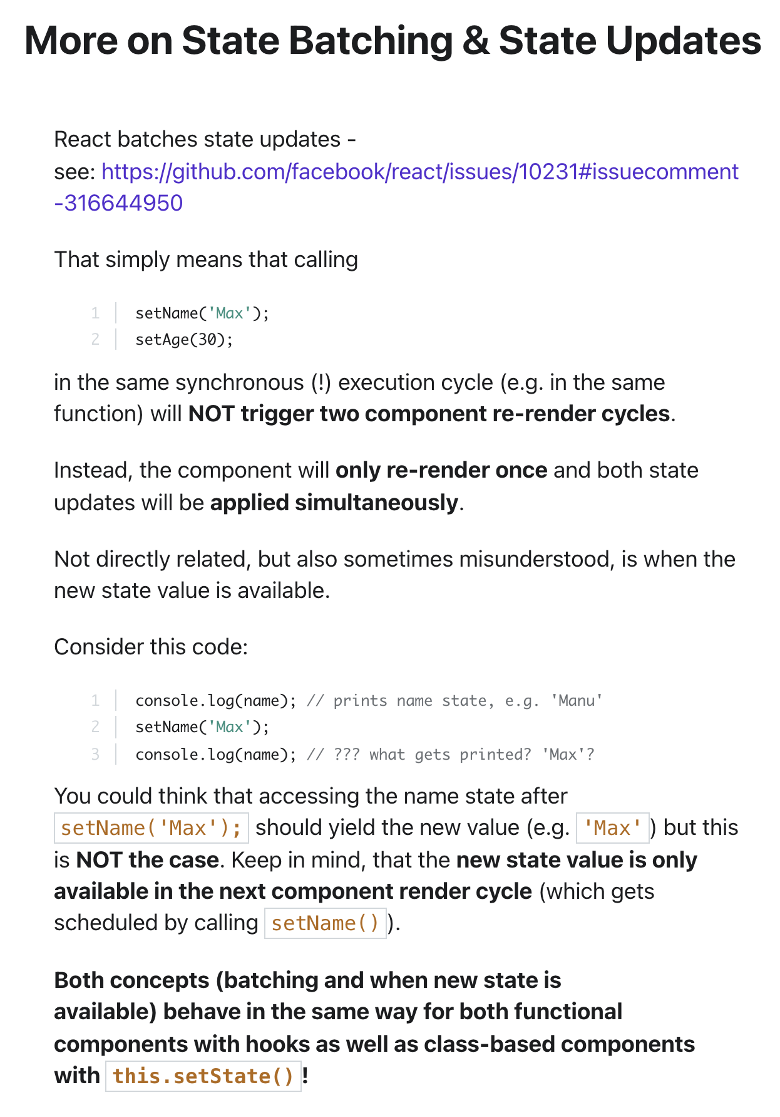

## Performance Optimization

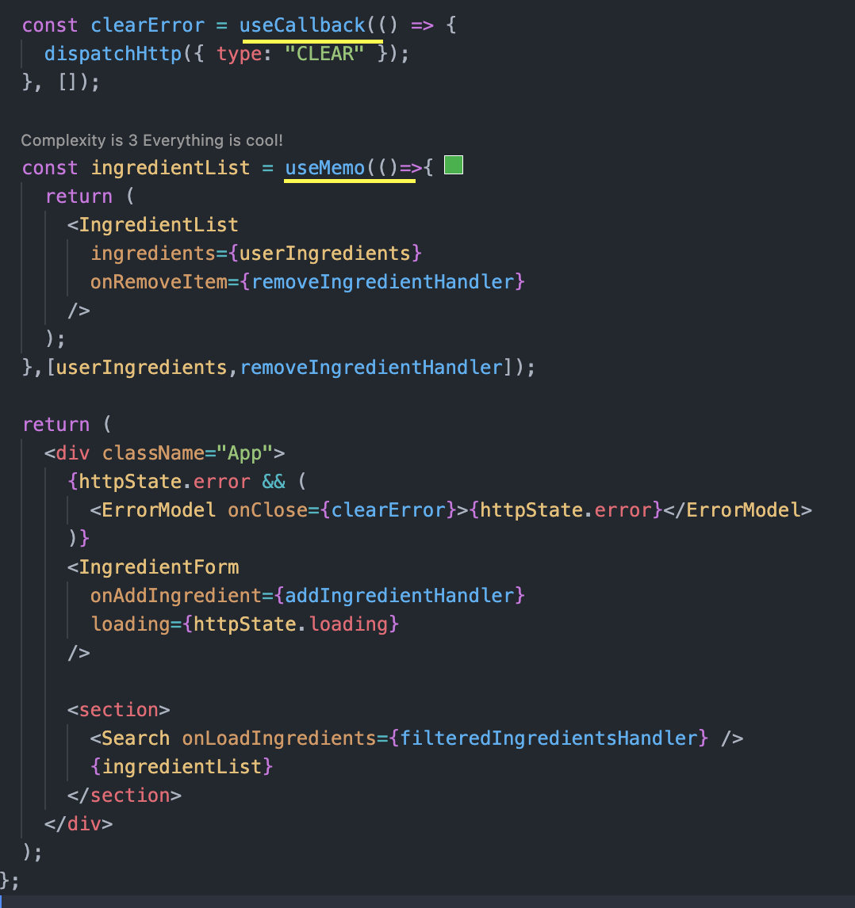

# React Summary

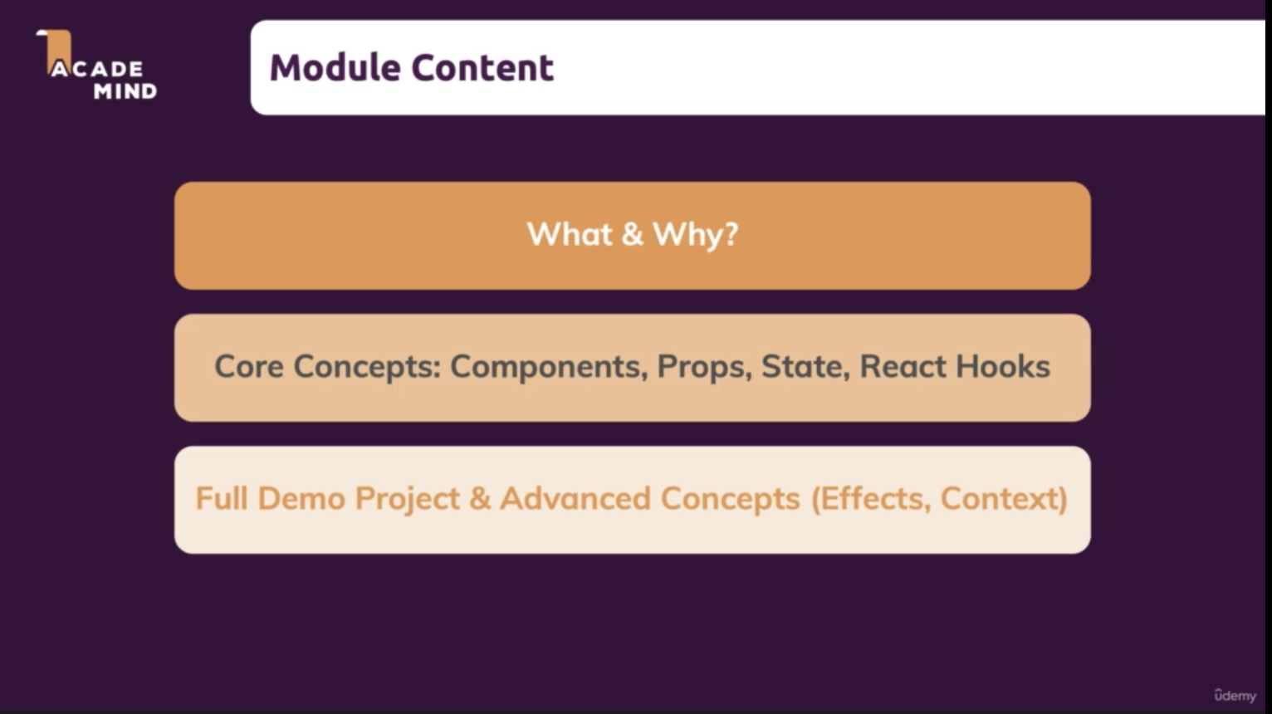

# What is React ?

Java script library for building user interface.

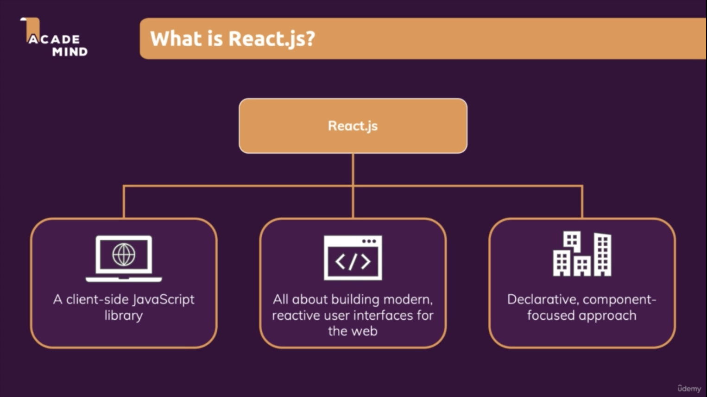

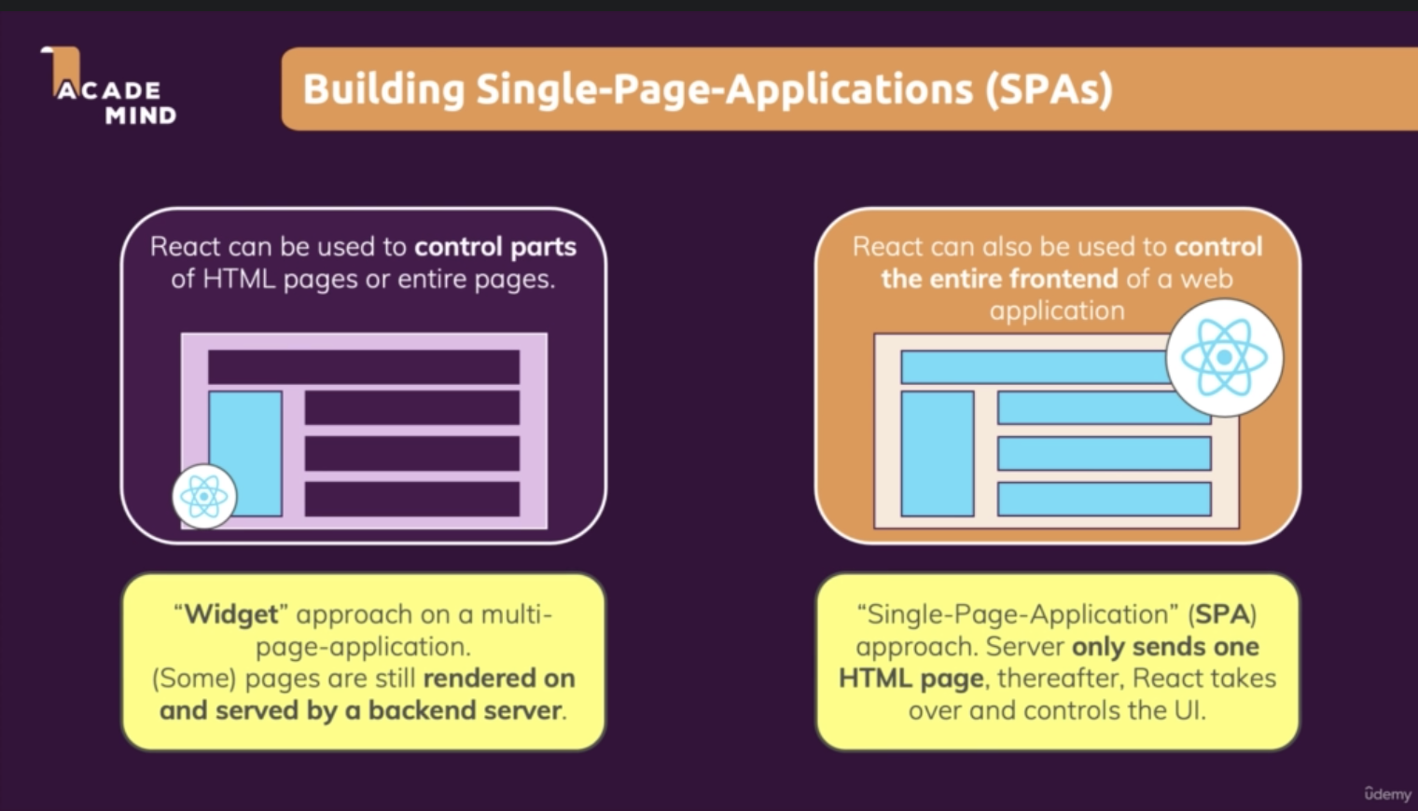

## Reactive Alternative

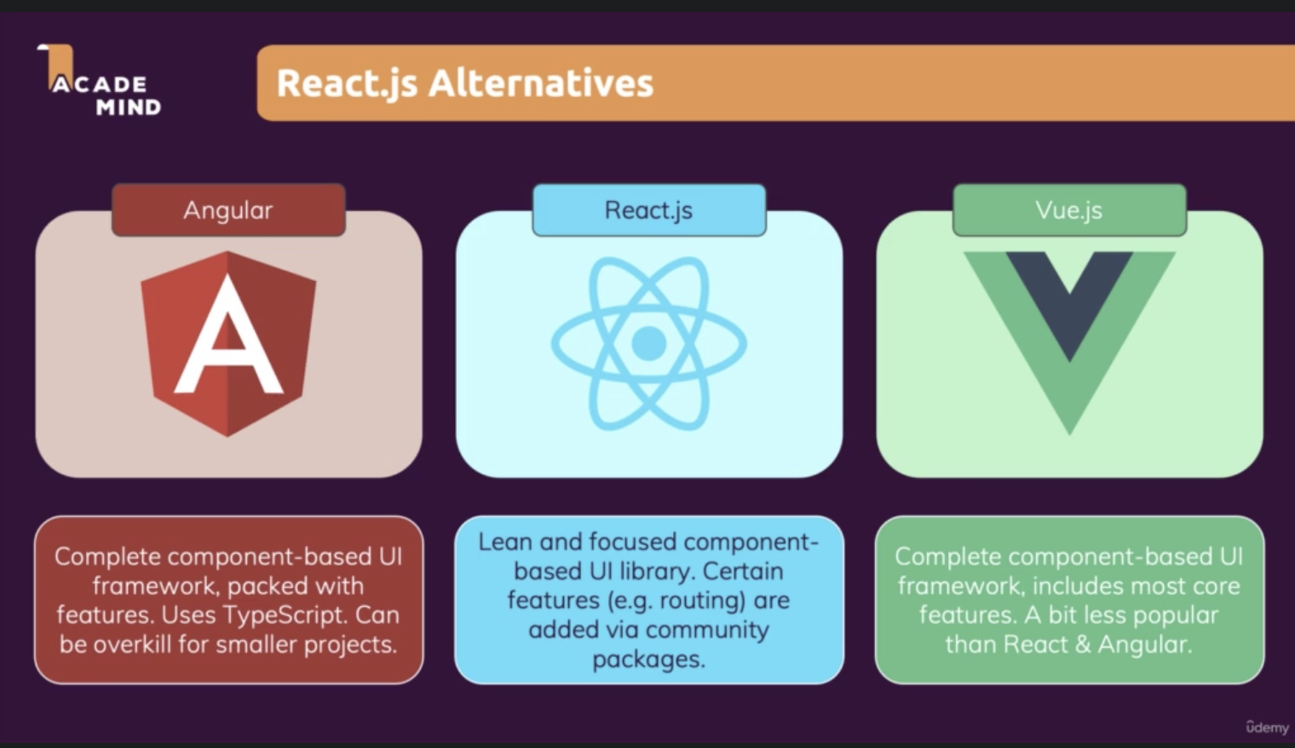

## Creating a React project

npx create-react-app my-app

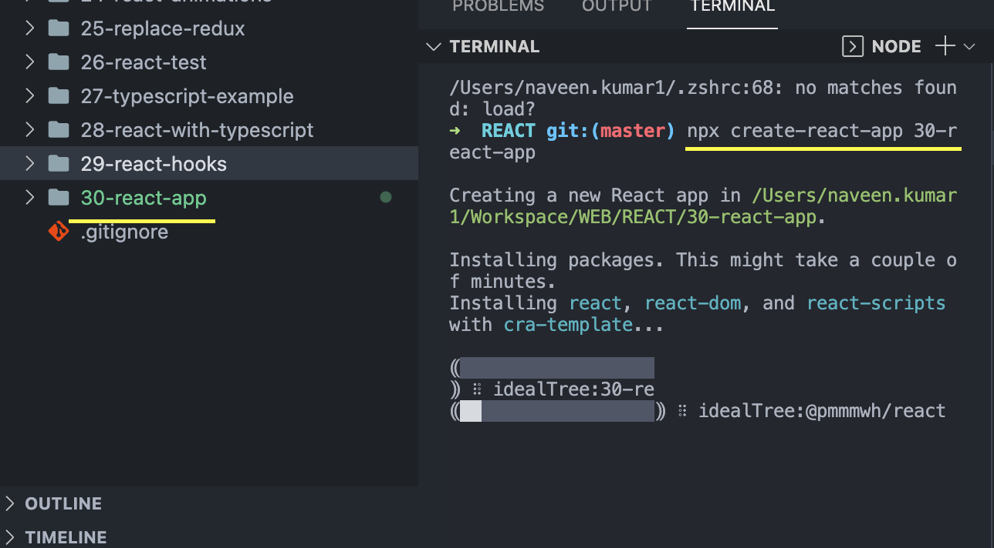

# React Eco System

